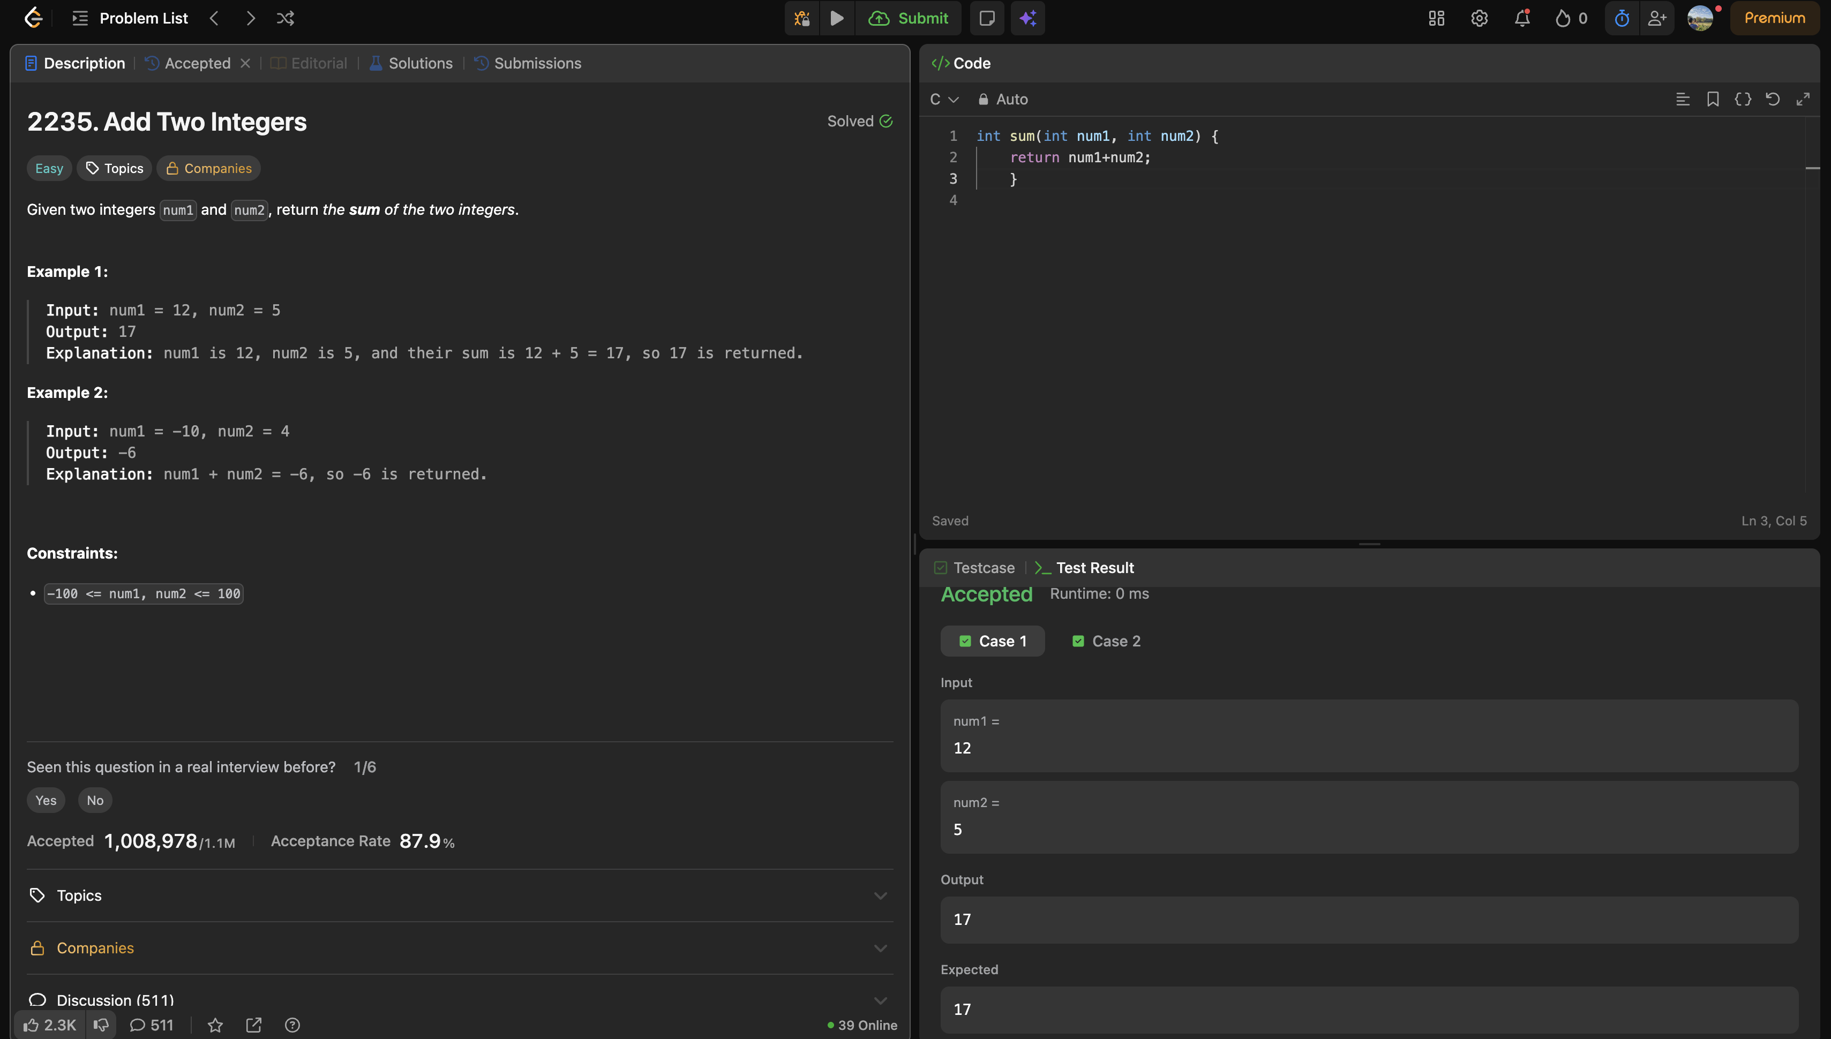

Problem link: https://leetcode.com/problems/add-two-integers/description/

int sum(int num1, int num2) {
return num1+num2;
}

