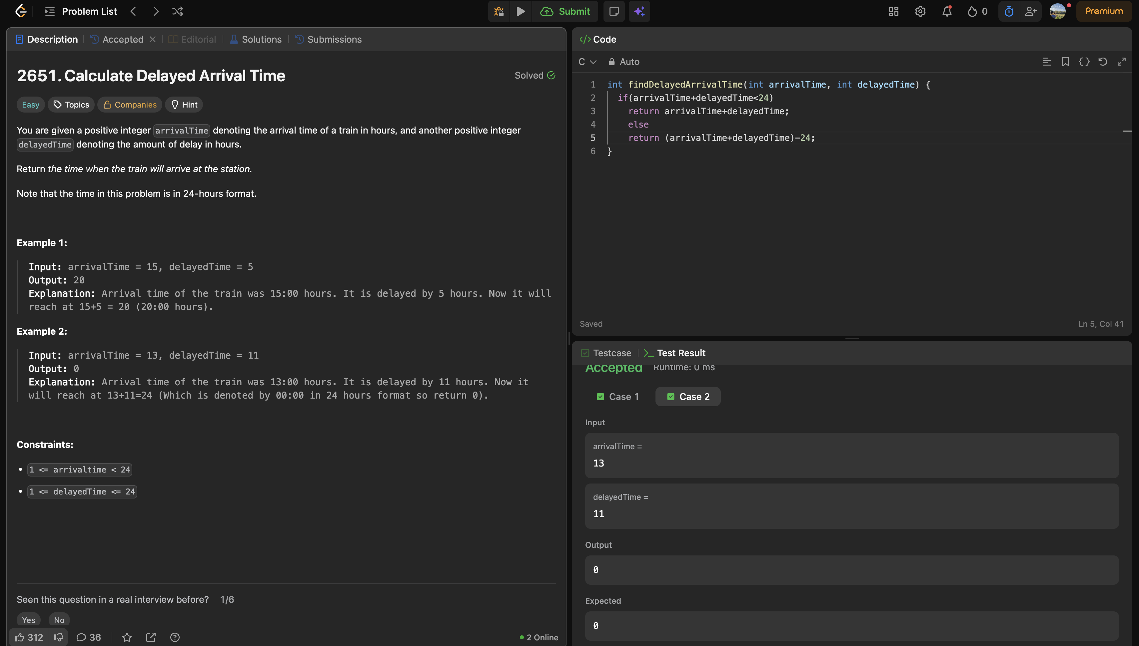

Problem link: https://leetcode.com/problems/calculate-delayed-arrival-time/description/

int findDelayedArrivalTime(int arrivalTime, int delayedTime) {
if(arrivalTime+delayedTime<24)
return arrivalTime+delayedTime;
else
return (arrivalTime+delayedTime)-24;
}

