Problem Link: https://www.hackerrank.com/challenges/conditional-statements-in-c/problem
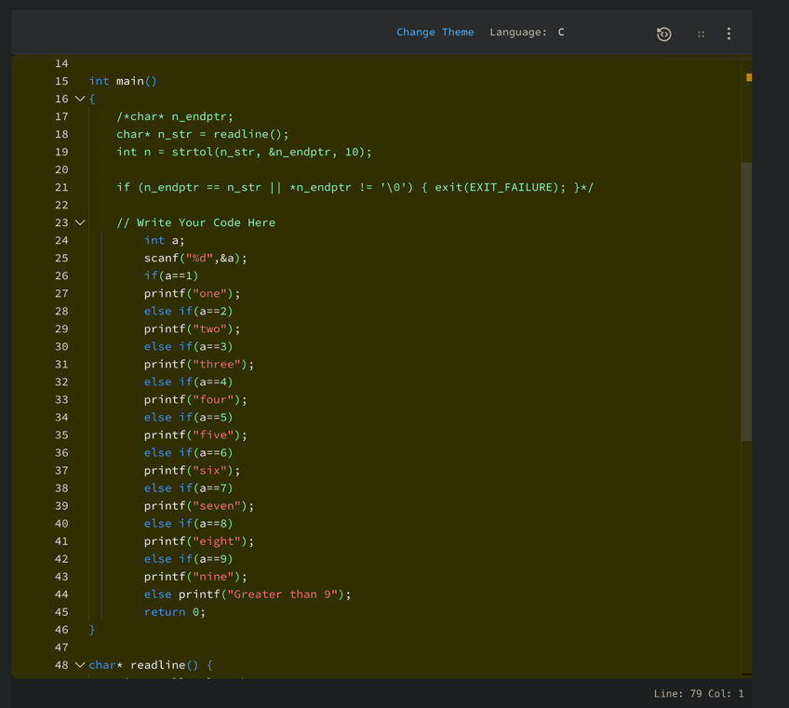

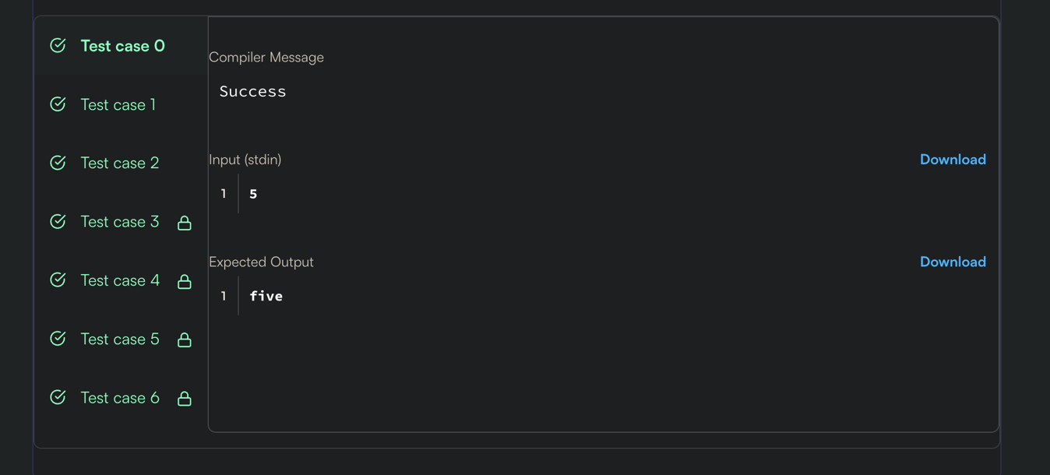

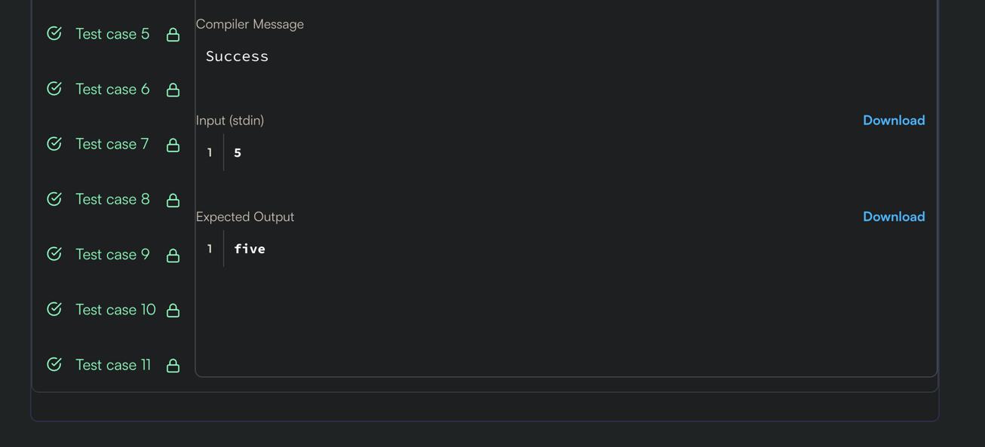

int a;
scanf("%d",&a);
if(a==1)
printf("one");
else if(a==2)
printf("two");
else if(a==3)
printf("three");
else if(a==4)
printf("four");
else if(a==5)
printf("five");
else if(a==6)
printf("six");
else if(a==7)
printf("seven");
else if(a==8)
printf("eight");
else if(a==9)
printf("nine");
else printf("Greater than 9");
return 0;
}

