

A Comparative Evaluation of a Hybrid NLP-Based Multilingual Patient Pre-Screening Chatbot Prototype for Medical Missions

Proponents:
Reanne Kevin R. Angcos
Christian Miguel E. Erojo
Kurt Lester M. Obregon
Computer Science Department, Ateneo de Davao University
CS 3248: CS Thesis Writing 1
Adviser:
Dr. Oneil B. Victoriano
October 2026

TABLE OF CONTENTS
Abstract 5
CHAPTER 1: INTRODUCTION 6
1.1 Background of the Study 6
1.2 Statement of the Problem 7
1.3 Objectives of the Study 8
1.4 Significance of the Study 8
1.5 Scope and Limitations 10
CHAPTER 2: REVIEW OF RELATED LITERATURE 12
2.1 Review of Related Literature 12
2.1.1 ESI and Provisional Pre-Screening 12
2.1.2 Patient Reports and Triage Questions 13
2.1.3 NLP and Selection of GPT-6 Luna 13
2.1.4 Performance and Limitations of LLM Triage 14
2.1.5 Rule-Based and Hybrid Decision Support 15
2.1.6 Vignette Evaluation and Research Gap 16
2.1.7 Comparison of Patient Triage Approaches 18
2.2 Theoretical Framework 19
CHAPTER 3: METHODOLOGY 21
3.1 Conceptual Framework 21
3.2 Operational Framework 23
3.3 Comparative Research Design 24
3.4 Medical-Professional Interviews and Requirements 25
3.5 Screening Inputs and Classification Definitions 25
3.6 Synthetic Case Construction and Sample Plan 26
3.7 Expert Reference Answers and Case Review 28
3.8 Language and Code-Switched Versions 29
3.9 Development and Final-Evaluation Separation 30
3.10 LLM-Only Baseline 31
3.11 Hybrid Rule-Layer Procedure 31
3.12 Evaluation Units and Experimental Execution 33
3.13 Metric Definitions and Paired Analysis 33
3.14 Reproducibility and Error Handling 36
3.15 Ethical Considerations and Study Limitations 37
Bibliography 39
Abstract
Advancements in artificial intelligence (AI), natural language processing (NLP), and large language models (LLMs) have enabled research on conversational patient triage. This study will compare two methods for predicting provisional Emergency Severity Index (ESI) levels from patient-reported information before nurse assessment. Method A will use OpenAI’s GPT-6 Luna to predict the level. Method B will use Luna to extract facts and a deterministic rule layer to assign its own prediction.
Published studies report varying triage agreement and error patterns across models, protocols, and evaluation settings [2], [3], [9]. These findings motivate a controlled comparison; they do not establish how the proposed prototype will perform on multilingual medical-mission screening inputs. The study will examine English, Tagalog, Bisaya, and three code-switching pairs without assuming equivalent performance across these conditions.
The study will reuse the existing synthetic dataset and its validated ESI labels. The planned sample contains 150 distinct adult cases, with 30 cases at each of five reference ESI levels. Each case has English, Tagalog, Bisaya and two code-switched versions, giving 750 case versions. Both methods will use equivalent information and criteria. Predictions will be compared with the reference labels using accuracy, macro-F1, consistency, misclassification, overtriage and undertriage rates. An output such as “Provisional ESI prediction: 3” remains a numbered classification for evaluation; it does not confirm completion of clinical ESI assessment. Needs review is an unresolved processing status, not a sixth level. The study excludes diagnosis, treatment recommendations, measured vital signs, actual-patient evaluation and deployment. Improvement is a hypothesis to be tested.
CHAPTER 1

1.1 Background of the Study
Patient triage is a critical process in healthcare systems that prioritizes patients based on the severity and urgency of their condition to ensure timely medical intervention. This process becomes more challenging in environments such as medical missions, where healthcare resources are limited and patient volume is high. In such settings, the ability to quickly and accurately classify patients is essential to prevent delays in treatment and to optimize the allocation of limited medical resources.
Traditional triage systems rely on structured information and predefined clinical guidelines to support decision-making. For example, injury field-triage guidance specifies criteria for routing injured patients to appropriate care [1]. Such guidance illustrates structured decision logic, but its setting and information requirements differ from text-based medical-mission pre-screening. Patients may describe symptoms using informal language, incomplete information, or a mixture of languages, making direct interpretation difficult for a rule engine that expects structured facts.
To address these limitations, artificial intelligence technologies such as natural language processing (NLP) and large language models (LLMs) have been investigated in triage. NLP enables extraction of information from unstructured text [7]. In this study, the existing LLM will perform the language-processing and information-extraction tasks. NLP describes those functions; it is not a separately specified model or an additional model-training stage. The study will test whether the selected LLM interprets the targeted multilingual inputs adequately.
Despite these capabilities, published triage evaluations report model-dependent agreement and errors [3], [9]. Colakca et al. [2] reported promising results using Emergency Severity Index criteria, but their cases included staff-measured information outside this study’s input scope. Consequently, results from clinical triage studies cannot establish the performance of a surface-level pre-screening prototype. The effect of adding coded rules must be measured using a fair baseline and reference answers appropriate to the proposed task.
The proposed input conditions are English, Tagalog, everyday Bisaya, and three code-switching pairs. These conditions are intended to represent language variation relevant to the proposed Philippine medical-mission context. Interviews have not yet established local questioning practices or common expressions. Language variants will therefore require review for realism and preservation of the same screening facts before they can be used to assess classification consistency.
Given these challenges, this study proposes a hybrid NLP-based patient pre-screening chatbot that combines LLM-based interpretation with a deterministic rule-based decision layer. Luna will interpret multilingual input and extract reported facts. In Method A, Luna will also predict a provisional ESI level. In Method B, the rule layer will independently assign a provisional level using only the extracted facts. Luna’s predicted level and explanation will not enter Method B. Fixed rules produce repeatable decisions for identical structured inputs, but their correctness depends on extraction quality and reviewed criteria. The comparison will measure the effect of coded rule enforcement.

1.2 Statement of the Problem
This study addresses the technical limitations of LLM-based patient triage systems, particularly their inconsistency, sensitivity to input variations, and unreliable classification performance.
Specifically, the study seeks to answer the following:
- How accurately do the LLM-only and hybrid methods predict provisional ESI levels from patient-reported multilingual information, compared with validated reference labels, in terms of:
  - Accuracy
  - Macro-F1 score
- How consistent are the classification outputs when the system is given semantically equivalent inputs with variations in phrasing, in terms of:
  - Consistency rate
- What effect does the deterministic rule-based decision layer have on prediction reliability compared with standalone LLM outputs, in terms of:
  - Misclassification rate
  - Overtriage rate
  - Undertriage rate

1.3 Objectives of the Study
General Objective
The general objective of this study is to develop a multilingual patient pre-screening chatbot and compare LLM-only and hybrid rule-based methods in predicting provisional ESI levels from patient-reported information, using classification performance, consistency and reliability on validated synthetic cases.
Specific Objectives
- To compare the classification performance of the LLM-only and hybrid methods in predicting provisional ESI levels against validated reference labels, as measured by:
  - Accuracy
  - Macro-F1 score
- To measure the consistency of classification outputs across semantically equivalent inputs, as measured by:
  - Consistency rate
- To quantitatively evaluate the effect of the deterministic rule-based decision layer on prediction reliability, as measured by:
  - Misclassification rate
  - Overtriage rate
  - Undertriage rate

1.4 Significance of the Study
This study will contribute evidence about the performance of an LLM-based pre-screening prototype with and without coded rule enforcement. Published triage studies motivate examining agreement and error patterns [3], [9], while the proposed multilingual synthetic evaluation addresses a more specific setting. Its contribution will be the comparative results, reviewed case resource, and documented implementation, whether the hybrid method improves, matches, or performs worse than the baseline.

1. Subject Area, Technology, and Methods
This study applies hybrid artificial intelligence by combining language processing through an existing LLM with deterministic decision logic. NLP research supports information extraction from free text [7], while ESI-based decision-support research illustrates translating reviewed criteria into explicit rules [10]. The experiment will examine the effect of enforcing reviewed criteria in code without training a new model. Deterministic execution alone does not establish clinical reliability.
2. Stakeholders
Healthcare Personnel: The study may provide healthcare workers with evidence about a possible future pre-screening support tool. The prototype will display simulated classifications and rule traces for inspection. Reduced workload, faster assessment, and improved prioritization in medical missions will not be measured in this study.
Patients: More consistent multilingual screening could have future value for patients if later clinical evaluation supports its use. No actual patients will be tested, and the study will not measure patient outcomes, waiting times, or access to care.
Researchers and Developers: The study will document a comparative framework, validated synthetic reference labels, and reproducible evaluation procedures for examining LLM predictions and predictions independently assigned by rules from the same extracted facts.
3. UNDP Sustainable Development Goals (SDGs)
SDG 3 (Good Health and Well-Being): The study is relevant to research on healthcare decision support. Any contribution to improved care would require future clinical validation beyond this synthetic evaluation.
SDG 9 (Industry, Innovation, and Infrastructure): The prototype will support investigation of an existing LLM combined with coded rules. The effectiveness of that architecture remains an experimental question.
SDG 10 (Reduced Inequalities): Testing equivalent multilingual inputs may identify differences that warrant further development. Language robustness in synthetic cases will not by itself demonstrate improved healthcare accessibility or reduced inequality.
Overall, the study will provide evidence about a proposed pre-screening architecture under controlled conditions. Its findings will support a bounded assessment of feasibility rather than a claim of readiness for clinical deployment.

1.5 Scope and Limitations
This study focuses on a web-based, multilingual patient pre-screening chatbot prototype for medical-mission settings. The experiment compares OpenAI’s GPT-6 Luna alone with a hybrid method using the same model for fact extraction and deterministic rules for the decision. Method A retains Luna’s provisional ESI prediction unchanged. Method B receives only the extracted facts and produces its own provisional ESI prediction or Needs review status.

The dataset and evaluation are limited to adults aged 18 years and above. Outputs retain the ESI 1–5 numerical scale, with ESI 1 most urgent and ESI 5 least urgent, but are explicitly provisional predictions before nurse assessment. The ESI v4 handbook requires a vital-sign check before completing the ESI 3 branch [14]. Because measured vital signs are excluded, the study does not claim to complete that branch or implement full clinical ESI assessment. A provisional ESI 3 prediction requires a documented, clinically reviewed mapping from permitted patient-reported facts. Missing vital signs will not be assumed normal. When the available facts do not support an approved mapping, the result will be Needs review with no assigned level.

To ensure safety and isolate technical variables, the study will solely utilize synthetic, researcher-generated cases containing surface-level, patient-reported information. There will be absolutely no deployment involving real patients, real medical records, or live medical mission queues, which eliminates direct risks to patient safety and complex data privacy liabilities. Furthermore, the chatbot only processes conversational inputs regarding symptoms and does not collect, interpret, or integrate measured vital signs, physician examination findings, laboratory results, or imaging data. The prototype functions strictly as a pre-screening prioritization tool; it will not generate medical diagnoses, recommend treatment plans, prescribe medications, or replace the ultimate clinical judgment of healthcare professionals.

From a technical and operational standpoint, the prototype relies on cloud-based LLM inference via GPT-6 Luna, meaning it requires a stable internet connection to process natural language and cannot operate in a fully offline capacity. While the prototype will feature synthetic case and session identifiers to ensure the traceability of the system's logic and rule execution, these are simulated and do not represent a functional real-world patient queue or hospital information system integration. Finally, the intended improvement of the hybrid model over the baseline LLM will be tested strictly as a technical hypothesis using defined computational metrics. The study does not attempt to measure real-world operational benefits, such as reduced patient wait times, staff workload reduction, or actual health outcomes.

CHAPTER 2

2.1 Review of Related Literature

2.1.1 ESI and Provisional Pre-Screening
Triage protocols define urgency within particular clinical settings. The field-triage guideline for injured patients [1] addresses assessment and destination decisions, while the mass-casualty application evaluated by Schmollinger et al. [6] supports disaster workflows. These sources illustrate structured triage, but their categories and criteria cannot be transferred directly to patient-only medical-mission screening. The present study uses the Emergency Severity Index (ESI) Version 4 Implementation Handbook, 2012 Edition, as its clinical reference [14].
The handbook orders decisions from immediate life-saving intervention at A, to high-risk presentations, altered mental status or qualifying pain/distress at B, expected resources at C, and vital signs on the ESI 3 pathway at D [14]. A high pain score alone does not establish ESI 2. Without the information required by that sequence, a pre-screening output must remain a provisional prediction rather than a completed clinical assessment.
Gaber et al. [4] evaluated 2,000 cases derived from MIMIC records under general-user and clinician-input conditions. General-user inputs contained patient information and symptom history; clinician inputs added initial vital signs. Measurements generally improved triage performance. The study provides a precedent for examining predictions before measurements, although its clinician-recorded histories, model families and case distribution differ from the present dataset. Its results do not establish that vital signs are unnecessary.
Sharma et al. [5] describe a two-phase system: a provisional ESI-scaled signal from symptom-only information, followed by a criterion-linked recommendation after vital signs are available. The published abstract reports evaluation on standardized cases and an external benchmark, while identifying prospective clinical validation as future work. This supports distinguishing pre-screening predictions from later assessment. Its multi-agent LLM and retrieval architecture does not provide a validated deterministic rule set for this study.
The present study therefore treats the absence of measured vital signs as an input restriction to be evaluated. A supported prediction of 3 will remain provisional, with Decision D unassessed. Missing or contradictory facts at earlier decisions will produce Needs review. The adaptation requires review of how the available patient reports support each condition; published pre-vital prediction studies do not themselves approve those mappings.
2.1.2 Patient Reports and Triage Questions
Fraser et al. [3] evaluated symptom checkers and ChatGPT using self-reported information from adults attending an emergency department. The histories included age, sex, relevant conditions and present or absent symptoms. Participants had already undergone nurse triage, so the study supports investigating these forms of patient information while providing limited evidence about a workflow before nurse assessment. Agreement and unsafe recommendations varied across the evaluated systems.
Trivedi et al. [21] compared self-triage tools with nurse-assigned Canadian Triage and Acuity Scale (CTAS) levels and found poor agreement. Patient reports can contribute useful preliminary information, but they do not automatically reproduce professional triage decisions. CTAS findings inform the need for evaluation and oversight; CTAS thresholds will not be used as ESI rules.
For this prototype, the existing dataset determines the question content. Questions will elicit the main complaint, symptom details, other symptoms, onset, duration, reported severity and worsening, together with age, sex, known conditions, allergies and maintenance medications. Information about completed or requested tests and devices will remain contextual. These studies support examining patient histories; they do not independently validate every field or question in this particular dataset.
The questioning procedure will preserve the distinction between an explicit negative answer, an unknown answer, missing information and a fact that does not apply. Follow-up questions will seek missing or unclear permitted facts and avoid repeating information already supplied. Question wording and everyday Tagalog, Bisaya and code-switched expressions will undergo the language-review procedure in Chapter 3. Neither examination findings nor expected resource counts will be invented from a narrative or test list.
2.1.3 NLP and Selection of GPT-6 Luna
Stewart et al. [7] reviewed natural language processing (NLP) applications at emergency-department triage, including the use of free-text information in prediction. This supports extracting structured facts from symptom narratives. In the proposed system, NLP describes the language-processing functions performed by the selected LLM; it does not introduce a separate trained model. Extraction quality will affect both methods because they share the same accepted facts.
OpenAI documents GPT-6 Luna as a model for focused, high-volume tasks with support for structured outputs [23]. These capabilities provide a practical basis for selecting it for repeated text-processing requests and a fixed response schema. The model documentation is a technical source, not clinical validation. It does not establish ESI accuracy or reliable interpretation of everyday Tagalog, Bisaya or code-switching.
The experiment will keep Luna and its supported configuration fixed to examine the effect of the decision layer. Method A will retain Luna’s own provisional ESI prediction. Method B will receive only the extracted facts, and its deterministic rules will assign the prediction. Luna’s level and explanation will not be inputs to Method B. No fine-tuning or weight training will occur.
The language conditions will be evaluated using equivalent case versions. Informal phrasing may affect extraction even when the intended facts are unchanged. Consequently, structured-output conformance and identical rule execution will be checked separately from semantic accuracy. Development checks will establish whether the selected configuration can perform the task; the held-out evaluation will measure its actual classification and consistency results.
2.1.4 Performance and Limitations of LLM Triage
Published performance varies with model, triage protocol and available information. Cui et al. [16] reviewed 11 studies involving 3,088 real or simulated emergency cases. Their analysis found substantial variation between studies and limited sensitivity for the highest-acuity reference category. These findings support reporting errors by level and input condition. Pooled findings from other models cannot be treated as an expected accuracy for Luna.
Colakca et al. [2] reported 76.6% overall accuracy when evaluating ChatGPT using ESI principles, with measured clinical information among the inputs. The study also reported overtriage and undertriage, supporting separate reporting of the two error directions. Lederer et al. [15] compared 12 LLMs on 194 emergency encounters using chief complaints, vital signs and pain scores, and reported differences in agreement and error direction. Both studies inform comparative evaluation, but neither establishes performance when vital signs are excluded.
Masanneck et al. [9] observed a tendency toward overtriage in the tested Manchester Triage System (MTS) vignettes. Arslan et al. [12] reported moderate agreement with physician assessments and stronger identification of high-acuity cases by the evaluated LLM tools than by nurses in their study. These findings show why performance must be interpreted within each protocol and reference standard. MTS categories will not be adopted as ESI criteria.
Franc et al. [13], in a published conference abstract, examined repeated-query and prompt variation using START disaster-triage vignettes. This motivates separating repeatability for an identical input from consistency across equivalent language versions. The present study will preserve all three runs and will measure these two forms of agreement separately.
Wong’s preprint [17] reported different urgency recommendations for a fixed neurological symptom profile when the stated age and gender changed. Its narrow scenario and preprint status limit generalization. It nevertheless motivates checking whether outputs reflect the supplied facts and reviewed criteria, rather than unreported diagnostic assumptions. It does not establish a demographic correction rule for this prototype.
Adjacent prediction tasks also require careful interpretation. Sánchez-Salmerón et al. [8] reviewed machine learning in emergency triage, and Yao et al. [11] studied outcome prediction from electronic records. Chen et al. [18] evaluated LLM approaches for 30-day emergency revisits using 138,010 visits. Revisit and clinical-outcome prediction differ from provisional ESI classification. Their findings cannot validate the proposed chatbot’s priority labels or justify adding outcome-prediction tasks to its scope.
The evidence supports a controlled comparison with the existing reference labels. Accuracy, macro-F1 and error direction will be considered together with coverage and unresolved outputs. An improvement in agreement on classified cases will not establish overall superiority if many cases remain unclassified, and repeated agreement will not establish that the agreed prediction is correct.
2.1.5 Rule-Based and Hybrid Decision Support
Dehghani Soufi et al. [10] combined rule-based reasoning and fuzzy logic using ESI guidance and specialist knowledge. They converted narrative knowledge into explicit if-then rules; their fuzzy component used vital-sign data. This provides a software-design precedent for documented rules and an inspectable decision sequence. Its clinical inputs and fuzzy reasoning differ from the deterministic patient-report adaptation proposed here.
Nordman et al. [22] combined LLM processing with a rule-based algorithm for catheter-associated urinary tract infection surveillance. Their comparison supports investigating a division between language processing and explicit clinical criteria. Surveillance definitions and retrospective records differ from ESI pre-screening, so that study supplies architectural evidence rather than transferable triage rules.
Wong and Wong [19] compared a retrieval-augmented system with a prompt-only LLM on 236 emergency encounters. The system retrieved local Hong Kong triage guidelines and prior cases and used clinical information including vital signs. Its reported improvement supports testing whether additional decision support changes performance. However, retrieval-assisted LLM reasoning is different from a deterministic rule engine, and the Hong Kong urgency categories are not ESI rules.
For the present comparison, the handbook [14] supplies the decision structure, while each adaptation must specify its permitted facts, earlier-decision exclusions and source. Tests already completed or requested, or an existing device, will not automatically establish expected ESI resources. The proposed provisional ESI 3 branch requires supported negative A/B conditions and at least two expected resources; Decision D remains unassessed. Unclear prerequisites produce Needs review rather than a default prediction of 3.
Each rule will retain its identifier, conditions, evidence, source, reviewer status and version. Review concerns the proposed patient-fact mappings, separately from the existing validation of case labels. Given identical structured facts and a fixed rule version, Method B will produce the same result. This makes execution traceable, while clinical appropriateness and the accuracy of extracted facts remain questions for review and evaluation.
2.1.6 Vignette Evaluation and Research Gap
Elias et al. [20] evaluated a web-based triage tool against 73 ESI handbook vignettes. The work provides a precedent for comparing digital predictions with reference categories on fixed cases. Available measurements and examination findings were included, and its algorithm differed from direct ESI rule execution. Its agreement therefore does not demonstrate that patient reports alone can establish every ESI level.
The present study will retain its validated synthetic cases and group equivalent language versions under their canonical case. Development cases will support implementation checks, while the final set will be reserved for evaluation. This permits a repeatable comparison without involving actual patients. Synthetic results will remain limited by the available case information, reference-label documentation and language review; they will not establish clinical outcomes or deployment safety.
The reviewed evidence supports the separate components of the study: patient-history inputs [3], [21], provisional prediction before measurements [4], [5], language extraction [7], explicit decision logic [10], [22], and comparison against reference cases [20]. Luna’s documented technical features support implementation [23]. These sources do not establish the performance of their combination in this dataset.
The remaining research question is whether deterministic enforcement of the same reviewed criteria improves provisional ESI predictions over Luna alone across English, Tagalog, Bisaya and code-switched versions. Both methods will use the same accepted facts and will be evaluated against the preserved reference labels. Needs review, coverage and provisional ESI 3 outcomes will be reported alongside classification metrics. Improvement, no benefit and worse performance are all possible findings.
2.1.7 Comparison of Patient Triage Approaches
Approach | Input Handling | Consistency | Clinical Reliability | Trace | Computing Demands
Rule-Based Triage Systems | Requires facts in a defined structure | Repeatable for identical facts and fixed rules | Depends on suitable criteria and inputs [10], [14] | Explicit conditions can be inspected | Depends on rule set and code design
Machine Learning / Deep Learning Models | Depends on model and input format | Task and model dependent [8], [11] | Published outcome prediction differs from this task | Depends on model and explanation method | Training and inference costs vary
NLP / LLM-Based Triage Systems | Free-text processing; target languages need testing [7] | Variation reported under tested conditions [13] | Mixed findings across studies [2], [9], [12] | Model reasoning is not fully visible | Model and request costs vary
Proposed LLM + Rule-Based System | Planned multilingual evaluation; untested | Hypothesis to be evaluated | Not clinically validated; synthetic evaluation planned | Rule trace planned; LLM reasoning remains opaque | LLM calls plus code; cost not yet measured

The comparison summarizes reported research and architectural properties rather than ranking approaches on a common clinical benchmark. Findings depend on the datasets, protocols, and tasks used in each cited study. In particular, repeatable code execution does not establish clinical reliability, and free-text processing does not establish performance in every language.
The proposed system remains untested. Its language robustness, classification consistency, and reference-label agreement will be measured, while recorded rule identifiers will make the coded decision path inspectable. Neither interpretability of the full LLM nor clinical safety is established by that trace.

2.2 Theoretical Framework
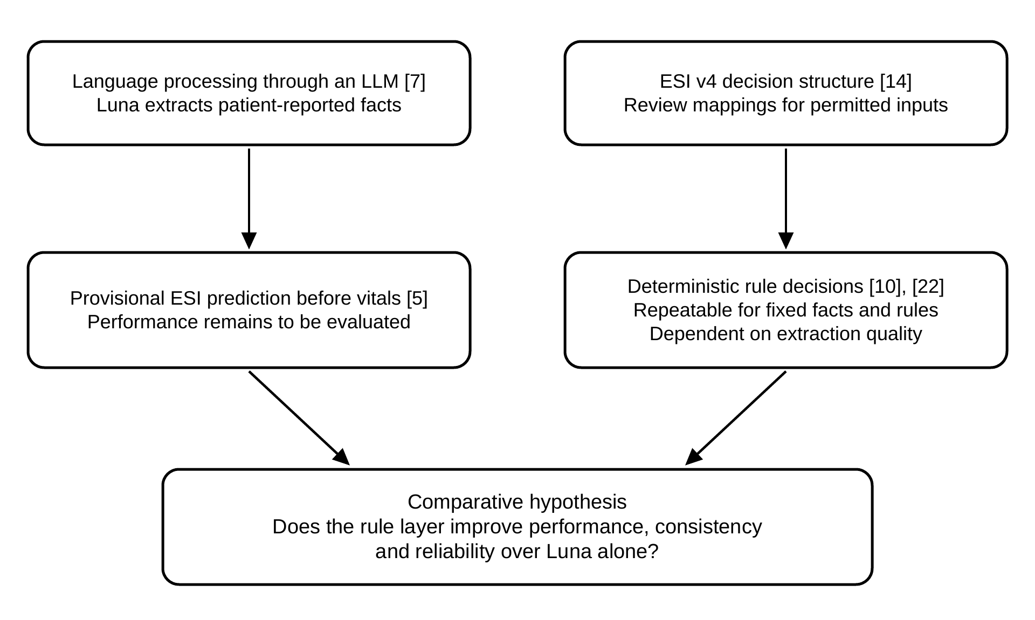
Figure 2.2: Theoretical Framework of the Proposed Hybrid System.
The theoretical framework in Figure 2.2 combines language processing through an LLM with explicit decision logic. It treats these as complementary foundations for a comparative hypothesis, not as evidence that their integration already improves performance.
NLP provides the basis for extracting information from text [7]. In the proposed architecture, GPT-6 Luna performs that function for both methods and produces a separate ESI prediction for Method A. Only the extracted facts are passed to Method B, where deterministic rules assign the prediction. No separate NLP model or model-training procedure is specified.
LLM triage evaluations report different agreement and error patterns [3], [9], [16]. Repeated-query studies [13] motivate measuring repeatability separately from language-version consistency. Official model documentation [23] establishes technical features, while the clinical and multilingual performance of Luna remains an empirical question for this study.
The ESI v4 handbook supplies the clinical decision structure [14]. Dehghani Soufi et al. [10] and Nordman et al. [22] support investigating explicit rules in clinical decision-support software. Their findings do not validate this study’s patient-report mappings. Each mapping will therefore record its source, required facts, exclusions, clinical review and version before final testing.
The resulting hypothesis is that coded enforcement may improve the specified classification measures over the same LLM operating without that layer. Because rules receive LLM-extracted information, extraction errors may persist or affect both methods. The experiment will test this hypothesis against reviewed reference answers and will allow a finding of no benefit.
Chapter 3
Methodology
3.1 Conceptual Framework
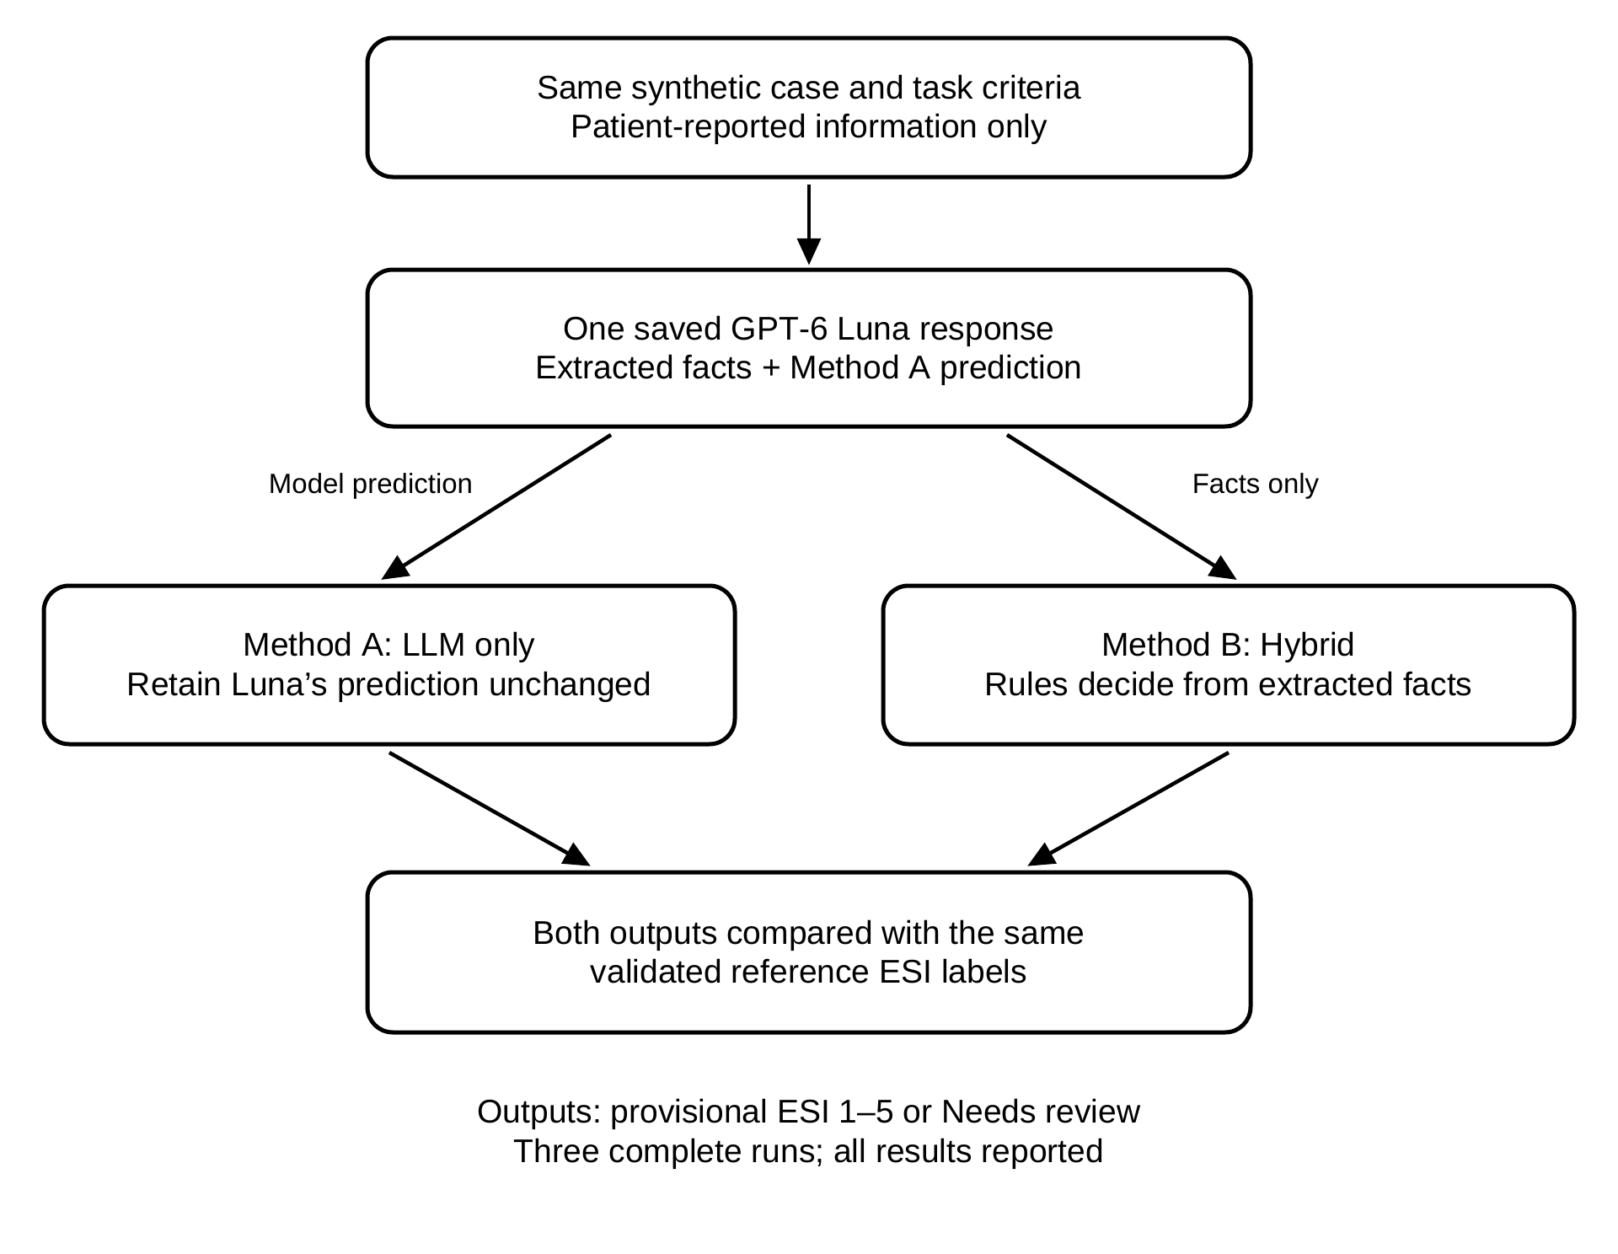
Figure 3.1: Conceptual Framework of the Proposed Paired Comparison

The conceptual framework (Figure 3.1) presents a paired comparison of two methods for provisional ESI prediction using fixed synthetic patient-reported records. The existing validated workbook supplies the cases and reference labels. Blank medical-mission forms and preliminary nurse consultation explain the input template. Both methods will receive the same permitted information, without measured vital signs, examination findings or diagnostic test results.
One saved Luna response will contain extracted patient facts and a separate provisional ESI prediction for Method A. The server will retain Method A’s prediction unchanged. It will pass only the extracted facts to Method B’s deterministic rule engine, which will independently produce a priority and status. Luna’s predicted level and explanation will not enter Method B. The shared response pairs the comparison; both methods will have the same available case information and supplied screening criteria.
The rule layer will evaluate documented conditions in the ESI v4 decision order and record matched rules and supporting facts. It will assign its own provisional level rather than revise or adopt Luna’s prediction. Any difference between the two outputs will be observed after both are saved. If no approved rule supports a decision, required facts are missing, or contradictory evidence prevents a decision, Method B will return Needs review with no level.
Both outputs will be compared with the existing validated reference labels, which will be withheld from model requests and will not be generated by the rule engine. Macro-F1 will remain the primary performance measure. Accuracy, consistency, misclassification, overtriage and undertriage rates will describe other aspects of performance. Coverage and Needs review rates will show how often each method produces a prediction. These measures assess agreement with the reference labels, not completion of clinical ESI assessment.

3.2 Operational Framework
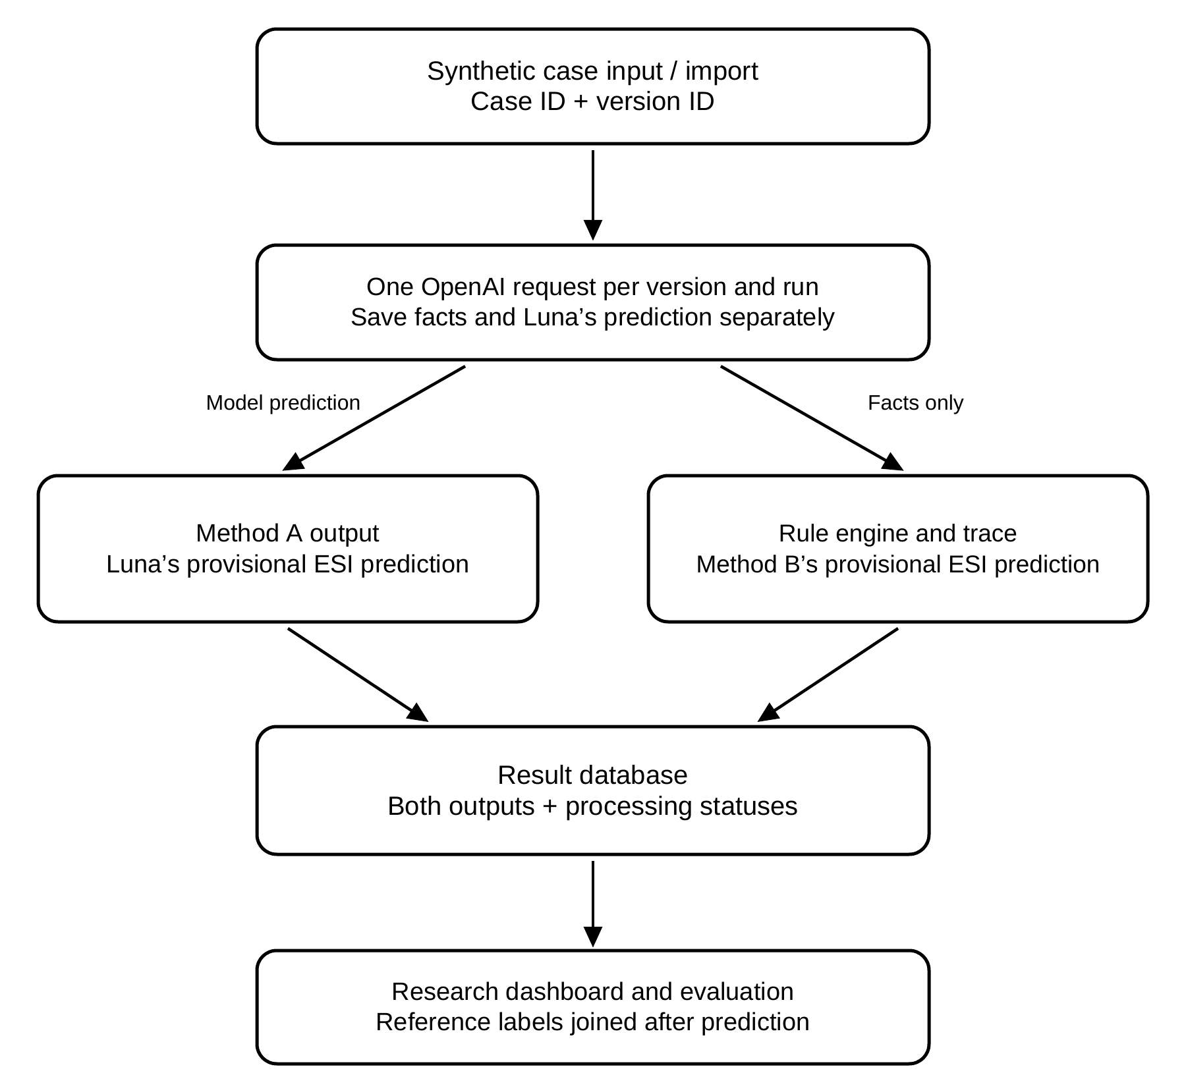
Figure 3.2: Operational Framework of the Simulated Prototype
The operational framework (Figure 3.2) describes a simulated research workflow. Researchers will enter or import reviewed synthetic case versions into the web prototype. Case, version, and session identifiers will connect the input, model response, rule trace, and evaluation record. These identifiers will not represent actual patients or positions in a real-world queue.
The main experiment will use fixed-case evaluation: each input will contain a completed synthetic screening record with the information available for that case. A completed record may explicitly state that some information is unknown. The interface may demonstrate chatbot interaction, but question selection, follow-up conversations and information-gathering effectiveness are outside the main comparison.
For each case version and experimental run, the server will make one fresh LLM request and retain the response. Luna’s prediction will form Method A’s output. Only the extracted facts will enter the rule engine for Method B’s independent output. Both numerical outputs will be identified as provisional ESI predictions. Technical failures and Needs review outcomes will be recorded separately, with no automatic fallback to ESI 3, ESI 5 or Method A’s label.
The system will store both outputs and show the synthetic case identifier, extracted facts, applicable rules, and processing status on a research dashboard. Reference labels will be used by the evaluation module after predictions are recorded. A displayed priority list, if retained in the interface, will be a simulation and will not demonstrate reduced waiting time or real-patient prioritization.

3.3 Comparative Research Design
The study will use a comparative experimental design with a web-based prototype as the evaluation instrument. Method A’s provisional ESI prediction will be generated by Luna under task instructions. Method B’s prediction will be generated by deterministic rules using Luna-extracted facts. No fine-tuning or training of model parameters will be performed. Development will consist of prompt design, structured-output specification, rule implementation and debugging using the development set.
The shared-response design will obtain one saved LLM response for each case version in each run. Method A will use the LLM-generated prediction, while Method B will use only the extracted facts to reach an independent rule decision. This pairing controls variation from separate requests and measures the effect of coded decision rules on a common extraction. The study will not compare two independently operating conversational systems.
Both methods will classify the same fixed records under the same task definitions. The rules and category criteria will also be supplied as instructions to the LLM baseline, so the comparison will examine execution of those criteria in code rather than unequal access to clinical information. Three complete runs will be conducted using the frozen configuration. Each run will generate fresh responses, and all runs will be reported.
3.4 Medical-Professional Interviews and Requirements
The researchers have obtained blank City Health Office of Davao Individual Treatment Record forms from medical-mission staff and conducted a preliminary consultation with a nurse. According to the consultation, patients generally complete the forms, while nurses become involved when vital signs are needed. This account will be documented as a description of the reported local workflow, rather than treated as evidence that all medical missions use the same process. No actual patient records will form part of the synthetic dataset.
The forms will be reviewed to identify information that can be reported before professional assessment. Administrative details, clinician examination findings, assessment and treatment-plan entries will not become chatbot inputs. Further consultation will clarify which reported facts support preliminary priority, when additional questions are necessary, and when the available information is insufficient. The researchers will organize these requirements into a specification recording each field, question, answer format, follow-up condition and source. The printed form alone does not provide a complete priority-classification rule set.
The blank forms and preliminary consultation establish the source of the screening template. The study will reuse the existing validated dataset and its ESI labels. Approval of those labels will be distinguished from approval of general patient-report decision rules. The workbook contains labels without written case-level reasons; the report will describe the validation records actually available and will not invent rationales or completed rule approvals. The study remains restricted to adults aged 18 years and above.
3.5 Screening Inputs and Classification Definitions
The proposed patient-reported fields are age, sex reported, main complaint, symptom description, other reported symptoms, relevant known conditions, known allergies, maintenance medications, onset, duration, severity and worsening. Additional context may record tests already completed, tests already requested by a clinician, and existing medical devices or catheters. These entries describe information already known or reported at screening; the chatbot will not order tests, prescribe medication, infer a new diagnosis or recommend treatment. Their relevance to classification will require clinical review. Device presence or a requested test will not, by itself, be assigned an automatic priority.
The study will exclude measured vital signs, clinician examination findings and laboratory or imaging result values from model inputs. Reporting that a test was completed is distinct from supplying or interpreting its result. A criterion requiring excluded information will not be implemented by inventing a substitute. The input specification will distinguish present, absent, unknown and not-applicable information. An omitted answer will not be treated as a negative finding, and every extracted fact must be traceable to the supplied record.
The output will be a provisional prediction on the ESI 1–5 scale, with 1 most urgent and 5 least urgent [14]. For example, “Provisional ESI prediction: 3” is a numerical classification for comparison with the validated reference label. It does not certify physiological stability or completion of Decision D. Each patient-report mapping, including a provisional ESI 3 mapping, must specify supporting facts, exclusions and clinical review. Validated labels will remain the reference answers even when a method cannot predict them. Needs review leaves the level unassigned and is a processing status, not a sixth ESI level.
3.6 Synthetic Case Construction and Sample Plan
3.6.1 Data Description
The study will reuse the existing synthetic case workbook and its validated ESI labels. The planned analytical sample remains 150 distinct canonical adult cases. A canonical case is one fictional screening situation with a fixed set of patient-reported facts. Blank City Health Office forms and preliminary nurse consultation explain the input structure. Ten cases, with two at each ESI level, will be selected from the development portion for the software pilot; a new dataset is not required.
Each case will retain its identifier, permitted input fields, version and reference label. The label will be stored as answer-key metadata and excluded from model requests. Existing validation records will be retained where available; absent reviewer reasons or dates will not be reconstructed as if documented. Google Sheets and CSV exports will support preparation and execution. Case preparation, language checks, corrections and any AI-assisted drafting will be recorded separately from clinical rule approval.
The target distribution remains 30 canonical cases at each reference ESI level. The existing cases vary in complaints, reported severity, duration, worsening and relevant history. Validated labels will not be changed to match system outputs or force a sampling quota. The achieved distribution will be reported, and any correction before dataset freeze will be documented. A case will not be removed merely because a method returns Needs review; such outcomes are part of the evaluation.
The dataset will allocate 30 canonical cases to development and 120 to final evaluation, with 6 development and 24 final cases per ESI level. Each case will have five versions, producing 750 inputs: 150 for development and 600 for final evaluation, as shown in Table 3.1. These counts are planning targets rather than a statistically established minimum or proof of clinical reliability. The achieved distribution and uncertainty of the results will be reported. Additional versions of one case are related observations, not new independent clinical cases.
Table 3.1: Planned Dataset Composition
Dataset portion | Canonical cases | Versions per case | Total inputs
Development (20%) | 30 | 5 | 150
Final evaluation (80%) | 120 | 5 | 600
Total | 150 | 5 | 750
3.6.2 Synthetic Case Description
Each fictional case will describe what a patient could report before professional assessment. Table 3.2 illustrates the proposed fields using a draft English pilot case. All symptom and history details shown as inputs will be available to both methods. The expert-answer fields will be withheld from model requests. This illustration has no approved priority and does not establish a clinical rule.
Table 3.2: Sample Synthetic Pre-Screening Case (Unreviewed)
Information | Illustrative entry
Case ID | P001
Age | 24 years
Sex reported | Female
Main complaint | Cough
Symptom description | Occasional dry cough and scratchy throat. Reports comfortable breathing, normal speech, and usual eating, drinking and activities.
Other reported symptoms | Runny nose. Reports no chest pain, fainting, blood when coughing or feeling feverish.
Known conditions | None reported
Known allergies | None reported
Maintenance medications | None reported
Onset | Started gradually three days ago
Duration | Three days; occasional episodes
Severity reported | Mild
Getting worse? | No; cough is less frequent today
Tests already completed | None reported
Tests requested by a clinician | None reported
Medical devices or catheters | None reported
Expert priority (withheld) | Unassigned; clinical reviewer to select ESI 1, ESI 2, ESI 3, ESI 4 or ESI 5 only when permitted information is sufficient
3.7 Expert Reference Answers and Case Review
3.7.1 Clinical Reviewer Role
The study will use the existing nurse-validated ESI labels as its reference answers. The clinical reviewer’s identity, role, review procedure and dates will be reported to the extent supported by the available validation records. Reusing these labels does not require relabeling the entire dataset. Review of the general rules that map patient-reported facts to provisional predictions remains a separate task before final evaluation.
3.7.2 Case Labeling and Review Records
The workbook contains validated ESI labels but no written case-level rationales. The study will preserve these labels, keep them outside model requests and disclose the available validation evidence. A label alone does not specify a reusable decision rule. Proposed rules will therefore receive separate review of their conditions, exclusions, supported level and source. Final-evaluation labels will not be used to tune the rules, and no reviewer reasons will be invented retrospectively.
All frozen cases will remain in the reported evaluation, including cases on which a method fails or returns Needs review. A system’s inability to predict a validated label will be recorded as an evaluation outcome. Any correction to a case or reference label before dataset freeze will require a documented reason; labels will not be changed in response to final-test predictions.
3.7.3 Review Disagreements and Limitations
The primary clinical reviewer may consult a physician to clarify a proposed rule or its interpretation. Additional physician participation is not assumed. Any consultation, rule revision and final approval will be recorded separately from the existing dataset labels. A rule whose patient-report conditions remain unresolved will not be activated for the final experiment.
The reference set relies on the existing clinical validation. The study will disclose the number of reviewers and records actually available and will not claim independent dual labeling or inter-rater agreement without evidence. The absence of case-level rationales limits assessment of why particular labels were assigned and whether each label can be recovered from the permitted fields. Researcher-led language checks and rule-review records will be documented separately.
3.8 Language and Code-Switched Versions
Each canonical case has five versions: V1 English, V2 Tagalog, V3 Bisaya, and V4–V5 in two different code-switched language pairs. The planned total remains 150 × 5 = 750 versions. Language variation occurs in complaint and symptom narratives; other structured fields remain shared, mainly in English. The existing validated canonical label will be retained across versions that preserve the same facts. Language equivalence will be checked separately, without claiming that label validation alone establishes translation quality.
All three researchers, who report fluency in English, Tagalog and Bisaya, will share variant writing and review. Each variant will be checked by at least one groupmate other than its writer. Checks will address everyday patient phrasing, including ordinary shorthand and preservation of symptoms, severity, duration, negation and other priority-relevant facts. The review log will record the writer, checker, date, decision and corrections. This procedure will be described as researcher-led language review, not independent external language validation. Uncertain clinical wording will be referred to the nurse.
Each case has two code-switched versions, selected from English-Tagalog, English-Bisaya and Tagalog-Bisaya. In each provisional ESI sheet, 10 cases use English-Tagalog and English-Bisaya, 10 use English-Bisaya and Tagalog-Bisaya, and 10 use Tagalog-Bisaya and English-Tagalog. Across 150 cases, this yields 100 versions per language pair, or 300 code-switched versions, alongside 150 each in English, Tagalog and Bisaya. The draft workbook contains no separate wrong-spelling condition. Informal wording will remain subject to meaning-equivalence review; spelling robustness will not be reported as a separate experimental outcome. The language-pair distribution will be recorded in both dataset portions before testing.
3.9 Development and Final-Evaluation Separation
Allocation will occur at the canonical-case level, keeping all five versions and any closely derived duplicates together. Ten reviewed pilot cases, with two at each ESI level, will stay in the development set. Remaining cases will be randomly allocated within priority categories to reach 6 development and 24 final cases per ESI level, using a recorded random seed of 42. The saved allocation will also document the distribution of code-switched language pairs. A case will not appear in both portions.
Development cases will support prompt revision, output-schema design, implementation debugging, and checks that the code implements the reviewed rules. This is system development, not fine-tuning. Final-evaluation cases and reference labels will be withheld from that process. The plan does not require a model-training split because no model parameter training is specified.
One researcher will serve as dataset custodian and will not participate in prompt or rule tuning. Development records and review logs will be organized in Google Sheets; final-test inputs and keys will be kept in a separate spreadsheet with access restricted during tuning. Before final testing, the team will freeze the cases, reference labels, prompt, model configuration and rule specification. Any prior researcher exposure during case writing will be disclosed as a limitation. A test set used to guide revisions will no longer be described as untouched evaluation data.
3.10 LLM-Only Baseline
Method A will receive the case input, reviewed category definitions, the same criteria available to the coded layer, and instructions to predict a provisional ESI level. The saved response will contain extracted facts, the LLM-generated priority and its processing status. The priority will be ESI 1–5 when supported, otherwise null with Needs review. Its prediction will be saved unchanged for comparison. No reference label, reviewer reason or validation metadata will enter the model request. Missing, unknown and not-applicable facts will remain distinct.
OpenAI’s pretrained GPT-6 Luna is selected and will be checked using development cases before final evaluation. The exact API model identifier, any available snapshot, supported settings, prompt and JSON schema will be recorded and held constant throughout the comparison. Model integration and task performance have not yet been tested. Case text will be submitted in its original language and spelling, without automatic translation or spelling correction. Prompt and configuration checks will be completed before the final dataset is evaluated.
Hyperparameter policy. No model fine-tuning, weight training or hyperparameter search will be performed. The model-side settings will be fixed before final testing; temperature will be set to 0 when supported, while top_p, output limits and other API defaults will be recorded and held constant. Grid search, random search and Bayesian optimization are therefore not applicable. Development cases will be used to check GPT-6 Luna and verify the prompt, structured-output schema and rule implementation; they will not be used to tune model parameters or alter the final test cases.
Selected model configuration. OpenAI’s pretrained GPT-6 Luna (API identifier: gpt-6-luna) is the selected model. Its integration and supported settings will be checked using development cases before final evaluation. The exact API model identifier, execution date, prompt, JSON schema and supported settings will be recorded before final evaluation. Both Method A and Method B will use the same model configuration; different model configurations will not be mixed in one comparison. The model will receive the original English, Tagalog, Bisaya or code-switched input without automatic translation or spelling correction.
3.11 Hybrid Rule-Layer Procedure
Method B will receive only the extracted facts from the saved LLM response used for Method A. It will not receive Luna’s predicted level or explanation. The deterministic engine will evaluate explicit conditions and record matched rule identifiers, supporting facts, its own provisional ESI prediction and processing status. Both methods’ results will be stored separately for comparison. The engine will not be a machine-learned decision tree fitted to the evaluation labels.
Every rule will record its ID, ESI decision point, required fields, conditions, exclusions, matched evidence, source section, clinical approval and version. The ESI v4 handbook will guide the decision structure [14]. Any adaptation to patient-reported information will be identified and justified; excluded measurements, examination findings and diagnoses will not be inferred. Completed or requested tests and device presence will not automatically establish expected ESI resource counts. Reviewed mappings and the prompt will be frozen before final testing.
Rules will follow the ESI v4 sequence: immediate life-saving intervention at A, high-risk or other qualifying presentations at B, expected resources at C, and measured vital signs at D [14]. Patient-report mappings will require documented conditions and exclusions for earlier decision points. Decision D will remain unassessed because vital signs are outside the inputs. Missing required facts, unresolved earlier risk or contradictory rule matches will produce Needs review. A pain score of 7/10 or above alone will not automatically assign ESI 2.
Responses will undergo JSON and field validation. A failed request or malformed response may receive up to two additional attempts, for a maximum of three attempts per input per run. Attempts and failure reasons will be logged. Persistent technical failures will remain in the evaluation records. A valid Needs review response will not be retried, and an unwanted predicted priority will not justify a retry. Both methods will use the same accepted response from the shared request sequence.
A reviewed provisional ESI 3 mapping may produce the numerical prediction 3 from permitted facts, but it must be identified as an adaptation with Decision D unassessed. If no supported mapping exists, the engine will return Needs review. It will not assume normal vital signs, infer resources from a test list, or copy Method A’s level. For the same extracted facts and rule version, the result and trace will remain identical. Differences between Methods A and B will be analyzed as separate predictions, not overrides.
Rules cannot guarantee correction of language-understanding errors. If the LLM misses a relevant fact, the rule layer may also miss it; if it invents a fact, the rules may apply an inappropriate condition. Determinism will be distinguished from correctness throughout interpretation of the results.
3.12 Evaluation Units and Experimental Execution
The unit of prediction will be a case version. The unit for grouping related observations and estimating uncertainty will be the canonical case. Final comparison will use 600 held-out versions from 120 reviewed canonical cases. The 150 versions of the 30 development cases will not contribute to final performance estimates. Across three runs, the experiment will produce 1,800 planned paired prediction records before technical retries; these remain observations of 120 underlying cases.
For each held-out version, the execution program will submit the frozen request, retain the raw and parsed response, save Method A’s prediction and pass only the extracted facts to the frozen rule engine for Method B. Reference keys will be joined after both outputs are saved. Within each run, input order will be randomized using recorded seeds. Case and version IDs, run IDs, timestamps, input conditions and every technical attempt will be retained. Retries will not count as additional evaluation cases.
Three complete runs will use the same model configuration, prompt, dataset and rules. A fresh response will be generated for each version in each run. Results from all runs will be retained, with per-run metrics and their arithmetic mean reported. No best run will be selected. Consistency across five versions and repeatability of one version across three runs will be treated as distinct measures. Repetitions will not be counted as independent clinical situations.
3.13 Metric Definitions and Paired Analysis
The metrics will address the research questions and objectives, including both overtriage and undertriage as directional error measures. Macro-F1 will remain the primary performance score. Rates will be displayed as percentages by multiplying each proportion by 100, with the numerator and denominator reported. Within a run, N will denote reference-labeled versions for which both methods return valid priorities. On this common paired set, C will count a method's correct predictions, E its incorrect predictions, O its more-urgent predictions (a lower ESI number than the reference) and U its less-urgent predictions (a higher ESI number than the reference). ESI 1 is most urgent and ESI 5 least urgent. Needs review and technical failures will be reported as unresolved outcomes rather than priority classes.
Accuracy = C / N. Misclassification rate = E / N. On this same fully classified paired set, C + E = N, so misclassification rate = 1 − accuracy. These are complementary summaries, not independent evidence of improvement. Separate five-by-five confusion matrices will show the reference and predicted ESI levels.
For category k, F1(k) = 2TP(k) / [2TP(k) + FP(k) + FN(k)], using one-versus-rest counts. Macro-F1 = [F1(ESI 1) + F1(ESI 2) + F1(ESI 3) + F1(ESI 4) + F1(ESI 5)] / 5 will be the primary performance score, giving equal weight to all five levels. A zero class denominator will receive a score of zero for calculation, with the absent support disclosed. If no valid paired outputs exist, conditional metrics will be reported as not estimable. Per-category scores and support will accompany the macro average.
Overtriage rate = O / N and undertriage rate = U / N will use the same valid paired set, with all five reference levels included in the denominator. Undertriage occurs when a predicted ESI number is higher, and therefore less urgent, than the validated reference label; a reference ESI 2 predicted as ESI 3 is one undertriage error. Overtriage occurs when the predicted number is lower, and therefore more urgent. Each incorrect valid prediction belongs to exactly one direction, so overtriage rate + undertriage rate = misclassification rate on this set. Results will include error counts and denominators by reference ESI level, including ESI 1 and ESI 2. A supported provisional ESI 3 prediction will be scored as the numerical level 3. Needs review and technical failures have no valid level and will not be counted as overtriage or undertriage; their separate rates and coverage must accompany the error rates.
For each run, across-version consistency will equal the number of canonical groups whose five outputs are all valid and identical, divided by all 120 reviewed final groups. Any missing priority, invalid output or Needs review status will prevent that group from counting as consistent. Five identical but incorrect predictions will count as consistent while remaining incorrect for accuracy and F1. This separates agreement across wording from agreement with the clinical reference.
Each metric will be calculated for each of the three runs and summarized by its arithmetic mean. The main comparison will show Run 1, Run 2 and Run 3 for both methods, followed by the three-run mean and the paired difference, Method B minus Method A. Numerical ESI predictions will not be averaged to create a new predicted level. Supplementary identical-input repeatability will be the proportion of final input versions with valid, identical priorities in all three runs; a missing or unresolved output will not count as repeatable. Repeated outputs will remain linked to their original case groups. Neither pooling repeats as independent cases nor selecting a favorable run will be permitted.
Accuracy, macro-F1 and error rates above will be conditional on the common valid paired set. For each run, T will denote all planned reference-labeled versions attempted (600 under the sample plan), V a method’s valid ESI predictions, R its Needs review outcomes and F its persistent technical failures. Completion rate = V / T; Needs review rate = R / T; technical-failure rate = F / T; and common-pair coverage = N / T. Each attempted version will have exactly one final processing outcome, so V + R + F = T. Completion-adjusted accuracy will equal all correct predictions by that method divided by T, including correct predictions outside the common paired set. Needs review and technical failures remain in this denominator without being assigned an ESI level. Counts and rates will be reported overall and by input condition and reference level. A higher conditional macro-F1 with lower coverage will not by itself establish overall superiority.
The comparison will report Method A, Method B and their paired difference, B minus A. Positive differences favor B for macro-F1, accuracy and consistency; negative differences favor B for error rates. Uncertainty will be estimated using 2,000 paired bootstrap resamples of the 120 canonical groups, sampled with replacement using a recorded seed of 42. All five variants and all three runs of a selected group will remain together. The mean per-run difference will be recalculated in each resample, and its 2.5th and 97.5th percentiles will form a 95% interval. Undefined resamples will be disclosed. Secondary comparisons will be interpreted descriptively rather than as separate confirmatory tests.
Computational performance and solution quality. Computational performance will be reported for the application and evaluation program using wall-clock execution time per batch and per input, Docker-container CPU utilization, peak host memory and the number and duration of retries. Measurements will use the same Mac, Docker configuration and network conditions for both methods; an initial warm-up will be excluded, input order will be randomized with recorded seeds, and repeated runs will be summarized by mean and variability. Because inference is performed by the external OpenAI service, local GPU utilization and provider-side latency will be identified as unavailable rather than estimated. Solution quality will be defined by macro-F1, accuracy, consistency, misclassification, overtriage, undertriage and completion coverage against the nurse-reviewed reference labels. An optimality gap and convergence rate are not applicable because the study does not optimize a numerical objective or train an iterative model; this limitation will be stated explicitly.
Statistical model comparison. A secondary paired model-comparison test will be performed at the canonical-case level using the English version from the prespecified first run of each of the 120 final canonical cases, so the five related language versions and repeated runs are not treated as independent clinical cases. Only cases with valid priorities from both methods will enter this conditional test; the included and excluded counts will be reported. McNemar’s test will compare paired correctness: b is the number of cases correct for Method A and incorrect for Method B, and c is the number incorrect for Method A and correct for Method B. When b+c is nonzero, the continuity-corrected statistic is χ² = [max(0, |b−c|−1)]²/(b+c), with a two-sided α = 0.05; when b+c < 25, the exact binomial version will be used. If b+c = 0, the result will be reported as no discordant pairs (p = 1). The primary uncertainty analysis will remain the 2,000 canonical-group bootstrap already specified above, and the test result will be reported together with the paired effect size and confidence interval rather than treated as proof of clinical safety.
Results will be reported overall and for English, Tagalog, Bisaya, English-Tagalog, English-Bisaya and Tagalog-Bisaya where supported by the available counts. Each case contains two of the three code-switch pairs; no separate spelling-error condition is included. Interpretation will address category balance, variant coverage, unresolved outputs, reviewer limitations and uncertainty. Balanced synthetic cases will not be presented as the natural frequency of priorities in medical missions. Findings of no improvement or worse performance will be reported without changing the frozen criteria.
3.14 Reproducibility and Error Handling
The research record will retain the dataset version, case-group split, reviewed reference labels, question and rule specifications, prompt text, model identifier, supported configuration parameters, preprocessing, output schema, and code version. Each attempt will record the case/version ID, run ID where applicable, request status, raw response, parsed fields, both outputs, and applicable rule trace. Access credentials will not be included in exported logs.
Hardware and software environment. The experiment will run in a Docker environment on a 16-inch MacBook Pro (November 2024) with an Apple M4 Max 16-core CPU, integrated 40-core GPU and 48 GB memory, running macOS Tahoe 26.5.2. The recorded software environment is Docker 29.6.2 with Docker Compose v5.3.1, Laravel Framework 13.30.1, PHP 8.5.8, Composer 2.10.2, Node.js 24.14.1, npm 11.11.0, React 19.2.8, Inertia React 2.3.27, Inertia Laravel 2.0.25, TypeScript 5.9.3, Vite 8.2.2 and Tailwind CSS 4.3.3. The OpenAI model is externally hosted; the local GPU is not used to run the model, so provider-side GPU utilization and provider-side model memory are outside the measurements.
Version control and reproducibility. The source code is maintained in the public GitHub repository https://github.com/reanneangcos/TriageFlow. The repository README provides dependency-installation steps and instructions for running the application. Before final evaluation, the team will record the repository commit, Docker image or configuration, dependency lockfiles, dataset version, prompt version, rule version and random seeds. A minimal working run will be tested from a clean checkout so another researcher can reproduce the application and evaluation procedure without access credentials.
Before final evaluation, development checks will verify that the code implements the approved rule specification, preserves unknown values, rejects malformed output, and keeps the baseline and hybrid records paired. Technical retries will be logged with their reasons; persistent failures will remain in the attempt counts. Revised prompts or rules will trigger a new recorded version rather than overwrite the original experiment.
Availability or behavior of an externally hosted model may change. The exact identifier and execution dates will be reported, and the team will avoid mixing configurations within an experiment. If a model change makes the frozen configuration unavailable, a revised experiment and its consequences for comparability will be documented.
3.15 Ethical Considerations and Study Limitations
The evaluation will use fictional cases and will not involve actual patients, measured vital signs or clinical care. Demonstrations will identify the system as a research prototype. Case identifiers will track synthetic records rather than real patients.
Formal review will follow applicable university ethics and consent requirements. Participation, blank-form permissions and any required institutional determination will be documented before the relevant activities; completion is not claimed. Identifiable patient information will be excluded. Working files will have restricted access, and the custodian will manage the final test set. Retention and deletion will follow approved university arrangements.
Synthetic cases may not represent actual complaint frequencies, language use or urgent situations in medical missions. Available validation records, absent case-level rationales and researcher-led translation limit interpretation. Reference ESI labels are comparison targets, not proof that all clinical ESI decisions can be established from the permitted fields. In particular, a provisional ESI 3 prediction does not assess Decision D [14]. Reporting Needs review and coverage will distinguish unsupported predictions from completed classifications.
Conclusions will concern the selected model, reviewed rules and held-out synthetic cases. They will not establish clinical safety, deployment readiness, improved patient outcomes, shorter queues or reduced staff workload.
Bibliography
[1] American College of Surgeons Committee on Trauma. 2021. National guideline for the field triage of injured patients. https://www.facs.org/media/2zdltley/field-triage-handout-vfinal-revise.pdf

[2] C. Colakca, M. Ergın, H. S. Ozensoy, A. Sener, S. Guru, and A. Ozhasenekler. 2024. Emergency department triaging using ChatGPT based on emergency severity index principles: a cross-sectional study. Scientific Reports 14, 1 (2024), Art. no. 22106.
https://doi.org/10.1038/s41598-024-73229-7

[3] Hamish Fraser, Daven Crossland, Ian Bacher, Megan Ranney, Tracy Madsen, and Ross Hilliard. 2023. Comparison of Diagnostic and Triage Accuracy of Ada Health and WebMD Symptom Checkers, ChatGPT, and Physicians for Patients in an Emergency Department: Clinical Data Analysis Study. JMIR mHealth and uHealth 11 (2023), e49995.
https://doi.org/10.2196/49995

[4] F. Gaber, M. Shaik, F. Allega, A. J. Bilecz, F. Busch, K. Goon, V. Franke, and A. Akalin. 2025. Evaluating large language model workflows in clinical decision support for triage and referral and diagnosis. npj Digital Medicine 8, 1 (2025), Art. no. 263.
https://doi.org/10.1038/s41746-025-01684-1

[5] K. Sharma, H. Sivadas, C. Edwards, N. Gunja, and S. Reddy. 2026. ED-triage-agent: a multi-agent framework for human-in-the-loop emergency triage. International Journal of Medical Informatics 221, 106652. Published online August 18, 2026.
https://doi.org/10.1016/j.ijmedinf.2026.106652

[6] M. Schmollinger, J. Gerstner, E. Stricker, A. Muench, B. Breckwoldt, M. Sigle, P. Rosenberger, and R. Wunderlich. 2024. Evaluation of an App-Based Mobile Triage System for Mass Casualty Incidents: Within-Subjects Experimental Study. Journal of Medical Internet Research 26 (2024), e65728.
https://doi.org/10.2196/65728

[7] J. Stewart et al. 2023. Applications of natural language processing at emergency department triage: A narrative review. PLOS ONE 18, 12 (2023), e0279953.
https://doi.org/10.1371/journal.pone.0279953

[8] Rocío Sánchez-Salmerón, José L. Gómez-Urquiza, Luis Albendín-García, María Correa-Rodríguez, María Begoña Martos-Cabrera, Almudena Velando-Soriano, and Nora Suleiman-Martos. 2022. Machine learning methods applied to triage in emergency services: A systematic review. International Emergency Nursing 60 (2022), 101109.
https://doi.org/10.1016/j.ienj.2021.101109

[9] L. Masanneck, L. Schmidt, A. Seifert, T. Kölsche, N. Huntemann, R. Jansen, M. Mehsin, M. Bernhard, S. G. Meuth, L. Böhm, and M. Pawlitzki. 2024. Triage Performance Across Large Language Models, ChatGPT, and Untrained Doctors in Emergency Medicine: Comparative Study. Journal of Medical Internet Research 26 (2024), e53297.
https://doi.org/10.2196/53297

[10] M. Dehghani Soufi, T. Samad-Soltani, S. Shams Vahdati, and P. Rezaei-Hachesu. 2018. Decision support system for triage management: A hybrid approach using rule-based reasoning and fuzzy logic. International Journal of Medical Informatics 114, 35–44.
https://doi.org/10.1016/j.ijmedinf.2018.03.008

[11] L. H. Yao, K. C. Leung, C. L. Tsai, C. H. Huang, and L. C. Fu. 2021. A Novel Deep Learning–Based System for Triage in the Emergency Department Using Electronic Medical Records: Retrospective Cohort Study. Journal of Medical Internet Research 23, 12 (2021), e27008.
https://doi.org/10.2196/27008

[12] B. Arslan, C. Nuhoglu, M. O. Satici, and E. Altinbilek. 2025. Evaluating LLM-based generative AI tools in emergency triage: A comparative study of ChatGPT Plus, Copilot Pro, and triage nurses. The American Journal of Emergency Medicine 89 (2025), 174-181. https://doi.org/10.1016/j.ajem.2024.12.024

[13] J. M. Franc, A. Hertelendy, L. Cheng, R. Hata, and M. Verde. 2024. Repeatability, Reproducibility, and Diagnostic Accuracy of a Commercial Large Language Model (ChatGPT) to Perform Disaster Triage Using the Simple Triage and Rapid Treatment (START) Protocol. Disaster Medicine and Public Health Preparedness 18 (2024), Art. no. e183 (abstract).
https://doi.org/10.1017/dmp.2024.194
[14] N. Gilboy, P. Tanabe, D. Travers, and A. M. Rosenau. 2011. Emergency Severity Index (ESI): A Triage Tool for Emergency Department Care, Version 4. Implementation Handbook, 2012 Edition. AHRQ Publication No. 12-0014. Agency for Healthcare Research and Quality, Rockville, MD.
https://www.govinfo.gov/content/pkg/GOVPUB-HE20_6500-PURL-gpo23161/pdf/GOVPUB-HE20_6500-PURL-gpo23161.pdf
[15] T. G. Lederer, W. C. Herring, L. A. Ammar, B. S. Abella, D. J. Apakama, E. E. Abbott, and A. C. Shekhar. 2026. Large Language Models (LLM) for Emergency Department Triage Based on Vital Signs. Emergency Care and Medicine 3, 1, Art. no. 9.
https://doi.org/10.3390/ecm3010009
[16] L. Cui, M. Wang, Y. Xu, W. Wei, and X. Zhao. 2026. Diagnostic accuracy of large language models for emergency department triage: a systematic review and meta-analysis. BMC Emergency Medicine 26, Art. no. 228.
https://doi.org/10.1186/s12873-026-01639-z
[17] Q. H. Wong. 2026. Gender-Dependent Diagnostic Substitution in LLM Medical Triage: Same Symptoms, Unequal Urgency. arXiv preprint arXiv:2606.03641. Submitted June 2, 2026.
https://doi.org/10.48550/arXiv.2606.03641
[18] E. Chen, L. Luo, F. Gunturkun, S. Sambara, R. Arora, B. T. Jin, P. Rajpurkar, and D. A. Kim. 2026. Evaluation of Large Language Models as Emergency Department Revisit Predictors. Pacific Symposium on Biocomputing 31, 130–143.
https://psb.stanford.edu/psb-online/proceedings/psb26/chen_emma.pdf
[19] H. Wong and T. Wong. 2026. Multi-Evidence Clinical Reasoning With Retrieval-Augmented Generation for Emergency Triage: Retrospective Evaluation Study. JMIR Medical Informatics 14, e82026.
https://doi.org/10.2196/82026
[20] P. Elias et al. 2015. A Web-Based Tool for Patient Triage in Emergency Department Settings: Validation Using the Emergency Severity Index. JMIR Medical Informatics 3, 2, e23.
https://doi.org/10.2196/medinform.3508

[21] S. V. Trivedi, R. Batta, N. Henao-Romero, P. Mondal, T. Wilson, and J. Stempien. 2024. A comparison of self-triage tools to nurse driven triage in the emergency department. PLOS ONE 19, 8, e0297321.
https://doi.org/10.1371/journal.pone.0297321

[22] J. Nordman et al. 2026. The Best of Both Worlds: How Combining a Large Language Model and a Rule-Based Algorithm Makes Catheter-Associated Urinary Tract Infection Surveillance More Efficient. Clinical Infectious Diseases 83, 1, e120–e126.
https://doi.org/10.1093/cid/ciag301
[23] OpenAI. 2026. GPT-6 Luna. OpenAI API model documentation. Accessed October 11, 2026.
https://developers.openai.com/api/docs/models/gpt-6-luna

