**Website Planning Document**_________________________________________________________________________

The Mountain Spoke  
Author: Andrew G. Svahins

**Site Purpose  
-------------------------**‘The Mountain Spoke is a fictitious online shop located in Bozeman, Montana. It specializes in bicycles, bicycle parts, bicycle repair, and bicycle tours. We support bicycle enthusiasts and organize tours in the area for serious bicyclists from around the world. Our goal is to provide a fresh new website experience for our clients.

**Target Audience  
-------------------------**  
We created this website in order to provide service to the following Audience Groups:   
General and private sector audience: bicycle enthusiasts, bicycle owners interested in related products, repair services and parts.   
Business related audience: Private bicycle tours in our area. Companies and businesses interested to organize bicycle tours in our area for their employees and/or customers.

**Site Map  
------------------------**

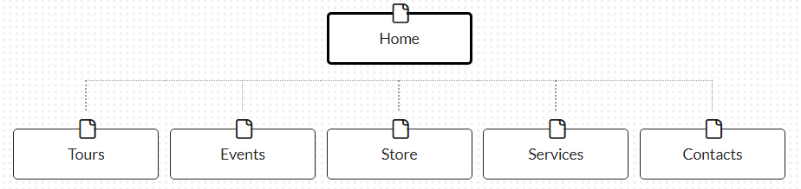 **(**[**https://writemaps.com**](https://writemaps.com)**)**

**Color Scheme  
-------------------------------------**

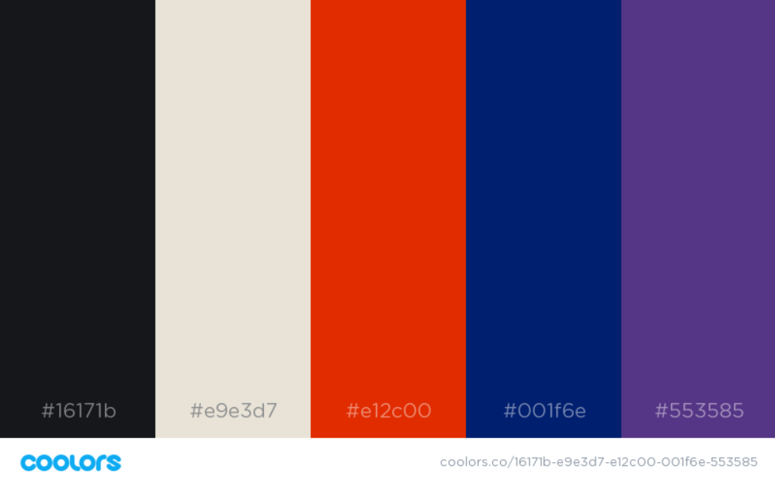

<https://coolors.co/bcddce-00000c-447cba-0049af-4a91d3>)  
  
  
Color References:

|  |  |
| --- | --- |
| Logo text | #553585 |
| Title Text | #001f6e |
| Motto, Box Template main, Headers Text | #16171b |
| Box Template Background | #e9e3d7 |
| Navigation | #e12c00 |
| Navigation Text | #16171b |
| Footer background | #e9e3d7 |
| Footer text | #553585 |

**Typography  
---------------------------------**

|  |  |
| --- | --- |
| **Main font** – Roboto Regular |  |
| **Title font** – Roboto Medium |  |
| **Footer/motto font** – Roboto Thin |  |
|  |  |

**Wire-Frame Sketches  
----------------------------------------**

