Refer the below image for the project hierarchy created for the demo project.

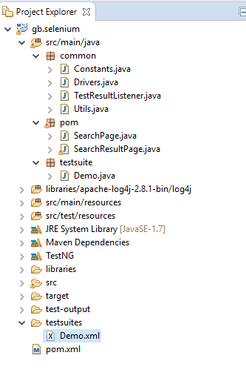

Project Folder Structure

1. Common:
   1. Constants: Use to setup browser to test and URL to test

**public** **static** String *BROWSER* = "chrome";

**public** **static** String *MAIN_URL* = https://www.gobear.com/ph?x_session_type=UAT";

* 1. Drivers: Controlling driver to test

**getBrowserDriver**

**getChromeWebDriver**

**getFirefoxWebDriver**

* 1. TestResultListener: Listeners "listen" to the event defined in the selenium script and behave accordingly.
  2. Utils: The folder is constituted of the classes which contain functions and methods that can be shared and used amongst the multiple classes.

**launchWebPage**

**scrollIntoView**

**waitForElementClickable**

**waitForElementVisible**

**waitForPageLoaded**

**waitVisibilityOfElementLocated**

1. Pom: Contains all page element and functions that only use for specific page.



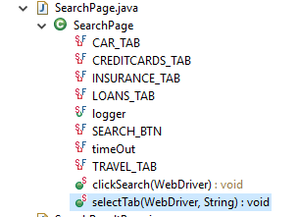

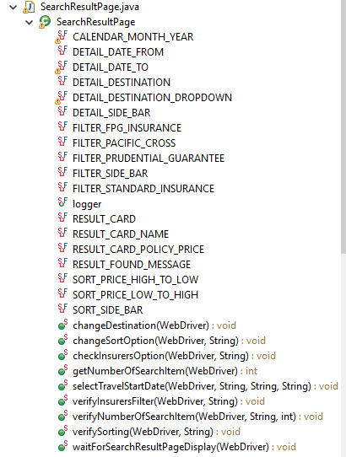

1. testsuite: Contains all testcase to run.
2. Libraries: repository for all the required jar files, libraries, drivers etc to successfully build the test environment and to execute the test scripts.
3. test-output – The folder contains html report and log for debugging.

