# Design

## Introduction

Design is transforming the software and user's requirement to any suitable form of representation like step processes or diagrams that further helps the developer in implementing the software. It generally shows the workflow of the system

## Project Design Plan

Certain modelling methods are used while designing the system. All the methodologies are selected based on the software that is being designed. The modelling that are being designed are listed below:

* Structural Modelling
* Behavorial Modelling
* Database Modelling
* Architectural Modelling
* UI Modelling

## Structural Modelling

Structural modelling is referred as a diagram that represents how the individual components interact to create the whole system. In this project, structural modelling has been utilized by using Class diagram and Data flow diagram.

## Final Class Diagram

A class diagram is a static diagram that shows the systems structure representing the classes, their properties, all operations and the relationship between the classes.

### Justification

* Models the static view of the system
* Shows the relationship between all classes
* Shows the datatype used by all attributes

### Notation

### Diagram

### Description

## Behavorial Modelling

Behavorial Modelling is the design diagram that represents the dynamic features of the system showing business processes.

## Activity Diagram

Activity diagram is a behavioral model that shows the flow from one activity to another in the system.

### Justification

* Represents dynamic flow of data between different activities
* Models step by step flow with used business logic
* Models complex workflow in operations between/within activities

### Notation

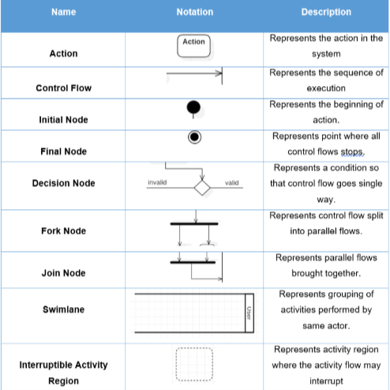

### Diagram

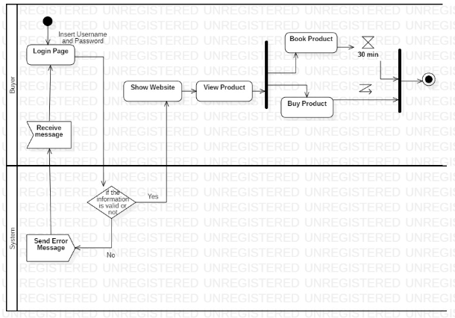

The above activity diagram represents user activity in the system. User logins in the system with a valid username and password. If the system verifies the username and password to be true then user can go to shop and view products, view category, buy products, etc.

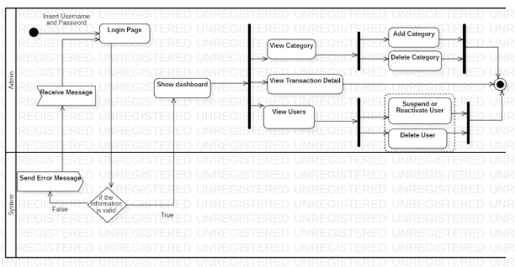

The following activity diagram shows the activity flow of the admin. Admin login the system providing the username and password which is validated in the system. If true then admin is sent to dashboard else back to login page. In the dashboard there are two option: View category where the admin either add or delete category and View Users where admin either suspend user or reactivates the suspended user and delete user and also can see the total transaction details. Finally, the activity flow ends.

## Sequence Diagram

A sequence diagram shows the interaction between objects within the system in a hierarchal order.

### Justification

* Helps in visualizing the interaction between objects
* Helps in finding a logical problem
* Can help in the reverse-engineering of the system

### Notation

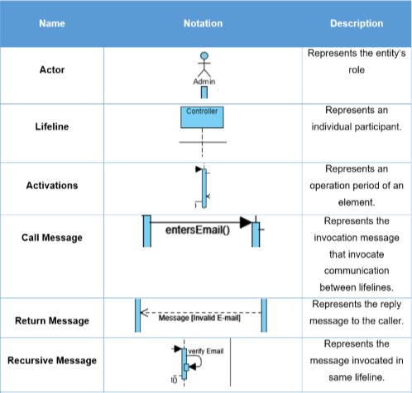

### Diagrams

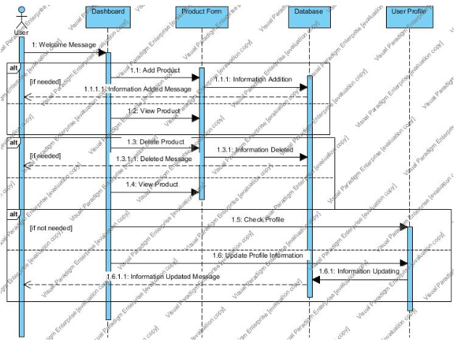

The following sequence show how the user manage their profile. The user can change profile information as he needed and if done updated message is provided.

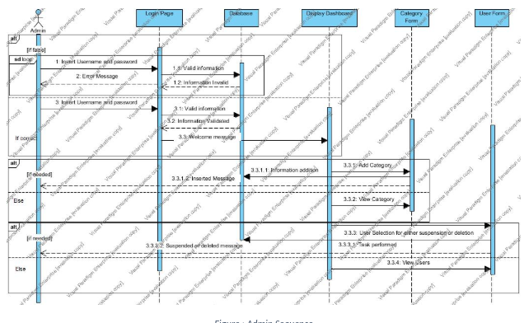

The following sequence diagram show how the admin interacts with the system. First the admin provides login credentials if correct sent to dashboard else error message is generated. In dashboard admin can add category and manage users. In category form if the admin adds the category then added message is displayed and if the admin either delete or suspend or reactivate the user the message is displayed as per the action.

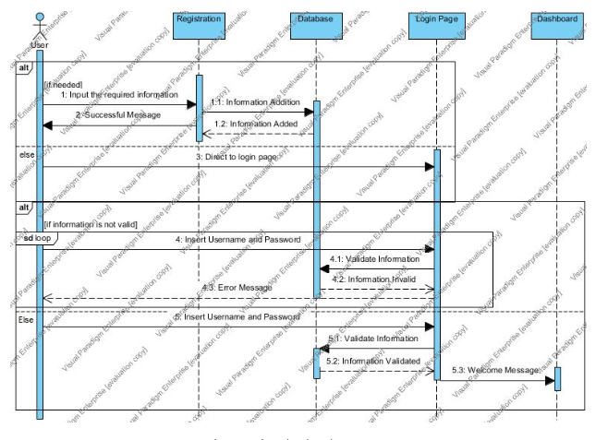

The following sequence show how the user registers and login in the system. If the required field in registration is filled then the user is created and directed to login page. Here the user provides the login credentials and if correct sent to dashboard else error message is displayed.

## Database Modelling

A database model is the logical design that represents the layout of the database and how the data will be stored. An ER diagram along with a data dictionary is drawn in this modelling.

### Entity Relationship Diagram

ER diagram represents the relationship between all the entities in the database.

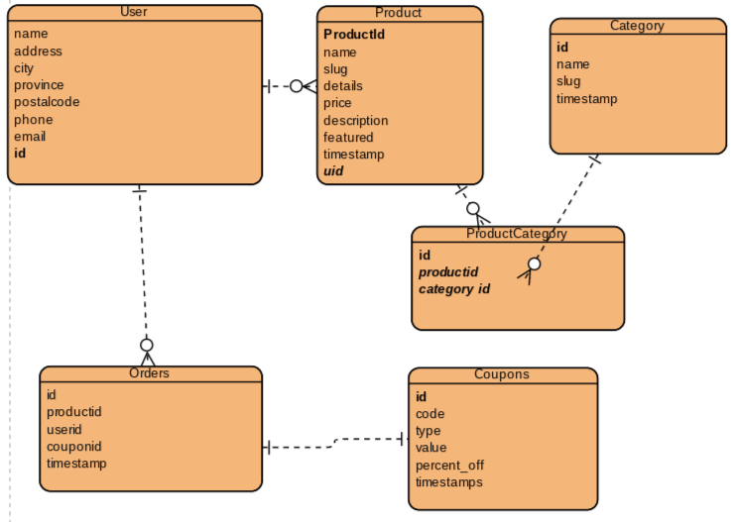

### Data Dictionary

Data dictionary is a set of files consisting the metadata of all entities of the database.

(ER not finalised...)

## Architectural Modelling

Architectural modelling is a model that is designed to study different architectural aspects of the system. This project follows 3-tier architecture which is divided into following parts:

* Client Layer: contains the UI of the application, also known as presentation layer.
* Business Layer: all the business logics like calculations, validation, etc. occurs
* Data Layer: all the data are stored in or are received from the database

## UI Modelling

### Prototypes

Prototyping is an early sample design of the system UI.

