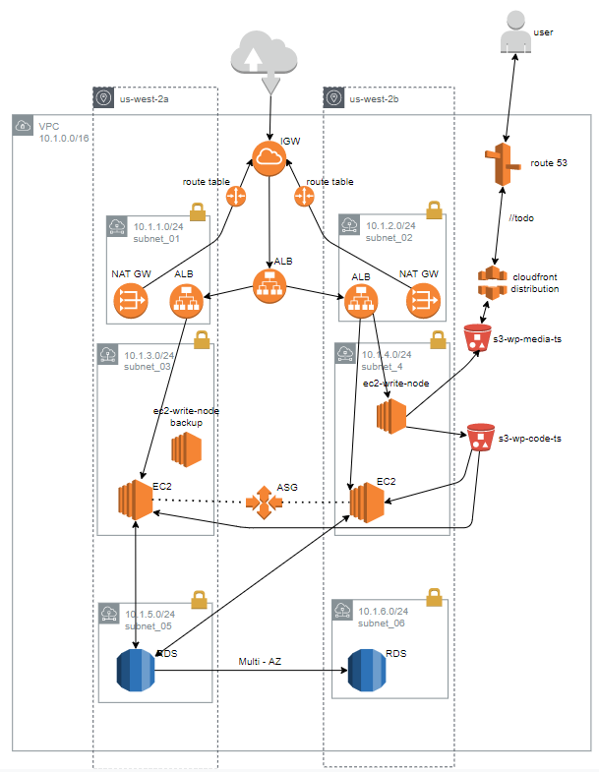

cd /var/www/html/

ls

service httpd start

service httpd statut

service httpd status

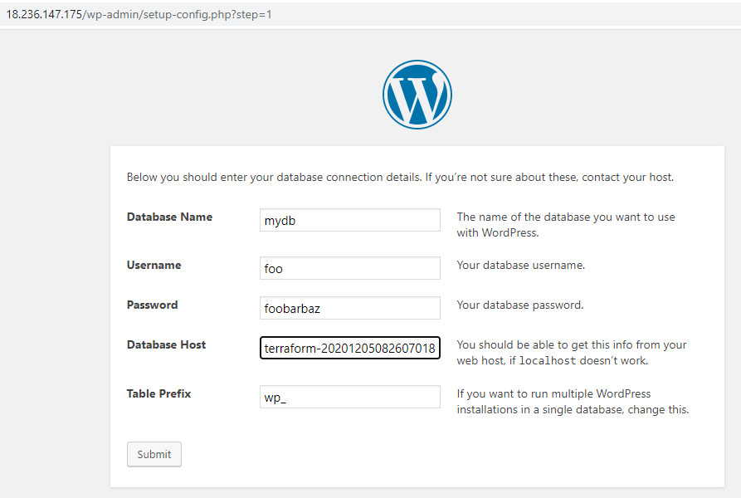

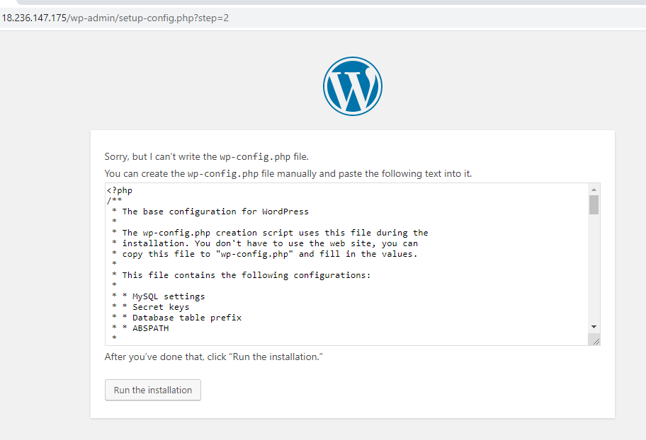

Ctrl c

Nano wp-config.php

Ctrl x y enter

Run the installation

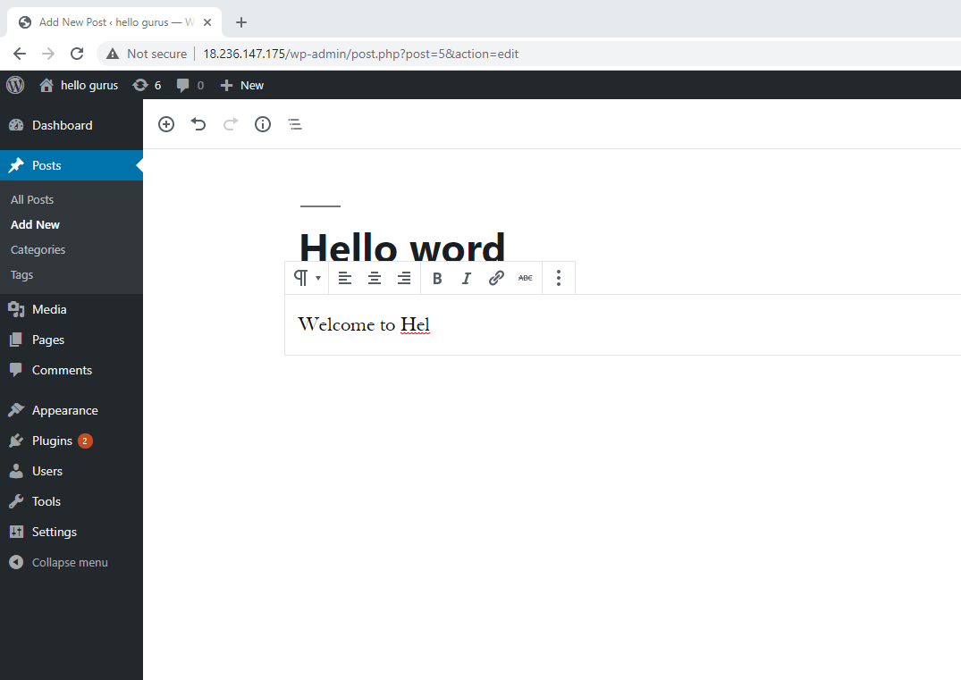

Publish

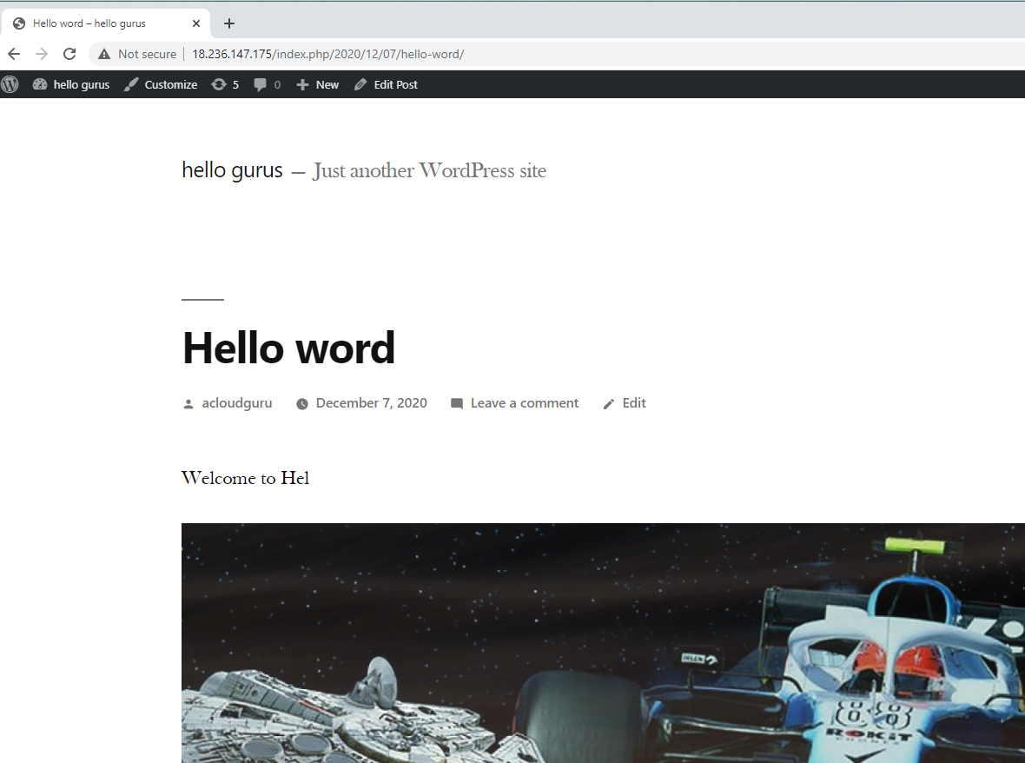

nano /var/www/html/wp-config.php

if (strpos($_SERVER['HTTP_X_FORWARDED_PROTO'], 'https') !== false)

$_SERVER['HTTPS']='on';

//before

require_once( ABSPATH . 'wp-settings.php' );

change home_url and site_url in db table wp_options

cd wp-content

Ls

Cd uploads

ls

cd 2020

ls

cd 12

ls

aws s3 ls

aws s3 cp --recursive /var/www/html/wp-content/uploads s3://s3-wp-media-ts

aws s3 cp --recursive /var/www/html/ s3://s3-wp-code-ts

aws s3 ls s3://s3-wp-code-ts

cd /var/www/html

cat healthy.html

nano .htaccess

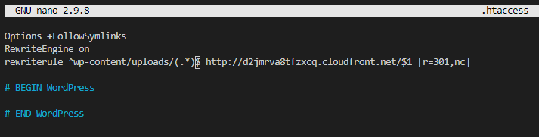

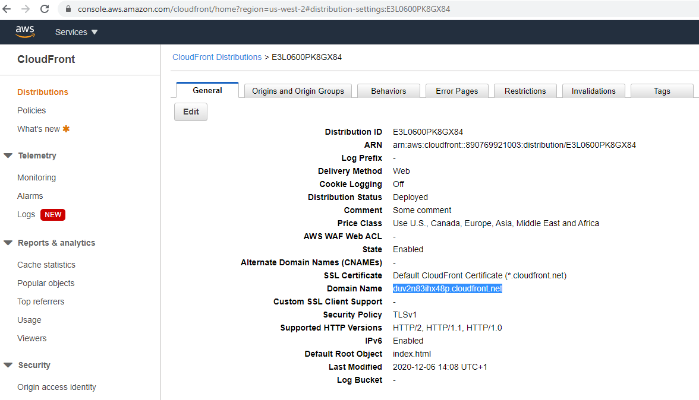

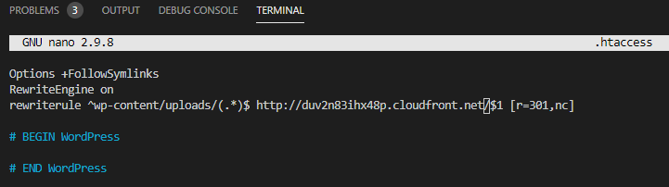

aws s3 ls

aws s3 sync /var/www/html s3://s3-wp-code-ts

cd /etc/httpd/conf

ls

cp httpd.conf httpd-copy.conf

ls

nano httpd.conf

ls

history

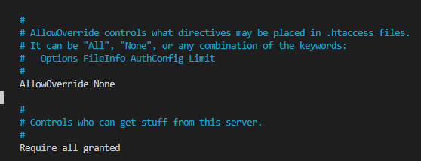

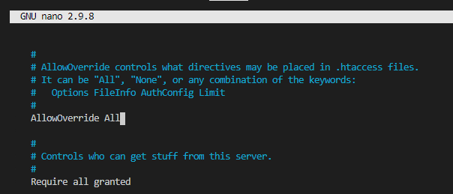

service httpd restart

cd /etc

nano crontab

*/1 * * * * root aws s3 sync --delete s3://s3-wp-code-ts /var/www/html

service crond restart

Upload file to s3 hello.txt

service crond restart

cd /var/www/html

Ls

Ec2 panel

Instance -> action -> image -> name

ami-0f7e3927cee806b59

AMIs panel

On read node launch configuration

#!/bin/bash

yum update -y

aws s3 sync --delete s3://s3-wp-code-ts /var/www/html

(for write node)

sudo su

cd /etc

nano crontab

*/1 * * * * root aws s3 sync --delete /var/www/html s3://s3-wp-code-ts

*/1 * * * * root aws s3 sync -- delete /var/www/html/wp-content/uploads s3://s3-wp-media-ts

cd /var/www/html

echo “testdd” > test.txt

service crond restart

cd /var/www/html

service httpd status