SC4001 Project Handbook
Oct 26, 2026 · @reathan

Start here
We are testing the cheapest way to make a small language model better at grade-school maths. We compare two approaches on Qwen2.5 models with 0.5B and 1.5B parameters, at the same token budget:
- training the model on long, standard or concise worked solutions;
- leaving it untrained, asking it several times and taking a majority vote.
This handbook summarises what we decided and why. Read it before you start your first task.
- Deadline: Nov 16, 2026, 11:59 PM. We plan to submit a day early, on 15 Nov.
- Live task status: SC4001 Project Tracker. Update your tasks there.
- Where we are (26 Oct): the evaluation code is written and tested on a laptop. Nothing has run on the NTU GPU cluster yet.

What the assignment requires
We submit one PDF report of at most 10 pages and a ZIP of our code. The group leader uploads both on NTULearn by 16 Nov, 11:59 PM. The requirements below come from project_handout.pdf and FAQ.pdf.
Item | Requirement
Team | Up to 3 people. Each member enrols individually in the same NTULearn group.
The work | A focused question, a baseline, and a well-motivated modification or comparison. Keep test data out of development, and analyse limitations and failure cases. Well-supported negative results count.
Training | We must train or fine-tune a model and add our own idea. Running existing models and reporting their output is not enough (FAQ 4).
Report format | A4, single column, Arial 10 pt, 10 pages maximum. The cover, contents page, references and appendix don't count toward the limit. All main content must fit in the 10 pages.
Report contents | Cover with names and group number, introduction, review of existing techniques, methods, experiments and results, discussion, AI Use Statement
Code | Commented. A README covering dependencies, data preparation and the commands that reproduce our main results.
Credit | Cite every library, existing piece of code and pretrained model we use. State clearly what our own contribution is.
Late penalty | 5% per day, for up to 3 days
Not needed | A presentation video
Grading: experiments and results 40%, report presentation 30%, novelty 20%, peer review 10%. Novelty can be a justified change of method or an original investigation that produces useful insight. A bigger model or a higher score on its own doesn't count.
Using AI: it's allowed. The report must include an AI Use Statement covering:
- which tools we used, and for what;
- how we checked or revised their output;
- what our team decided and did ourselves.
Hallucinated content loses marks, so every reference must be checked against the original paper. Every member must be able to explain all of the work.

Our research question
If a 0.5B–1.5B model may only spend a fixed number of tokens per question, which gives the best accuracy: training it on concise worked solutions, training it on long ones, or leaving it untrained and taking a majority vote over several attempts? And do training and voting work well together?
Why it matters. Small models run on cheap hardware, and every token they write costs compute. Earlier work has studied shortening a model's reasoning and spending extra compute at answer time. It has mostly done so separately, and on larger models. Our contribution is to compare and combine the two at 1.5B parameters or fewer, with one consistent way of counting cost. We sit in Topic G of the handout, Efficient Reasoning with Small Language Models.
 | Hypothesis, in plain words | Supported if | Disproved if
H1 | At a low or medium budget (up to about 512 tokens per question), training on concise solutions gives the best accuracy per token. | The concise model's accuracy-vs-tokens curve sits above every other curve on gsm8k_test. This must hold across 3 seeds, with a 95% confidence interval that excludes zero. | The standard or long model matches or beats it at equal tokens, or the untrained model with voting beats every trained model.
H2 | Concise training makes the model's attempts more alike, so voting helps it less. | Fewer distinct answers among 8 attempts, and a smaller accuracy gain from 1 to 8 votes, than the standard model shows. | Diversity is the same, or the voting gain is equal or larger.
H3 | At this size, training on long solutions does worse than training on concise ones. Long-trained models also ramble until they are cut off more often. | Lower accuracy and a higher truncation rate for the long model. | At 1.5B, the long model is at least as accurate as the concise model.
Any of these can turn out false. A clearly measured "no" is still a valid result and still earns marks.

Key concepts, explained simply
You need eight ideas to follow the project. Each builds on the one before it.

1. Tokens and how a model writes
A language model predicts the next token, a chunk of text roughly ¾ of an English word. It writes an answer one token at a time, feeding each new token back in as input. Every extra token is one more full pass through the network, so longer answers cost more compute. "Qwen2.5-0.5B" means the network has about 0.5 billion learned weights.
At each step the model gives a probability for every possible next token:
- Greedy decoding always takes the most likely token, so the same question gives the same answer every time.
- Sampling at temperature T picks at random in proportion to those probabilities. We use T = 0.7, so repeated attempts differ slightly.

2. Base and Instruct models
- A base model was only trained to continue internet text. We show it 8 solved examples first, and it copies the pattern. This is called few-shot prompting, and it makes the prompt about 1,050 tokens long.
- An Instruct model has already been fine-tuned by its makers to follow instructions. We use it as a reference point.

3. Chain-of-thought (the worked solution)
Writing the steps before the answer ("48 / 2 = 24, then 48 + 24 = 72") is called chain-of-thought, or a rationale. It works like scratch paper: the model can read its own intermediate results. More working usually means more accuracy, but every token costs compute. That trade-off is our whole project.
Style | What it looks like | Rough length (to be measured)
Long | Detailed, with re-checking ("wait, let me verify…") | 500–1,500 tokens
Standard | Two or three lines of working | 100–250 tokens
Concise | Only the key steps: "48/2=24. 48+24=72." | 30–80 tokens
Answer only (control) | #### 72 | about 5 tokens

4. Fine-tuning
Fine-tuning is ordinary neural-network training that starts from a model which is already trained. Each training example is a question plus the target answer we want. The loss is cross-entropy on each next token, computed only on the answer tokens, and backpropagation adjusts the weights. After about 7,000 examples, the model imitates the style of its targets. We train one copy per style on the same problems, so any difference between copies comes from the style alone.

5. LoRA
Updating all 1.5 billion weights needs about 16 bytes per weight once gradients and Adam's optimiser state are included. That's roughly 24 GB. LoRA instead freezes each pretrained weight matrix W₀ and learns a small correction ΔW to add on top: the product of two thin matrices, A and B. We use the same notation as Lecture 10.
W = W_0 + \Delta W, \qquad \Delta W = A B, \qquad A \in \mathbb{R}^{D \times R},\; B \in \mathbb{R}^{R \times D},\; R \ll D
For a 1536 × 1536 matrix (D = 1536) with rank R = 16, the comparison is:
- the full matrix W₀ has 2,359,296 numbers, all frozen;
- A and B together have 49,152 numbers (2 × 1536 × 16), about 2%, and only these are trained.
A starts random and B starts at zero, so ΔW = 0 and training begins from the original model. A trained adapter is a few MB, so we keep one base model and swap adapters in and out. The rank R is a hyperparameter we tune on the validation set.

6. Distillation
A bigger teacher model (about 7B parameters) writes solutions to the practice problems. We keep only the ones with the correct final answer, which is called rejection sampling. The small student is then fine-tuned to copy them.
This is the simple, text-only form of distillation. Hinton-style distillation instead matches the teacher's full probability distributions, and the report should say which kind we used. Earlier work found that students of 3B parameters or fewer often learn better from short solutions than from long ones. Our H3 tests that claim.

7. Self-consistency (majority vote)
Ask the same question k times with sampling, extract each final number, and keep the most common one. It works because there is usually one right answer but many different wrong ones, so the errors scatter while correct attempts agree.
It has three costs:
- k times the tokens.
- Diminishing returns: going from 1 to 4 votes helps much more than going from 16 to 32.
- It only helps when attempts differ. If every attempt makes the same mistake, voting can't fix it.
In our results, maj@k means accuracy with a vote over k attempts.

8. Measuring cost
We count cost three ways:
- Generated tokens per question. This is our main measure and doesn't depend on hardware.
- FLOPs, estimated with the rule below. Each weight does one multiply and one add per token, hence the 2.
- Wall-clock time on the GPU.
\text{FLOPs} \approx 2 \times N_{\text{params}} \times N_{\text{tokens}}
For example, a 0.5B model writing 300 tokens costs about the same as a 1.5B model writing 100 tokens: roughly 3 × 10¹¹ FLOPs each. FLOPs let us compare model sizes fairly. The few-shot prompt's fixed 8-example prefix is cached across questions, so we report its cost separately.

How the project uses SC4001 lectures
Lecture 10 describes most of our method, and Weeks 2–7 supply how we train, evaluate and count cost. Use the lecture's terms and notation in the report, so readers can see what we built on.
Week | Lecture idea | Where it shows up in our project | What to write in the report
W2–W3 | Softmax layer, one-hot targets, cross-entropy, GD/SGD, learning rates | Every next-token prediction is a softmax classification over Qwen's ~152k-token vocabulary. SFT minimises cross-entropy on the answer tokens only. | Methods: state the loss as softmax cross-entropy per position (Lecture 3).
W5 | Train/validation/test holdout, K-fold CV, early stopping, L2 weight decay, dropout | gsm8k_val for every choice, gsm8k_test only at the end. Checkpoints chosen by validation accuracy. Weight decay and LoRA dropout tuned there. | Setup: explain why we use a holdout split plus 3 seeds rather than K-fold CV, which would mean training 24 models K times.
W6 | Momentum, Adam, learning-rate annealing | AdamW with a learning-rate schedule, the rate chosen on gsm8k_val | Methods: one sentence and the hyperparameter table
W7 | Counting parameters; FLOPs = 2 × multiply-adds; transfer learning | The LoRA parameter count (49,152 trainable per matrix). Our cost estimate FLOPs ≈ 2 × N × tokens uses the same counting rule. The whole project is transfer learning. | Methods: show the parameter count the way Lecture 7 does, and derive our FLOPs formula from its convention.
W8 | Language modelling as next-word prediction; vanishing gradients | Our models are language models solving a sequence task | Background: one or two sentences on why Transformers replaced RNNs for long sequences
W9 | Self-attention, Q/K/V, multi-head attention, layer norm, masked autoregressive decoding | Qwen2.5 is built from these blocks | Background: describe the student model in the lecture's terms
W10 | GPT: decoder-only, causal mask, next-token prediction | Qwen2.5 is a GPT-style model | Background: the core paragraph
W10 | Greedy decoding vs sampling with temperature τ | Greedy for single answers; τ = 0.7 sampling for self-consistency | Methods: the temperature softmax explains why sampled attempts differ, which voting relies on (H2).
W10 | KV cache: reuse keys and values; memory grows with sequence length | Cost grows with every generated token. vLLM's prefix caching reuses the shared 8-shot prompt. | Methods: justify measuring cost in generated tokens. Discussion: long rationales also cost memory.
W10 | In-context learning and instruction tuning | The 8-shot base baseline and the Instruct baselines | Setup: contrast prompting (no weight updates) with our fine-tuning
W10 | Chain-of-thought can be trained with SFT on teacher-written steps; long chains can amplify errors ("reasoning drift") | This is exactly our method, and the motivation for H3 | Introduction: motivate H3 with this slide, then cite the papers
W10 | PEFT methods; LoRA, ΔW = AB with W₀ frozen and R ≪ D | Our training method, written in the same notation | Methods: say why LoRA rather than prompt tuning or adapters: no extra inference latency, and vLLM can swap adapters
W10 | RoPE; quality can drop beyond the trained context length | Qwen2.5 uses RoPE | Discussion (optional): very long rationales push toward that limit
W11 | Autoencoder bottleneck D → R → D, link to PCA | LoRA's A (D → R) and B (R → D) have the shape of a linear bottleneck | Discussion: offer it as our own analogy. LoRA assumes the weight update lives in a small subspace, much as an autoencoder assumes the data does.
Weeks 1, 4 and 12 (neuron basics, DNNs, GANs) are background only and need no mention.
Not covered in the course, so cite the original papers (check each one before citing):
- knowledge distillation: Hinton et al., 2015;
- self-consistency: Wang et al., Self-Consistency Improves Chain of Thought Reasoning in Language Models, ICLR 2023;
- small students and long reasoning: Li et al., 2025 (in the paper list below);
- paired bootstrap and McNemar tests.
Two cheap experiments that tie straight to lectures:
- Temperature sweep (W10). Run self-consistency at τ = 0.3, 0.7 and 1.0. Higher τ gives more varied attempts, which may help voting or may only add wrong answers. It tests H2 directly and needs no new training.
- Overfitting curves (W5). Log training loss and validation accuracy every epoch for each style. If the long-rationale model overfits sooner, that helps explain H3, and the curves make a good appendix figure.

The experiment
We train 24 small models that differ only in the style of worked solution they learned from. Each is scored on accuracy against tokens used.
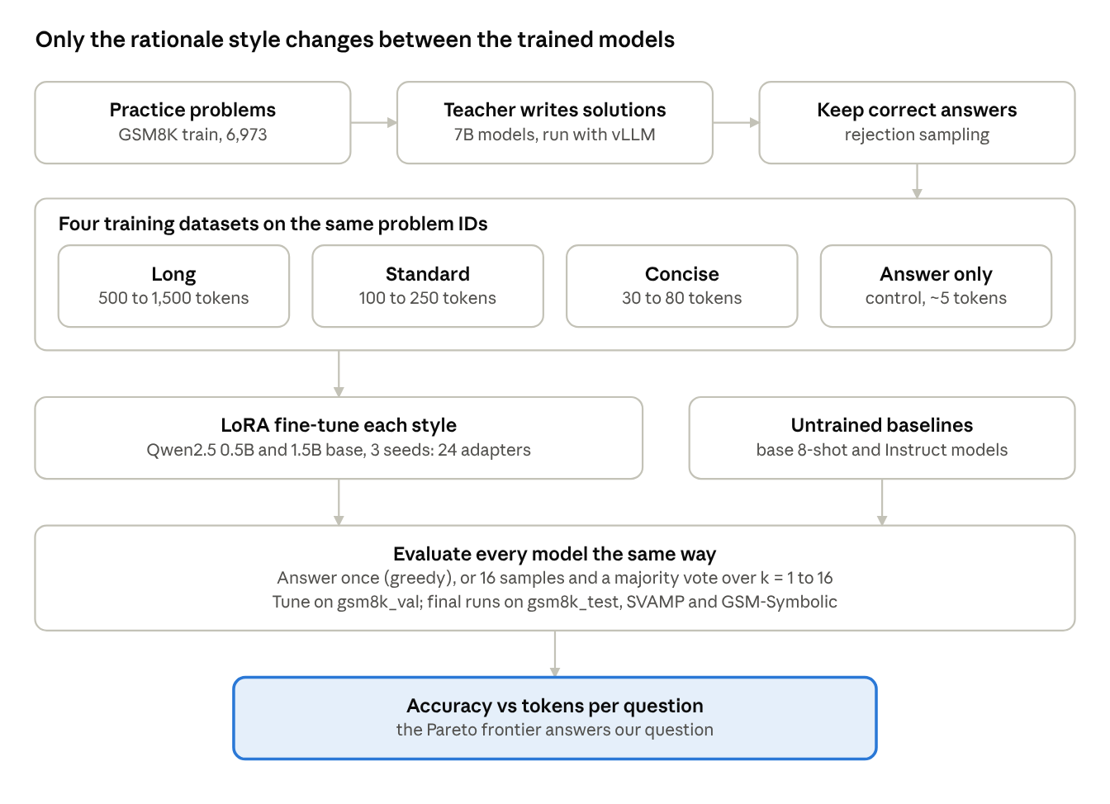
experiment pipeline · 4 rationale styles, 2 model sizes, 3 seeds
Read the diagram top to bottom. A teacher solves the practice problems, and we keep only correct solutions. We save them in four styles over exactly the same problem IDs. Each style trains its own LoRA adapter, at two model sizes with three seeds each. Every trained and untrained model then goes through the same evaluation.
What stays fixed across every condition:
- the problems and their order;
- the prompt wording;
- the training hyperparameters (chosen once on gsm8k_val, then frozen);
- the answer parser;
- the test questions.
Data splits:
- gsm8k_train (6,973) is for teacher generation and training.
- gsm8k_val (500, held out from train) is for all tuning and debugging.
- gsm8k_test (1,319) is for final runs only.
- SVAMP (1,000) and GSM-Symbolic (5,000) test how well results generalise.
The main figure plots accuracy against generated tokens per question, with one curve per model as the number of votes goes from 1 to 16. The best methods sit top-left. The boundary of best-achievable points, the Pareto frontier, answers H1.
Supporting analysis:
- answer diversity among the 16 samples (H2);
- truncation rates (H3);
- an error taxonomy of about 100 wrong answers per person: arithmetic slip, wrong plan, misread question, rambling, cut off, bad format.

The code so far
The evaluation harness in code/ is written, and its 26 unit tests pass. It has run end to end on a laptop, but its vLLM path has never run on the NTU cluster. The teacher-generation code (Person A) and the SFT training code (Person B) don't exist yet. Both will plug into this harness.
File | What it does
reasoning/data.py | Builds the fixed splits everyone shares: GSM8K train 6,973, val 500, test 1,319, plus SVAMP (1,000) and GSM-Symbolic (5,000). They're already saved in data/splits/.
reasoning/prompts.py | The 8-shot prompt for base models, and one chat prompt used by every Instruct and trained model. Training code must use chat_prompt and format_target from here.
reasoning/answer.py | One answer parser for every condition. It also records whether the model used the #### N format or the parser fell back to the last number.
reasoning/generate.py | Runs a model with vLLM (or slowly with Hugging Face for local debugging). Saves raw text, token counts, and whether each answer was cut off at the length limit.
reasoning/evaluate.py | Scores a run: accuracy, maj@k for k = 1 to 16 with 95% confidence intervals, tokens and FLOPs per question, truncation rate, answer diversity
reasoning/compare.py | Paired significance test (bootstrap and McNemar) between two runs on the same questions
scripts/run_baselines.sh | The full baseline matrix on gsm8k_val for 0.5B and 1.5B
scripts/slurm_baselines.sh | The cluster job wrapper. Its partition, QoS and time-limit lines still need the NTU values.
First run on the cluster. Download the models on the login node, because compute nodes may have no internet. Then:
conda create -n sc4001-g python=3.11 -y && conda activate sc4001-g
pip install -r requirements.txt
python -m pytest tests # must pass before any run
sbatch scripts/slurm_baselines.sh # after editing the ADAPT lines
Scoring and comparing runs:
python -m reasoning.evaluate runs/baselines/gsm8k_val/*.jsonl
python -m reasoning.compare runs/A.scored.jsonl runs/B.scored.jsonl --k 1
On V100-class GPUs, set DTYPE=float16, because they don't support bf16. Full details are in code/README.md.

Who does what
Each person owns one stage of the pipeline and writes the report sections that describe it. Everyone shares the error analysis and the final write-up. Track progress in the SC4001 Project Tracker.
Person | Owns | Hands off | Report sections
A: Teacher data | Teacher generation, filtering, the 4 datasets (data/sft/), checking the papers | 4 datasets on identical problem IDs, by 2 Nov | Literature review, Data
B: Training | LoRA SFT script, hyperparameter sweep, 24 adapters (ckpt/) | Adapters named ckpt/{style}_{size}_s{seed}/ | Methods, hyperparameter table
C: Evaluation | Cluster setup, baselines, all evaluation runs, figures, statistics (runs/) | Frozen figures and tables, by 12 Nov | Experiments and Results
Everyone | Error taxonomy, Intro, Discussion, AI Use Statement, cross-review | Submission on 15 Nov | All, reviewed by all
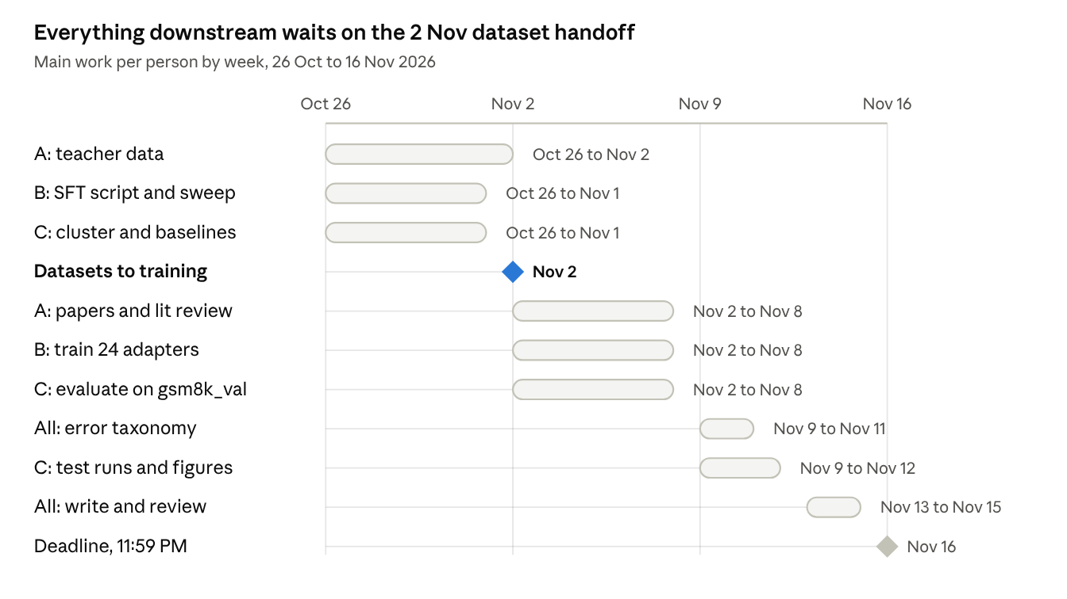
team timeline · 26 Oct to 16 Nov 2026
Person B doesn't need to wait for the data. Build and debug the training script on GSM8K's own human solutions, which are already in gsm8k_train. If the 2 Nov handoff slips, every later date slips with it. We check in for 15 minutes every Monday and Thursday.

Risks, rules and what to cut
The biggest risk is the schedule. Everything waits on the 2 Nov dataset handoff, and nothing has run on the cluster yet.
Risk | What goes wrong | What we do
Peeking at the test set | Results become invalid | Tune everything on gsm8k_val. Leave gsm8k_test alone until 9 Nov.
Noise mistaken for a result | A 1–2 point gap on 1,319 questions can be chance | Run 3 seeds and check every claim with compare.py
Contamination | Qwen2.5 may have seen GSM8K during pretraining | Also report GSM-Symbolic, which rewords the test questions
Unfair comparison | A difference comes from something other than style | Same problems, prompt, hyperparameters and parser for every condition
Long-trained models never stopping | Answers hit the length limit | Track the truncation rate; it is evidence for H3
Cluster friction | Queues, time limits, no internet on compute nodes | Pre-download models, save checkpoints, submit jobs early
Wrong citations | Marks deducted | Read each paper in full before citing it
If we fall behind, cut in this order:
- The LoRA rank ablation
- GSM-Symbolic runs (keep SVAMP as the out-of-distribution test)
- Seeds on the 1.5B model, from 3 down to 2
Never cut: baselines, all 4 styles on 0.5B with 3 seeds, the self-consistency curves, and the error taxonomy. These carry the 40% for experiments.

Related papers to read and verify
These six papers frame our gap. So far we have only seen their abstracts and search summaries. Person A reads each in full before anyone cites it.
Paper | Venue | Why it matters for us
Small Models Struggle to Learn from Strong Reasoners (Li et al.) | ICML 2025 | The closest prior work. Students of 3B or fewer learn better from short reasoning. Directly behind H3.
TokenSkip: Controllable Chain-of-Thought Compression (Xia et al.) | EMNLP 2025 | Fine-tunes on shortened reasoning. A possible way to build our concise style.
Scaling LLM Test-Time Compute Optimally (Snell et al.) | ICLR 2025 | Framing for trading answer-time compute against other compute
Self-Training Elicits Concise Reasoning (Munkhbat et al.) | ACL Findings 2025 | About 30% fewer tokens on GSM8K and MATH at similar accuracy
DRP: Distilled Reasoning Pruning (Jiang et al.) | ACL Findings 2026 | Pruned teacher reasoning gave a student shorter and more accurate answers
How Well do LLMs Compress Their Own Chain-of-Thought? (Lee et al.) | arXiv 2025 | Asking for brevity in the prompt gives only modest compression. A baseline idea.
- ☐ Li et al. read in full
- ☐ Xia et al. read in full
- ☐ Snell et al. read in full
- ☐ Munkhbat et al. read in full
- ☐ Jiang et al. read in full
- ☐ Lee et al. read in full

Where to find everything
Everything except the tracker and this handbook lives in our shared Group Assignment folder.
What | Where
Assignment handout and FAQ | project_handout.pdf, FAQ.pdf
Research plan, hypotheses, paper notes | research-question-card.md
Code and setup instructions | code/ (start with code/README.md)
Fixed data splits | code/data/splits/
Task status | SC4001 Project Tracker
Full planning chat history | An exported zip. Ask @reathan for it.
To get edit access to the tracker or this handbook, ask to be invited by email as an Editor. Leave comments on anything in this doc that's unclear.

