NKHEDMOU.COM — WEBSITE REQUIREMENTS
Simplified English version for development and implementation
Main goal: Build a simple, secure and easy-to-use recruitment platform for cooks, hospitality workers, restaurants and hotels, with the main target market being Morocco.
1. GENERAL WEBSITE
- Website languages: French and Arabic. Add a clear and easy language-switch button. (Explore the possibility to translate to dialectal Arabic (Moroccan Arabic)
- The first page must be the website home page.
- Visitors can browse offers and profiles, but when they click on an offer or a cook profile, they must sign in or create an account to continue.
- Add a Sign Up button next to the offer browsing section :
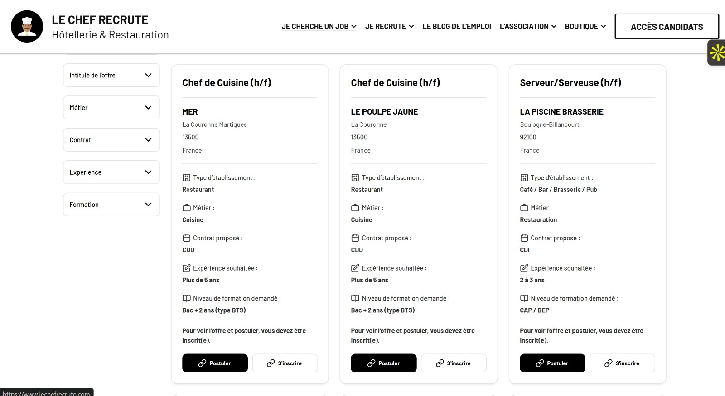
- Main objective: register as many relevant users as possible.
- The platform may later limit the number of searches per user or employer to protect the database from excessive use.
2. SIGN IN / ACCOUNT CREATION
Login page
- Replace the current wording with: “Join Nkhedmou.ma”
- “I’m a cook” → “I’m looking for a job”
- “I’m a restaurant” → “I’m an employer”
Account creation
- Allow account creation directly on the platform or through Gmail/Google.
- After 3 failed login attempts, temporarily suspend the account and suggest password reset.
- Password reset must work by email. Check whether reset by WhatsApp code or link can also be offered.
- Password requirements: at least one uppercase letter, one lowercase letter, one number and one special character.

3. EMPLOYEE / CANDIDATE SIGN UP
- Initial sign-up fields: First name, Last name, Email, Password and email confirmation.
- After sign-up, redirect the user directly to the profile completion page :
- The candidate must complete all required profile fields before applying to job offers.
- If required fields are missing, show: “Incomplete profile” and redirect the user to “Edit My Profile” :
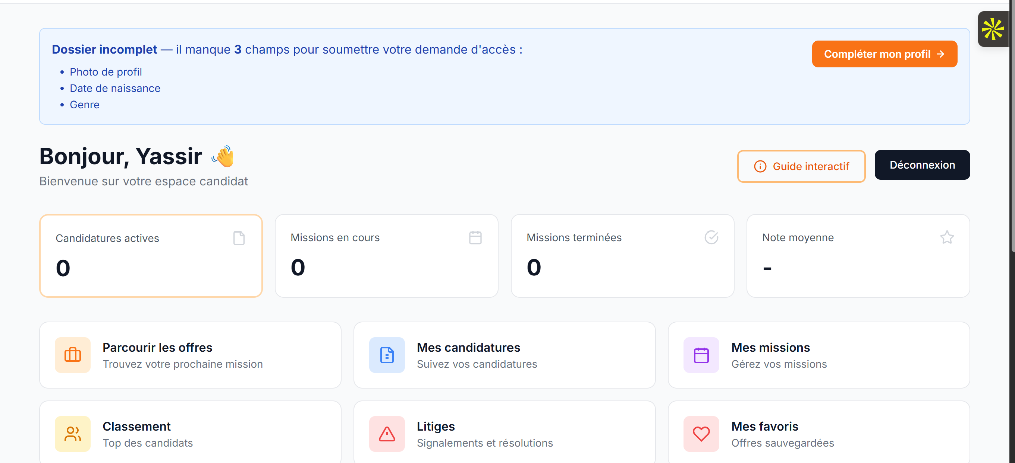

- Candidates without a CV must be able to enter their information and create a CV-like profile, inspired by LinkedIn :
- Job selection must be linked to the selected sector. The employer/candidate must first select a sector (Hotel / Hospitality, Restaurant / Café / Collective Catering, Bakery / Pastry, or Asian Cuisine). Only the job positions related to the selected sector will then be displayed and available for selection. The user cannot select a job position before selecting a sector.

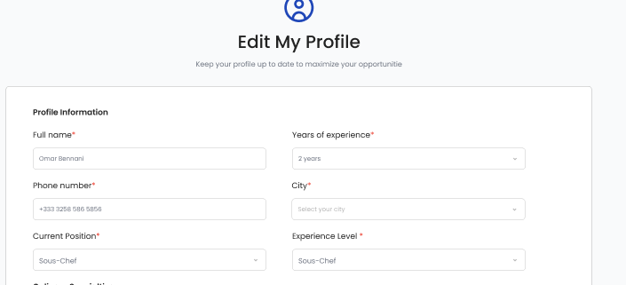

- On Edit My Profile, allow the candidate to add a profile photo. Recommend a professional photo to improve recruitment chances.

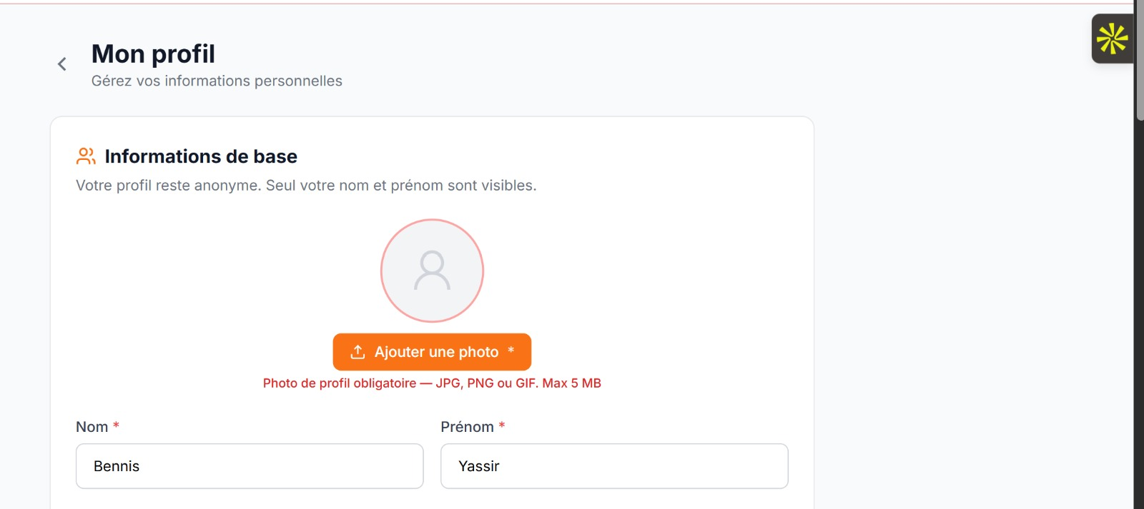
- Job titles, sectors and experience should be selected from scrolling/drop-down options. Do not allow free text for these fields.

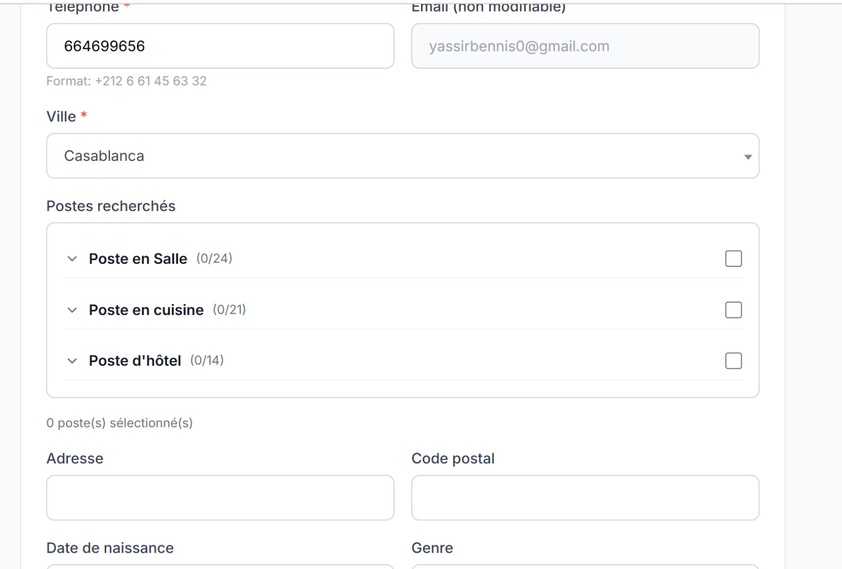

4. CANDIDATE PROFILE
Information for profiles such as cooks, bakery/pastry workers and other relevant food-service jobs
- Name and surname
- Phone number
- Years of experience
- City
- Current status
- Academic / professional training, with dates from–to
- Previous experience: establishment name, position/status and dates from–to
- CV upload or CV creation directly on the platform
- Profile photo
Food photos
Only kitchen and bakery/pastry profiles can upload photos of food they prepared. The number of photos must be limited per profile (6 for example or 8)
- The following profiles are concerned: Executive Chef, Head Chef, Sous-Chef, Chef de Partie, Garde-Manger Chef, Demi Chef de Partie, Cook, Kitchen Commis, Sushiman, Sushi Chef, Apprentice/Trainee, Chef de Rang, Delivery Drivers, Pizzaiolo, Barman/Barmaid, Barista,
- Head Baker, Pastry Chef, Baker, Pastry Chef, Baker Assistant, Pastry Assistant, Baker Apprentice, Pastry Apprentice, Viennoisier, Chocolatier and Ice Cream Maker.
- Asian cuisine roles also include: Asian Cuisine Chef, Asian Cuisine Sous-Chef, Asian Cuisine Chef de Partie, Asian Cook, Asian Kitchen Commis, Sushi Chef, Sushiman/Sushiwoman, Sushi Commis, Teppanyaki Chef, Teppanyaki Cook and Sushi Preparer.
- The exact photo quota must be defined. Add security measures to prevent malicious uploads and hacking.
5. CANDIDATE JOB CATEGORIES
Category 1 — Café / Restaurant / Collective Catering
- Executive Chef
- Head Chef
- Sous-Chef
- Chef de Partie
- Garde-Manger Chef
- Demi Chef de Partie
- Cook
- Kitchen Commis
- Sushiman / Sushi Chef
- Apprentice / Trainee
- Dishwasher
- Maintenance / Cleaning Worker
- Chef de Rang
- Delivery Driver
- Cashier
- Pizzaiolo
- Barman / Barmaid
- Barista
- Waiter / Server
- Site Manager / Restaurant Manager
- Storekeeper / Stock Manager
- Valet
Category 2 — Hotels
- Hotel Director
- Guest Relations / Customer Service
- Front Office Manager / Head Receptionist
- Receptionist
- Bellman / Porter
- Concierge
- Housekeeper / Room Attendant
- Linen Attendant
- Valet
- Cleaning Agent
- Gardener
- Security Guard
Category 3 — Bakery / Pastry
- Head Baker
- Head Pastry Chef
- Baker
- Pastry Chef
- Baker Assistant
- Pastry Assistant
- Baker Apprentice
- Pastry Apprentice
- Salesperson
- Viennoisier
- Chocolatier
- Ice Cream Maker
- Production Manager
- Shop / Boutique Manager
Category 4 — Asian Cuisine
- Asian Cuisine Chef
- Asian Cuisine Sous-Chef
- Asian Cuisine Chef de Partie
- Asian Cook
- Asian Kitchen Commis
- Sushi Chef
- Sushiman / Sushiwoman
- Sushi Commis
- Teppanyaki Chef
- Teppanyaki Cook
- Sushi Preparer
6. JOB OFFERS — CANDIDATE SIDE
- Add a direct search button covering the full database for users who do not want to select filters manually.
- Filters: Job title, required years of experience, city and country.
- Keep Morocco fixed as the country while Morocco is the first target market.
- Keep the current offer display structure.
- Send email notifications to relevant cooks when new offers are published.
- Job offer filters must also include: Job type (long-term or short-term), city, establishment type (hotel, restaurant, bakery, etc.) and job title.
- Display 12 profiles per page in the candidate search area.
- Candidate profile search filters: city, sector, job and experience.
7. HOME PAGE
- Admin must be able to change the home-page background by uploading an image, or keep the existing blank background.

- Simplify the main registration section while keeping the same visual style.
- Replace the existing icons with: chef/cook icon, restaurant icon, and a paper/document icon with a green validation logo.
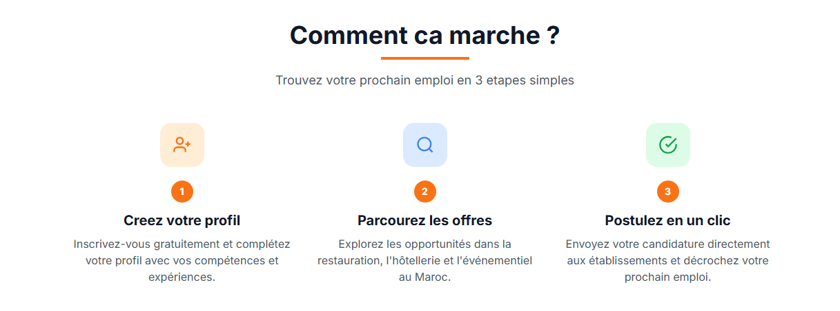
- Replace “Satisfaction Rate” with “People who successfully found a job”.
- Add the planned advertising section.
8. ADVERTISING
- Add two banner advertising locations on the home page.
- These two main banners remain fixed on the home page.
- Other advertising spaces can appear on other pages while users browse the website.
- Exact advertising locations can be defined later.
- Admin must be able to manage home-page and other advertising backgrounds/banners.
9. RESTAURANT / EMPLOYER PROFILE
- Allow the employer to upload the establishment photo or logo to increase credibility.
- The employer’s phone number must not be displayed to employees/candidates.
- Add a profile option to activate or deactivate phone-number display where appropriate, subject to the platform’s privacy rules.
- Add a “Save / Continue to Recruitment” button that redirects to the recruitment page.
- Add a “Post a Job” button next to “Find the Best Profiles”.
- “Find the Best Profiles” should become a button leading to the profile filters on the same page.
- Show the default profile filters.
- Allow the employer to add social links such as Instagram, LinkedIn or another relevant social network.
- Allow the employer to add a profile photo or establishment logo.
10. EMPLOYER JOB POSTING
- After the employer submits a job offer, show: “Your job offer is under approval.”
- All employer job offers must be controlled and approved by the platform administration before publication.
Job Requirements — selectable options
- Availability: Immediately available; Available in the morning; Available in the evening; Available on weekends and public holidays.
- Skills: Cooking diploma or no diploma; Moroccan cuisine; International cuisine; Italian cuisine; Asian cuisine; Collective catering experience; Bakery/pastry skills; Hotel experience; Management experience.
- Hygiene: HACCP knowledge; Food hygiene training; Professional uniform required.
- Mobility: Driving licence; Geographic mobility.
- Languages: French; Arabic; English; Spanish.
Job Benefits — selectable options
- Salary: Fixed salary; Bonuses; Tips; Paid overtime.
- Social protection: CNSS declaration; Health insurance; Employment contract.
- Meals / transport: Meal or lunch provided; Transport provided; Transport allowance.
- Working conditions: Uniform provided; Paid leave / leave entitlement; Accommodation provided.
11. JOB OFFER DEADLINE
- When an offer reaches its deadline, remove it from the active job-offer list.
- Keep the expired offer in the employer’s history, including the profiles/candidates who applied.
- Maximum deadline: 60 days per job offer.
- After 60 days, automatically remove the offer from active listings.
- The employer should be able to republish an expired offer where appropriate.
12. SAVED PROFILES
- Add a “Saved Profiles” section in the employer main page for candidates who have not applied but were saved by the employer during profile searches.
13. ADMIN DASHBOARD — MAIN STATISTICS
Candidate statistics
- Total number of candidates
- New candidates today
- New candidates this week
- New candidates this month
- Active candidates
- Profiles completed 100%
- Verified candidates
- Candidates available immediately
Employer statistics
- Total number of establishments
- New employers today / this week / this month
- Verified employers
- Employers waiting for verification
- Blocked employers
- Active employers
- Number of restaurants
- Number of hotels
- Number of caterers
- Number of collective catering companies
Job offer statistics
- Active offers
- Offers published today
- Offers published this month
- Offers expiring within 7 days
- Expired offers
- Closed offers
- Offers waiting for approval
- Reported offers
14. ADMIN — CANDIDATE MANAGEMENT
- Admin must have a CV database that can be exported to Excel.
Candidate database filters
- Name
- City
- Job title
- Sub-job / specialization
- Experience
- Availability
- Expected salary
- Preferred contract type
- Languages
- Skills
- Education / training
- Registration date
- Last login
- Profile completion
- Verified / not verified
- Available / unavailable
Administrator actions
- View the complete profile
- Edit the profile
- Verify the profile
- Deactivate the profile
- Delete the profile
- Restore a profile
- Add a skill
- Correct information
- View profile history
- View applications
- See which employers requested the candidate’s contact details
- Approve or remove uploaded photos
15. EMPLOYER MANAGEMENT
- View employer information.
- See number of published offers.
- See number of active offers.
- See number of applications received.
- See number of profiles viewed.
- See number of contact requests.
- See number of reported/declared recruitments.
- See last activity.
- Check how many candidate contacts each employer has requested and whether the employer is actively posting job offers.
Employer offer filters
- Active
- Pending approval
- Expired
- Closed
- Rejected
Actions on each job offer
- Edit
- Approve
- Reject
- Deactivate
- Extend exceptionally
- Republish
- Delete
16. PLATFORM STATISTICS / MARKET DATA
- Most searched job titles
- Most searched cities
- Average salaries offered
- The admin must be able to approve or remove inappropriate photos.
- If a user uploads abusive or inappropriate photos, the admin must be able to block the user.
17. APPROVAL NOTIFICATIONS
- After admin approval, send a notification on the website and by email confirming that the profile or job offer has been approved.
- In Job Management, approved offers should be clearly marked in green or removed from the pending-approval list to make management easy.
- If an uploaded photo does not meet the required quality, notify the employee during the first upload and explain that a better-quality photo is required.
18. ADMIN ROLES AND PERMISSIONS
- The platform must allow the main admin to create internal company admin profiles with restricted permissions.
- Example: an internal admin can have permission only to approve photos and job offers.
- Full control must remain with the main platform administrator.
19. USER FEEDBACK
- Admin must be able to answer user feedback.
- When admin replies, notify the user on the website and by email.
20. SECURITY AND DATA PROTECTION — DEVELOPMENT REQUIREMENT
- Candidate phone numbers and other sensitive contact information must be protected and accessible only according to the platform’s recruitment rules.
- Employer access to candidate contact details should be traceable in the admin dashboard.
- The platform should keep an activity/history log for important administrative actions and access to candidate contact information.
- Photo uploads must be checked for file type, size and security before being stored.
- The developer must implement appropriate protection against malicious uploads, automated abuse and unauthorized database access.
- The exact data-protection and privacy workflow must be defined before launching access to candidate contact details.

