11 Elevator Project: Communication/Fire Alarms Drawings

* TE-103 : 207TH STREET STATION below:

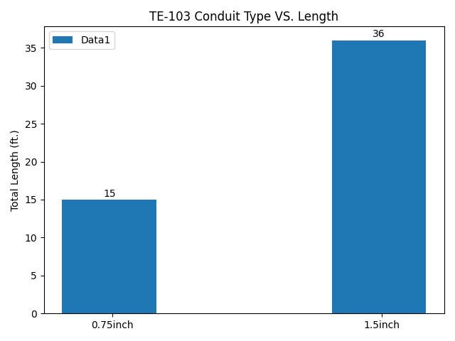

* TE-103 : 207TH STREET STATION below:

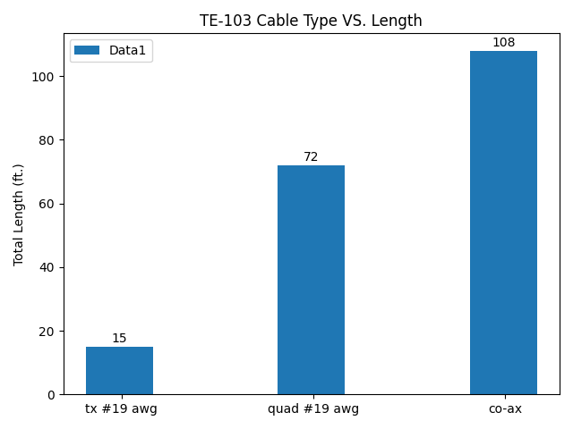

* TE-108 : 207TH STREET STATION below:

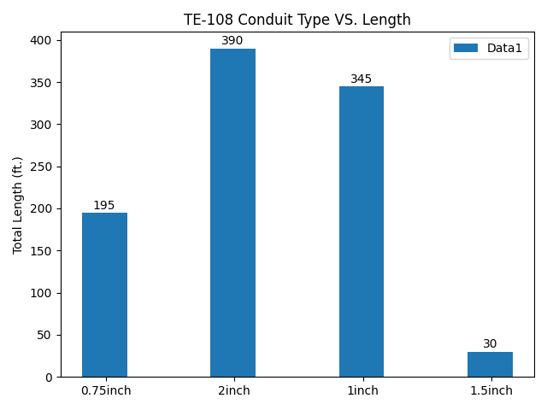

* TE-108 : 207TH STREET STATION below:

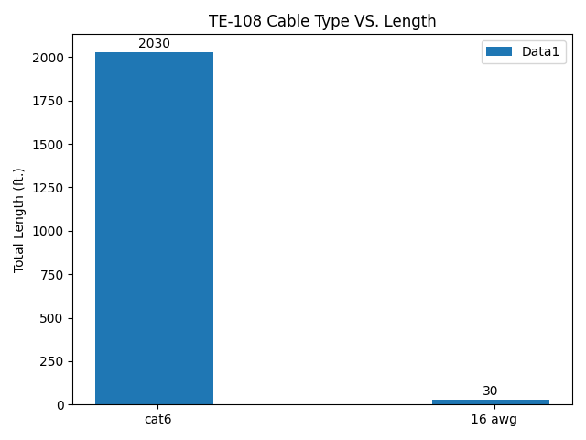

* TE-109 : 207TH STREET STATION below:

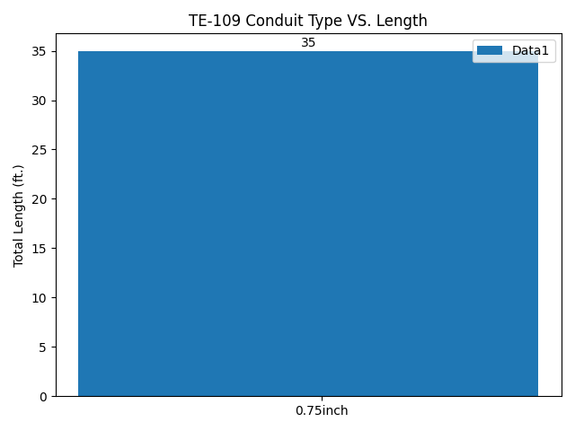

* TE-109 : 207TH STREET STATION below:

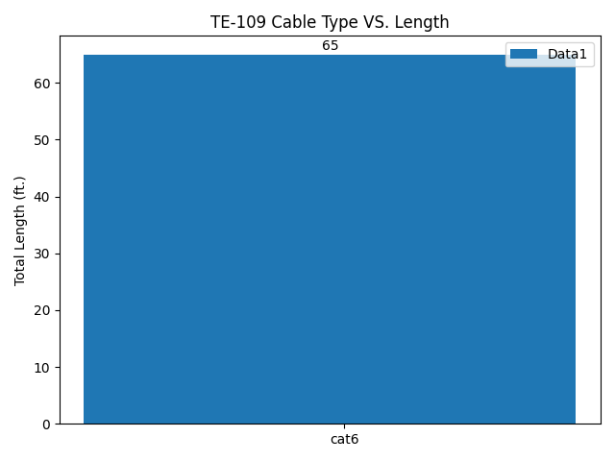

* TE-110 : 207TH STREET STATION below:

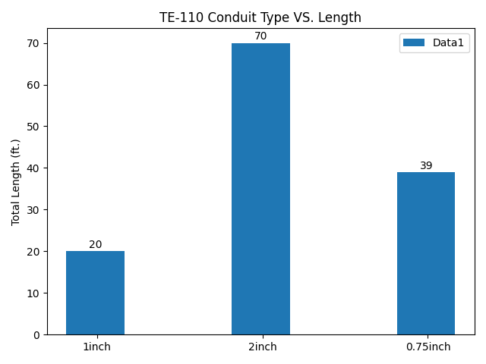

* TE-110 : 207TH STREET STATION below:

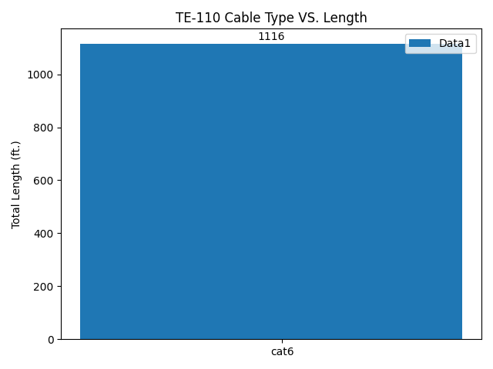

* TE-111 : 207TH STREET STATION below:

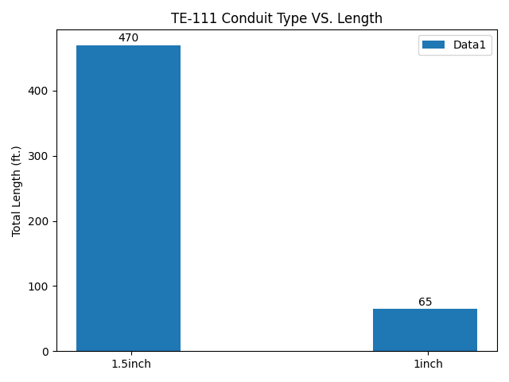

* TE-111 : 207TH STREET STATION below:

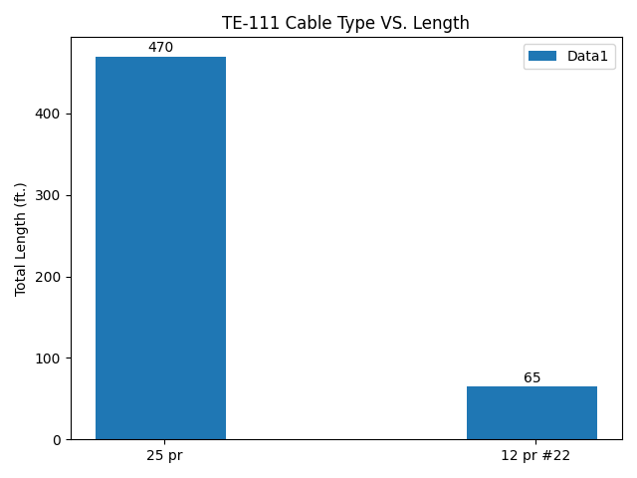

* TE-113 : 207TH STREET STATION below:

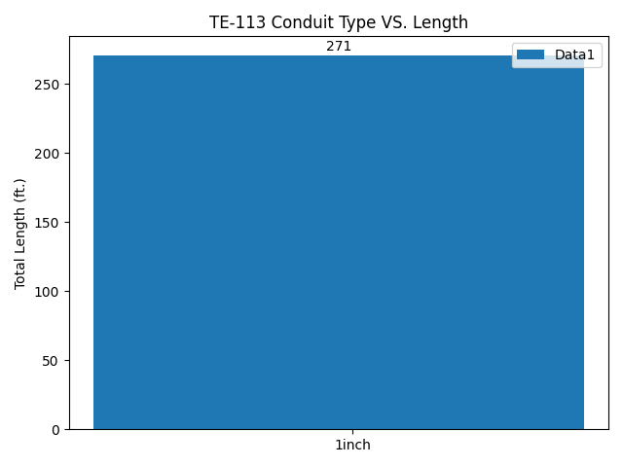

* TE-113 : 207TH STREET STATION below:

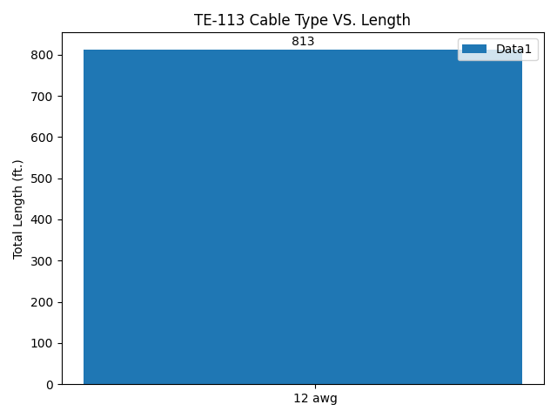

* TE-115 : 207TH STREET STATION below:

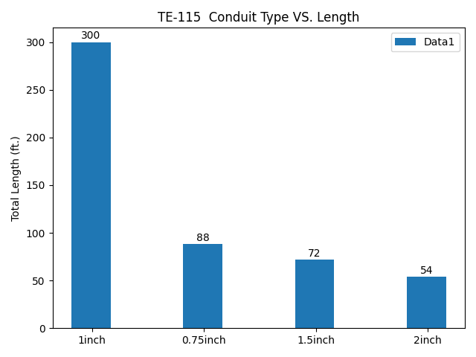

* TE-115 : 207TH STREET STATION below:

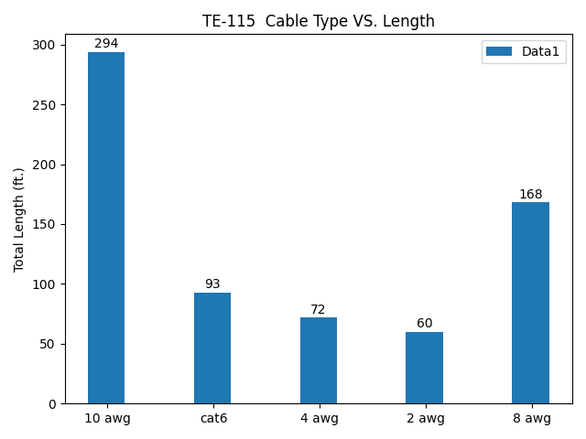

* TE-116 : 207TH STREET STATION below:

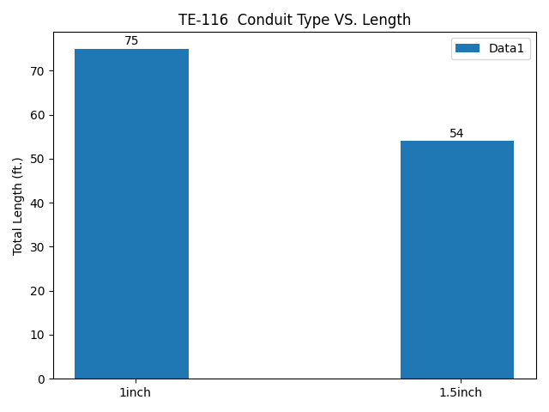

* TE-116 : 207TH STREET STATION below:

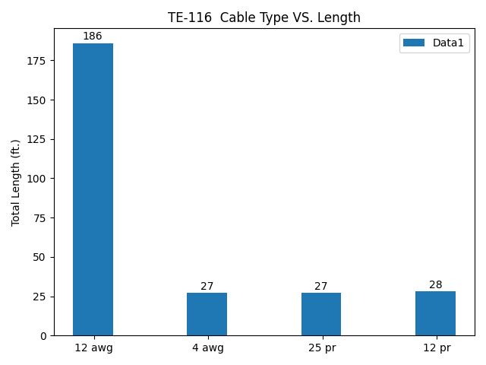

* TE-133 : 207TH STREET STATION below:

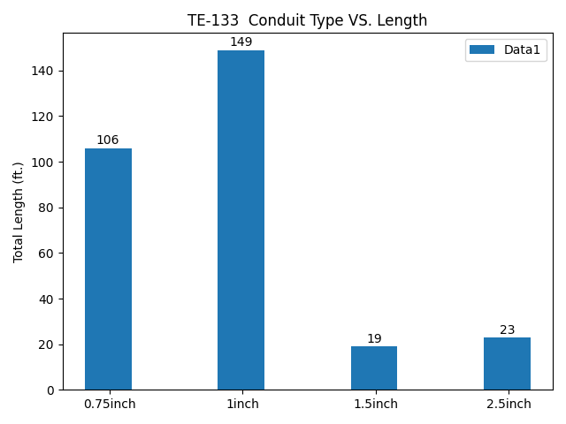

* TE-133 : 207TH STREET STATION below:

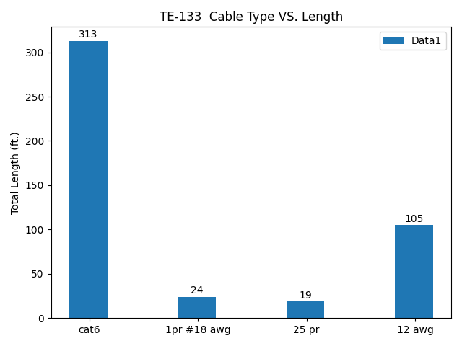

* TE-134 : 207TH STREET STATION below:

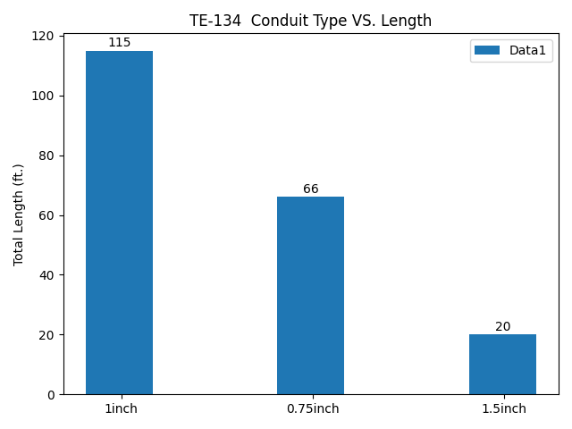

* TE-134 : 207TH STREET STATION below:

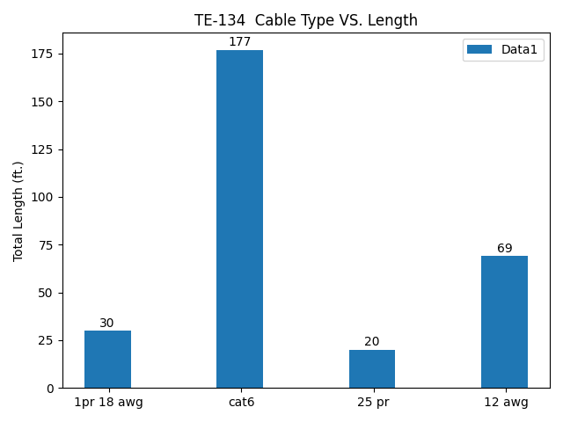

* TE-203 : 34TH HERALD SQUARE STATION 6TH AVE (IND) below:

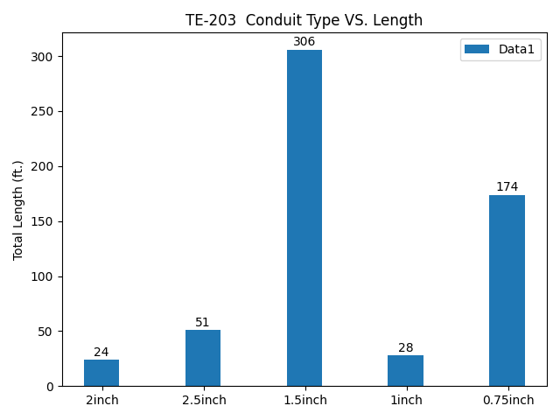

* TE-203 : 34TH HERALD SQUARE STATION 6TH AVE (IND) below:

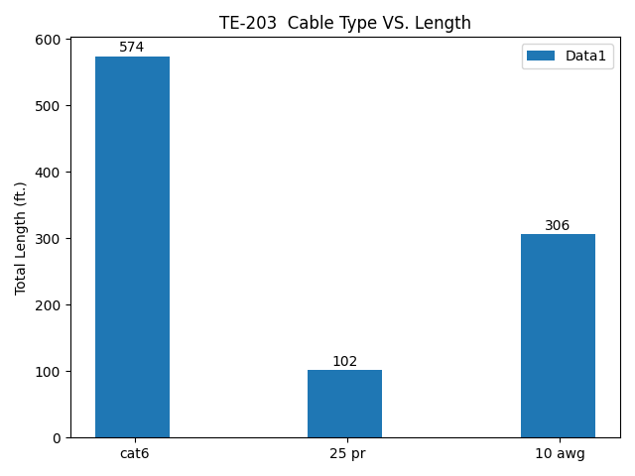

* TE-204 : 34TH HERALD SQUARE STATION 6TH AVE (IND) below:

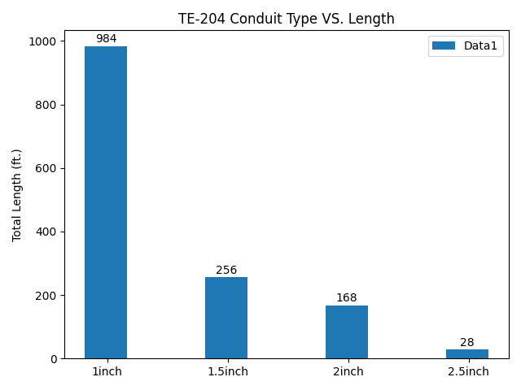

* TE-204 : 34TH HERALD SQUARE STATION 6TH AVE (IND) below:

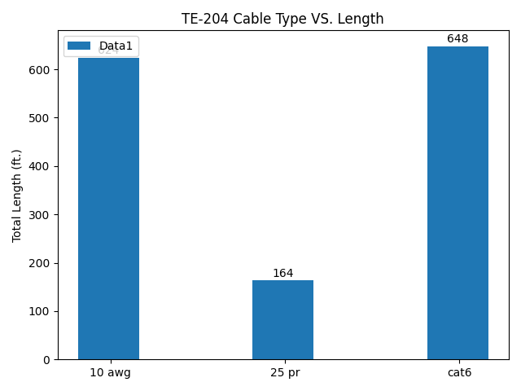

* TE-205 : 34TH HERALD SQUARE STATION 6TH AVE (IND) below:

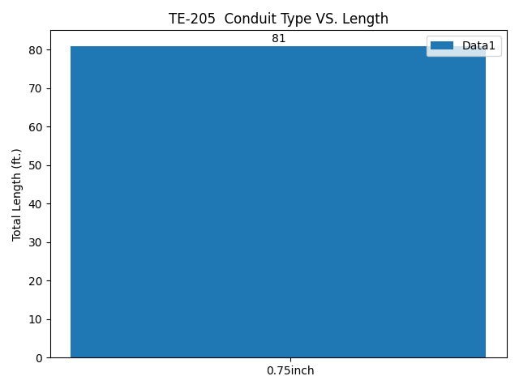

* TE-205 : 34TH HERALD SQUARE STATION 6TH AVE (IND) below:

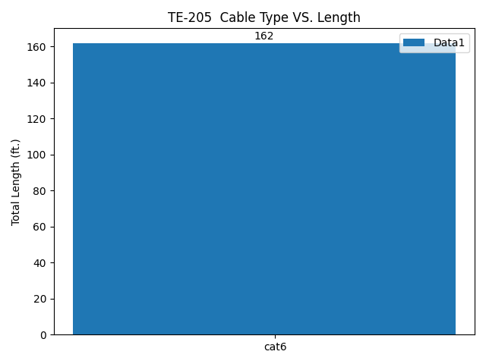

* TE-207 : 34TH HERALD SQUARE STATION 6TH AVE (IND) below:

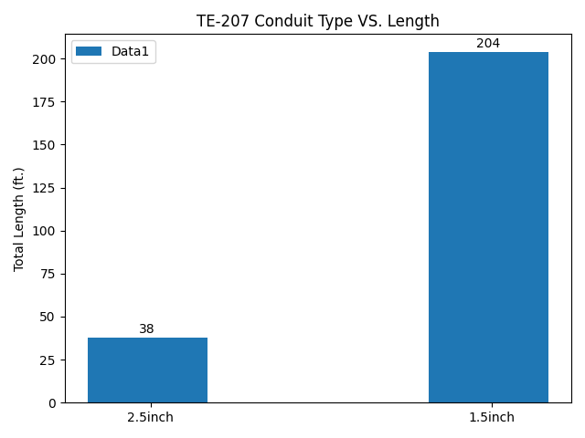

* TE-207 : 34TH HERALD SQUARE STATION 6TH AVE (IND) below:

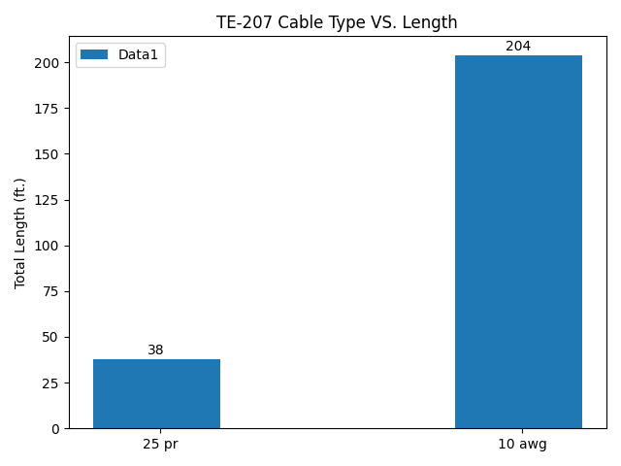

* TE-208 : 34TH HERALD SQUARE STATION 6TH AVE (IND) below:

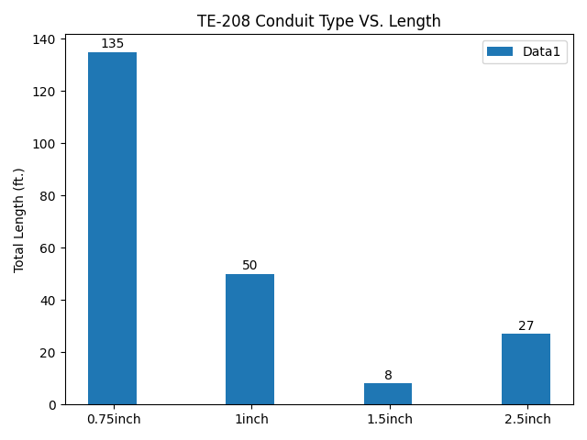

* TE-208 : 34TH HERALD SQUARE STATION 6TH AVE (IND) below:

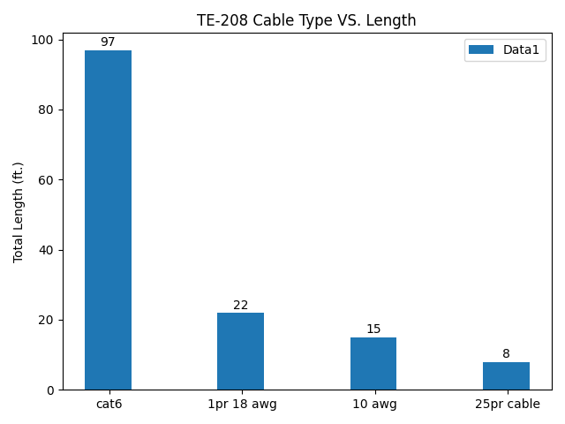

* TE-209 : 34TH HERALD SQUARE STATION 6TH AVE (IND) below:

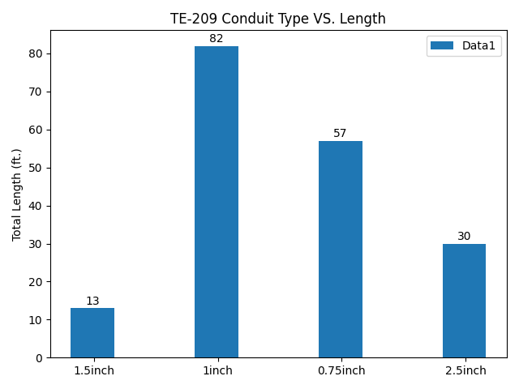

* TE-209 : 34TH HERALD SQUARE STATION 6TH AVE (IND) below:

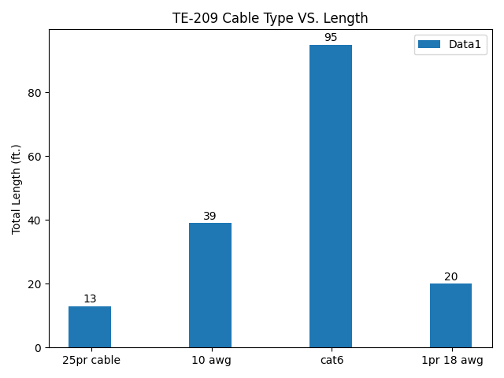

* TE-304 : 34TH HERALD SQUARE STATION BROADWAY (BMT) below:

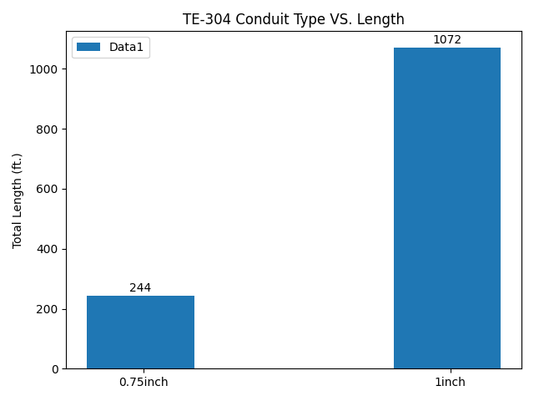

* TE-304 : 34TH HERALD SQUARE STATION BROADWAY (BMT) below:

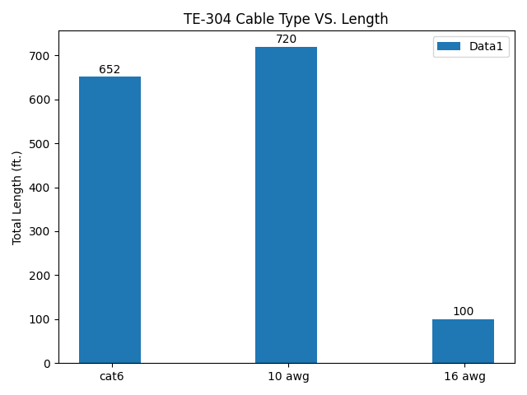

* TE-305 : 34TH HERALD SQUARE STATION BROADWAY (BMT) below:

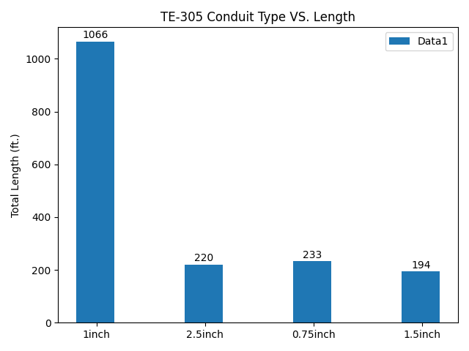

* TE-305 : 34TH HERALD SQUARE STATION BROADWAY (BMT) below:

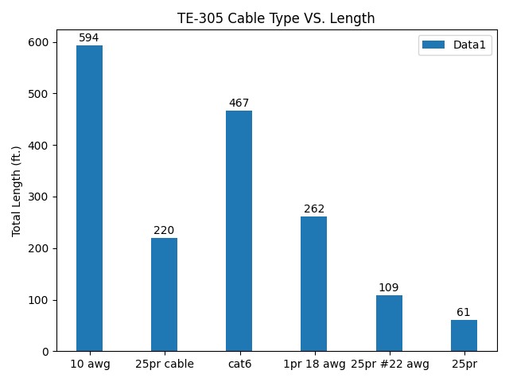

* TE-306 : 34TH HERALD SQUARE STATION BROADWAY (BMT) below:

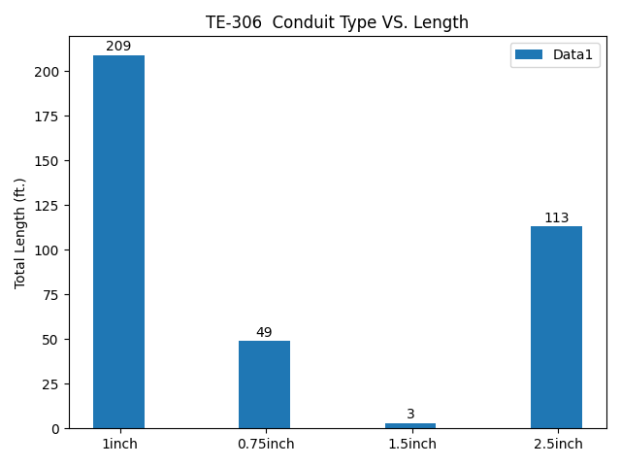

* TE-306 : 34TH HERALD SQUARE STATION BROADWAY (BMT) below:

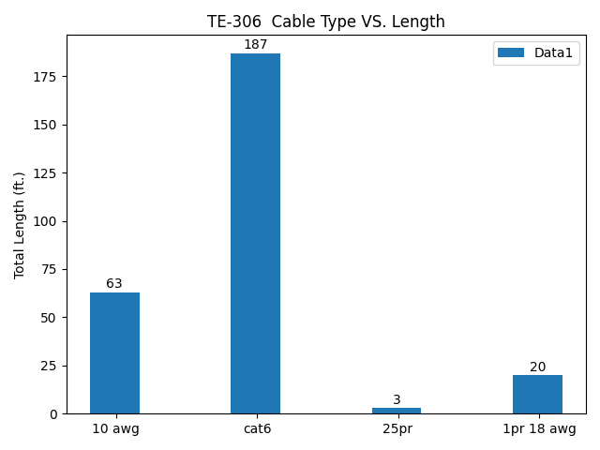

* TE-307 : 34TH HERALD SQUARE STATION BROADWAY (BMT) below:

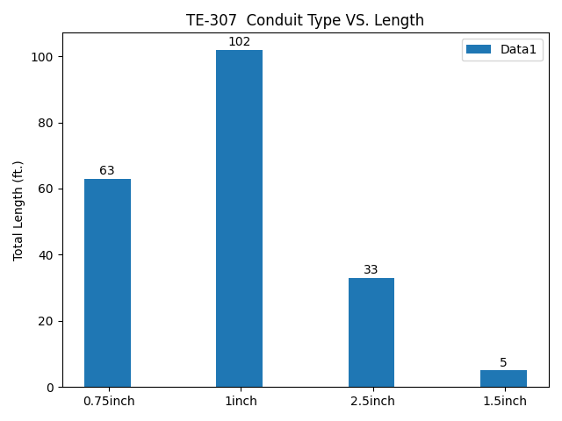

* TE-307 : 34TH HERALD SQUARE STATION BROADWAY (BMT) below:

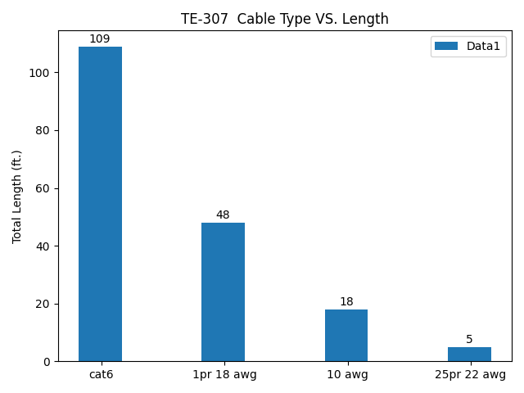

* TE-308 : 34TH HERALD SQUARE STATION BROADWAY (BMT) below:

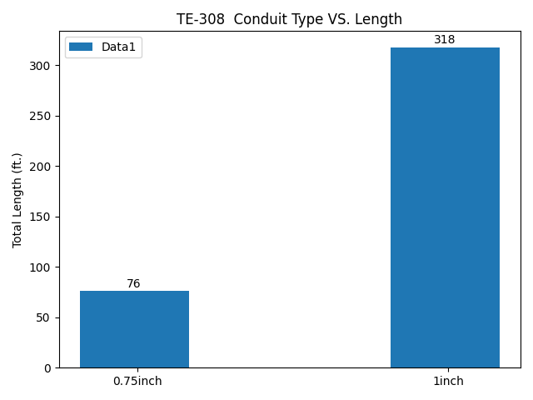

* TE-308 : 34TH HERALD SQUARE STATION BROADWAY (BMT) below:

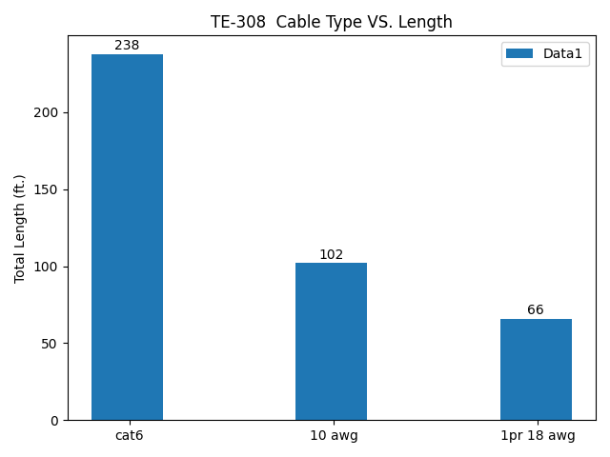

* TE-310 : 34TH HERALD SQUARE STATION BROADWAY (BMT) below:

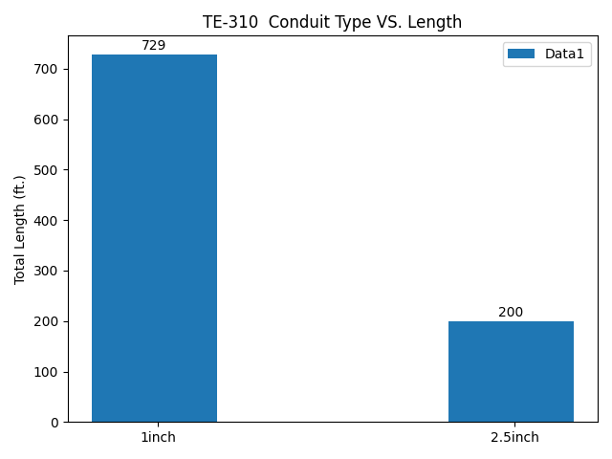

* TE-310 : 34TH HERALD SQUARE STATION BROADWAY (BMT) below:

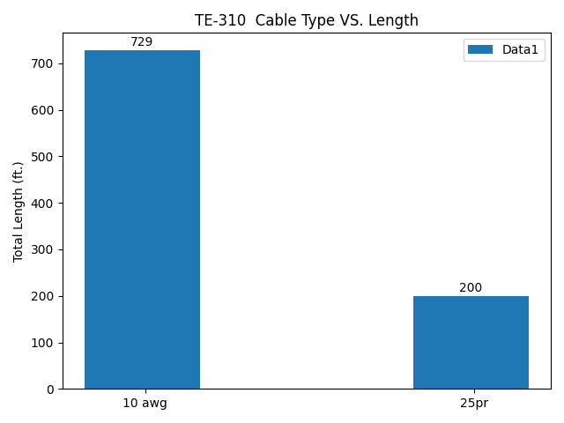

* TE-402 : FLATBUSH AVE STATION below:

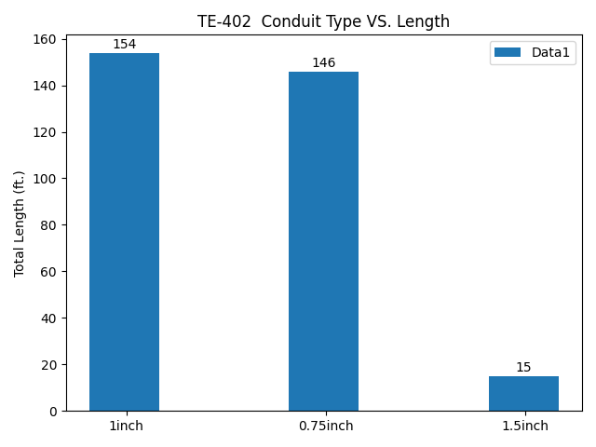

* TE-402 : FLATBUSH AVE STATION below:

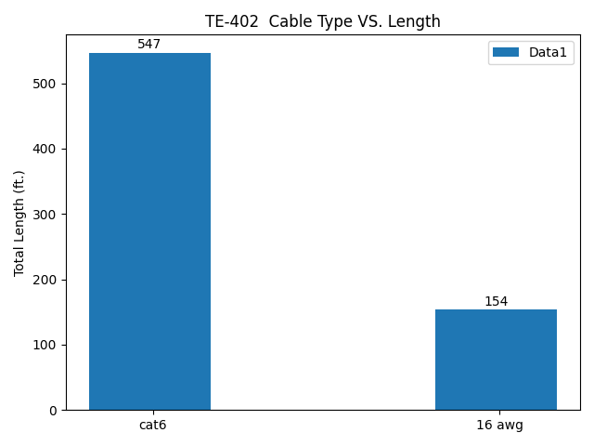

* TE-403 : FLATBUSH AVE STATION below:

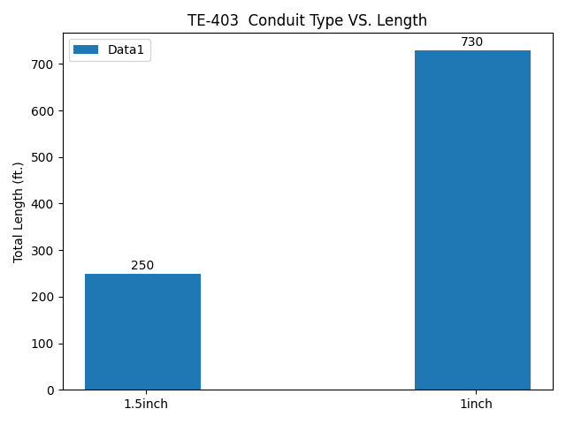

* TE-403 : FLATBUSH AVE STATION below:

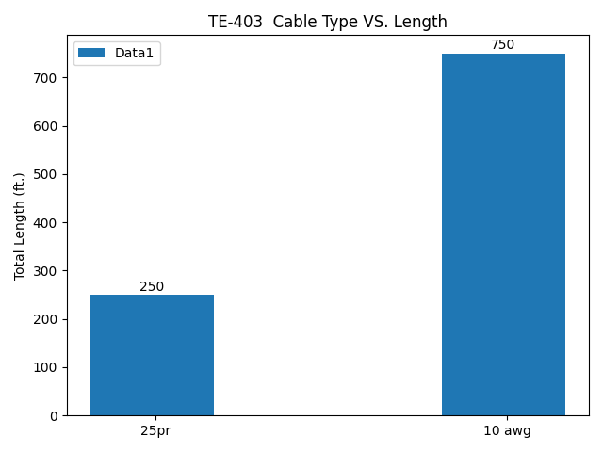

* TE-405 : FLATBUSH AVE STATION below:

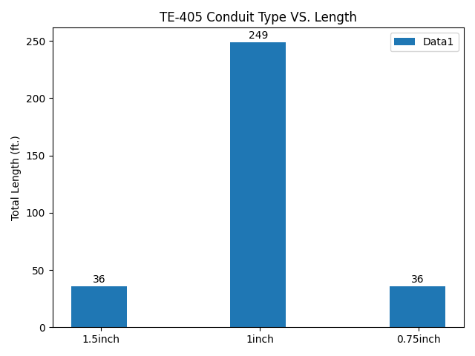

* TE-405 : FLATBUSH AVE STATION below:

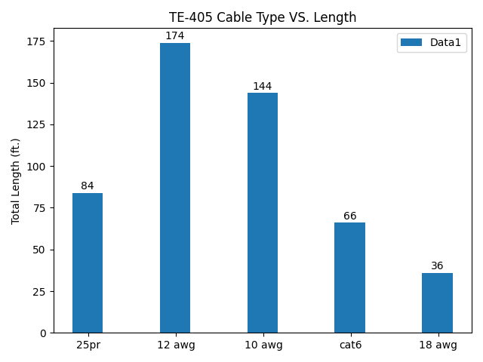

* TE-408 : FLATBUSH AVE STATION below:

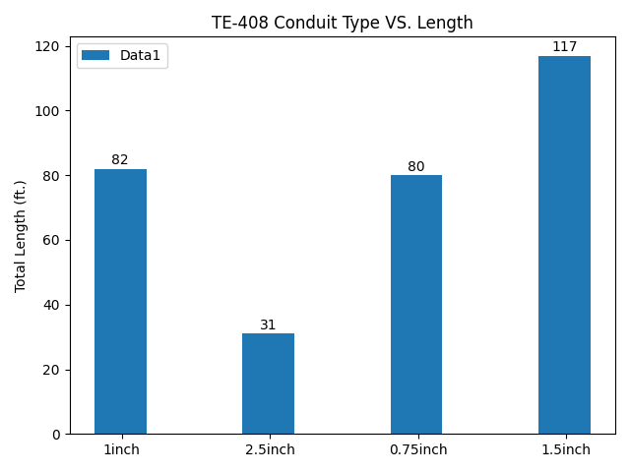

* TE-408 : FLATBUSH AVE STATION below:

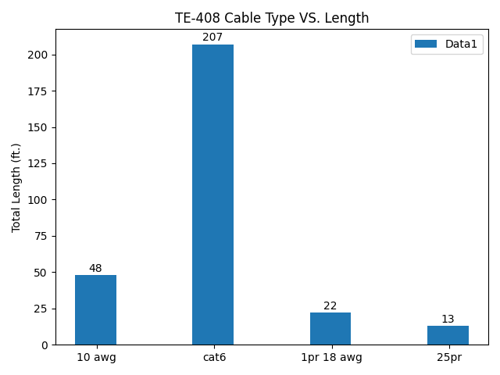

* TE-502 : CHURCH AVE STATION below:

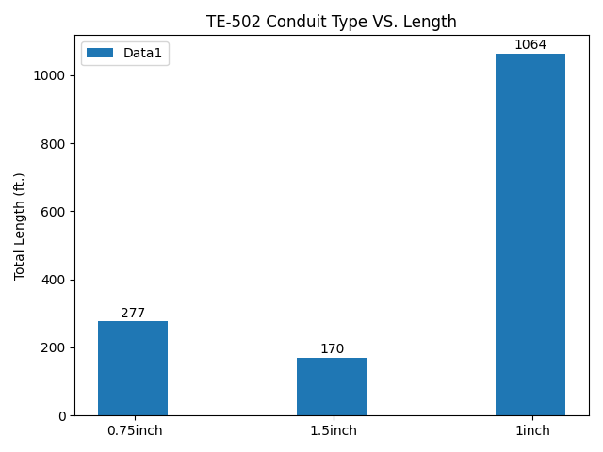

* TE-502 : CHURCH AVE STATION below:

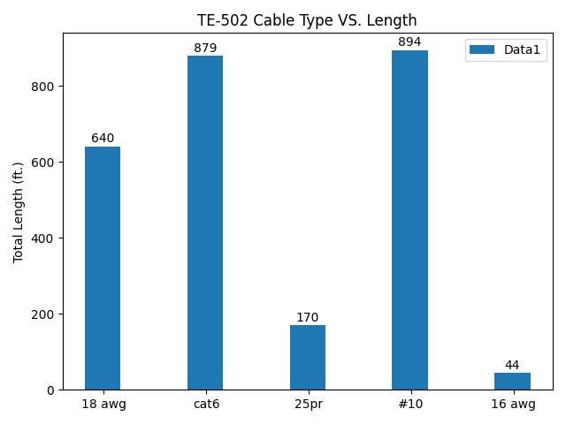

* TE-503 : CHURCH AVE STATION below:

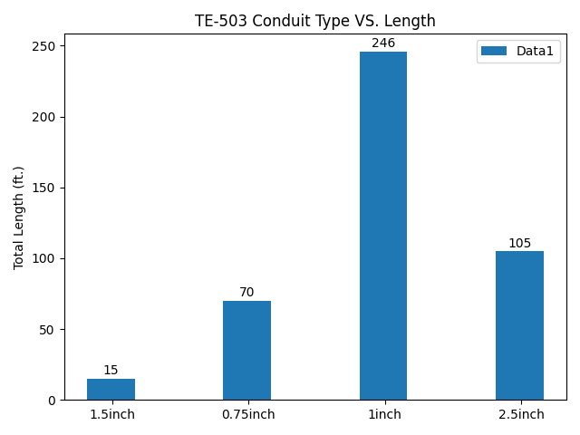

* TE-503 : CHURCH AVE STATION below:

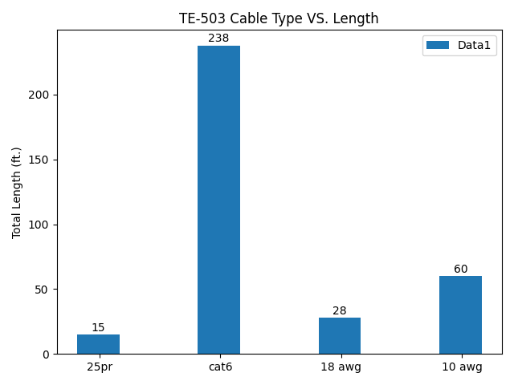

* TE-506 : CHURCH AVE STATION below:

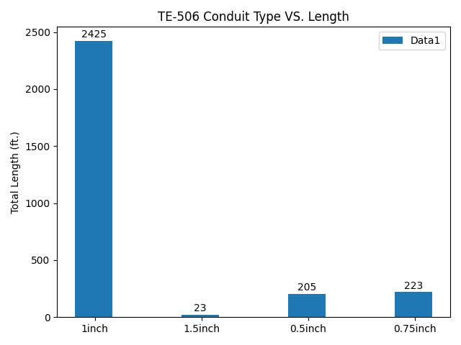

* TE-506 : CHURCH AVE STATION below:

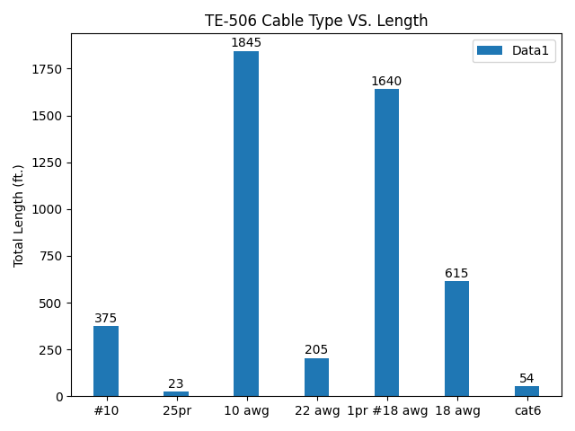

* TE-507 : CHURCH AVE STATION below:

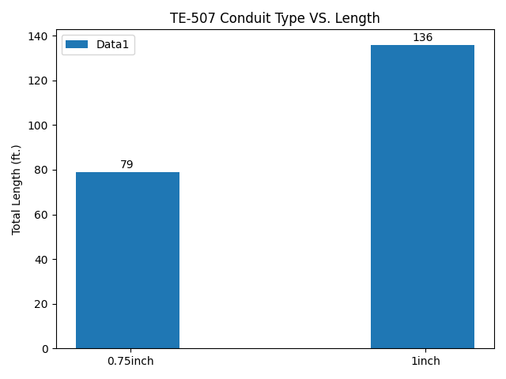

* TE-507 : CHURCH AVE STATION below:

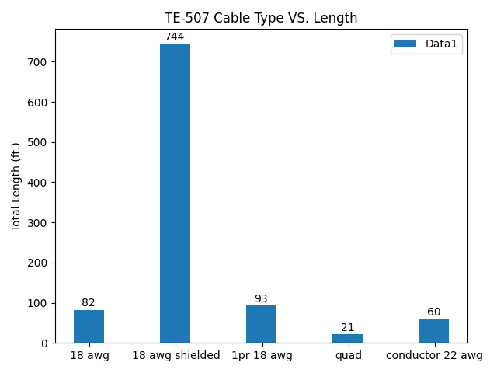

* TE-603 : JAMAICA CENTER PARSONS/ ARCHER STATION below:

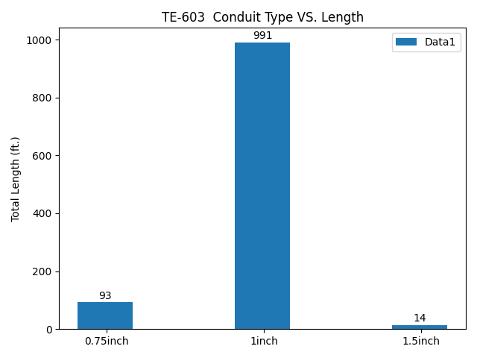

* TE-603 : JAMAICA CENTER PARSONS/ ARCHER STATION below:

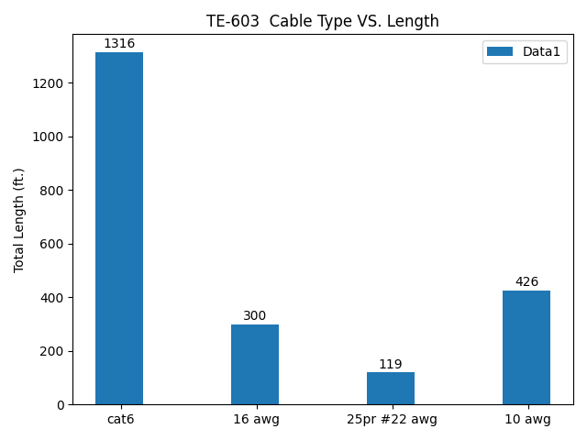

* TE-604 : JAMAICA CENTER PARSONS/ ARCHER STATION below:

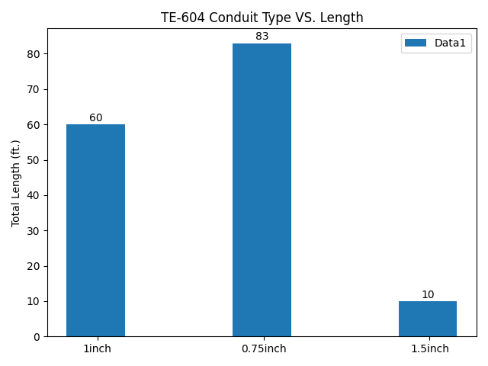

* TE-604 : JAMAICA CENTER PARSONS/ ARCHER STATION below:

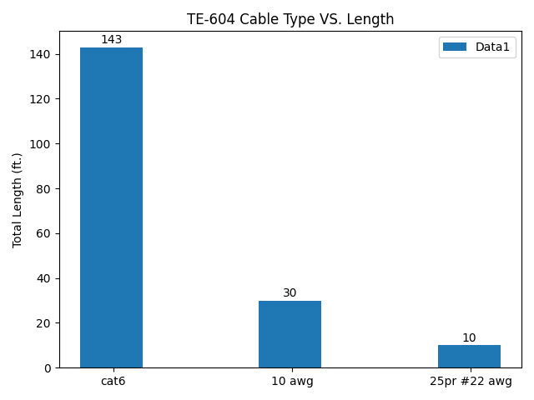

* TE-605 : JAMAICA CENTER PARSONS/ ARCHER STATION below:

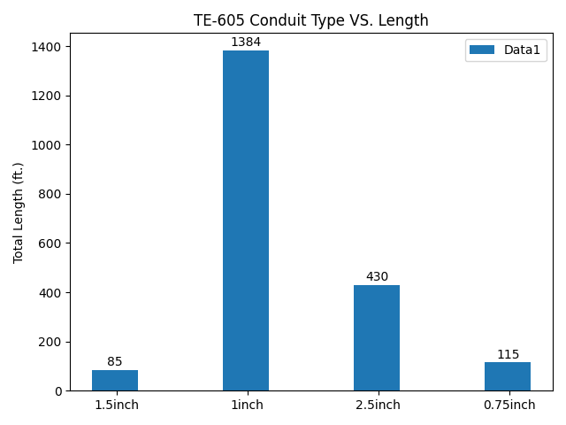

* TE-605 : JAMAICA CENTER PARSONS/ ARCHER STATION below:

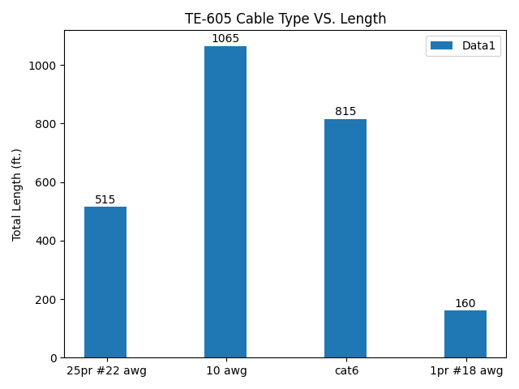

* TE-606 : JAMAICA CENTER PARSONS/ ARCHER STATION below:

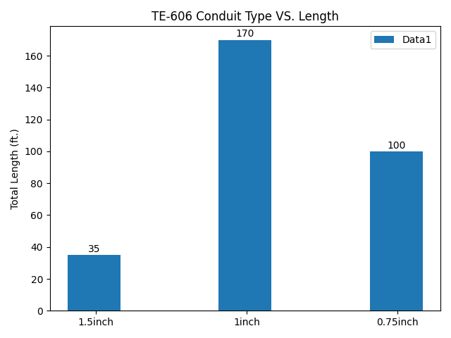

* TE-606 : JAMAICA CENTER PARSONS/ ARCHER STATION below:

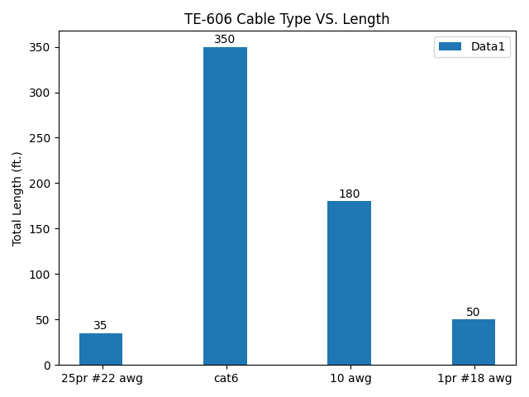

* TE-607 : JAMAICA CENTER PARSONS/ ARCHER STATION below:

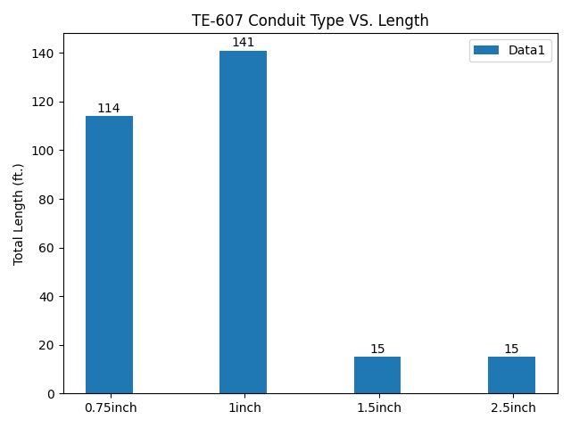

* TE-607 : JAMAICA CENTER PARSONS/ ARCHER STATION below:

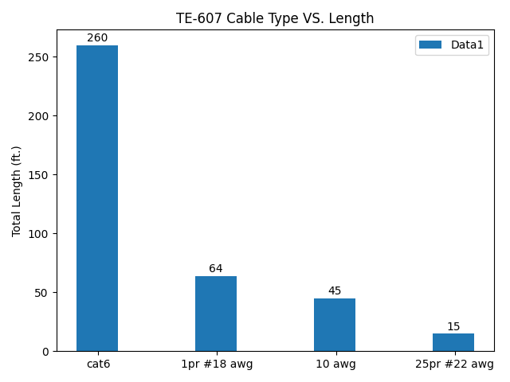

* TE-608 : JAMAICA CENTER PARSONS/ ARCHER STATION below:

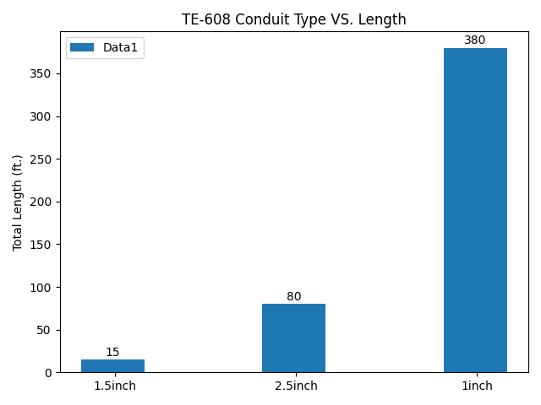

* TE-608 : JAMAICA CENTER PARSONS/ ARCHER STATION below:

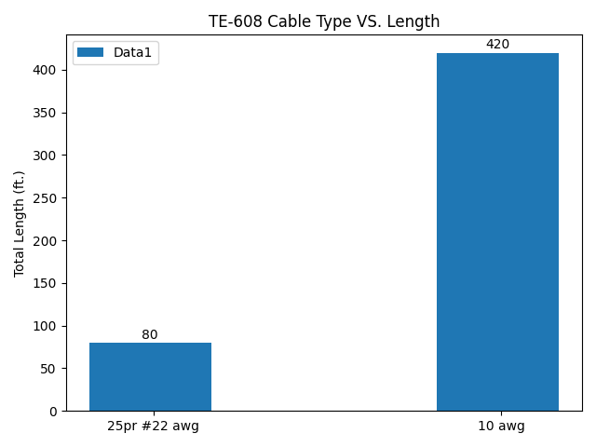

* TE-609 : JAMAICA CENTER PARSONS/ ARCHER STATION below:

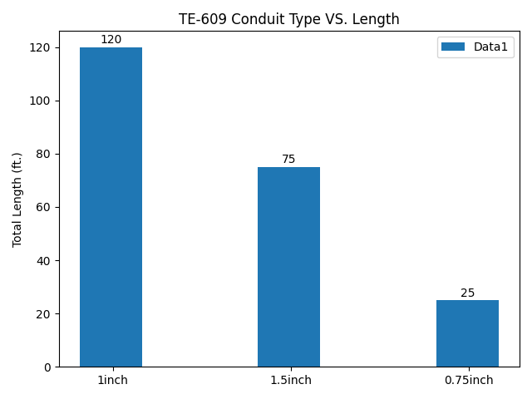

* TE-609 : JAMAICA CENTER PARSONS/ ARCHER STATION below:

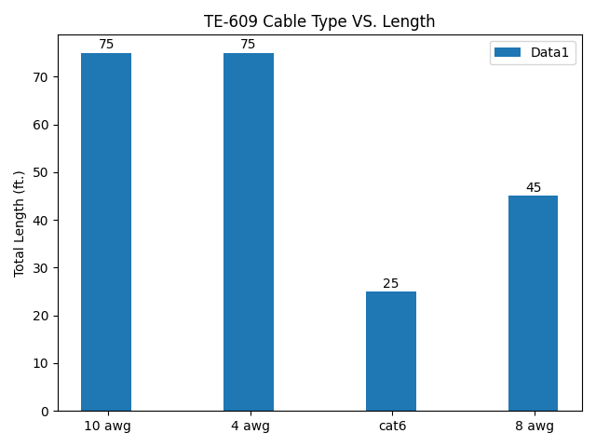

* TE-702 : SUTPHIN BOULEVARD/ ARCHER AVE STATION below:

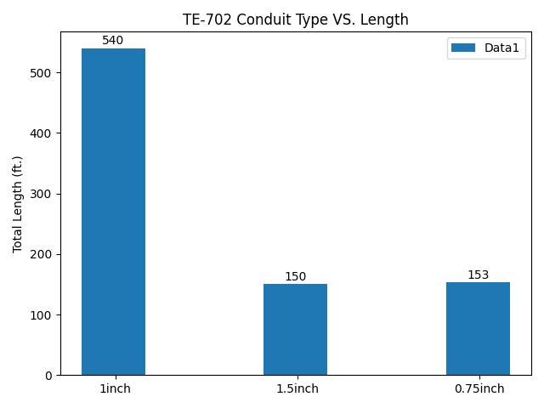

* TE-702 : SUTPHIN BOULEVARD/ ARCHER AVE STATION below:

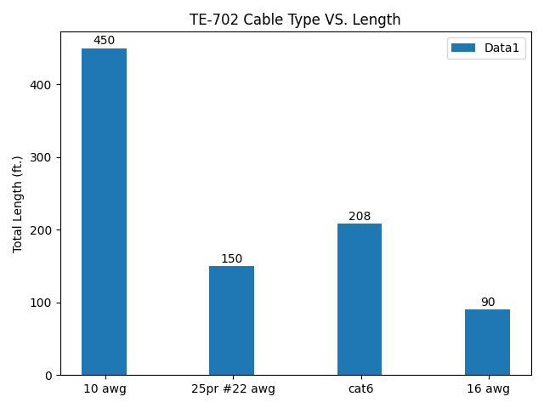

* TE-703 : SUTPHIN BOULEVARD/ ARCHER AVE STATION below:

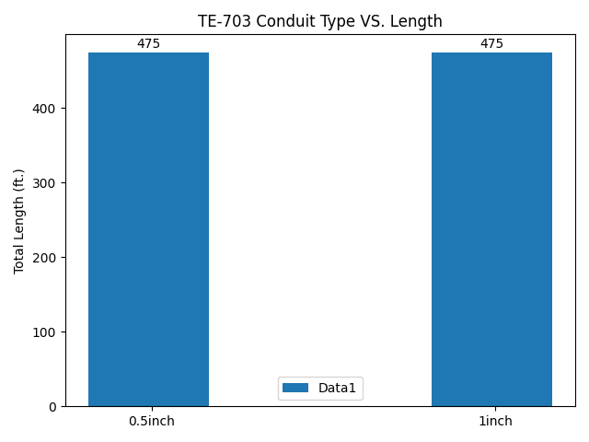

* TE-703 : SUTPHIN BOULEVARD/ ARCHER AVE STATION below:

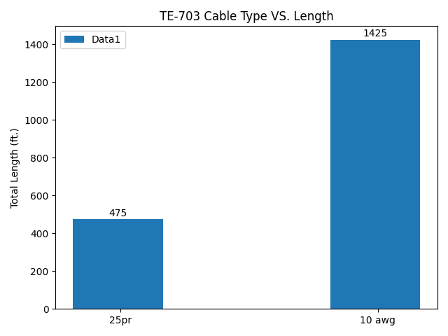

* TE-704 : SUTPHIN BOULEVARD/ ARCHER AVE STATION below:

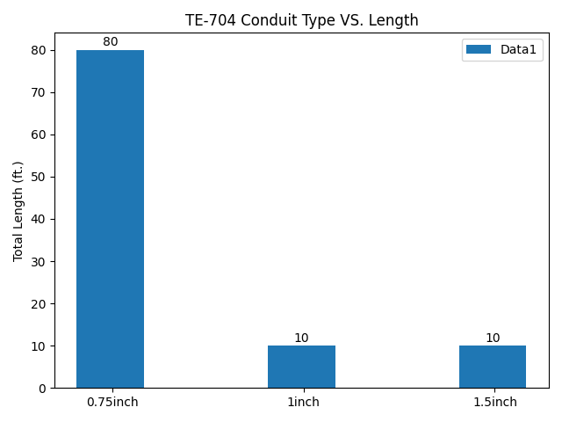

* TE-704 : SUTPHIN BOULEVARD/ ARCHER AVE STATION below:

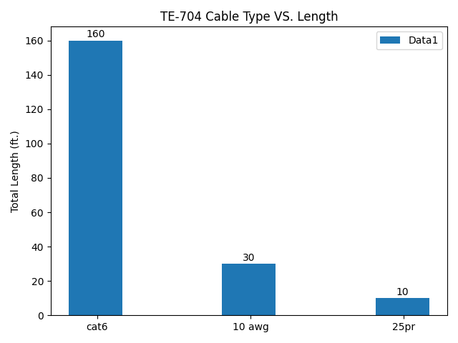

* TE-705 : SUTPHIN BOULEVARD/ ARCHER AVE STATION below:

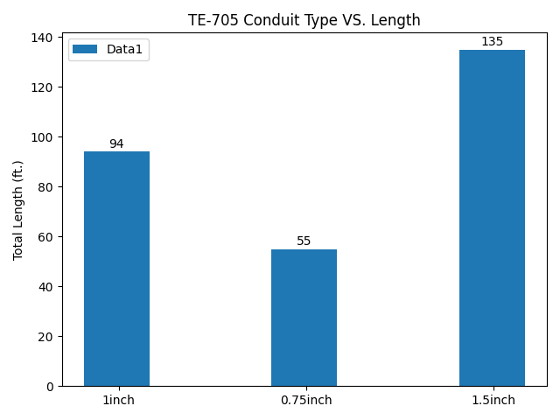

* TE-705 : SUTPHIN BOULEVARD/ ARCHER AVE STATION below:

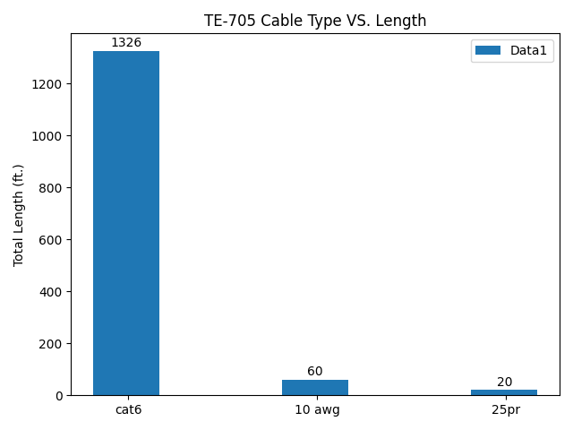

* TE-707 : SUTPHIN BOULEVARD/ ARCHER AVE STATION below:

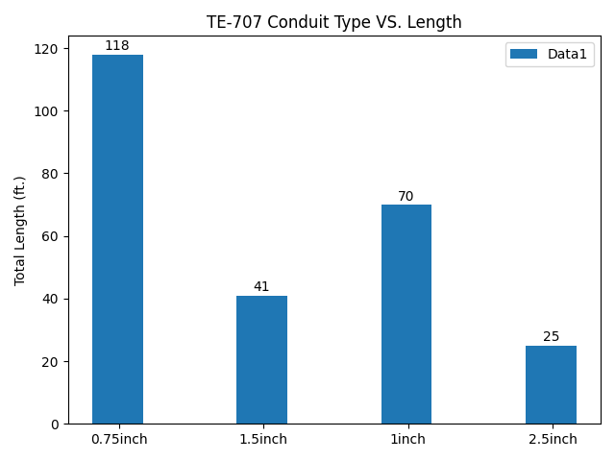

* TE-707 : SUTPHIN BOULEVARD/ ARCHER AVE STATION below:

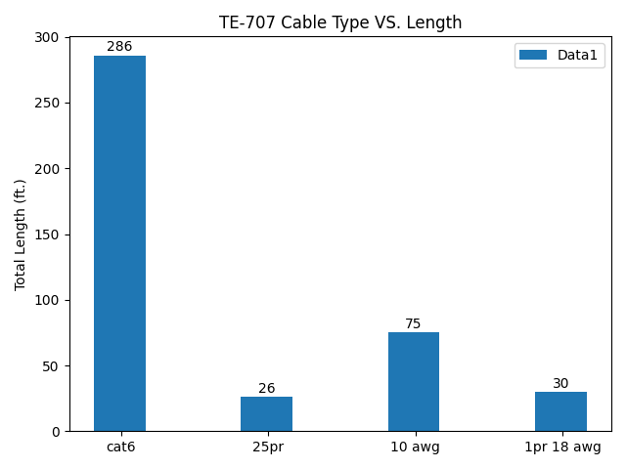

* TE-708 : SUTPHIN BOULEVARD/ ARCHER AVE STATION below:

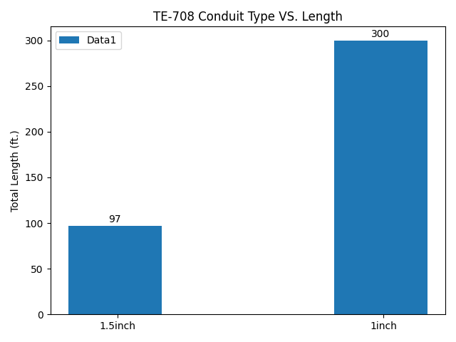

* TE-708 : SUTPHIN BOULEVARD/ ARCHER AVE STATION below:

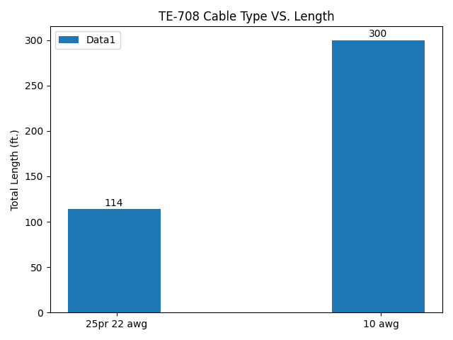

* TE-710 : SUTPHIN BOULEVARD/ ARCHER AVE STATION below:

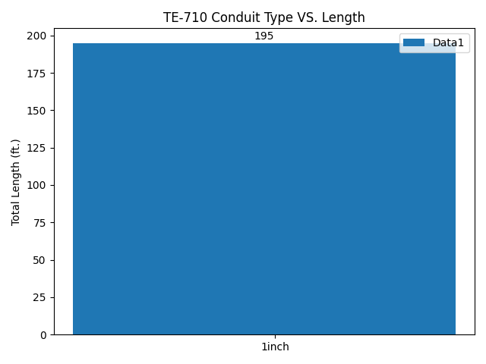

* TE-710 : SUTPHIN BOULEVARD/ ARCHER AVE STATION below:

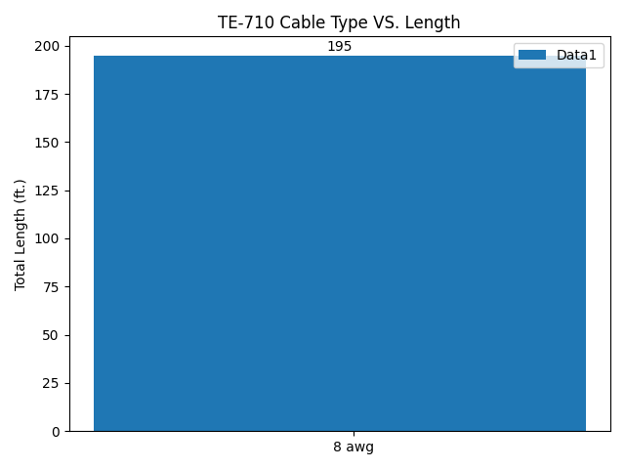

* TF-101 : 207TH STREET STATION below:

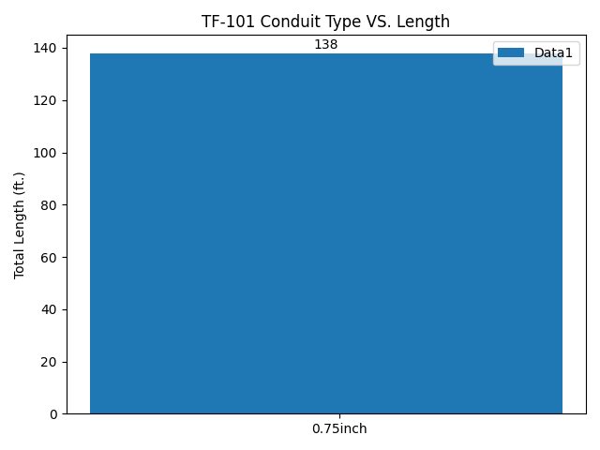

* TF-101 : 207TH STREET STATION below:

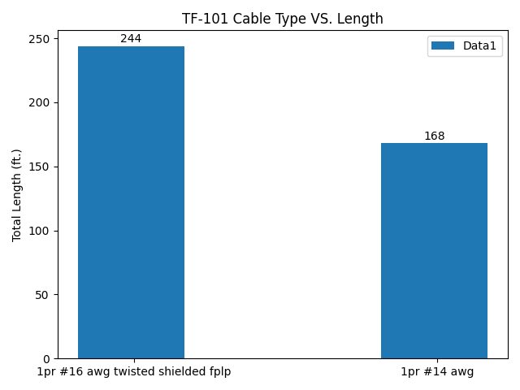

* TF-102 : 207TH STREET STATION below:

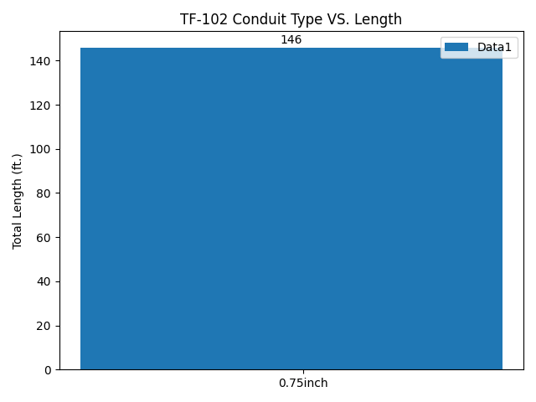

* TF-102 : 207TH STREET STATION below:

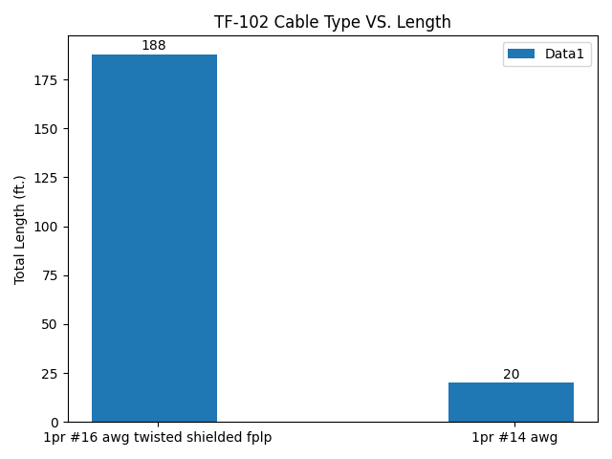

* TF-103 : 207TH STREET STATION below:

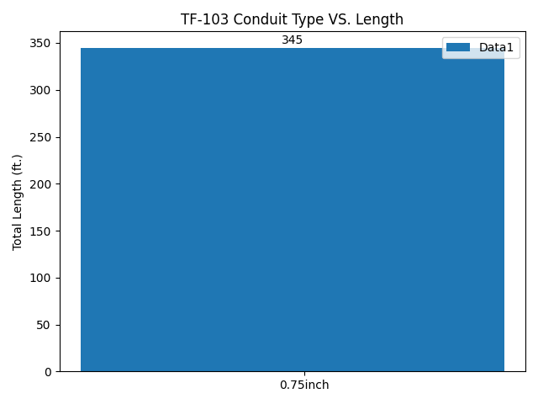

* TF-103 : 207TH STREET STATION below:

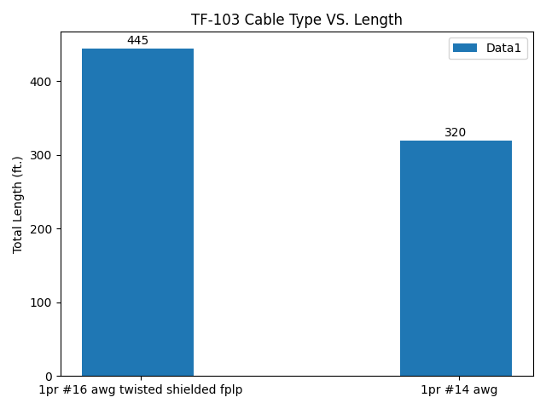

* TF-401 : FLATBUSH AVE STATION below:

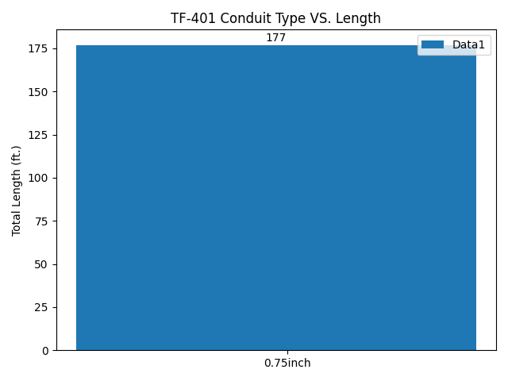

* TF-401 : FLATBUSH AVE STATION below:

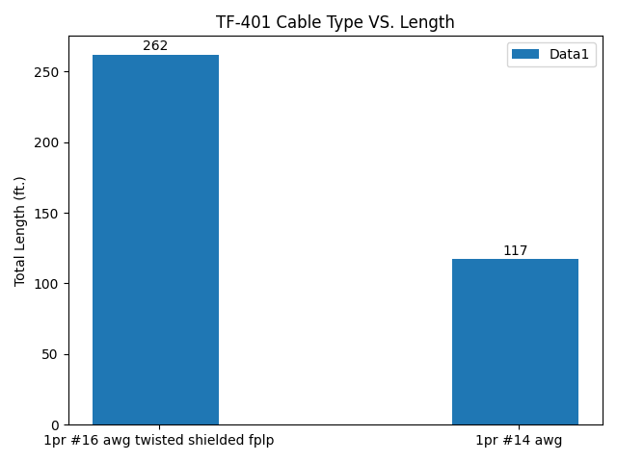

* TF-702 : SUTPHIN BOULEVARD/ ARCHER AVE STATION below:

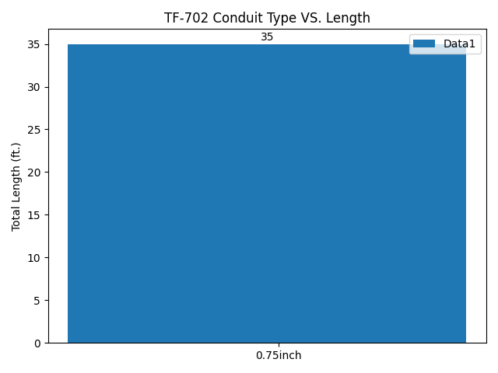

* TF-702 : SUTPHIN BOULEVARD/ ARCHER AVE STATION below:

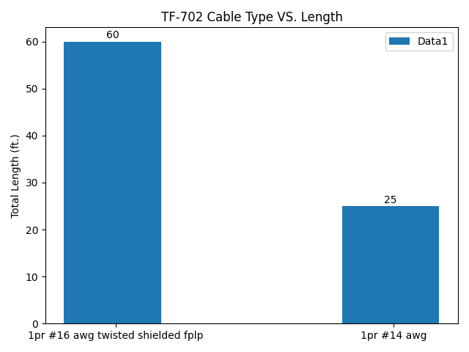

* TF-703 : SUTPHIN BOULEVARD/ ARCHER AVE STATION below:

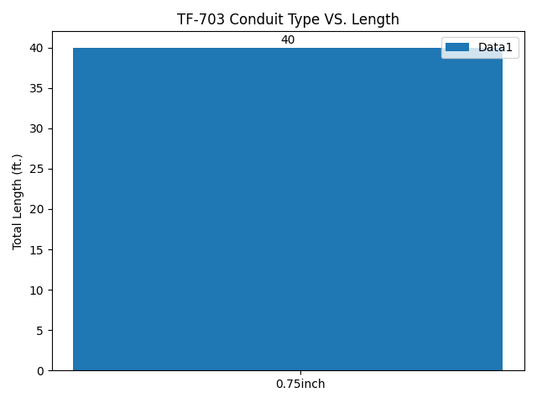

* TF-703 : SUTPHIN BOULEVARD/ ARCHER AVE STATION below:

