11 Elevator Project: Electrical Drawings

* L-106 : 207TH STREET STATION below:

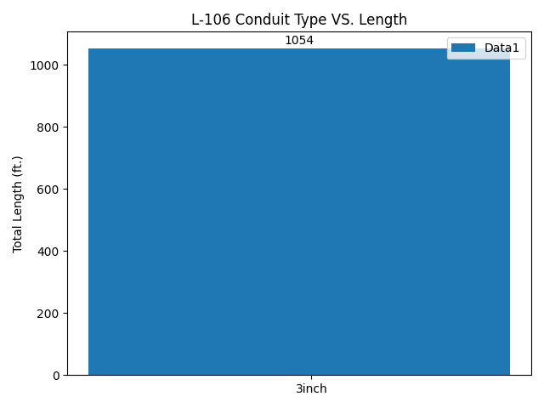

* L-106 : 207TH STREET STATION below:

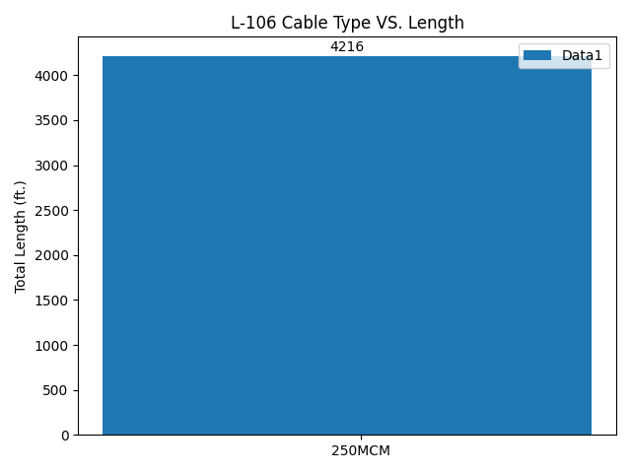

* L-206 : 34TH HERALD SQUARE STATION 6TH AVE (IND) below:

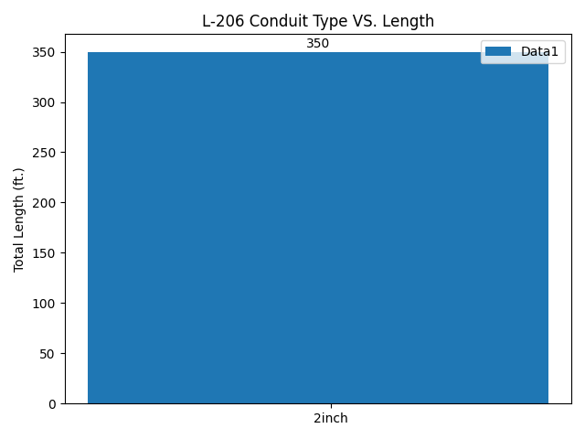

* L-206 : 34TH HERALD SQUARE STATION 6TH AVE (IND) below:

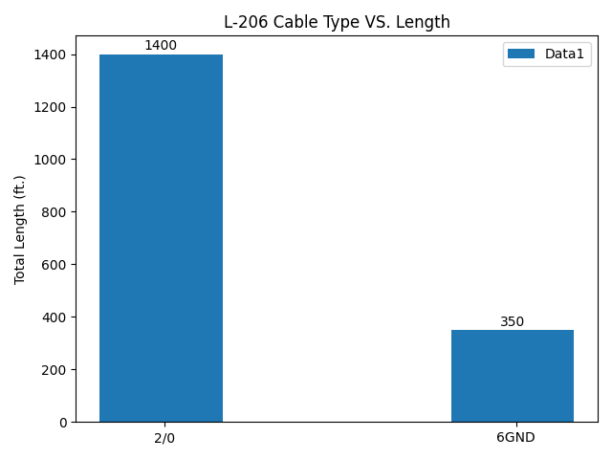

* L-306 : 34TH HERALD SQUARE STATION BROADWAY (BMT) below:

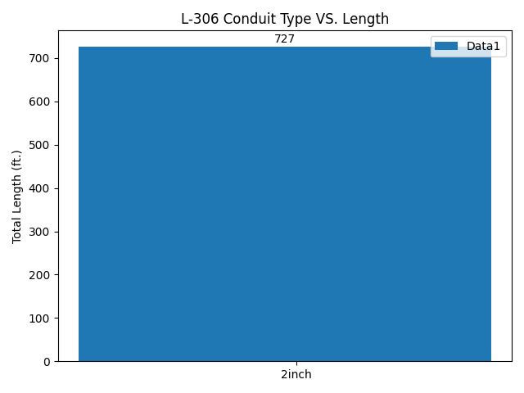

* L-306 : 34TH HERALD SQUARE STATION BROADWAY (BMT) below:

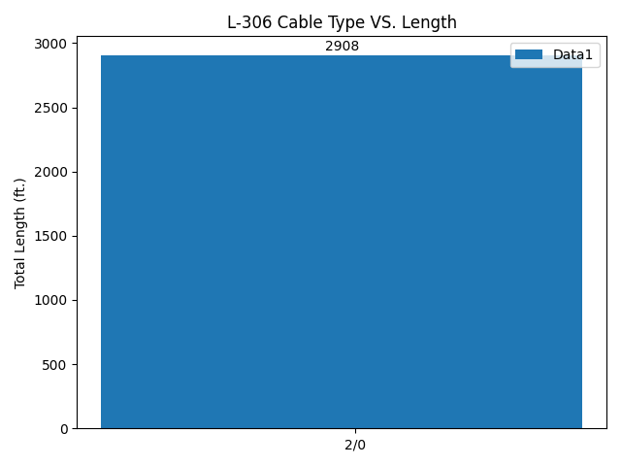

* L-406 : FLATBUSH AVE STATION below:

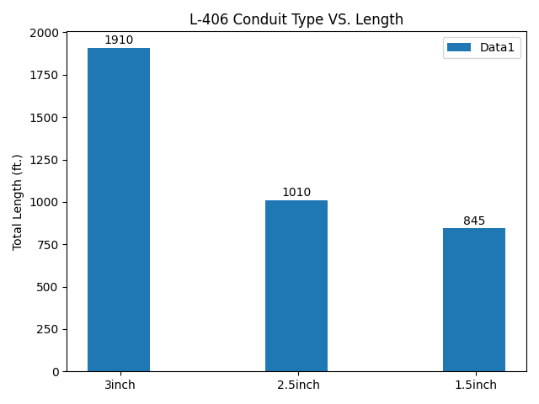

* L-406 : FLATBUSH AVE STATION below:

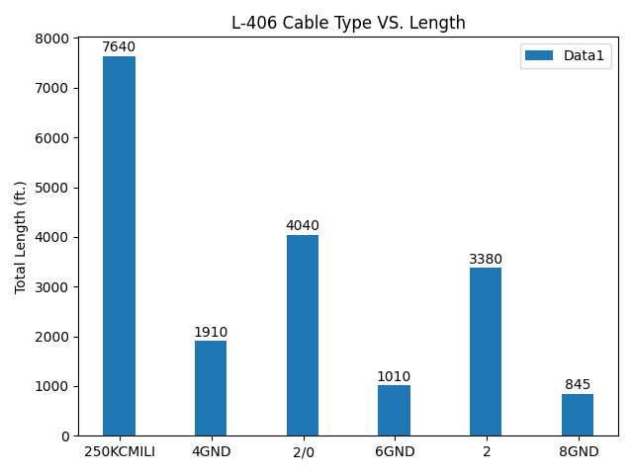

* L-606 : JAMAICA CENTER PARSONS/ ARCHER STATION below:

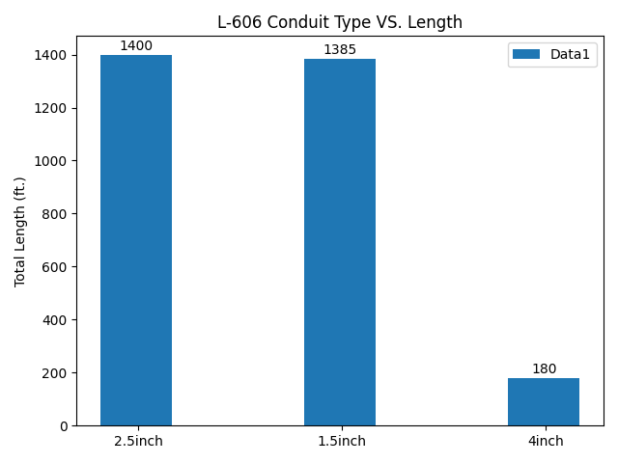

* L-606 : JAMAICA CENTER PARSONS/ ARCHER STATION below:

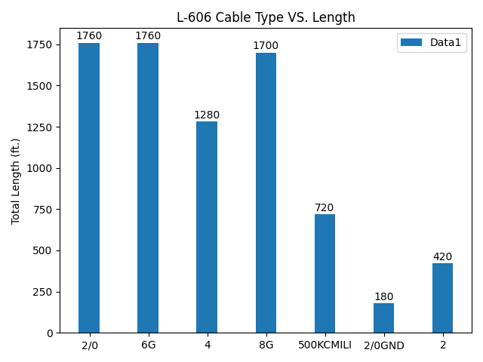

* L-506 : CHURCH AVE STATION below:

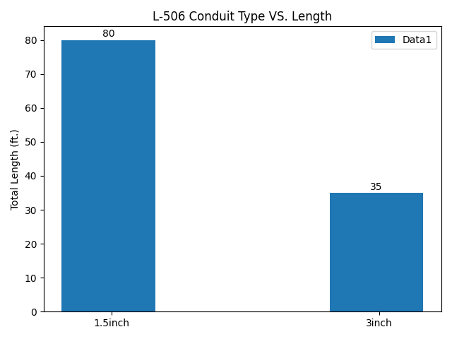

* L-506 : CHURCH AVE STATION below:

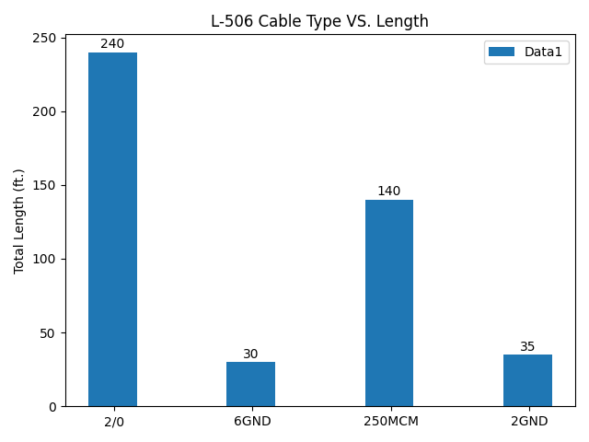

* L-706 : SUTPHIN BOULEVARD/ ARCHER AVE STATION below:

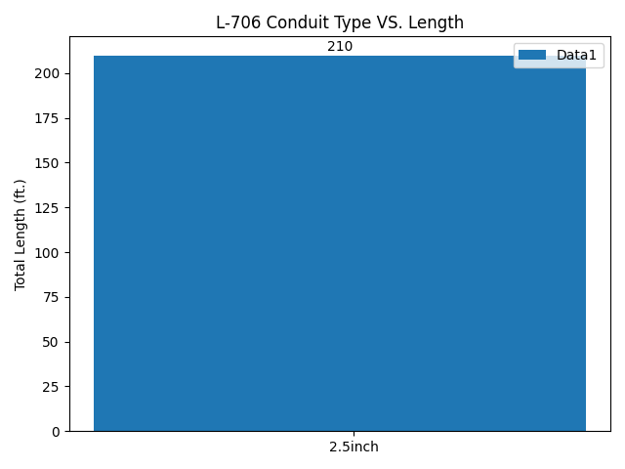

* L-706 : SUTPHIN BOULEVARD/ ARCHER AVE STATION below:

