11 Elevator Project: Fiber Optics Drawings

* FOC-102 : 207TH STREET STATION below:

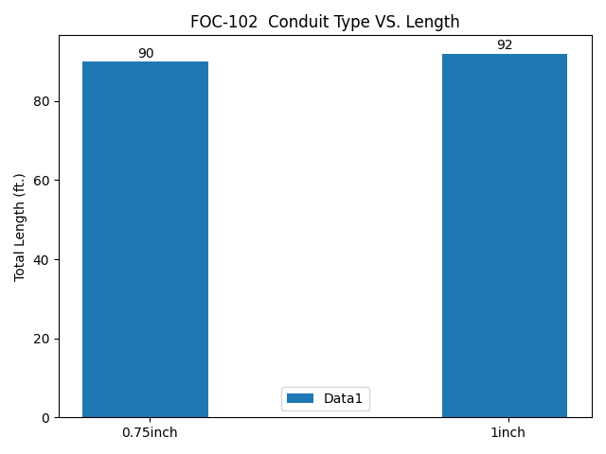

* FOC-102 : 207TH STREET STATION below:

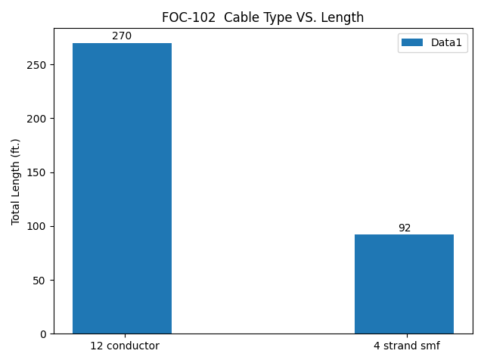

* FOC-103 : 207TH STREET STATION below:

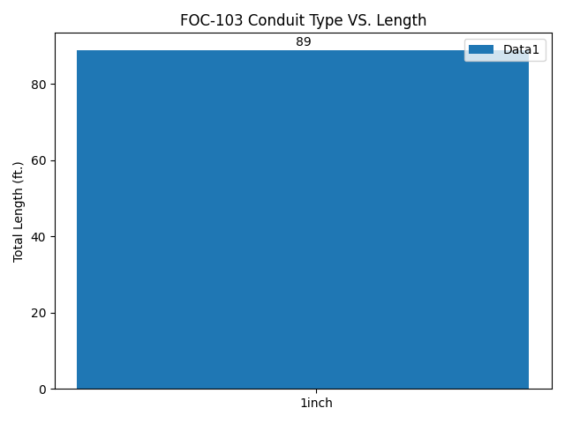

* FOC-103 : 207TH STREET STATION below:

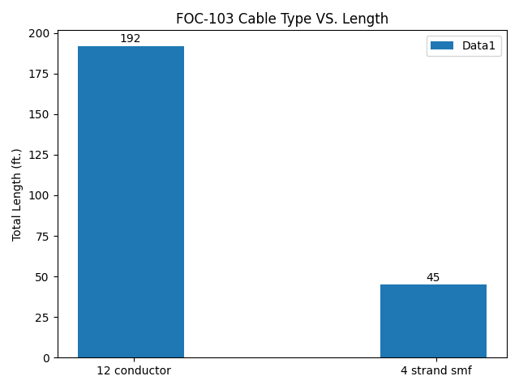

* FOC-104 : 207TH STREET STATION below:

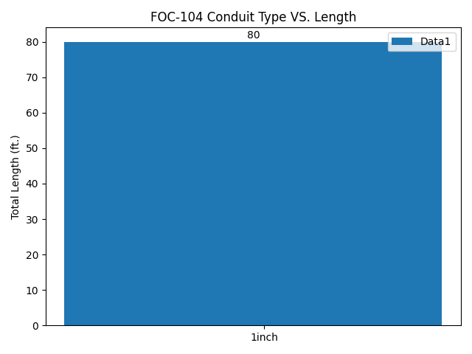

* FOC-104 : 207TH STREET STATION below:

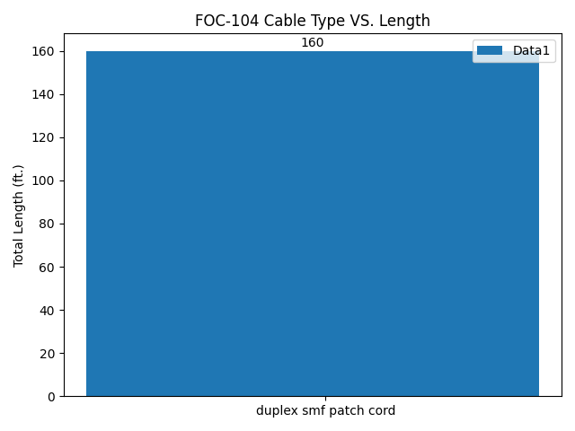

* FOC-202 : 34TH HERALD SQUARE STATION 6TH AVE (IND) below:

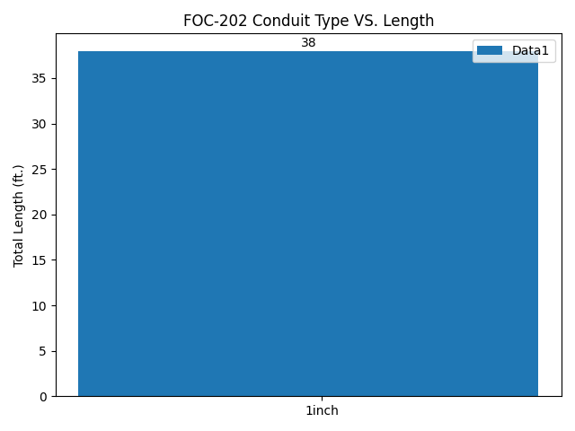

* FOC-202 : 34TH HERALD SQUARE STATION 6TH AVE (IND) below:

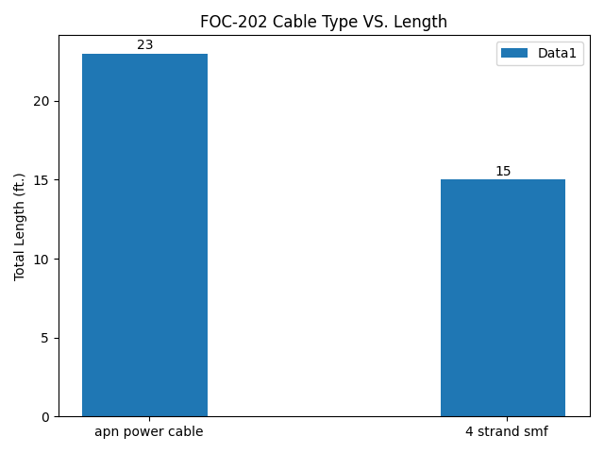

* FOC-203 : 34TH HERALD SQUARE STATION 6TH AVE (IND) below:

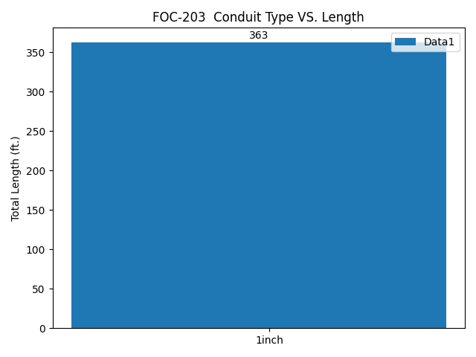

* FOC-203 : 34TH HERALD SQUARE STATION 6TH AVE (IND) below:

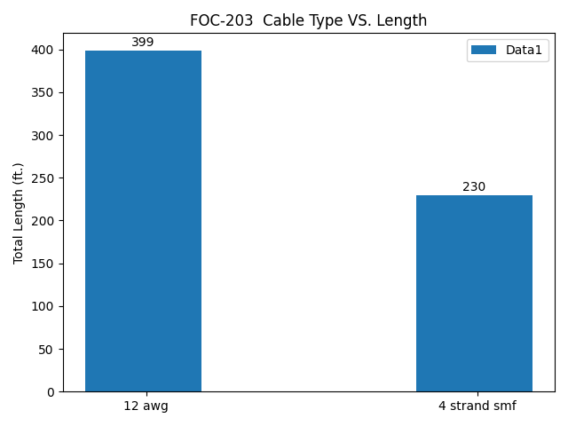

* FOC-204 : 34TH HERALD SQUARE STATION 6TH AVE (IND) below:

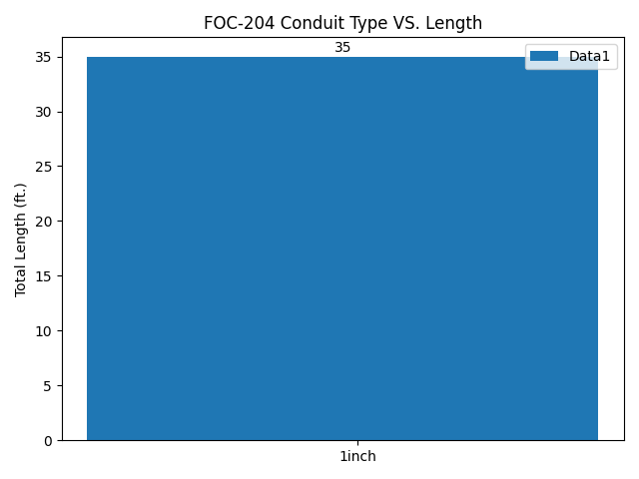

* FOC-204 : 34TH HERALD SQUARE STATION 6TH AVE (IND) below:

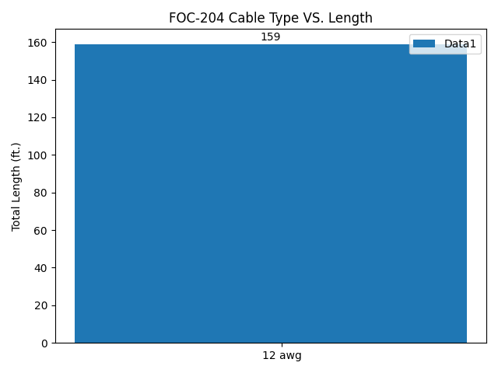

* FOC-205 : 34TH HERALD SQUARE STATION 6TH AVE (IND) below:

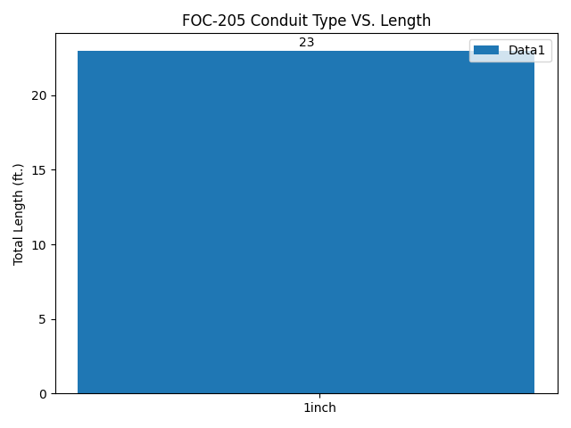

* FOC-205 : 34TH HERALD SQUARE STATION 6TH AVE (IND) below:

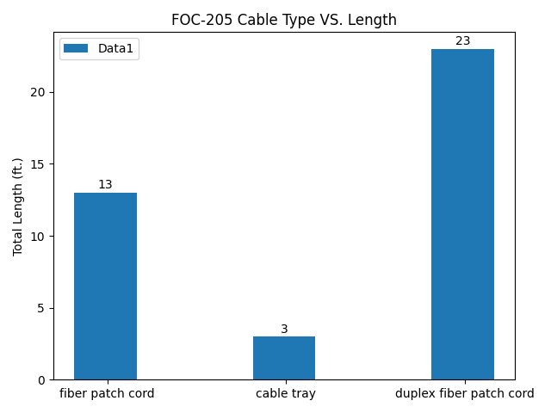

* FOC-302 : 34TH HERALD SQUARE STATION BROADWAY (BMT) below:

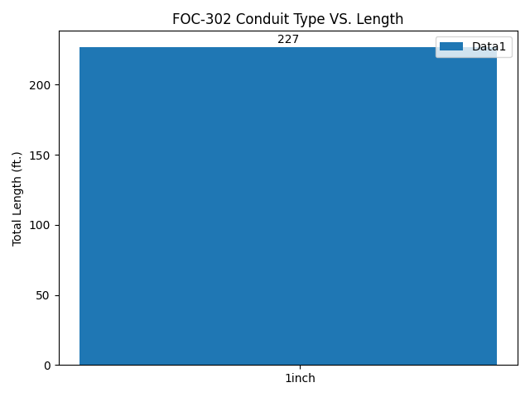

* FOC-302 : 34TH HERALD SQUARE STATION BROADWAY (BMT) below:

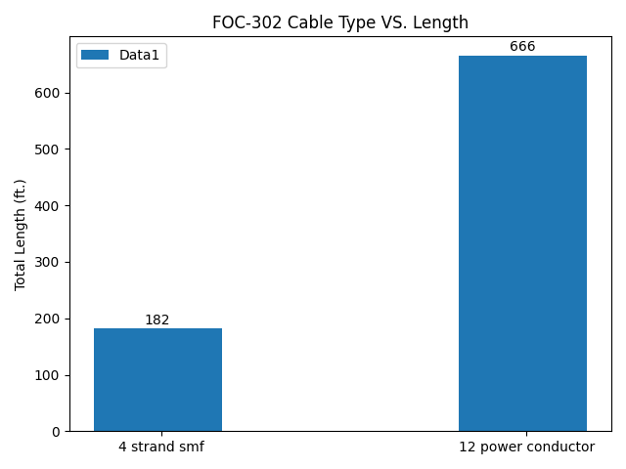

* FOC-303 : 34TH HERALD SQUARE STATION BROADWAY (BMT) below:

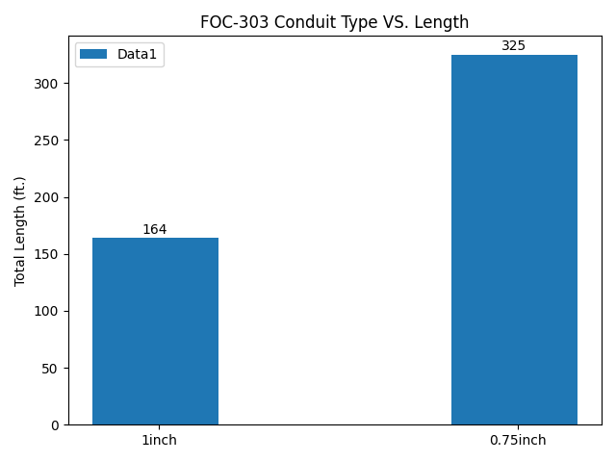

* FOC-303 : 34TH HERALD SQUARE STATION BROADWAY (BMT) below:

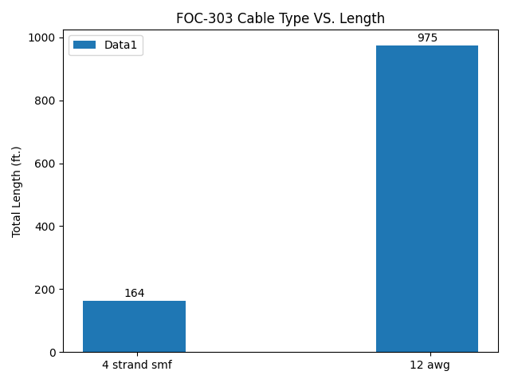

* FOC-304 : 34TH HERALD SQUARE STATION BROADWAY (BMT) below:

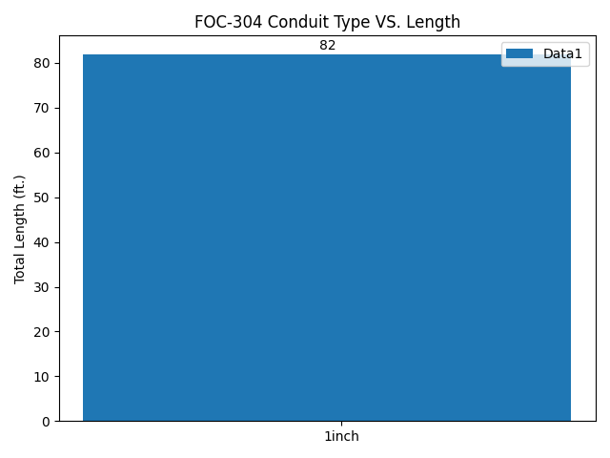

* FOC-304 : 34TH HERALD SQUARE STATION BROADWAY (BMT) below:

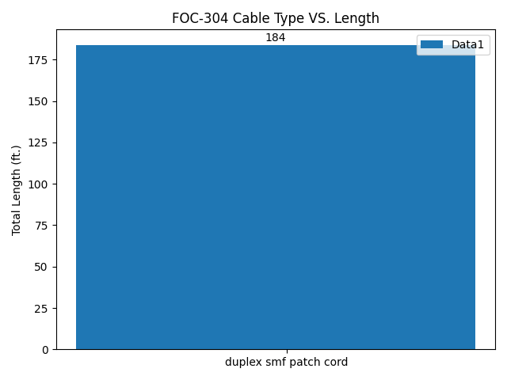

* FOC-402 : FLATBUSH AVE STATION below:

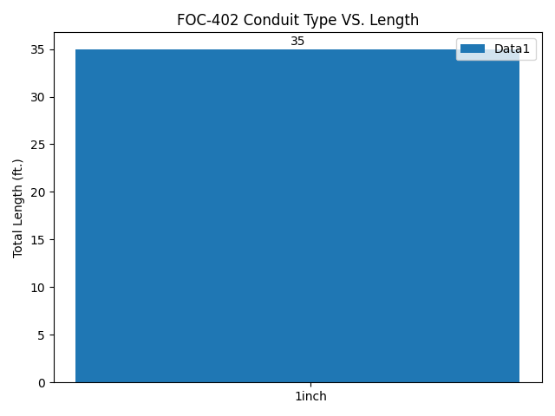

* FOC-402 : FLATBUSH AVE STATION below:

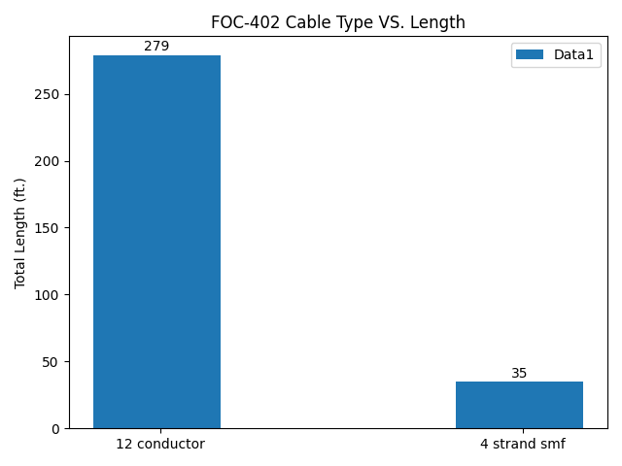

* FOC-502 : CHURCH AVE STATION below:

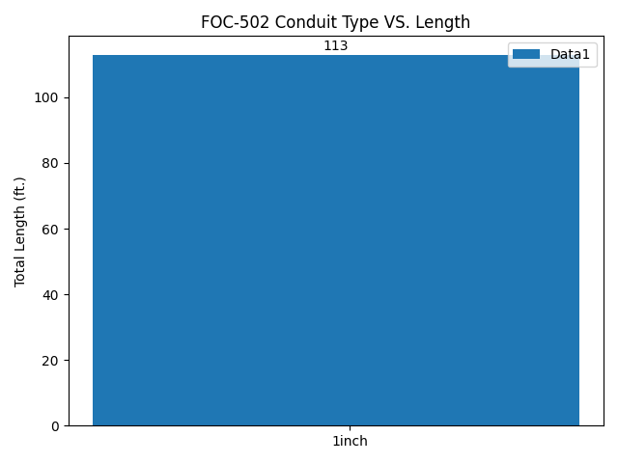

* FOC-502 : CHURCH AVE STATION below:

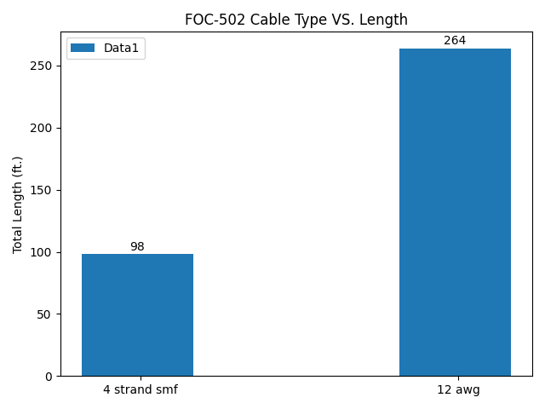

* FOC-602 : JAMAICA CENTER PARSONS/ ARCHER STATION below:

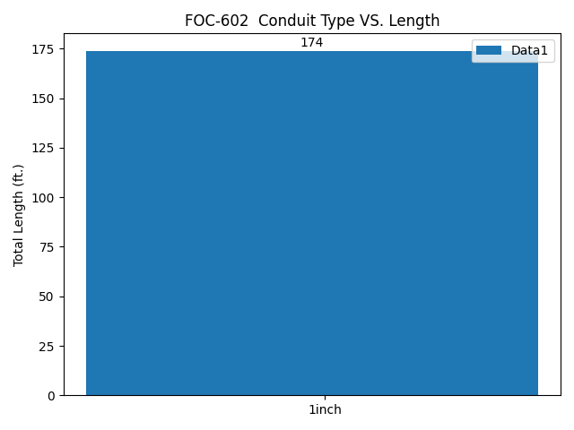

* FOC-602 : JAMAICA CENTER PARSONS/ ARCHER STATION below:

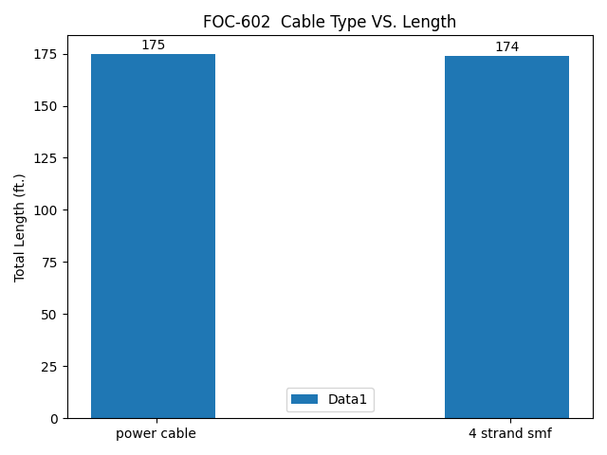

* FOC-603 : JAMAICA CENTER PARSONS/ ARCHER STATION below:

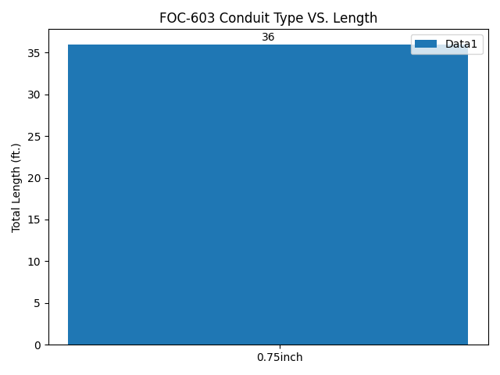

* FOC-603 : JAMAICA CENTER PARSONS/ ARCHER STATION below:

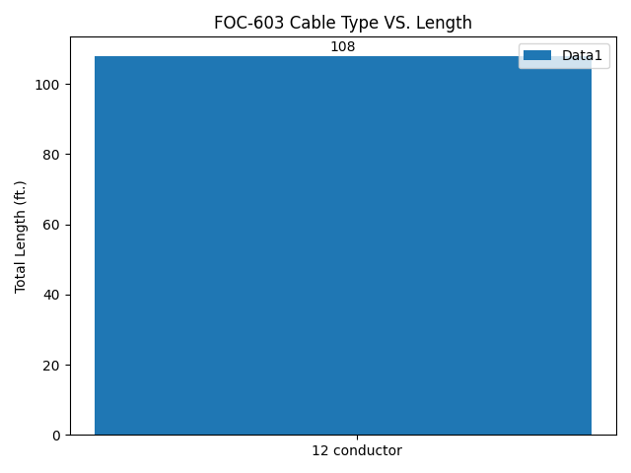

* FOC-604 : JAMAICA CENTER PARSONS/ ARCHER STATION below:

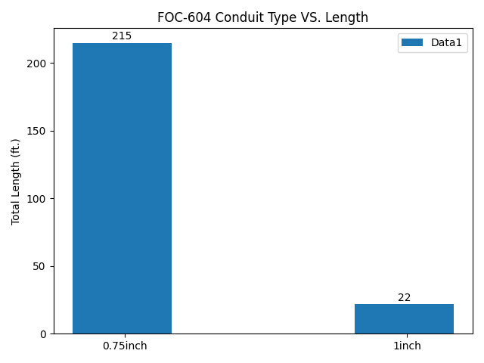

* FOC-604 : JAMAICA CENTER PARSONS/ ARCHER STATION below:

