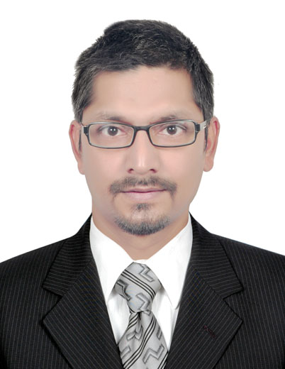

**Deb Prasad Bhattarai**

***Senior PHP Web Developer***

*Port Saeed, Deira, Nearby Clock tower, Dubai*

*UAE* ***Visit Visa*** *valid till October, 2016* [*phpdeveloper.deb@gmail.com*](mailto:phpdeveloper.deb@gmail.com)

Nationality : Nepales[*https://linkedin.com/in/bhattraideb*](https://linkedin.com/in/bhattraideb)

*+971-544355615*

**Objective:**

To obtain a position that is challenging and provides an opportunity to expand practical experience and academic knowledge to become a proficient software engineer.

**Profiles:**

* Six years of experience as a web application developer and team lead.
* Professional experience of requirement analysis, requirement specification and agile methodologies.
* Quick learner and committed to software quality.

**Technical Skills:**

**Programming Language**

* + **Server Side :** PHP (Object Oriented), Python (Intermediate)
  + **Client Side :** HTML, JavaScript, CSS, jQuery/Ajax, Twitter Bootstrap, XML, JSON
* **Others :** C, C++

**Databases :** MySQL, PostgreSQL, SQL Server, Sqllite

**CMS :** Wordpress, Joomla, Drupal

**Framework**

* **PHP :** Codeignitor, Zend Framework
* **Python :** Django, Flask (Intermediate)

**Third Party API :** Google, Facebook Open Graph, HRMS, Payment Gateway

**Webservice :** SOAP, RESTful API

**Operating Systems :** Windows, Linux

**Professional Experience:**

**1- Sonitek Consultancy Pvt. Ltd, New Delhi, India**

***Sr. PHP developer/Team Lead* October, 2014 – June, 2016 (20 Months)**

**Responsibilities and Achievement:**

* Requirement Analysis, Establish technology architecture and Implementation.
* Database Architecture and Designing, Optimization.
* Provide technical related consultation and expertise to colleagues.
* Guide business decisions from technical perspective like performance, reliability, scalability and security.

1. **I Digitex Solutions, New Delhi, India**

***Sr. PHP Developer* October, 2012 – September, 2014 (24 Months)**

**Responsibilities and Achievement:**

* Database Design, develop, test and deploy web applications.
* Ownership of code throughout development, staging, testing and product.
* Develop and enhance existing applications.

1. **CoDe JaMMeR Technologies, New Delhi, India**

***PHP Developer* August, 2010– September, 2012 (26 Months)**

**Responsibilities and Achievement:**

* Modules Development, Test the Application, Fix bugs.
* Third Party API integration.
* Daily reporting to Team Lead.

**I Follow:**

* Analysis and Discussion before start.
* Relational Database Design.
* OOPS/SEO friendly code.
* Design Patterns: MVC, HMVC.
* Test Driven Development/Continuous Integration and Deployment.
* Version controlling using GIT.
* Use of ORM.

**Professional Qualification:**

**Tribhuwan University, Institute of Engineering, Nepal March, 2011**

***B.E. Computer Science and Engineering***

**Licences/Certification:**

**Nepal Engineering Council – 2391’A’ January, 2012**

**Projects worked on:**

[**http://availabletable.sonitekinternational.com/**](http://availabletable.sonitekinternational.com/)

[**http://iwebdirectory.ca/**](http://iwebdirectory.ca/)

[**http://www.globalheadlines.ca/**](http://www.globalheadlines.ca/)

[**http://aventerraestates.com/**](http://aventerraestates.com/)

[**http://www.secretingredient.com.hk/**](http://www.secretingredient.com.hk/)

[**http://btwindia.com/**](http://btwindia.com/)

[**http://www.ijrws.org**/](http://www.ijrws.org/)

[**http://www.milsky.com/**](http://www.milsky.com/)

[**http://canadianpizzaunlimited.ca/**](http://canadianpizzaunlimited.ca/)

[**http://www.globeium.com**/](http://www.globeium.com/)

[**http://www.colourmywall.co.uk**/](http://www.colourmywall.co.uk/)

[**http://www.comfortzoneapartments.com/**](http://www.comfortzoneapartments.com/)

[**http://canadianpizzaunlimited.ca/**](http://canadianpizzaunlimited.ca/)

**Extra curricular activities:**

* **Tex Yarn Recycling Mills Pvt. Ltd., Nepal** **August, 2009 – July, 2010 (12 Months)**

Consignment collaboration

* **Youth and Society(NGO), India March, 2013**

Advisory Board Member (<http://www.yhsw.org/>)

* **VDC, Madhawaliya, Nepal** **April,2015 – May, 2015 (1 Month)**

Mass population profile presentation/assistance during Nepal earthquake 2015 for government compensation.

**Hobbies:**

* Classical Music
* Vipassana Meditation

**References:**

References can be furnished upon request.

Date

Place: **(Deb Prasad Bhattrai)**