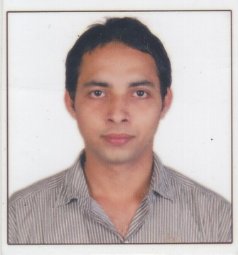

**Name:Madhu sudan panigrahy**

**E-mail:** [chandan92305@gmail.com](mailto:chandan92305@gmail.com)

**Mob:** +91-8080380557, 7021095482

**CAREER OBJECTIVE:**

To peruse a carrier in the concerned area, to this effect my educational base has help mature acumen and conceptual skills in establishing and harmonious working relationship, develop my skill and mature my temperament in the areas of communication **and Seeking career prospect in an organization and to make positive contribution to its growth by aligning my skills sets, efforts, and goals with the goals of organization.**

**PERSONAL SKILLS AND ABILITIES:**

* + Highly motivated and eager to learn new things.
  + Strong motivational and leadership skills
  + Excellent Communication skills in written and verbal both.
  + Ability to work as individual as well as in group.

**COMPUTER SKILLS:**

* MS Office
* Excel
* SQL
* SAP BI/BW
* .NET

**TRAINING:**

* Two months training on SAP BI/W.

**EDUCATIONAL QUALIFICATIONS:**

* Completed B.Tech in Vignan Institute of Technology and Management, Berhampur in Electronics and Telecommunication Engineering with an aggregate of 7.5 CGPA on 2015.
* Completed Intermediate from Kandakhai College of science arts in Science with an aggregate of 52% on 2010.
* Completed Matriculation from N.D high school with an aggregate of 62% on 2007.

**ACHIVEMENTS:**

* Got” Ncc c grade’’ from the Governor of Odisha govt.
* Participated in International Conference on Emerging Trends in Energy and Environment.

**PROJECT UNDERTAKEN:**

* **Xbee based patient monitoring system**
* **Description:**  In this project we use the power supply of 5v to the whole circuit and a heartbeat sensor there which gives out put to the AT89S52.at the same time it will give the temp reading to that perticular module through ADC0804.so we will see the output in the LCD display and same time it will transmit the output.
* **Automated milk processing plant using scada**
* **Description:** here in this project we use a software version called intech 10.8 and software wanderware. it runs only in windows xp.in this project we use some sensors, conveyor belt, pasteurization tank , homogenizer tank and a seperater tank to process the milk.

**HOBBIES:**

* Traveling new places.
* Listening music

**INTRESTS:**

* Learning new Technologies.
* Meeting with new peoples.

**PERSONAL PROFILE:**

* **Name**  : Madhu Sudan Panigrahy
* **Father’s Name** : Mr. Bhaskar Panigrahy
* **Mother’s Name** :Mrs. Gitanjali Panigrahy
* **Gender** : Male
* **Date of Birth** : 30/05/1992
* **Languages Known** : English, Odia, Bangali, Hindi.
* **Address** :S/o Bhaskar Panigrahy, At-Rath Street, Po-Pursotampur

Dist- Ganjam, Odisha, 761018

**DECLARETION**

I hereby declare that above mentioned information is correct up to my knowledge and I bear the responsibility for the correctness of the above mentioned particulars.

**Madhu Sudan Panigrahy**