**KAMARUDHEEN KV**

**Master of Computer Applications (MCA) Mobile: +971568897452**

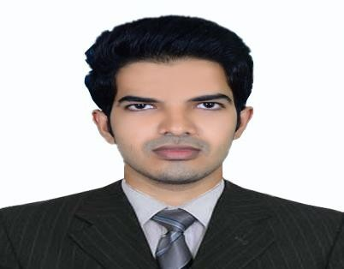

**E-mail :** [**kamarukv@gmail. com**](mailto:kamarukv@gmail.com)

**Sharjah, UAE**

**CAREER OBJECTIVE**

*To work in an organization where I can grow with it, by serving the clients with highest quality and best schedules and by enabling me to apply my technical and creative skills to its full extent by taking challenging assignments.*

**SUMMARY**

➢ A confident and reliable IT Professional with 5 month of experience in IT

industry and resolving any support issues.

* Possess strong knowledge of the software development and IT product design lifecycle.
* Recognized for delivering leading edge solutions that consistent meet complex business requirements.

* Adept in building strong relationships with IT staff, customers, vendors and third party contractors. Solid understand of application development, computer programming and architecture design.

* Streamlined Information Technology department by separating support tasks, creating new leadership positions and implementing best practices.

**KEY SKILLS**

➢ Experience in working as an application developer.

➢ Excellent customer facing skills.

➢ Provide support for Windows, Macintosh and Linux issues.

➢ Capable for configure and test any new hardware and software.

➢ Visit to client sites to help with installation, deployment, and troubleshooting.

➢ Installing the software, operating systems.

➢ Provide Database Support.

**PROFESSIONAL EXPERIENCE**

**Regional IIT, Calicut 15th June 2016 - 14th November 2016**

**Title: Question Answer System (QAS)**

**Role :** Developer Trainee

**Environment :** IIS Server, Technology: C#, ASP.NET, HTML, SQL Server

**Description :** QAS is made for end users to submit their queries and the expert user answer the questions based on the user questions. It has 3 modules

1. End User

2. Expert User

3. Admin

**Responsibilities :** Developed application using C#, ASP.NET, HTML, CSS, SQL Server

SQL Server database creation and manipulation

Functional and Unit Testing. Report documentation

**ACADEMIC DETAILS**

|  |  |  |
| --- | --- | --- |
| **MCA (Master of Computer**  **Applications)**  MES College of Engineering, Kuttipuram | Calicut University  2016 | 69.3% |
| **BSc. Statistics**  Sir Syed College, Taliparamba | Kannur University  2013 | 61.25% |
| **Class XII**  Govt. Higher Secondary School, Kannadiparamba | Kerala State Educational Board  2010 | 77% |
| **Class X**  Govt. Higher Secondary School, Kannadiparamba | Kerala State Educational Board  2008 | 73% |

**LANGUAGES KNOWN**

English, Hindi, Malayalam - Read, Write, Speak

Arabic - Read, Write

**PERSONAL PROFILE**

Date of Birth - 10th October 1992

Age - 24

Marital Status - Single

Nationality - Indian

Visa Status - Visit

**DECLARATION**

I hereby declare that the details furnished above are true to the best of my knowledge and belief.

**KAMARUDHEEN KV**