Mathematics
Sample Paper -2
SECTION A
Question 1
- If A=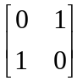 and B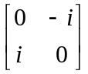 where ‘i’ is the square root of -1, verify that (A+B)²=A²+B².
- Determine the value of ‘k’ for which the equation 12x²-10xy+2y²+11x-5y+k=0 represents two straight lines.
- Show that the straight line x-3y=13 touches the ellipse 16x²+25y²=400. Also find the point of contact.
- If ylogx = x – y, prove that 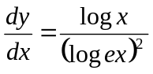.
- Integrate : 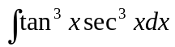
- Find the equation of the ellipse with eccentricity= ½ having focus at (1,-1) and directrix as 3x-4y=1.
- Three cards are drawn with replacement from a well shuffled pack of cards. Find the probability that the cards are a king, a queen and a jack.
- If a is an element of a Boolean Algebra , prove that a+a=a.
- If p and q are complex cube roots of unity, then prove that (1+p)(1+q)(1+p²)(1+q²)=1.
- Solve the following differential equation: 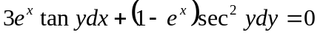
Question 2
- Prove using the properties of determinants that: 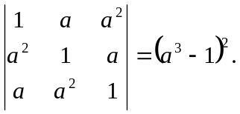
- If A=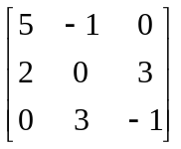, find the inverse of A and hence solve the following system of linear equations: 5x - y = - 7, 2x + 3z = 1, 3y - z = 5.

Question 3
- A,B and C represent switches in an ON position and A’,B’ and C’ represent switches in OFF position. Construct a switching circuit representing the polynomial [B(B+A)][C(B’+C)]. Use Boolean algebra to show that the circuit is equivalent to a switching circuit in which when B and C are on, the lights are on. Construct the simplified switching circuit.
- Find the equation of the hyperbola with the vertices(0,+4) and foci (0,+5).
Question 4
- If 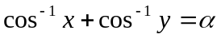then prove that 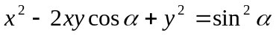.
- Find 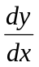if 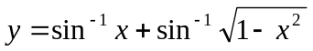
Question 5
- Verify Rolle’s theorem for the function 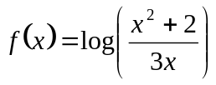in [1,2].
- Show that the rectangle of maximum area that can be inscribed in a circle of radius r is a square of side 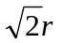.
Question 6
- Evaluate: 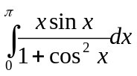.
- Find the area of the region bounded by the curve x²=4y and the straight line x = 4y – 2.
Question 7
- The mathematical aptitude score (MAS) of ten computer programmers, with job performance rating (JPR) is given below. Calculate Karl Pearson’s coefficient of correlation between MAS and JPR.
Person | A | B | C | D | E | F | G | H | I | J
MAS | 2 | 5 | 0 | 4 | 3 | 1 | 6 | 8 | 7 | 9
JPR | 8 | 16 | 8 | 9 | 5 | 4 | 3 | 17 | 8 | 12

- The following table shows the sales and advertisement expenditure of a firm:
 | Sales ( Rs. In crores) | Advertisement Expenditure (Rs. In crores)
Mean | 40 | 6
Standard | 10 | 1.5
Coefficient of correlation= r =0.9 .
Estimate the likely sales for a proposed advertisement expenditure of RS. 10 crores.

Question 8
- A problem in mathematics is given to three students whose chances of solving it are 1/2, 1/3, 1/4. What is the probability that the problem is solved.
- A purse contains two silver and four gold coins. A second purse contains four silver and three gold coins. If a coin is taken out at random from one of the two purses, what is the probability that it is a silver coin.

Question 9
- Using Demoivre’s theorem, find the least value of n for which the expression 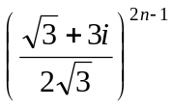is purely real.
- Solve the following differential equation: 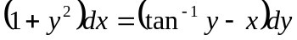

SECTION B
Question 10
- Find the vector equation of the plane passing through the point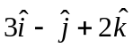 and parallel to the lines 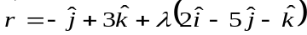 and 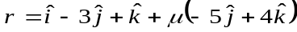 .
- Find the coordinates of the point where the line through the points (5, 1, 6) and (3, 4, 1) crosses the yz-plane.
Question 11
- If and are unit vecors such that 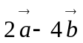and 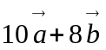are perpendicular to each other, find the angle between vectors and .
- The vectors 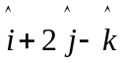, 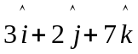and 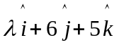 are coplanar. Find the value of .
Question 12
- In four throws of a pair of dice, what is the probability of throwing a doublet (i) exactly twice (ii) at least twice.
- For A, B and C the chances of being selected as the manager of a firm are 4:1:2 respectively. The respective probabilities for them to introduce a radical change in marketing strategy are 0.3, 0.8 and 0.5 respectively. If the change does takes place, find the probability that it is due to the appointment of B.

SECTION C
Question 13
- If the banker’s discount is in excess of the true discount by 1/25 of it in 146 days,then what is the rate percenr? Also find the face value of the bill if banker’s gain is Rs 100?
- A man retires at the age of 62 years and his employer gives him pension of Rs 1000 per month for the rest of his life. Reckoning his expectation of life to be 10 years and the interest rate is at 5% p.a., what single sum is equivalent to his pension at the time of his retirement?

Question 14
- A furniture dealer deals in only two items---- tables and chairs. He has Rs 10000 to invest and a space to store atmost 60 pieces. A table costs him Rs 500 and a chair costs him Rs 100. He can sell a table at Rs 550 and a chair at Rs 115. Assume that he can sell all the items that he buys.
- Formulate this problem as an L.P.P. so that he maximizes his profit.
- Draw the feasible region on a graph and clearly mention the corner points.
- Solve this problem using corner point method.
- A bicycle manufacturer produces x units per week at a fixed cost of Rs 2500 and variable cost of Rs (x+78) per unit. He is a monopolist and the demand function for his product is x= (600-p)/8, where the price is Rs p per unit. Show that the maximum profit is obtained when 29 units are produced per week. Also find the monopoly price.

Question 15
- Calculate the changes in the cost of living figures for the year 2009 as compared with the year 2008.
Items | Food | Rent | Clothing | Fuel | Miscellaneous
Prices (2009) | 250 | 60 | 80 | 50 | 200
Prices (2008) | 270 | 80 | 100 | 50 | 250
- Daily absence from a school during 3 weeks is recorded as follows:
 | Monday | Tuesday | Wednesday | Thursday | Friday
Week 1 | 23 | 28 | 21 | 33 | 40
Week 2 | 38 | 52 | 43 | 43 | 63
Week 3 | 52 | 54 | 61 | 61 | 51
Calculate 5 day moving averages and plot them on a graph paper.

