Figure 1. These are uninformed model predictions: Gaussian process regression, exponential and positive polynomial regression (only statistically (AIC-based) best fits selected). They know nothing about epidemics but are useful baselines: consistent with UK continuing to 1000 deaths per day. Credible? No reason to suspect they are, or not. Just baselines.

Figure 2. Two epidemic-informed but approximate multi-logistic regressions: blue line is with no isolation policy as of tomorrow, black is on the current policy. Latter showing 7,000-9,000 UK deaths (95% confidence interval). This model correctly predicted the top of Italy and Spain 10 days ago but miss-predicted UK at the same time at circa 3000 deaths. (But that was necessarily on 10 fewer datapoints.)

Figure 3. My optimal epidemic-aware model: this hindcasts data with greatest likelihood using minimal SIR equations. Predicting 15-17,000 UK total deaths.

Figure 4. This is a model-free data reduction technique (akin to machine learning): Bayesian singular value decomposition aggregates ‘optimally’ (in a probabilistic / Hilbert space sense) all current death data to extrapolate forwards in time Predicting circa 10,000 total UK deaths .

Figure 5. This is the same as Figure 4 but excludes all China data. The latter produced very small death statistics in a very large country, this could skew the analysis of Figure 4 downwards so we pretend China never happened and re-run the analysis. This increases expected UK deaths to circa 12,000.

Figure 6. This plots per capita deaths across Europe per day: here a flatline means exponential increase in deaths per day. Most EU countries closely follow exponential decrease in this measure which is consistent with single-epidemic SIR theory. The UK may be hanging on to a flatline and thus still increasing exponentially as are others (France too, not shown) but not Sweden. (This may be an indicator of multiple epidemic seedings, China does not flatline at all from its single epidemic.)

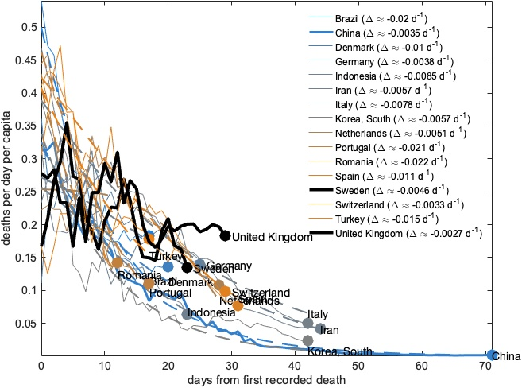

Figure 7. SIR epidemic theory and data to support Figure 6. The UK has a ‘fat middle’ that China did not have. Thus the epidemic has grown exponentially for longer here than there; US even more so, France too. More theory is needed (spatial SIR likely address this) but this may be consistent with multi-city, re-seeded epidemics.

