**Running the example**

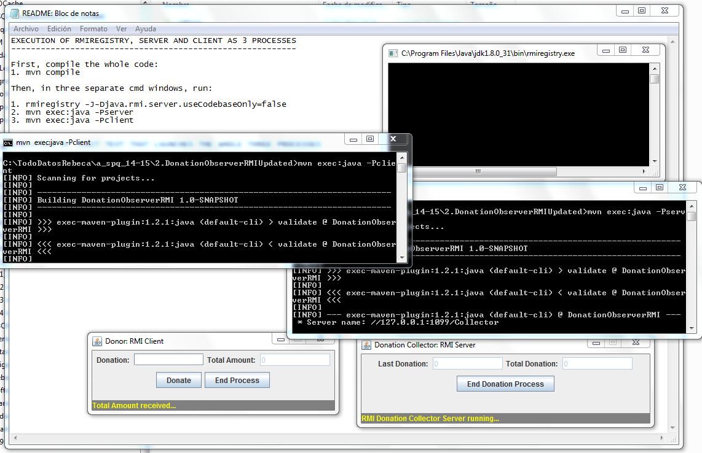

**Mvn test**

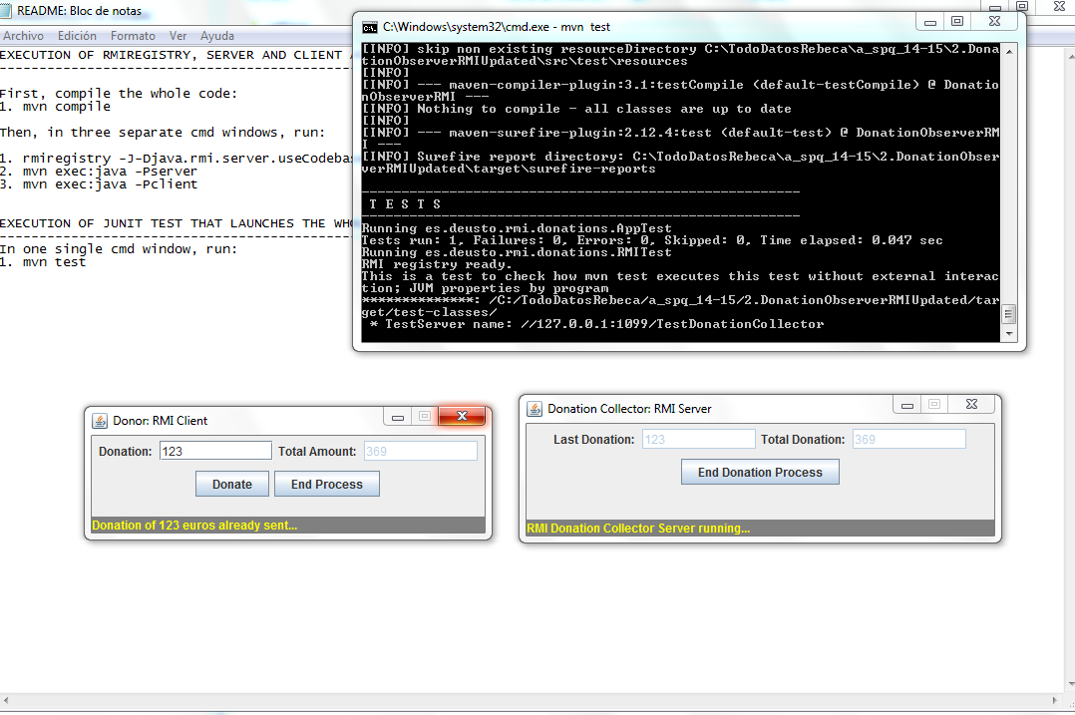

Note: this test will crash, but because it is a ‘fake’ test which uses a GUI and the direct involvement of the end-user. This means that the way to stop the test is calling a System.exit(0), and this is not supported but the Surefile library.

**http://maven.apache.org/surefire/maven-surefire-plugin/faq.html**

**Surefire fails with the message "The forked VM terminated without properly saying goodbye".**

Surefire does not support tests or any referenced libraries calling System.exit() at any time.