Descriptive Analysis of Automobile Insurance Fraud Data

1. Data Source
The analysis uses the local proprietary files train_model_dataset.parquet (444,074 training observations) and test_model_dataset.parquet (111,020 test observations). The grouped files contain 144 approved leakage-free features. Fraud/non-fraud comparisons use the training set only. The test target is not loaded; test features are used only for the distribution comparison.
The proprietary data are not included in the public repository. Each authorised team member must obtain the two Parquet files separately and place them in the local data folder.

2. Variable Names and Units
English names are used in the narrative and figures. Result tables retain the original Spanish variable code for traceability. Technical codes such as ine_008 are retained and paired with their English description. Original category values remain in Spanish because they may have company-specific meanings.
English name | Original variable | Reporting unit
Policy tenure | antiguedad_poliza | Years
Notification delay | dias_notificacion | Days

Both variables are described as days in the variable dictionary, but every supplied value becomes a whole number of days when multiplied by 365.25. This shows that the columns are stored as fractions of a year. Policy tenure is presented in years, while notification delay is converted back to days. The modelling values are not changed.

3. Dataset Summary
Metric | Result
Training observations | 444,074
Approved features | 144
Numeric/count features | 114
Categorical/code/binary features | 30
Missing cells | 0
Duplicate full rows | 3,503
Fraud observations | 1,860
Fraud prevalence | 0.4188%
Non-fraud to fraud ratio | 237.7:1

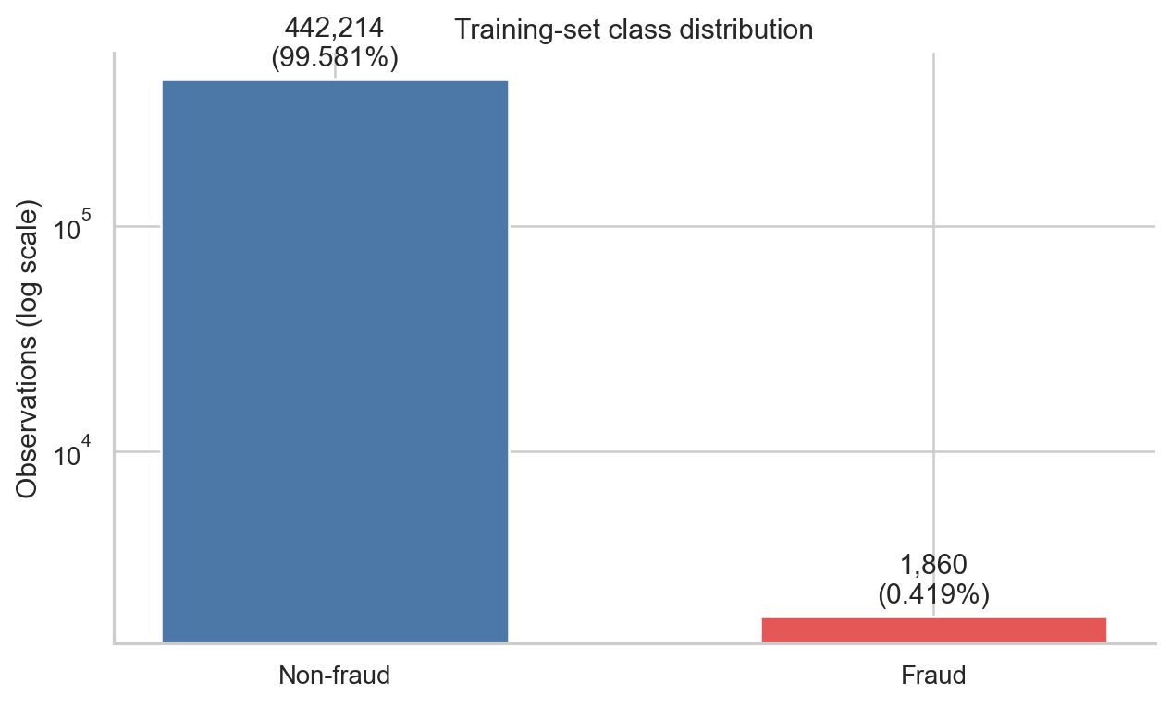
Figure 1. Training-set class distribution.
The training set contains 1,860 fraud cases (0.4188%), equivalent to approximately 238 non-fraud cases for every fraud case. Accuracy alone would therefore be misleading for model evaluation.

4. Data Quality
Variable | Review item | Records | Share (%)
pesomaxautorizado | Zero or negative value; review as a possible not-applicable code | 325,853 | 73.378
puertas | Non-integer number of doors | 42,858 | 9.651
valorvehiculofabrica | Zero or negative value; review as a possible not-applicable code | 32,370 | 7.289
valorvehiculomercado | Zero or negative value; review as a possible not-applicable code | 1,875 | 0.422
edad_conductor1 | Driver age outside 16-100 years | 792 | 0.178
pesovehiculo | Zero or negative value; review as a possible not-applicable code | 650 | 0.146
cilindrada | Zero or negative value; review as a possible not-applicable code | 342 | 0.077
dias_notificacion | Notification delay longer than 365 days | 331 | 0.075
puertas | Number of doors outside 1-6 | 77 | 0.017
potencia | Zero or negative value; review as a possible not-applicable code | 24 | 0.005
anyomatricula | Registration year outside 1900-2026 | 10 | 0.002
antiguedad_poliza | Negative policy tenure | 6 | 0.001

The largest issues are 325,853 zero maximum-authorised-weight values (73.38%), 42,858 non-integer door counts (9.65%), and 32,370 zero insured-vehicle values (7.29%). These may be structural not-applicable codes. There are also 331 notification delays longer than one year, 10 registration years outside 1900-2026, and 6 negative policy-tenure values. The lowest policy tenure equals -37 days after conversion.

5. Numeric Variables

Central tendency
English name | Original variable | Unit | Mean | Median
Previous claims count | actasvariacion |  | 1.97 | 1.00
Vehicle registration year | anyomatricula | year | 2,005.42 | 2,005.00
Vehicle market value | valorvehiculomercado | currency units | 21,265.24 | 19,556.00
Engine power | potencia | hp | 103.82 | 100.00
Driver age | edad_conductor1 | years | 47.31 | 47.20
Policy tenure | antiguedad_poliza | years | 3.28 | 1.98
Notification delay | dias_notificacion | days | 5.91 | 2.00

Range and quartiles
English name | Q1 | Q3 | Min | Max
Previous claims count | 1.00 | 3.00 | 0.00 | 66.00
Vehicle registration year | 2,002.00 | 2,009.00 | 2.00 | 2,023.00
Vehicle market value | 14,574.54 | 25,260.00 | 0.00 | 2,141,994.00
Engine power | 75.00 | 120.00 | 0.00 | 776.00
Driver age | 36.92 | 56.84 | 3.69 | 101.58
Policy tenure | 0.77 | 4.42 | -0.10 | 45.33
Notification delay | 1.00 | 4.00 | 0.00 | 4,744.00

Driver age averages 47.31 years. Policy tenure is right-skewed, with a median of 1.98 years and a mean of 3.28 years. Notification delay has a median of 2 days, a mean of 5.91 days, and a maximum of 4,744 days.
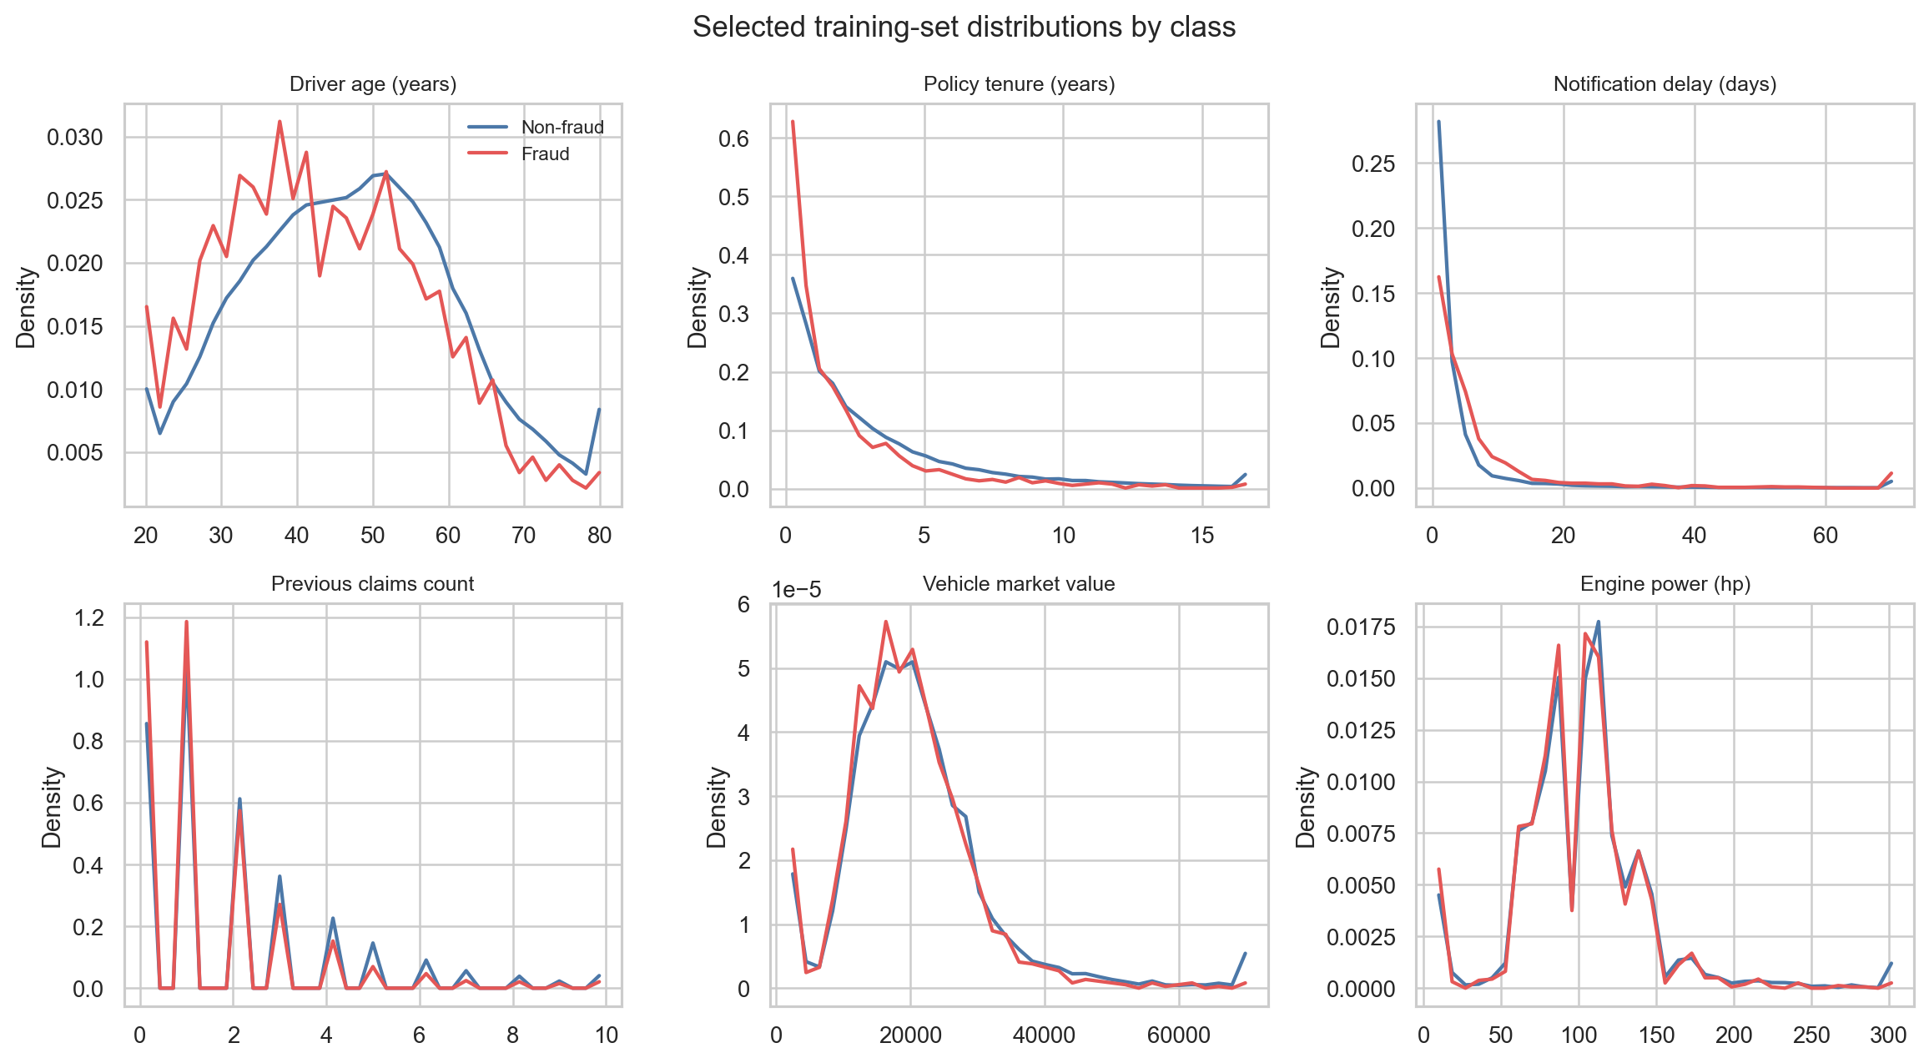
Figure 2. Selected numeric distributions by fraud class.
Fraud cases involve younger drivers (43.72 vs 47.32 years), shorter policy tenure (2.19 vs 3.28 years), and longer notification delays (median 4 vs 2 days; mean 11.30 vs 5.89 days).

6. Categorical Variables
English name | Original variable | Levels | Most common level | Most common share (%)
Risk scoring group | scoring | 6 | Grupo PROYECTA | 50.01
Sales channel | canalnombre | 5 | AGTES.EXCLUSIVOS | 46.88
Fleet indicator | flota | 2 | 0 | 97.98
Sex | sexo | 4 | m | 58.97
Grouped coverage | garantia_agrupada | 10 | ASISTENCIA | 50.71
Grouped payment method | formapago_agrupado | 2 | DOMICILIADO | 54.67

ASISTENCIA is the dominant grouped coverage with 225,195 observations (50.71%). Grupo PROYECTA is the largest risk-scoring group with 222,075 observations (50.01%). DOMICILIADO represents 54.67% of grouped payment methods.
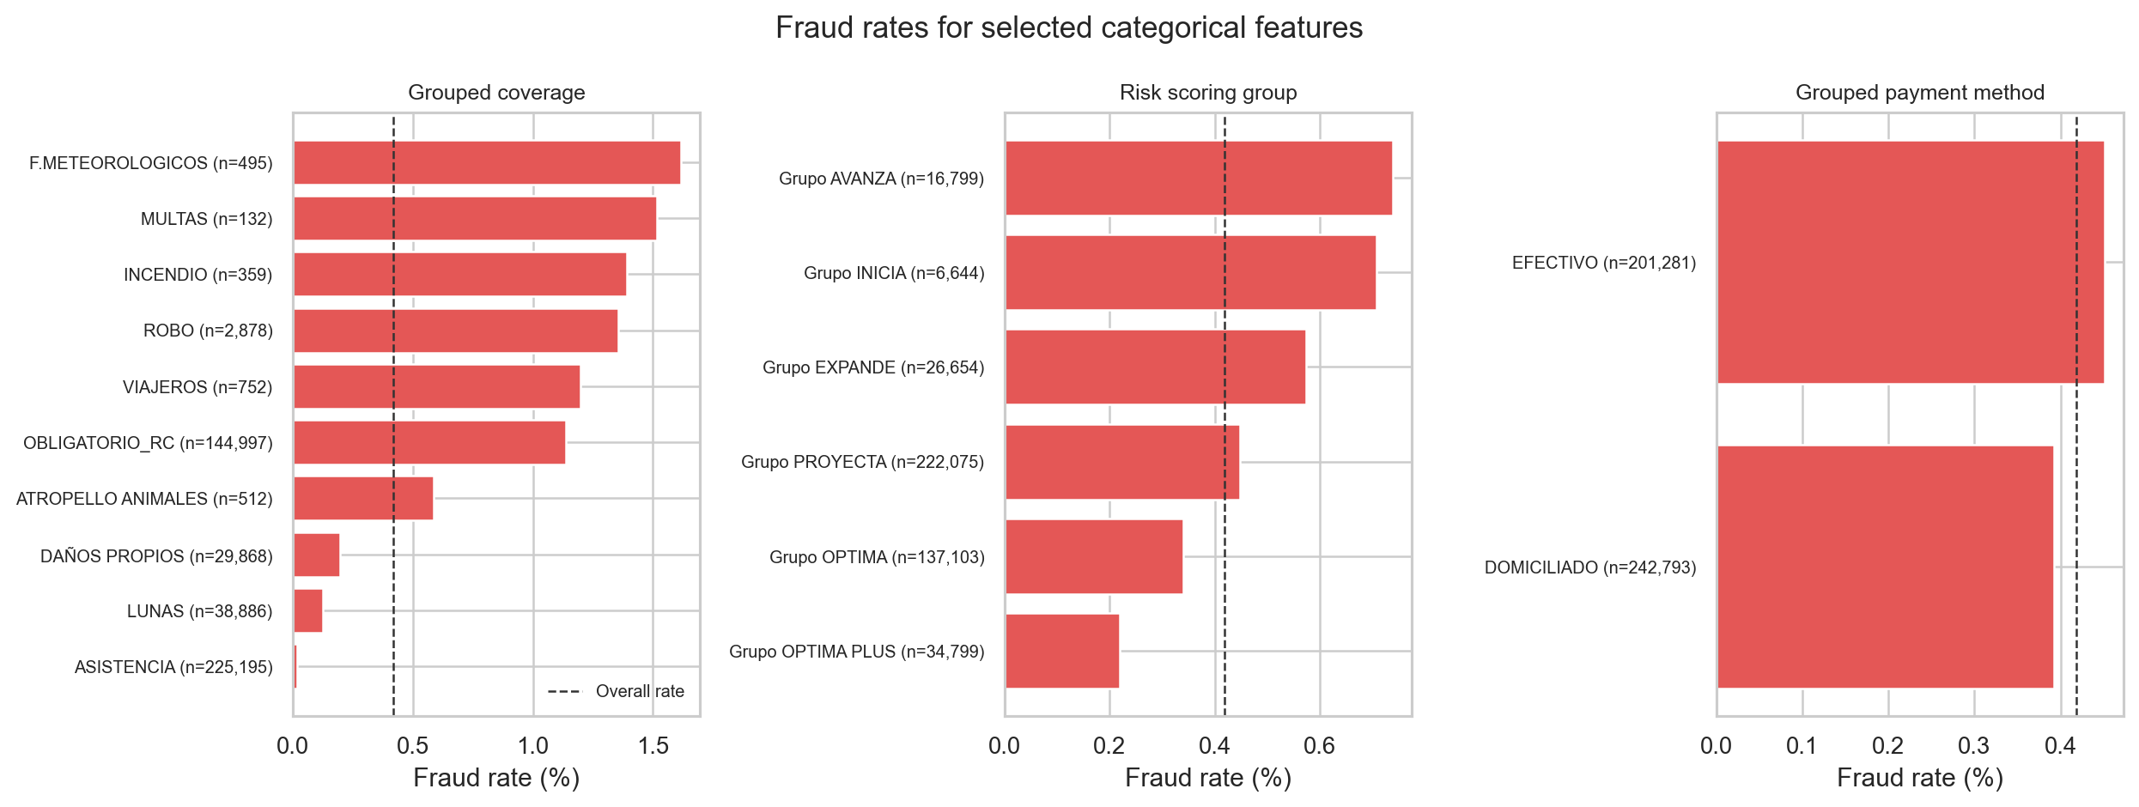
Figure 3. Fraud rates for selected categorical variables.
F.METEOROLOGICOS has a 1.62% fraud rate (8 of 495), ROBO has 1.36% (39 of 2,878), and ASISTENCIA has 0.018% (40 of 225,195). The small weather-related category is less stable. Grupo AVANZA has the highest risk-scoring-group rate at 0.738%; payment-method rates differ only slightly.

7. Fraud and Non-Fraud Comparison

Numeric differences
English name | Original variable | Direction | Std. difference | Correlation
Percentage of income from other benefits (disability, dependency...) | ine_008 | Higher in fraud | 0.378 | 0.024
Percentage of people with unmarried marital status | ine_041 | Higher in fraud | 0.338 | 0.022
Average household size | ine_011 | Higher in fraud | 0.337 | 0.022
Percentage of population retired due to retirement over population 16 and over=Pensioners due to retirement / Pop 16 and + | ine_038 | Lower in fraud | -0.326 | -0.021
Percentage of persons under 16 years of age | ine_026 | Higher in fraud | 0.313 | 0.020
Average age (census) | ine_025 | Lower in fraud | -0.309 | -0.020
Percentage of population under 18 years of age (census) | ine_015 | Higher in fraud | 0.301 | 0.019
Policy tenure | antiguedad_poliza | Lower in fraud | -0.299 | -0.019

The largest standardized numeric difference is income from other benefits (ine_008, 0.378). Policy tenure (-0.299) and driver age (-0.258) are lower among fraud cases. Point-biserial correlations remain small, with the largest around 0.024.

Categorical associations
English name | Original variable | Levels | Corrected Cramer's V
region_code o district_code | comarcaid | 77 | 0.092
coverage_type | garantia | 26 | 0.080
Grouped coverage | garantia_agrupada | 10 | 0.080
policyholder_customer_tier | tomadornivel | 11 | 0.050
policyholder_postal_code | tomadorcodigopostal | 2569 | 0.049
policyholder_nationality_id | tomadornacionalidadid | 2421 | 0.048
policyholder_municipality_id | tomadormunicipioid | 1816 | 0.035
policyholder_district_id | tomadorcomarcaid | 76 | 0.034

The strongest categorical association is region/district code (comarcaid, corrected Cramer's V = 0.092). Detailed and grouped coverage are both around 0.080. These are weak associations and do not provide stand-alone fraud rules.

8. Correlation Analysis
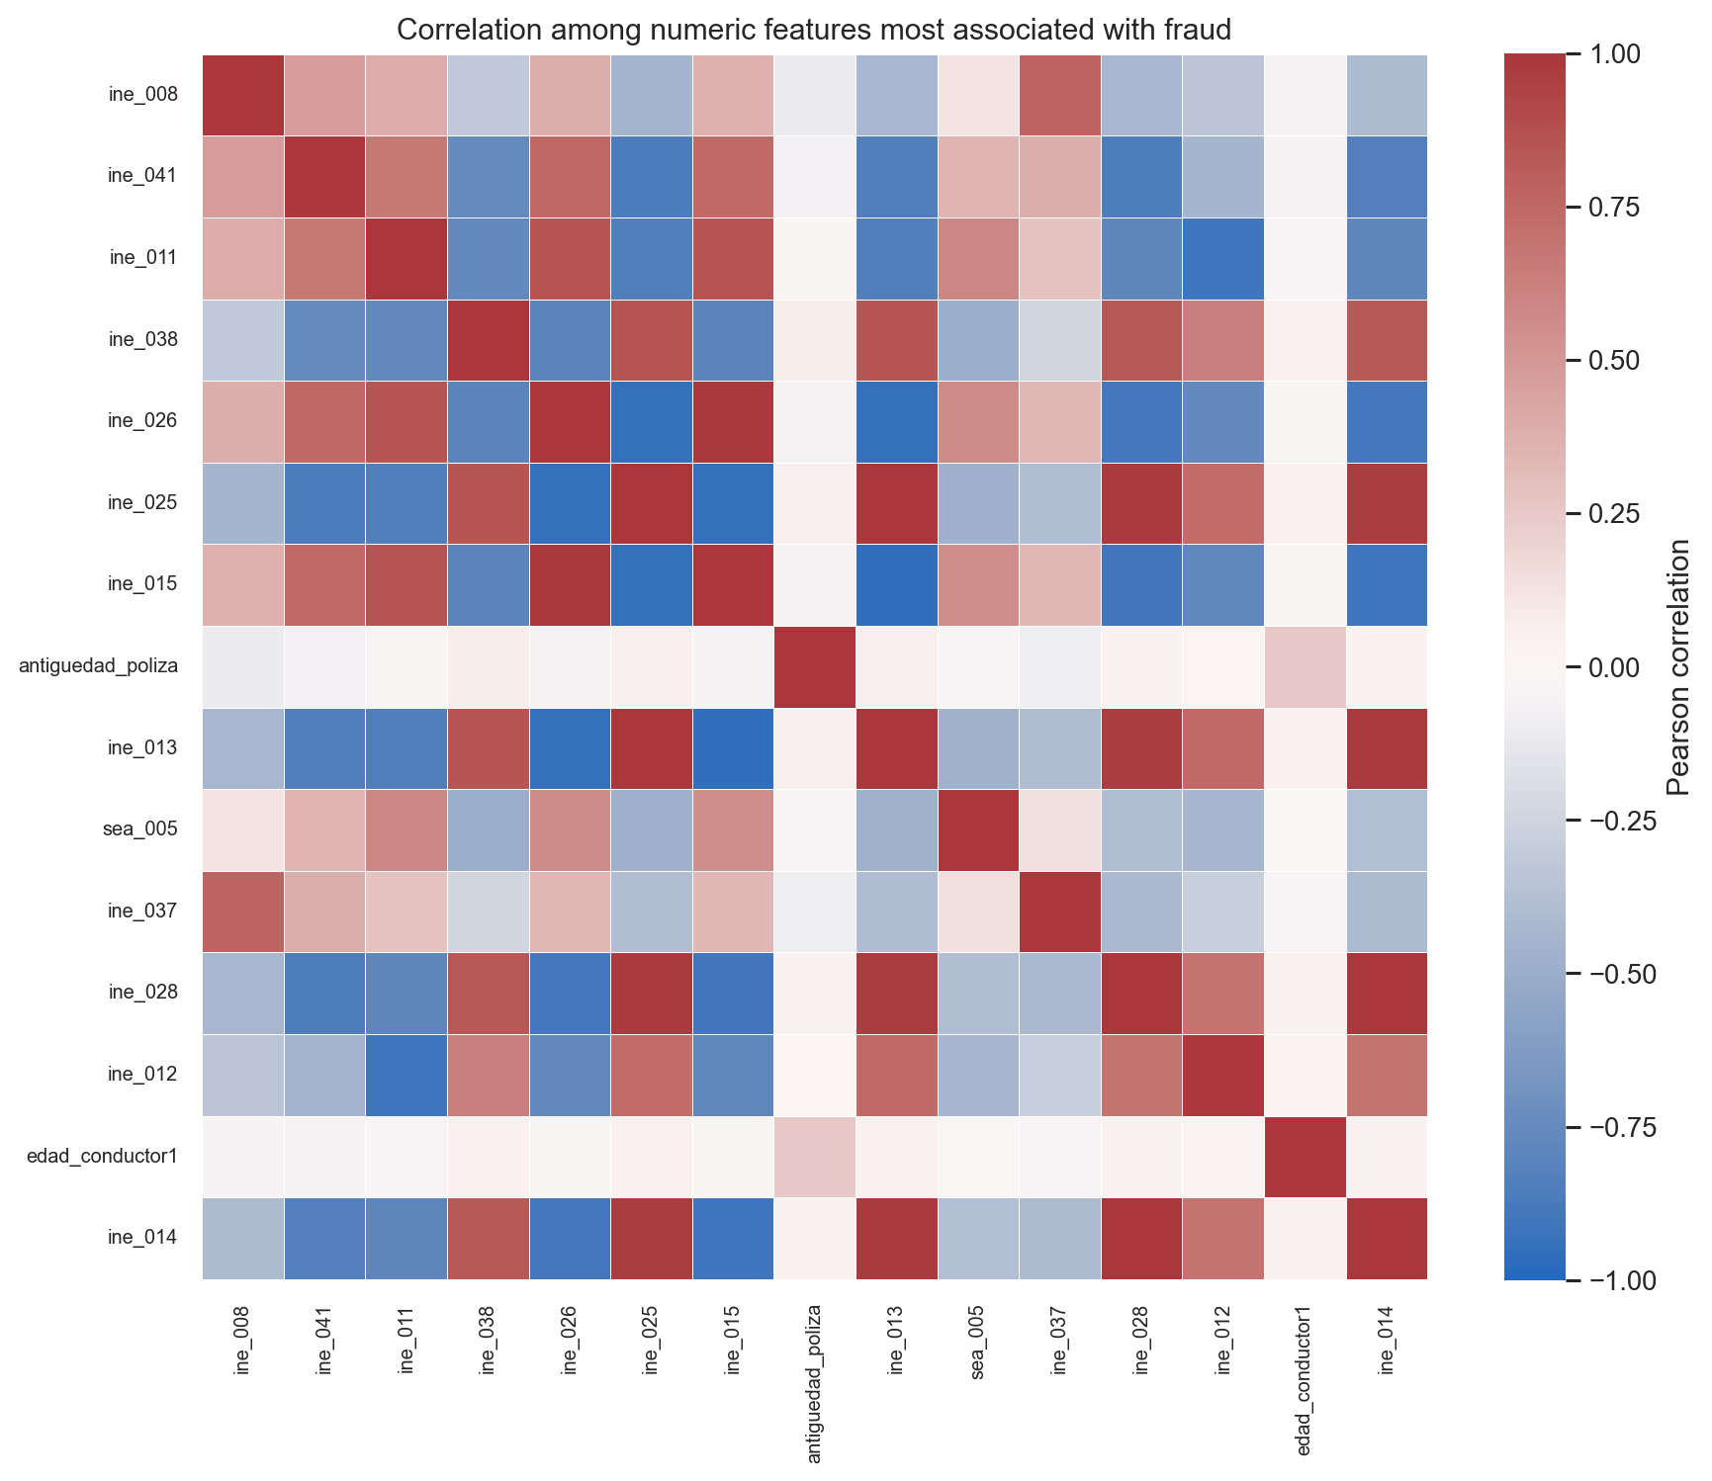
Figure 4. Correlation among numeric variables most associated with fraud.
There are 186 numeric feature pairs with |r| >= 0.80. Exact or near-exact relationships include women versus men (ine_023 and ine_024, r = -1.000), detached/semi-detached houses versus apartments (rep_002 and rep_003, r = -1.000), and principal dwellings versus total households (ine_047 and ine_052, r = 1.000).
Feature 1 | Feature 2 | Correlation
ine_047 | ine_052 | 1.000
ine_023 | ine_024 | -1.000
rep_002 | rep_003 | -1.000
ine_017 | ine_029 | 0.999
ine_014 | ine_028 | 0.994
ine_046 | ine_048 | 0.993
ine_013 | ine_025 | 0.993
ine_002 | ine_003 | 0.992
ine_015 | ine_026 | 0.991
ine_029 | ine_030 | 0.990

9. Train and Test Comparison
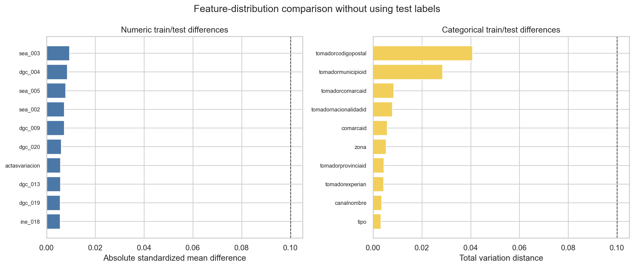
Figure 5. Train/test feature-distribution comparison without test labels.
The largest numeric standardized difference is 0.009 and the largest categorical total variation distance is 0.041. No feature exceeds the 0.10 review threshold, indicating comparable feature distributions.

Largest numeric differences
Numeric feature | Absolute standardised difference
sea_003 | 0.009
dgc_004 | 0.008
sea_005 | 0.008
sea_002 | 0.007
dgc_009 | 0.007
dgc_020 | 0.006
actasvariacion | 0.006
dgc_013 | 0.006
dgc_019 | 0.006
ine_018 | 0.005

Largest categorical differences
Categorical feature | Total variation distance
tomadorcodigopostal | 0.041
tomadormunicipioid | 0.028
tomadorcomarcaid | 0.008
tomadornacionalidadid | 0.008
comarcaid | 0.006
zona | 0.005
tomadorprovinciaid | 0.004
tomadorexperian | 0.004
canalnombre | 0.004
tipo | 0.003

10. Conclusions
- The training set contains 444,074 observations and 1,860 fraud cases, giving a fraud prevalence of 0.4188% and an imbalance ratio of about 238:1.
- There are no missing values, but major representation issues include zero maximum-authorised weights, non-integer door counts, long notification delays, and six negative policy-tenure values.
- Policy tenure and notification delay are stored as fractions of a year. Policy tenure is reported in years and notification delay in days.
- Fraud cases involve younger drivers, shorter policy tenure, and longer notification delays than non-fraud cases.
- No individual variable strongly separates fraud from non-fraud: the maximum corrected Cramer's V is 0.092 and the maximum numeric correlation is about 0.024.
- Area-level variables are highly redundant, with 186 numeric pairs having |r| >= 0.80.
- Train and test feature distributions are comparable, and the test target remains untouched for final model evaluation.

