**Unit 5 | Assignment - The Power of Plots**

**Pymaceuticals Inc**

The following conclusions are drawn from each one of the graphs generated:

1. There is a reduction in the volume of the tumor with the use of Capomulin. The rest of the drugs are close to the placebo effect.

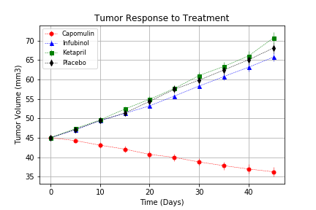

1. The drug that reduces the metastatic spread more significantly than the others is Capomulin.

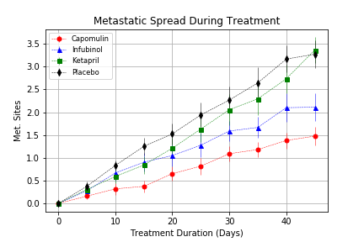

1. Again, Capomulin has the highest survival rate for mice taking this drug. Interestingly, the previous 2 graphs indicated that Infubitol was the second best alternative, as tumor volume and metastatic spread were lower than for the other drugs. But survival rates are the lowest, contradicting any previous conclusions drawn about its use.

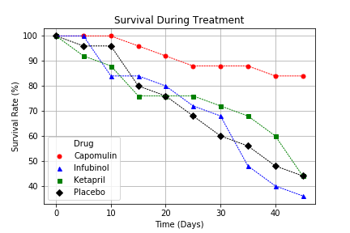

1. The only drug that reduces the volume of the tumor is Capomulin.

