**PyCity Schools Analysis**

For every single school, the average reading score is higher than the average math score. However, for charter schools the difference between math and reading grades is not significant, whereas for district schools, students are clearly scoring lower grades in math.

The school size seems to have a much more important role in students’ success than the average budget per student. This finding invites to take a deeper dive into the factors that are driving the differences in practices between the two types of schools and understand the practices in place at charter schools that could be implemented in the district ones to help improve performance.

**District Summary**



**School Summary**

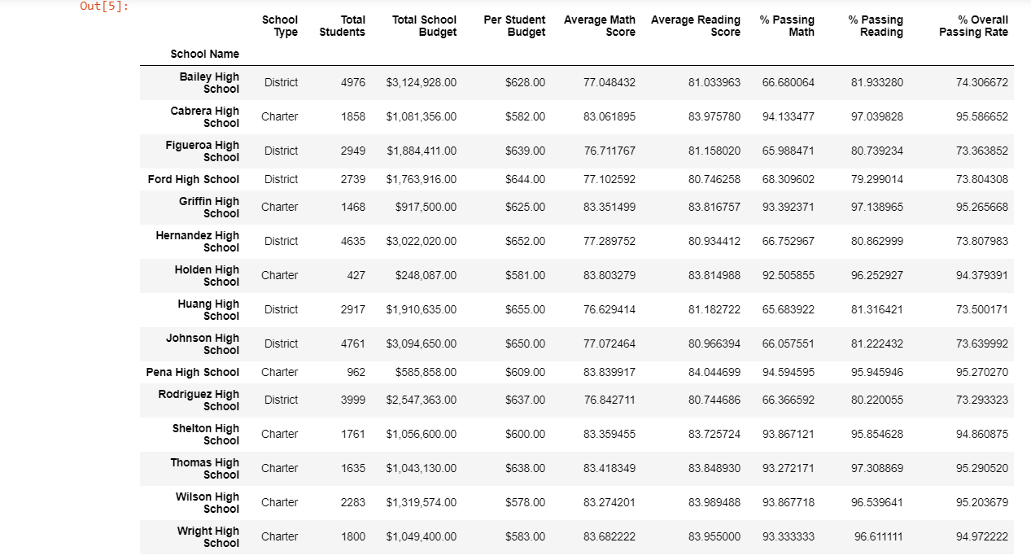

**Top Performing Schools (By Passing Rate)**

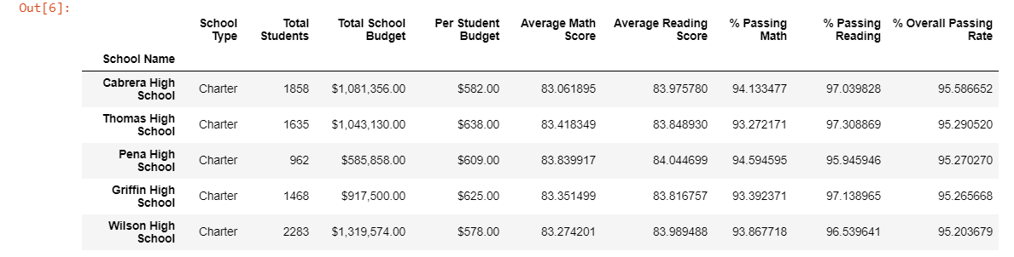

**Bottom Performing Schools (By Passing Rate)**

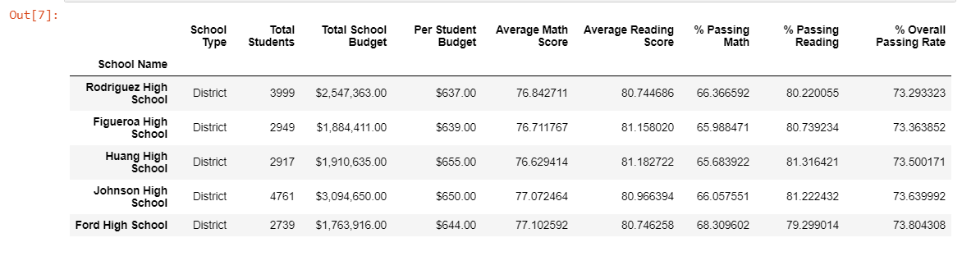

**Math Scores by Grade**

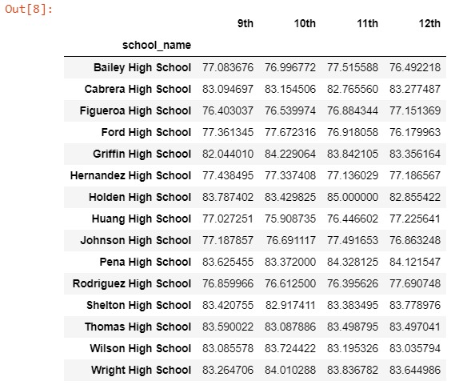

**Reading Scores by Grade**

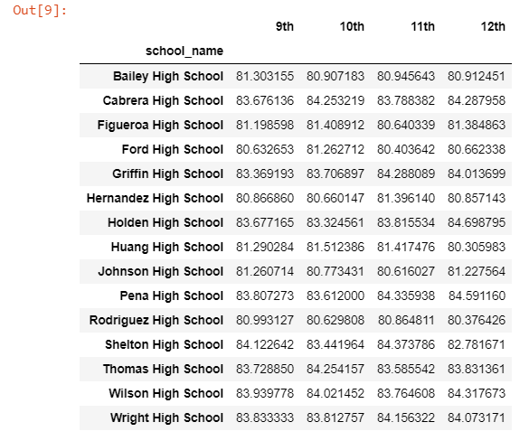

**Scores by School Spending**

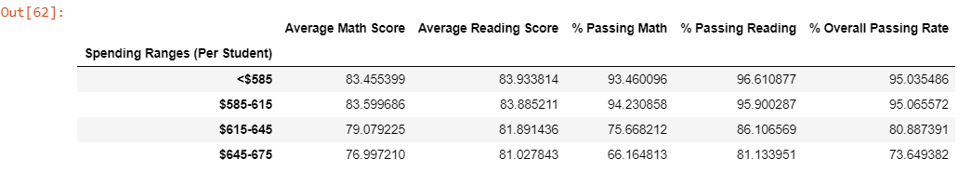

**Scores by School Size**

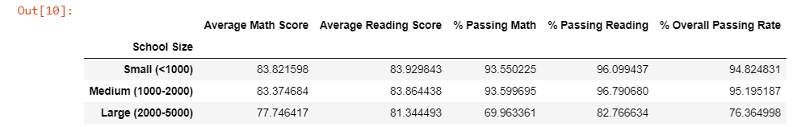

**Score by School Type**

