It would be interesting to consider if the “unraveling” technique could be applied to both spirals and sinusoids, and further applied to any other drawing that has a mathematical model for the ideal shape.

Classifiers that have been used: CNN, SVM, random forest, KNN, Naïve Bayes

Feature extractors used: DNN, HOG, FT distance metric, tremor estimation based distance (spiral length), unravelling (9 different metrics)

Things to consider doing for my research:

* feeding isolated hand-drawn shapes into CNN to obtain extracted features. Then feed these features into classifiers. Could try it for both spirals and sinusoids. Has not been done directly with sinusoids.
  + Also visualize the activations while this is happening
* Take the unraveled spirals (and sinusoids?), find a line of best fit, can “redraw” the spiral smoothly, can take the error of this new “ideal” spiral to the drawn spiral and use this as a feature for the classifier
* Take the unraveled, convert to the frequency domain and then run this through a CNN classifier. Could also try with sinusoids (hasn’t been done) – convert to IQ data? (I = A\*cos(theta), Q = A\*sin(theta))
* Run the combination features extracted through classifiers and compare the results

Kraus and Hoffmann [17] proposed a standardized testing method for rating kinetic tremor. It is compared against the previously published protocol by Bain and Findley. They unraveled the spiral in polar coordinates and compute a best-fit line against the test drawn spirals. The results are computed using regression against the Bain and Findley ratings. Spiralometry is exlusively focused on quantification of tremor amplitude, regardless of clinical diagnosis.

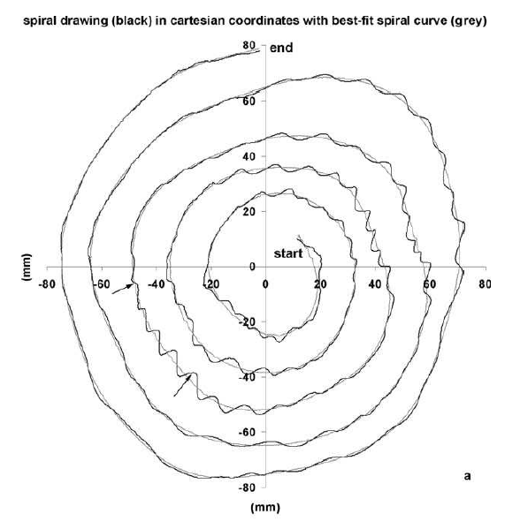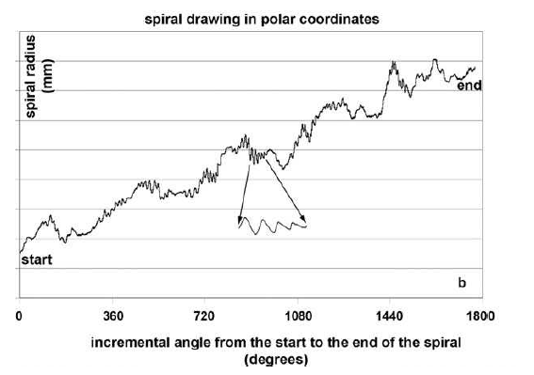

Pereira et al. [20] showcased the use of a new dataset called “HandPD”. This dataset has since been used as a baseline for more recently published work. The dataset consists of hand-drawn spirals drawn on top of a spiral template. In their work they are able to extract the sketch from the template and compute nine different features from the handwritten trace (HT) to the spiral template (ST) including (RMS, max difference, min difference, standard dev, mean relative tremor (MRT – a new metric), maximum HT, minimum HT, std dev of HT values, and the number of times the difference between ST and HT radius changes from negative to positive and vice-versa). These features are then passed into three different classifiers (Naïve Bayes, OPF, and SVM). In their second paper [21] the authors explore the use of CNNS with optimization techniques to perform the classification. Received a max accuracy of 90.38%.

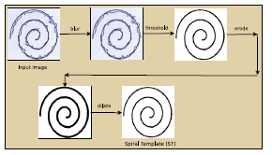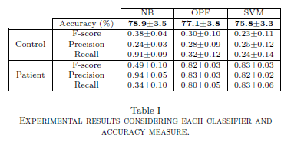

Passos et al. [22] use the “HandPD” dataset to get extracted features using ResNet-50 and feeds these features into classifiers including ResNet-50, OPF, SVM, and Bayes. They did not isolate the hand-drawn from the template spiral.

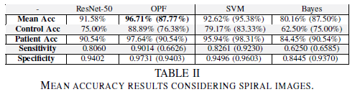

Gupta and Chanda [23] use SVM to classify unraveled spirals and converted to the frequency domain, taking the average of K intervals along the spiral (K=256 for their experiment). They also use the length of the spiral as a dual metric – PD drawings have more black pixels than healthy drawings due to the nature of having some “oscillation” in the spiral. They generate a histogram of C (the count of traversed elements of the spiral sequentially over a set distance value Q) – this histogram is taken as the tremor estimating distance-based feature. Their algorithm is tested on the benchmark database PaHaW, which consists of multiple handwriting samples from PD and healthy persons. They perform unravelling of the spirals, and convert to the frequency domain. The FT based distance feature (79.63% ACC) and Tremor Estimation distance feature (75.92% ACC) are passed through an SVM classifier. The combination of the two is also passed through (81.66% ACC).

Folador et al [HOG] have two papers published using two different spiral and sinusoidal datasets. In their 2019 published paper, they use the “original dataset”, which is the one that I’ve been used so far – this dataset contains 102 hand-drawn spirals and sinusoids each, from 12 healthy individuals and 15 people with PD. However, for this paper, they only analyzed on the sinusoidal drawings. Using HOG and the random forest classifier, they achieved an accuracy of 83%. In their second published paper in 2021, they collected a larger dataset (also consisting of spirals and sinusoids), containing a total of 960 images (480 spirals and 480 sinusoids). They again used HOG features and fed the data into various classifiers including: random forest, KNN, SVM, and CNNs. To the best of my knowledge, this data has not been made publicly available. This experimental team is arguing that sinusoids are more accurate over spirals for the classification of tremors. ey again