LCA Resource  78 Bates Road  Swampscott, MA 01907 | 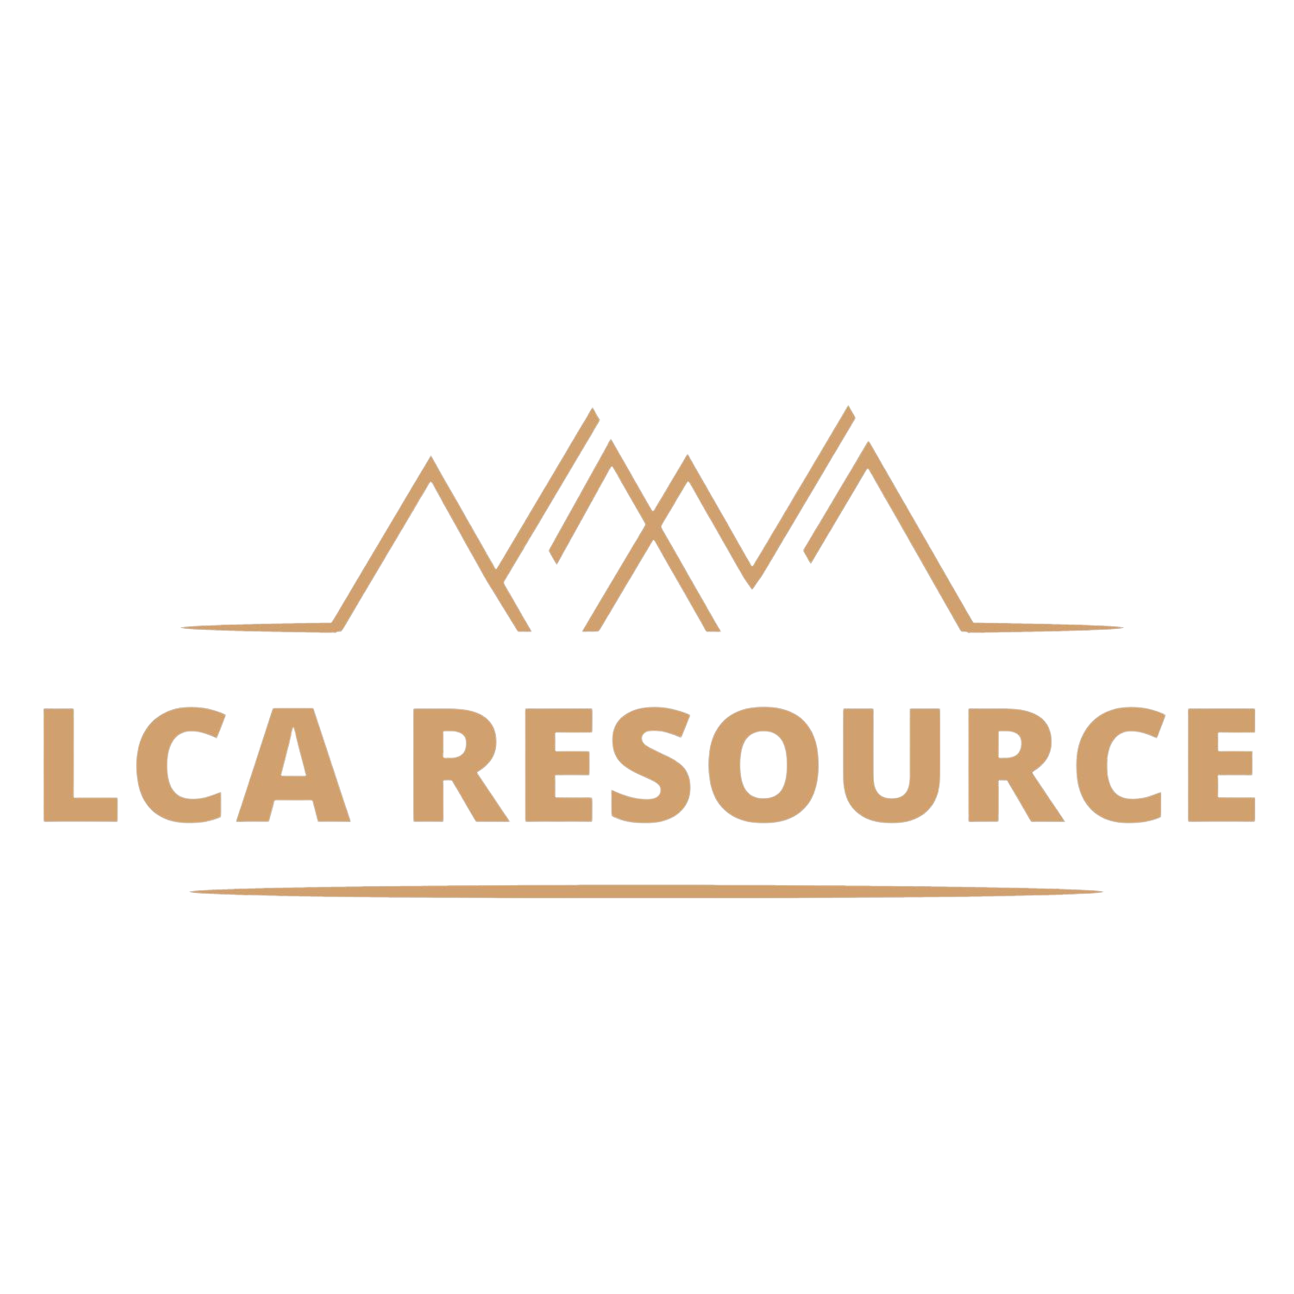
  - SOW - Client
Date | Services Performed By: | Services Performed For:
23.10.2022 | LCA Resource  78 Bates Road  Swampscott MA 01907 | Client  6150 Mumford Road  Bryan TX 77807
Goal
Applying a screening LCA approach, baseline the environmental impacts (focusing on CO2-eq and cumulative energy demand) of the BioVeritas technology for production of organic acids.
Activities/Scope
- Develop a baseline screening LCA (ISO 14040/44 aligned) model of all product system input and output flows.
  - Scope: Cradle-to-Gate.
- Assess the environmental “hot-spots” in the existing process.
- Develop 2-3 scenarios focusing on the hot-spots identified to inform CO2 mitigation options – especially in the downstream extraction process.
- Provide draft results in a .ppt format by January 15th, 2023.
- Produce final technical screening analysis by April 15th, 2023.

Period of Performance
The Services shall commence on November 16th, 2022 and shall continue through April 15th, 2023.
Phase | November | Goal & Scope Stage-Gate | December | January | February & March | April
Discovery Phase
Inventory Phase
Inventory Analysis - Data Collection
Analysis - Modeling
LCA 1 - Preliminary Results
Inventory Analysis continues
Impact Assessment & Interpretation
LCA 2- Final Technical Report

Engagement Resources
- Rebecca LeBlanc – LCA Resource Analyst

Scope of Work
Deliverables:
- LCA 1 - Draft Report and presentation of initial findings by January 15, 2023
- LCA 2 - Finalized Report and presentation by April 15, 2023

This SOW addresses the following project phases:
- Discovery
  - Review of deliverables, project plan and tasks proposed in this SOW with the BioVeritas team to refine the SOW, if needed, to address both tactical and strategic Client Business Goals.
  - LCA Kick-off meeting to define system boundaries and determine project timelines/roles. Creation of Product System Diagram.
  - Validation of BioVeritas provided data for completeness, resolving any data gaps and documenting assumptions and limitations of the data.
- Analysis: (“LCA”) in accordance with ISO-14040/44
  - Scope
    - Cradle-to-Gate
  - Inventory Analysis
    - Data quality guidelines established, system diagram produced, materiality assessment
  - Interpretation: Sensitivity and Contribution Analysis
    - The analysis will include a Sensitivity Analysis to understand the trade-offs between upstream impacts.
    - Impact Assessment Categories Recommended:
      - GWP – Global Warming Potential (kg CO2-eq)
      - Eutrophication Potential (kg N-eq)
      - CED – Cumulative Energy Demand (MJ)
      - Water Consumption (m3)
  - Results & Conclusions
    - All background project materials to be delivered to customer, including:
      - Umberto 11 model
      - Supplementary Information Workbook
      - Full Technical Report

Contractor Responsibilities
Rebecca LeBlanc will be the Senior Consultant on the project responsible for ensuring the timely delivery of the Project. In collaboration with Client team, she will manage progress updates, scheduling of meetings, change control when applicable, and any mitigation of deviations from scope.

Client Responsibilities
Executive Sponsor: The executive sponsor is the senior executive responsible and ultimately accountable to the business for the success of the project. The Executive Sponsor’s roles and responsibilities include:
- Ensuring the project's goals are aligned with the overall company strategy
- Gathering support, communicating goals and overcoming resistance
- Providing ongoing direction to the team and building coalitions to get the work done
Project Manager (PM) is responsible for shepherding the project through the project phases. This role is expected to require 1-2 hours/week of support.
In addition, Client agrees to the following:
- Client collaborators and subject matter experts will be available when needed to attend meetings and other activities as planned.
- Client will ensure that LCA Resource has access to all information having a bearing on the Project in a timely manner, making sure that any data submitted is “fit for purpose.”
- Client will notify LCA Resource of any anticipated or realized delays in meeting project deadlines.

Fee Schedule
50% upfront and 50% at project completion.
The project fee will be paid as a flat fee broken into two components (50% paid up front and 50% paid after delivery of the technical reports.) Payment is net 30. The budget is inclusive of all tasks and labor listed above, but does not include travel expenses. If travel is needed, client will pre-approve the trip and the estimated expenses in advance. LCA Resource will invoice the client separately for expenses incurred with no mark-up.
Bill To Address | Client Project Manager | Client Cost Center
6150 Mumford Road  Bryan TX 77807 | Makenzie Kulhanek | TBD

Expenses + Invoicing
This project is scoped at a fixed price of USD $18,000. Included in the price:
- LCA Software: Umberto 11
- Sensitivity Analysis: Palisade Software DecisionTools Suite
- Databases: ecoinvent v3.8, CarbonMinds chemical carbon footprint database, NREL LCI, literature research
- Impact Assessment Methodologies (GWP) and 3 others TBD

Completion Criteria
LCA Resource will have fulfilled its obligations under this SOW when any one of the following first occurs:
- LCA Resource completes the LCA Resource’s responsibilities described in this SOW; or
- The Services are amended and executed through an approved Change Order; or
- The Services are terminated in accordance with the provisions of this SOW and the Agreement.
Client shall approve each deliverable with a written disposition within three (3) business days from its receipt. The written disposition will consist of (i) a written approval of such deliverable or (ii) a written statement that identifies in reasonable detail, all of the deficiencies preventing approval (the “Deficiencies”).
LCA Resource shall have five (5) business days from the date it receives the notice of Deficiencies to complete corrective actions for such deliverable. Client shall complete its review of the corrected deliverable and notify LCA Resource in writing of acceptance or rejection in accordance with the provisions of this section.
Lack of a written disposition on a deliverable or the use of a deliverable by Client means approval of the deliverable. Both parties will rely on such approval in all subsequent phases of the Project.

Project Change Control Procedure
The following process will be followed if a change to this SOW is required:
LCA Resource or the Client may raise a change by submitting a written change request to the other party (“Change Request”). Upon receipt of such a Change Request, the Parties agree to promptly submit an impact analysis of the change to the Project schedule, charges, quality, and goals. The Parties also agree to continue performing the Services in accordance with the SOW unless the parties execute a change order varying the SOW effect to the Change (“Change Order”).
If any of the following events occur while LCA Resource is engaged to provide the Services (each a “Change Order Event”), LCA Resource shall be entitled to compensation for actual and anticipated additional effort at LCA Resource standard billing rates:
- The scope, approach or timing of the project or the Services change as directed by the Client,
- Delays are encountered that are beyond the reasonable control of the Parties,
- Any assumption set forth in this SOW proves to be invalid.
Notwithstanding anything to the contrary in this SOW, if the Parties are unable to reach a complete agreement on a Change Order within ten (10) business days of being notified of a Change Order Event, the Parties may suspend or terminate the Services upon written notice to the Client.

Acceptance
This SOW is the complete agreement regarding Services, and supersede any course of dealing, discussions, or representations between Client and LCA Resource. The parties acknowledge that they have read the Statement of Work, understand it, agree to be bound by its terms and conditions. The parties acknowledge and agree they have executed this agreement to be effective as of October 25th, 2022, the SOW Effective Date.
 | Client |  |  | LCA Resource
By: |  |  | By: | Rebecca LeBlanc
Name: |  |  | Name:
Title: |  |  | Title:

