1. Library Rentals – this library contains many different items such as books, audio CDs, DVDs, vinyl records, video tapes, cassettes, magazines, and academic papers. Ensure your database stores different information on each of these types.
   1. As a Librarian I want to query if any rentals are overdue so I can chase this up
   2. As a Customer I want to query by a particular author or artist in order to find items by someone I like
   3. As a Social Media Consultant I want to know which items get rented out the most so I can create effective campaigns for them
   4. As a Librarian I want to be able to see what rentals a particular customer has out currently.
   5. As a Librarian I want to see if a rental is available for rent.

Rentals

Members

RentedArchive

* Members: MemberID, Name, TelephoneNumber, Address, RentedItems – RentID, DateTakenOut, DateDue
* Rentals: RentID, Title, Type, Author/Artist, Copies, Description, Availability
* RentedArchive: MemberID, RentID, DateTakenOut, DateToReturn, Returned

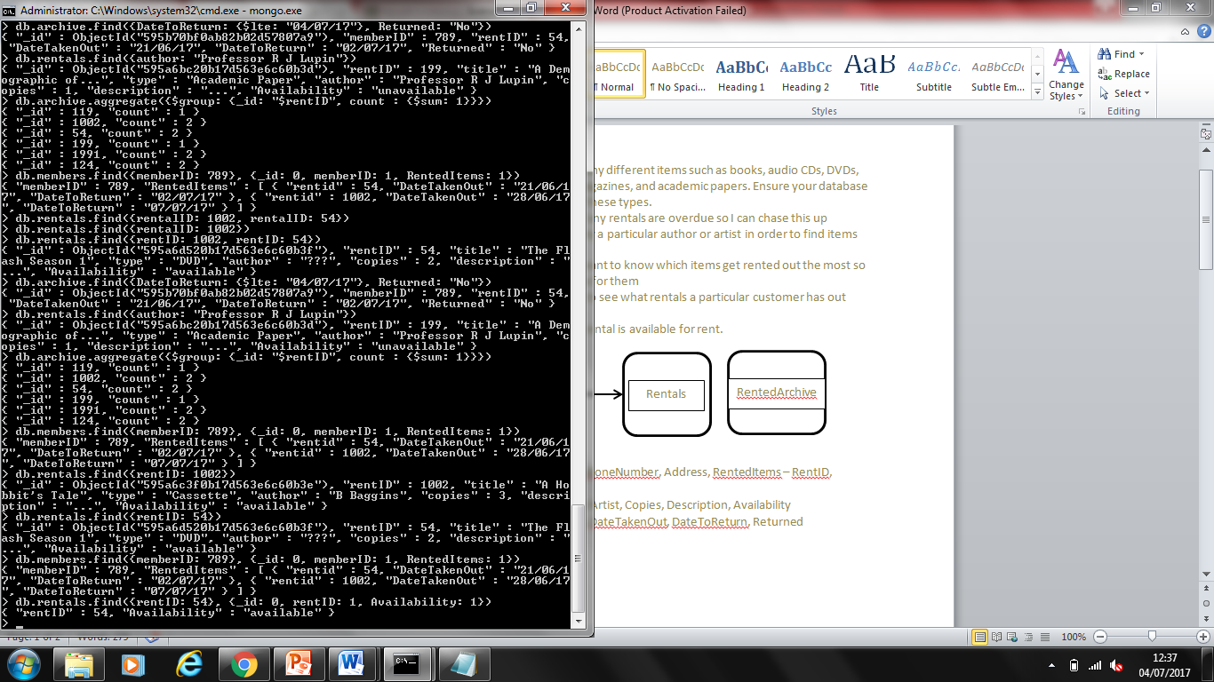

1. Emergency Services Logs – this should be documentation on calls made to the emergency services line. This should include information on what a customer is calling about, who handled the call, the type of resolution, and any additional comments at a minimum.
   1. As a Managing Director I want to query what the peak times for particular service requests are so I can appropriately assign staff
   2. As a Calls Manager I want to query which members of staff have taken the most calls so I know who is performing well
   3. As an Managing Director I want to query what the maximum call duration has been the past month so I can track statistics on this
   4. As a Managing Director I want to query what service is requested most in a day so I can track statistics on this
   5. As an investigator of a crime, I want to be able to look up the details of the emergency call which triggered the call out of the emergency services.