Remodel report

The most significant change we made to the data model is separating user information from trip and station information, creating a distinct table for each and linking the three tables through IDs. With the user_id, it is possible to categorize different age groups and ride durations based on deduplicated data, providing more accurate information. The original data lacks user identifiers, making it impossible to confirm whether the rides belong to the same user. Here are five simple business questions we designed.
1.What is the weekly trips trending for whole year?
2.What is the monthly trips volume?
3.Which area is the highest trips volume ?
4.when is the peak time?
5.Which age group has the longest trip duration?

Q1&Q2: For question one and two, to address them, we utilized Python to create visual charts for weekly and monthly orders, as shown in the attached images. To answer questions regarding the volume of weekly and monthly orders, we only need the trip time and ID from the trip table; detailed user information is not necessary. This approach enhances the efficiency of data extraction since we can avoid unnecessary user information retrieval.
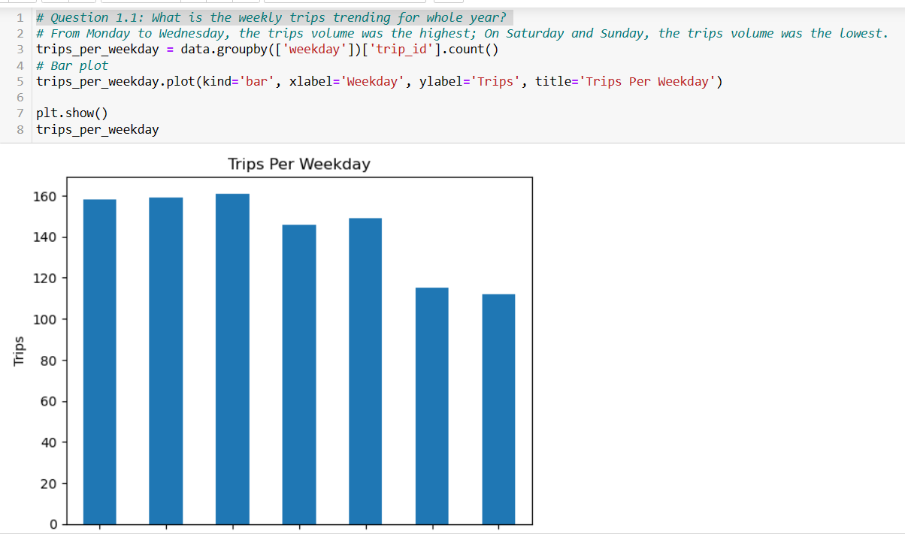
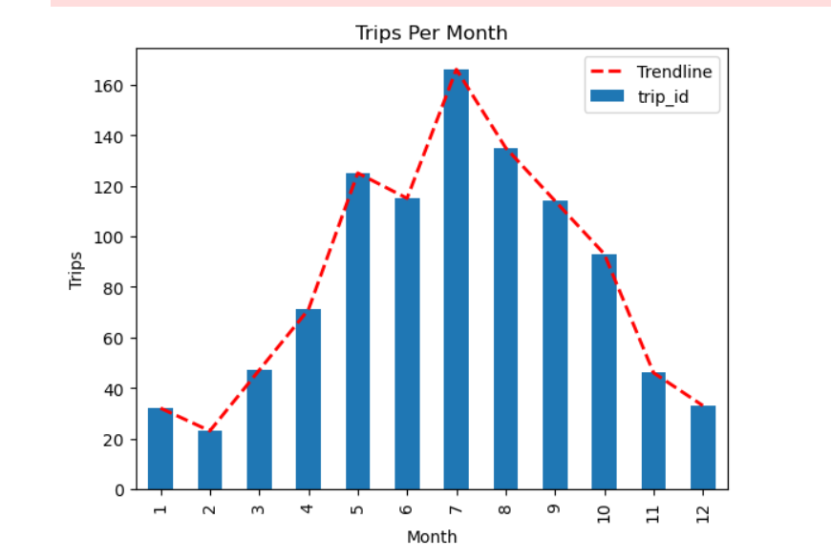

Q3: Which area is the highest trips volume ?
Used the tableau as below(sorry for Chinese version tableau), showing the the middle and north part of Chicago city has highest trips volumes.

Q4:when is the peak time?
SELECT HOUR(start_time) AS trip_hour, COUNT(*) AS num_trips
FROM Trips
WHERE start_time >= '2018-01-01 00:00:00' AND start_time < '2018-12-31 23:59:59'
GROUP BY trip_hour
ORDER BY num_trips DESC;
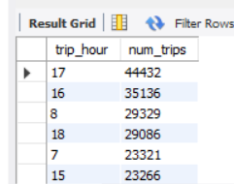

Q5:Which age group has the longest trip duration?

use Divvy;
Select avg(tripduration) from Trips
union
select FLOOR((YEAR(CURRENT_DATE) - birthyear) AS age
from User
WHERE (birthyear IS NOT NULL AND birthyear != '0') AND YEAR(CURRENT_DATE) - birthyear < 100
group by age
order by age desc;
"This question best demonstrates the impact of our remodeling. To analyze the bike ride durations across different age groups, our remodel addresses the issue of users riding bikes multiple times, enabling a more accurate analysis of age distribution among individuals. "

Group 3:
Yang wenqing
Zhang shujuan
Zhang xinyu
Zhang yujia
Zheng jing
Zheng panpan

