Rebecca Curro - 240405902

**Introduction:** The Hotel Management Application is a tool designed to help hotel staff and management handle booking information, track guest details and view financials. It is for a small hotel and simplifies the booking process, allowing for easy retrieval and modification of guest data and room information. It is also used to enter new bookings and new guests into the database. The project integrates Excel as a front-end for interaction, VBA code to handle database interactions and MS Access for the back-end database.

**Database:** The Hotel Management Database is composed of three main tables, encompassing all essential information related to guests, booking and rooms.

* **Tables:**
  + **Guests:** Stores information about hotel guests
    - **Fields:** GuestID, GuestName, Email, Phone
  + **Bookings:** Stores details of bookings made by guests
    - **Fields:** BookingID, GuestID, RoomID, CheckInDate, CheckOutDate, PaymentStatus, TotalCost
  + **Rooms:** Contains details about available rooms
    - **Fields:** RoomID, RoomType, RatePerNight
* **Relationships:**
  + Guests to Bookings, using GuestID (one to many)
  + Bookings to Rooms, using RoomID (one to many)
* **Queries:**
  + Guest Stay History:
    - SELECT Guests.GuestName, Bookings.BookingID, Bookings.CheckInDate, Bookings.CheckOutDate, Bookings.RoomID, Bookings.PaymentStatus, Bookings.TotalCost

FROM Bookings INNER JOIN Guests ON Bookings.GuestID Guests.GuestID

WHERE (((Guests.GuestName)="[Enter Guest Name]"))

* + Total Revenue Per Month:
    - SELECT YEAR(Bookings.CheckInDate) AS [Year], MONTH(Bookings.CheckInDate) AS [Month], SUM(Bookings.TotalCost) AS TotalRevenue

FROM Rooms INNER JOIN (Guests INNER JOIN Bookings ON Guests.GuestID = Bookings.GuestID) ON Rooms.RoomID = Bookings.RoomID

WHERE Bookings.CheckInDate BETWEEN #01/01/2024# AND #31/12/2024#

GROUP BY YEAR(Bookings.CheckInDate), MONTH(Bookings.CheckInDate)

ORDER BY YEAR(Bookings.CheckInDate), MONTH(Bookings.CheckInDate);

* + Total Spent Per Guest:
    - SELECT Guests.GuestName, SUM(Bookings.TotalCost) AS [Total Spent at Hotel]

FROM Guests INNER JOIN Bookings ON Guests.GuestID = Bookings.GuestID

WHERE Guests.GuestName="[Enter Guest Name]"

GROUP BY Guests.GuestName;

**Excel Front End:**

* **New Guest Form:** This form allows hotel staff to input new guests by entering GuestID, Guest Name and Guest Email. The Submit button automatically updates the database.
* **Order Form:** This sheet allows the hotel staff to input new bookings by selecting a Guest, a Room Type, Check In Date, Check Out Date, Payment Status and Total Cost of the stay. The form automatically updates the database with the entered information when the Submit button is pressed.
* **Booking Summary:** Summary of all bookings pulled directly from Access Database
* **Guest Summary:** Summary of all guest information pulled directly from Access Database
* **Rooms Summary:** Summary of all room information pulled directly from Access Database

**VBA Middleware:** The VBA code bridges the gap between the Excel front-end and the Access database. It handles the logic for querying the database and updating records. Here are the key subroutines:

* **Importing Data from Access:**

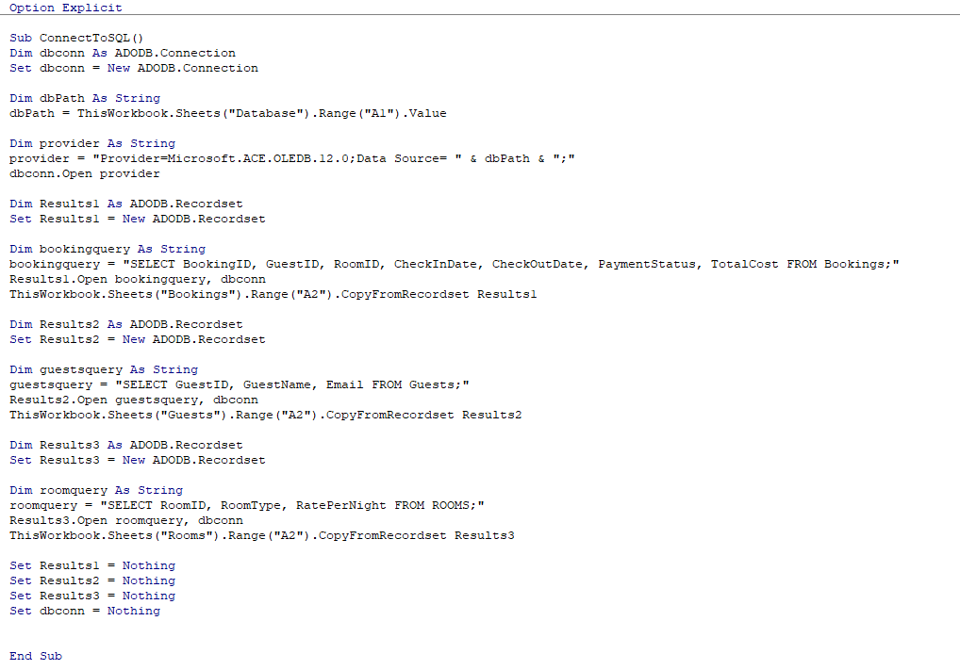

* 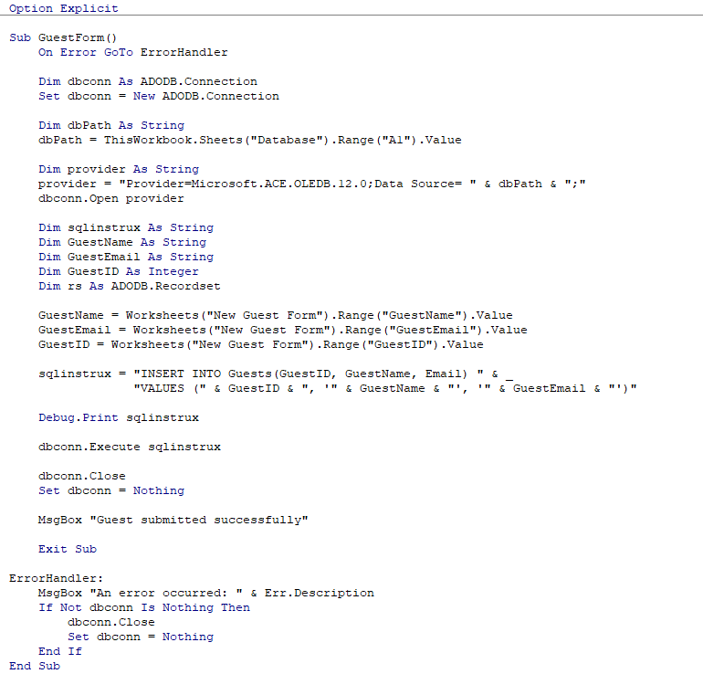**Submitting New Guest Form:**
* 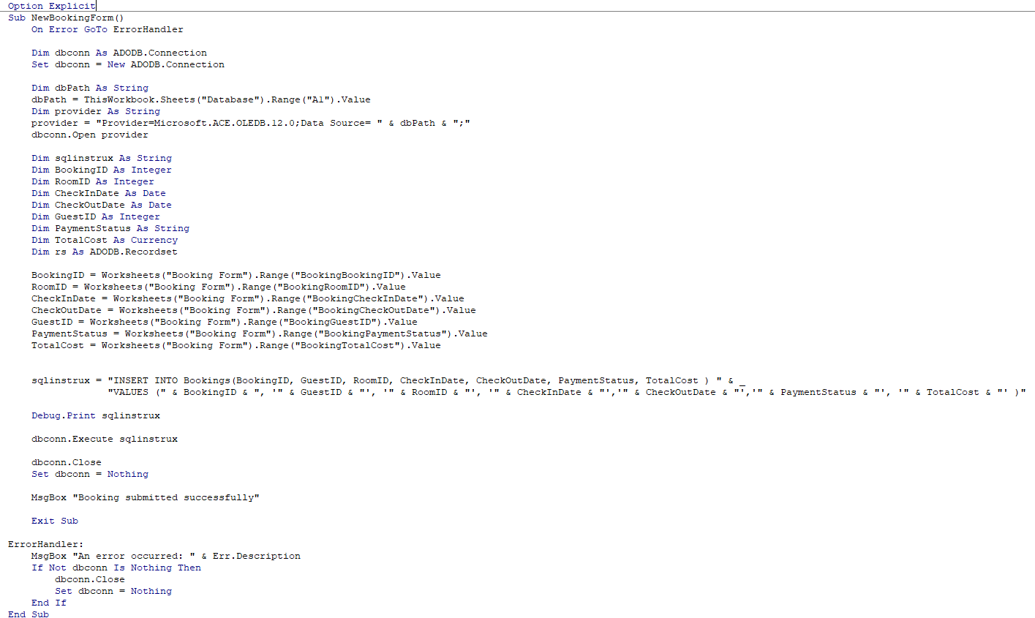**Submitting New Booking Form:**

**Conclusion:** This Hotel Management Application simplifies and automates the process of handing bookings, tracking guest information and generating revenue reports. It is well-suited for small hotels or boutiques that need an easy-to-use tool to track reservations and revenue. For a real-world business, the application could be scaled up by:

* Integrating with an online booking platform
* Implementing security features such as user authentication to restrict access to certain functionalities
* Expand the database to include additional features like staff management, inventory tracking (towels, bedding) and customer feedback

You can find the source code for this project on my GitHub (link)

**VBA Code Not Covered in Class:**

* File path: I put the file path from my computer into a hidden cell so that in the VBA code there was no file paths specific to my computer