**EXPERIMENT 01: Study of NIST model of Cloud Computing**

CLASS: BE CMPN A 2 ROLL NO. : 18

NAME: REBECCA DIAS PID: 182027

# **Aim:** Study of NIST model of Cloud Computing

# **Theory:**

## Define and explain cloud computing

Cloud computing is the delivery of different services through the Internet. These resources include tools and applications like data storage, servers, databases, networking, and software.

Rather than keeping files on a proprietary hard drive or local storage device, cloud-based storage makes it possible to save them to a remote database. As long as an electronic device has access to the web, it has access to the data and the software programs to run it.

Cloud computing is a popular option for people and businesses for a number of reasons including cost savings, increased productivity, speed and efficiency, performance, and security.

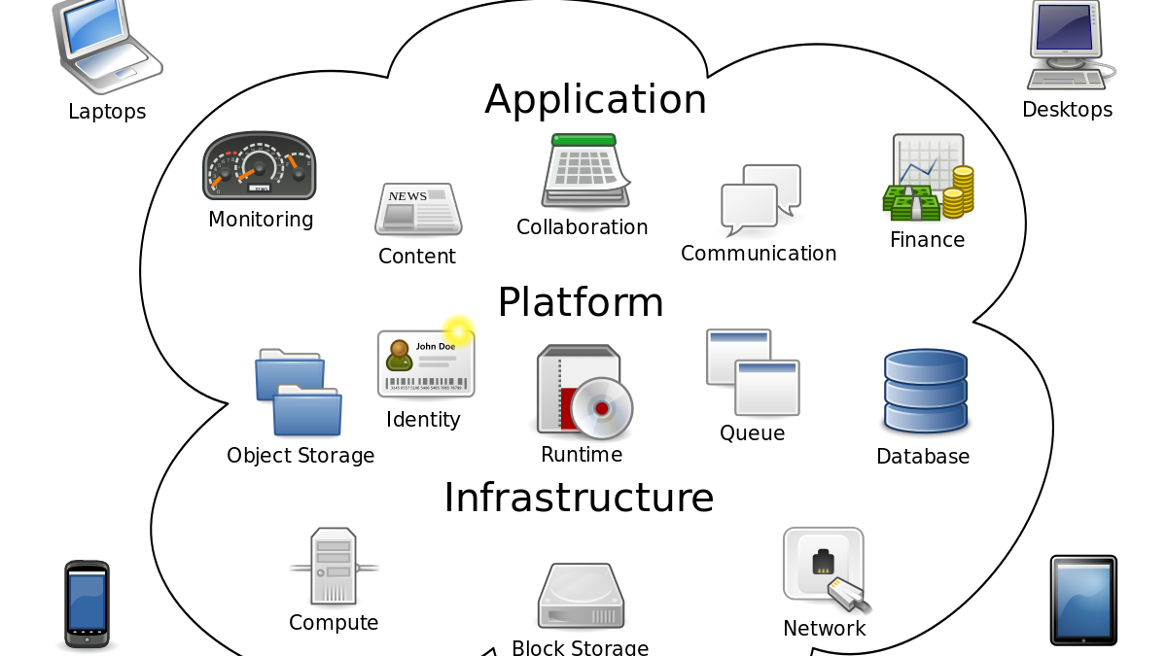

## Draw and explain NIST cloud computing Architecture

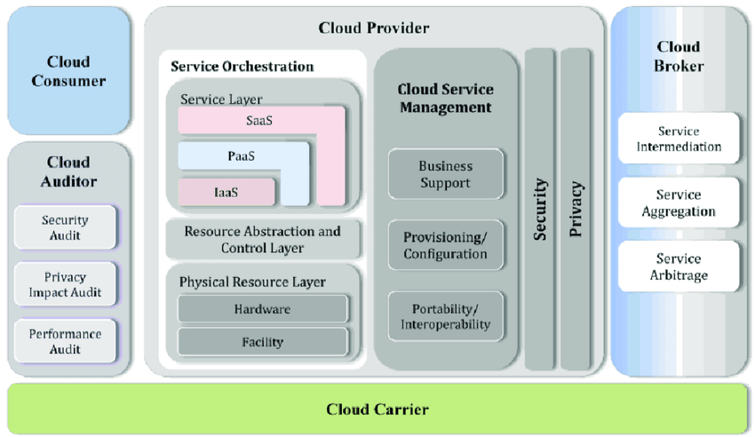

The first portion of NIST SP 500-292 defines the relationships between all stakeholders involved in [cloud computing](https://blog.rsisecurity.com/the-essential-characteristics-of-cloud-computing/). There are five major roles detailed within NIST SP 500-292:

* Cloud Consumer
* Cloud Provider
* Cloud Auditor
* Cloud Broker
* Cloud Carrier

1. Cloud Consumer

Cloud consumer is the main participants of cloud computing environment.

A cloud consumer is a person or organization that use the cloud services such as SaaS, PaaS and IaaS.

A cloud consumer browses the service catalog provided by a cloud provider, cloud consumer requests the appropriate service.

Cloud provider sets up cloud environment for the service and make a contracts with the cloud consumer for the use of the service.

Cloud consumers need cloud Service Level Agreement(SLA).

SLA act as a agreement for technical performance requirements provided by a cloud provider.

2. Cloud Provider

A cloud provider is responsible for making a service available to the cloud consumer. Cloud provider may be a person , team or an organization.

A Cloud Provider maintain and manages the different cloud computing services for the consumer and makes arrangement to deliver the cloud services to the Cloud Consumers suing network access or internet.

The major responsibilities of cloud provider in context to software as a service are to manage , control the applications and overall infrastructure.

3. Cloud Auditor

A cloud auditor is a dedicated team of technically skilled person that can perform an independent examination or review of cloud service controls with the intent to express strength and weakness of the process and some suggestion or improvement.

Audits are performed to verify the standards of services after checking the evidence.

4. Cloud Broker

Cloud Broker acts as mediator between consumer and provider.

* A cloud broker manages the delivery of cloud services , their performance and use.
* A cloud broker negotiates relationships between cloud providers and cloud consumers.

## Explain the need for cloud computing.

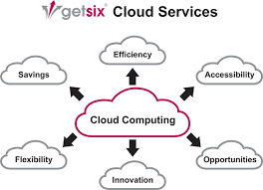

* Self-service provisioning. End users can spin up compute resources for almost any type of workload on demand. An end user can provision computing capabilities, such as server time and network storage, eliminating the traditional need for IT administrators to provision and manage compute resources.
* Elasticity. Companies can freely scale up as computing needs increase and scale down again as demands decrease. This eliminates the need for massive investments in local infrastructure, which might or might not remain active.
* Pay per use. Compute resources are measured at a granular level, enabling users to pay only for the resources and workloads they use.
* Workload resilience. CSPs often implement redundant resources to ensure resilient storage and to keep users' important workloads running -- often across multiple global regions.
* Migration flexibility. Organizations can move certain workloads to or from the cloud -- or to different cloud platforms -- as desired or automatically for better cost savings or to use new services as they emerge.
* Broad network access. A user can access cloud data or upload data to the cloud from anywhere with an internet connection using any device.

## Explain various service models of cloud computing with examples

There are the following three types of cloud service models -

1. Infrastructure as a Service (IaaS)

IaaS is also known as Hardware as a Service (HaaS). It is a computing infrastructure managed over the internet. The main advantage of using IaaS is that it helps users to avoid the cost and complexity of purchasing and managing the physical servers.

There are the following characteristics of IaaS -

* Resources are available as a service
* Services are highly scalable
* Dynamic and flexible
* GUI and API-based access
* Automated administrative tasks

Example: DigitalOcean, Linode, Amazon Web Services (AWS), Microsoft Azure, Google Compute Engine (GCE), Rackspace, and Cisco Metacloud.

1. Platform as a Service (PaaS)

PaaS cloud computing platform is created for the programmer to develop, test, run, and manage the applications.

There are the following characteristics of PaaS -

* Accessible to various users via the same development application.
* Integrates with web services and databases.
* Builds on virtualization technology, so resources can easily be scaled up or down as per the organization's need.
* Support multiple languages and frameworks.
* Provides an ability to "Auto-scale".

Example: AWS Elastic Beanstalk, Windows Azure, Heroku, Force.com, Google App Engine, Apache Stratos, Magento Commerce Cloud, and OpenShift.

1. Software as a Service (SaaS)

SaaS is also known as "on-demand software". It is a software in which the applications are hosted by a cloud service provider. Users can access these applications with the help of internet connection and web browser.

There are the following characteristics of SaaS -

* Managed from a central location
* Hosted on a remote server
* Accessible over the internet
* Users are not responsible for hardware and software updates. Updates are applied automatically.
* The services are purchased on the pay-as-per-use basis

Example: BigCommerce, Google Apps, Salesforce, Dropbox, ZenDesk, Cisco WebEx, ZenDesk, Slack, and GoToMeeting.

## 

## Explain various deployment models of cloud computing

The cloud deployment model identifies the specific type of cloud environment based on ownership, scale, and access, as well as the cloud’s nature and purpose. The location of the servers you’re utilizing and who controls them are defined by a cloud deployment model. It specifies how your cloud infrastructure will look, what you can change, and whether you will be given services or will have to create everything yourself. Relationships between the infrastructure and your users are also defined by cloud deployment types.

Different types of cloud computing deployment models are:

1. Public cloud

The public cloud makes it possible for anybody to access systems and services. The public cloud may be less secure as it is open for everyone. The public cloud is one in which cloud infrastructure services are provided over the internet to the general people or major industry groups. The infrastructure in this cloud model is owned by the entity that delivers the cloud services, not by the consumer. It is a type of cloud hosting that allows customers and users to easily access systems and services. This form of cloud computing is an excellent example of cloud hosting, in which service providers supply services to a variety of customers. In this arrangement, storage backup and retrieval services are given for free, as a subscription, or on a per-use basis. Example: Google App Engine etc.

1. Private cloud

The private cloud deployment model is the exact opposite of the public cloud deployment model. It’s a one-on-one environment for a single user (customer). There is no need to share your hardware with anyone else. The distinction between private and public cloud is in how you handle all of the hardware. It is also called the “internal cloud” & it refers to the ability to access systems and services within a given border or organization. The cloud platform is implemented in a cloud-based secure environment that is protected by powerful firewalls and under the supervision of an organization’s IT department.

The private cloud gives the greater flexibility of control over cloud resources.

1. Hybrid cloud

By bridging the public and private worlds with a layer of proprietary software, hybrid cloud computing gives the best of both worlds. With a hybrid solution, you may host the app in a safe environment while taking advantage of the public cloud’s cost savings. Organizations can move data and applications between different clouds using a combination of two or more cloud deployment methods, depending on their needs.

1. Community cloud

It allows systems and services to be accessible by a group of organizations. It is a distributed system that is created by integrating the services of different clouds to address the specific needs of a community, industry, or business. The infrastructure of the community could be shared between the organization which has shared concerns or tasks. It is generally managed by a third party or by the combination of one or more organizations in the community.

1. Multi-cloud

We’re talking about employing multiple cloud providers at the same time under this paradigm, as the name implies. It’s similar to the hybrid cloud deployment approach, which combines public and private cloud resources. Instead of merging private and public clouds, multi-cloud uses many public clouds. Although public cloud providers provide numerous tools to improve the reliability of their services, mishaps still occur. It’s quite rare that two distinct clouds would have an incident at the same moment. As a result, multi-cloud deployment improves the high availability of your services even more.

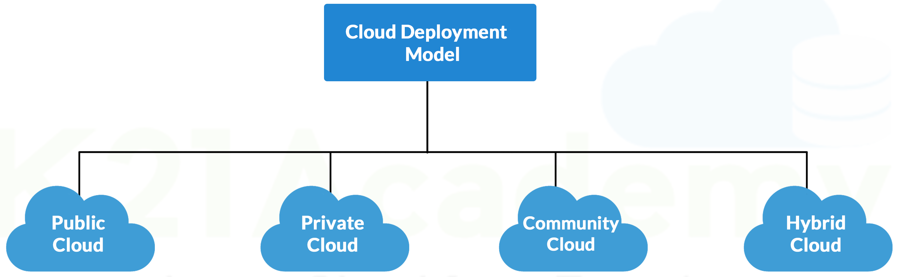

## Advantages and disadvantages of cloud computing

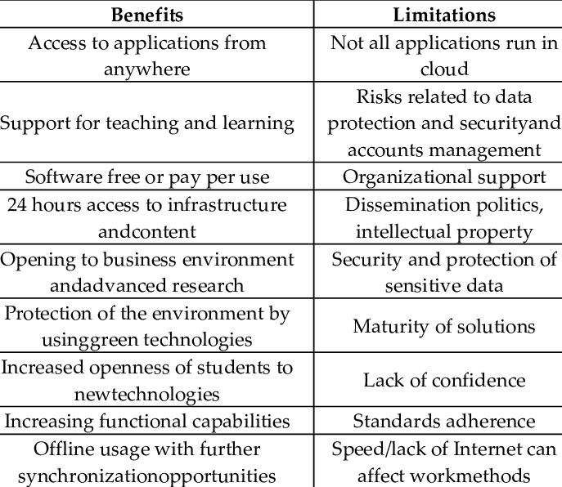

# **Conclusion:**

## Which factors to consider before opting for Cloud Computing

Here are seven critical questions you should ask when choosing a cloud computing provider.

1. What cloud computing services do you provide?
2. How secure is your cloud computing?
3. Where will my data be stored?
4. How will my business be able to access the cloud?
5. What is your pricing structure?
6. How do you handle regulatory compliance?
7. What customer support services do you offer?

# **References:**

1. <https://searchcloudcomputing.techtarget.com/definition/cloud-computing>
2. [What is Cloud Computing? Everything You Need to Know](https://searchcloudcomputing.techtarget.com/definition/cloud-computing)
3. [Benefits of Cloud Computing - Denmark | IBM](https://www.ibm.com/in-en/cloud/learn/benefits-of-cloud-computing)
4. <https://www.quora.com/What-is-the-need-for-cloud-computing>
5. [Cloud Deployment Models - GeeksforGeeks](https://www.geeksforgeeks.org/cloud-deployment-models/)
6. <https://www.accenture.com/in-en/insights/cloud-computing-index>
7. [7 things to consider when choosing a cloud computing provider](https://www.isgtech.com/7-things-to-consider-when-choosing-a-cloud-computing-provider/)
8. [Difference between Virtual Machines and Containers - GeeksforGeeks](https://www.geeksforgeeks.org/difference-between-virtual-machines-and-containers/)