**EXPERIMENT 02: Installation of Operating System on Virtual Machine**

CLASS: BE CMPN A 2 ROLL NO. : 18

NAME: REBECCA DIAS PID: 182027

**Aim:** Installation of Operating System on Virtual Machine.

**Theory:**

1. Explain virtualization and types of Virtualization.

Virtualization is the "creation of a virtual (rather than actual) version of something, such as a server, a desktop, a storage device, an operating system or network resources".

In other words, Virtualization is a technique, which allows to share a single physical instance of a resource or an application among multiple customers and organizations. It does by assigning a logical name to a physical storage and providing a pointer to that physical resource when demanded.

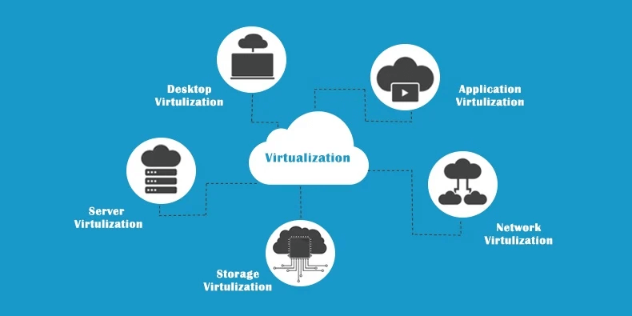

Types of Virtualization:

1. Hardware Virtualization.

When the virtual machine software or virtual machine manager (VMM) is directly installed on the hardware system is known as hardware virtualization.

The main job of hypervisor is to control and monitoring the processor, memory and other hardware resources.

After virtualization of hardware system we can install different operating system on it and run different applications on those OS.

Usage:

Hardware virtualization is mainly done for the server platforms, because controlling virtual machines is much easier than controlling a physical server.

1. Operating system Virtualization.

When the virtual machine software or virtual machine manager (VMM) is installed on the Host operating system instead of directly on the hardware system is known as operating system virtualization.

Usage:

Operating System Virtualization is mainly used for testing the applications on different platforms of OS.

1. Server Virtualization.

When the virtual machine software or virtual machine manager (VMM) is directly installed on the Server system is known as server virtualization.

Usage:

Server virtualization is done because a single physical server can be divided into multiple servers on the demand basis and for balancing the load.

1. Storage Virtualization.

Storage virtualization is the process of grouping the physical storage from multiple network storage devices so that it looks like a single storage device.

Storage virtualization is also implemented by using software applications.

Usage:

Storage virtualization is mainly done for back-up and recovery purposes.

1. Explain Hypervisor in detail (Host and Bare Metal Hypervisor)
2. What is a Virtual Box?

Oracle VM VirtualBox (formerly Sun VirtualBox, Sun xVM VirtualBox and Innotek VirtualBox) is a type-2 hypervisor for x86 virtualization developed by Oracle Corporation.

VirtualBox may be installed on Microsoft Windows, macOS, Linux, Solaris and OpenSolaris. There are also ports to FreeBSD and Genode. It supports the creation and management of guest virtual machines running Windows, Linux, BSD, OS/2, Solaris, Haiku, and OSx86, as well as limited virtualization of macOS guests on Apple hardware.For some guest operating systems, a "Guest Additions" package of device drivers and system applications is available, which typically improves performance, especially that of graphics, and allows changing the resolution of the guest OS automatically when the window of the virtual machine on the host OS is resized.

Users of VirtualBox can load multiple guest OSes under a single host operating-system (host OS). Each guest can be started, paused and stopped independently within its own virtual machine (VM). The user can independently configure each VM and run it under a choice of software-based virtualization or hardware assisted virtualization if the underlying host hardware supports this. The host OS and guest OSs and applications can communicate with each other through a number of mechanisms including a common clipboard and a virtualized network facility. Guest VMs can also directly communicate with each other if configured to do so

1. Role of Virtualization in cloud computing

Virtualization software allows multiple operating systems and applications to run on the same server at the same time, and, as a result, lowers costs and increases efficiency of a company’s existing hardware. It’s a fundamental technology that powers cloud computing.

Virtualization thus emulates hardware. Cloud computing is a service that results from that manipulation and is an external service. Cloud computing almost always assumes virtualization of certain resources (storage or data) that will be then delivered to the customer on-demand.

1. Advantage and limitation of virtualization

The Advantages of Virtualization

1. It is cheaper.

Because virtualization doesn’t require actual hardware components to be used or installed, IT infrastructures find it to be a cheaper system to implement. There is no longer a need to dedicate large areas of space and huge monetary investments to create an on-site resource. You just purchase the license or the access from a third-party provider and begin to work, just as if the hardware were installed locally.

2. It keeps costs predictable.

Because third-party providers typically provide virtualization options, individuals and corporations can have predictable costs for their information technology needs. For example: the cost of a Dell PowerEdge T330 Tower Server, at the time of writing, is $1,279 direct from the manufacturer. In comparison, services provided by Bluehost Web Hosting can be a slow as $2.95 per month.

3. It reduces the workload.

Most virtualization providers automatically update their hardware and software that will be utilized. Instead of sending people to do these updates locally, they are installed by the third-party provider. This allows local IT professionals to focus on other tasks and saves even more money for individuals or corporations.

4. It offers a better uptime.

Thanks to virtualization technologies, uptime has improved dramatically. Some providers offer an uptime that is 99.9999%. Even budget-friendly providers offer uptime at 99.99% today.

5. It allows for faster deployment of resources.

Resource provisioning is fast and simple when virtualization is being used. There is no longer a need to set up physical machines, create local networks, or install other information technology components. As long as there is at least one point of access to the virtual environment, it can be spread to the rest of the organization.

The Disadvantages of Virtualization

1. It can have a high cost of implementation.

The cost for the average individual or business when virtualization is being considered will be quite low. For the providers of a virtualization environment, however, the implementation costs can be quite high. Hardware and software are required at some point and that means devices must either be developed, manufactured, or purchased for implementation.

2. It still has limitations.

Not every application or server is going to work within an environment of virtualization. That means an individual or corporation may require a hybrid system to function properly. This still saves time and money in the long run, but since not every vendor supports virtualization and some may stop supporting it after initially starting it, there is always a level of uncertainty when fully implementing this type of system.

3. It creates a security risk.

Information is our modern currency. If you have it, you can make money. If you don’t have it, you’ll be ignored. Because data is crucial to the success of a business, it is targeted frequently. The average cost of a data security breach in 2017, according to a report published by the Ponemon Institute, was $3.62 million. For perspective: the chances of being struck by lightning are about 1 in a million. The chances of experiencing a data breach while using virtualization? 1 in 4.

4. It creates an availability issue.

The primary concern that many have with virtualization is what will happen to their work should their assets not be available. If an organization cannot connect to their data for an extended period of time, they will struggle to compete in their industry. And, since availability is controlled by third-party providers, the ability to stay connected in not in one’s control with virtualization.

**Installation of Operating System on Virtual Machine:**

Explain steps to install OS on VM using KVM/Virtual Box with screenshots.

**Conclusion:**

Criteria to select specific type of Hypervisor

How to resolve limitations of Virtualization.

Security primitives must be available on commodity computers with demonstrable assurance and understandable by

ordinary users with minimum effort. Trusted computing bases comprising

a hypervisor, which implements the reference monitor, and virtual machines whose layered operating system services are formally verified, will

continue to fail these criteria for client-side commodity computers. We argue that demonstrable high assurance will continue to elude commodity

computers, and complex policies that require management of multiple

subjects, object types, and permissions will continue to be misunderstood and misused by most users. We also argue that high-assurance,

usable commodity computers require only two security primitives: partitions for isolated code execution, and trustworthy communication between

partitions and between users and partitions

**References:**

<https://vittana.org/14-advantages-and-disadvantages-of-virtualization>

<https://www.infopulse.com/blog/what-is-the-role-of-virtualization-in-cloud-based-services/>

<http://blog.gdhconsulting.com/blog/7-common-virtualization-challenges-and-how-to-overcome-them>