**St. Francis Institute of Technology**

**Department of Computer Engineering**

**Academic Year: 2021-2022 Semester: VIII**

**Subject: Cloud Computing Lab Class / Branch / Division: BE/CMPN/A**

Name :-Rebecca Dias Roll Number:18

**Experiment No: 05**

# Aim: Implement Storage as a Service.

# Theory:

Storage as a Service or STaaS is cloud storage that you rent from a Cloud Service Provider (CSP) and that provides basic ways to access that storage. Enterprises, small and medium businesses, home offices, and individuals can use the cloud for multimedia storage, data repositories, data backup and recovery, and disaster recovery. There are also higher-tier managed services that build on top of STaaS, such as Database as a Service, in which you can write data into tables that are hosted through CSP resources.

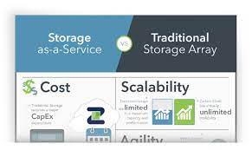

The key benefit to STaaS is that you are offloading the cost and effort to manage data storage infrastructure and technology to a third-party CSP. This makes it much more effective to scale up storage resources without investing in new hardware or taking on configuration costs. You can also respond to changing market conditions faster. With just a few clicks you can rent terabytes or more of storage, and you don’t have to spin up new storage appliances on your own.

Today, most STaaS providers will make use of a public cloud to store data. Utilizing cloud storage has many advantages, and not least the fact that cloud-based storage is easier to integrate with cloud-based applications that rely on these data. If companies are using cloud-based accounting software, for instance, linking this to a cloud-based STaaS system can reduce the latency required to work with these data.

Cloud-based STaaS also offers customers a wide range of functionality and additional services that can be performed without the expertise of a storage engineer. These include disaster recovery, data backup, data storage, bulk data transferred, block storage, and SSD storage to name a few.

The Advantages of StaaS

There are many advantages to using STaaS over traditional on-premises storage models:

* Storage costs will typically be lower, especially for SMEs that are unable to afford the hardware required for on-prem storage.
* Files are synced between local and cloud storage easily and frequently, so you’ll always have access to the most up-to-date data.
* Quality STaaS providers will also offer disaster recovery plans and capabilities that will help you get back to business quickly.
* STaaS solutions are also inherently scalable, and you only need to pay for the resources utilized.
* As long as you or your STaaS provider are using a secure cloud data system, STaaS can be a more secure solution than an on-prem storage system. However, the level of security offered by cloud providers can vary significantly, so make sure that you understand the level of protection they will afford your data.

The Disadvantages of StaaS

* If you exceed the amount of storage that is described in your contract, you could run into extra costs, and these may be significant.
* Potential downtime can also be a problem – since you do not have control of the servers which store your data, you will be reliant on your STaaS provider.
* Limited customization, since cloud infrastructure is owned and managed by the service provider.

# Activity:

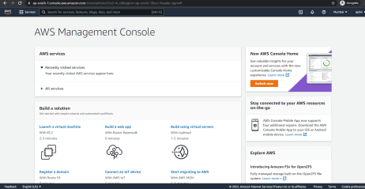

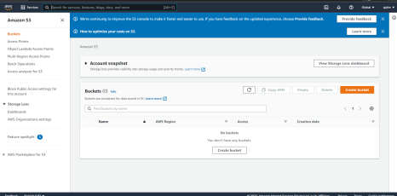

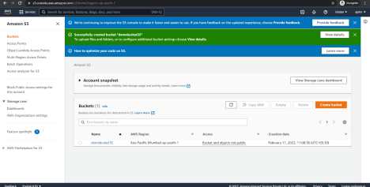

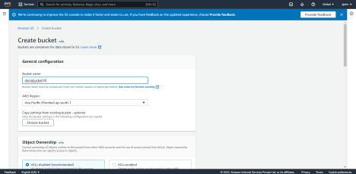

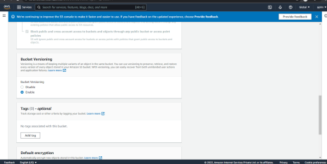

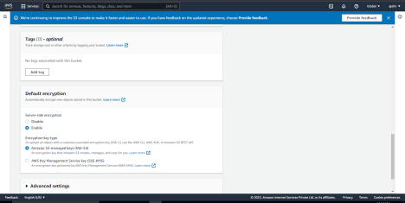

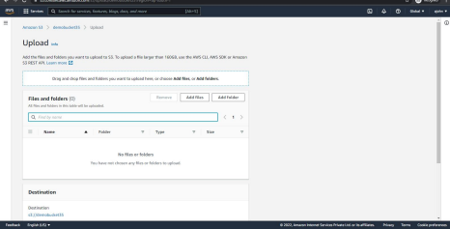

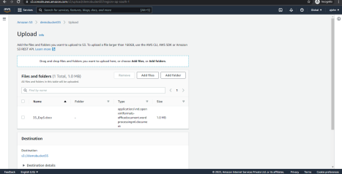

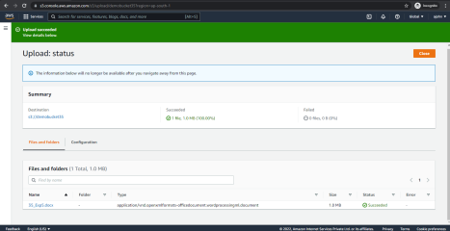

**VOLUMES: -**

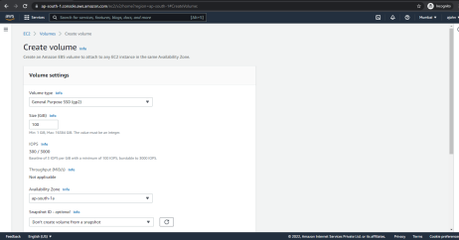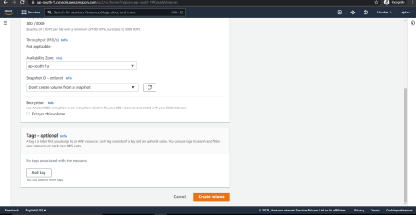

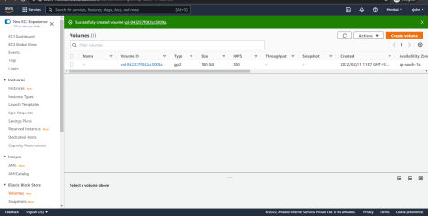

# Conclusion:

# Implemented Storage as a Service.

# References:

1. [Examples - ownCloud case study](https://uwe.pst.ifi.lmu.de/exampleownCloud.html)
2. [Pros and Cons of ownCloud 2022](https://www.trustradius.com/products/owncloud/reviews?qs=pros-and-cons)
3. [ownCloud Review: Pricing, Pros, Cons & Features | CompareCamp.com](https://comparecamp.com/owncloud-review-pricing-pros-cons-features/)
4. [Frequently asked questions (FAQs) around ownCloud](https://owncloud.com/faq/)
5. [ownCloud - Wikipedia](https://en.wikipedia.org/wiki/OwnCloud)