**St. Francis Institute of Technology**

**Department of Computer Engineering**

**Academic Year: 2021-2022 Semester: VIII**

**Subject: Human Machine Interaction Class / Branch / Division: BE/CMPN/A**

Name :-Rebecca Dias Roll Number:18

**Experiment No: 03**

**Aim:-** Identify and evaluate usability value of an e-learning website. Usability Measurement tool for E-learning(UMTEL) .

**I-OBJECTIVE**

1. To describe website usability criteria.

2. To learn how to identify usability problems in a website.

3. To use an online usability measurement scale for finding usability value of an e-learning website.

4. To compute the extent of conformance to usability norms for various website design parameters of an e-learning site.

**II-THEORY**

**Human Computer Interaction and E-learning**

E-learning course cannot be effective unless we understand the human factors like the learner’s psychology, learning needs and behavior. HCI studies in this area attempt to explore learning interfaces, pedagogy and learning experience design.

**What is E-learning?**

**E-learning** is the mode of learning through electronically supported teaching material. In a larger context it makes use of information and communication technology (ICT) to build a online learning community by connecting knowledge centers to distant learners. E-learning is looked upon as the most flexible and cost-effective mode of learning anytime, anywhere at your own pace mainly out-side class-room set-up.

**Generic website usability criteria**

**1. Accessibility:** Making users with disabilities perceive, understand, navigate, and interact with the website. In short avoiding anything that might keep a visitor from being able to access the information on a website. Few checklist points are mentioned below …..

● Site load-time should be reasonable ( avoid flash & add-ons )

● Text-to-background contrast should be adequate for readability

● Font size/spacing should be easy to read

● Images should have appropriate ALT tags.

● Site should have a custom not-found/404 page.

**2. Identity :** A website should quickly and clearly project its identity , its goals and its trustworthiness to the user. Few checklist points are mentioned below

● Company logo should be prominently placed

● Use of tagline is recommended to make company's purpose clear

● Use of tagline is recommended to make company's purpose clear

● User should get the company information quickly

● User should get contact information quickly

**3. Navigation :** User should be able to view contents of his relevance and interest with less efforts. Information architecture and navigation guidelines plays a vital role. Few checklist points are mentioned below …..

● Main navigation items should be easily identifiable

● Labels to navigation items should be clear & concise

● Number of buttons/links should be reasonable

● Links should be consistent & easy to identify

● Support user with site search feature for easy access

**4. Content :** Content is the most important part. Content needs to be consistent, organized, and easy to navigate through . Few checklist points are mentioned below …..

● Headings should be clear & descriptive

● Styles & colors need to be consistent

● Emphasis (bold, etc.) should be sparingly used

● Content should be concise , to-the-point & self-explaining

● URLs should be meaningful & user-friendly

**Pedagogic Usability**

***Pedagogic Usability denotes whether the tools , content , interface and tasks of the e-learning environment support various learners to learn in various learning contexts according to selected pedagogical objectives.***

There are several layers of website usability in context of learning like context-specific, pedagogic, general and technical usability. This is as shown below

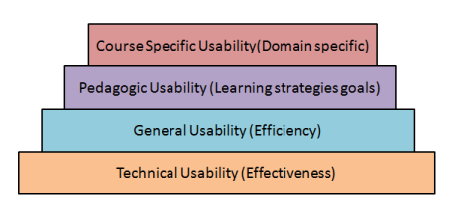

Figure 3.1 layers of website usability

**Pedagogical usability** should be the focal point of e-learning design. The academic content comprises of the learning objects while the pedagogy means learning strategies and mechanisms.

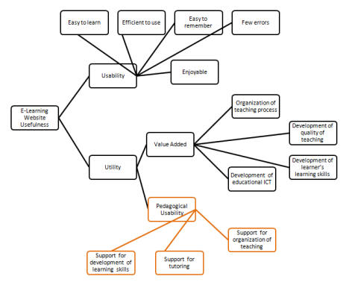

Figure 3.2 E-learning websites usefulness

[1]. Image reference : Silius, K. and Tervakari, A. "A multidisciplinary tool for the evaluation of usability,pedagogical usability, accessibility and informational quality of web-based courses *" The Eleventh International PEG.* (2003)

**III-PROCEDURE**

**Steps**

1. In this experiment, you will be using an online tool named UMTEL to evaluate usability of an e-learning web-site of your choice ( target website).

2. The online Usability Measurement Tool for E-Learning Sites ( UMTELS ) is composed of six sets of checklists.

3. These checklists belong to the following categories.

a) Content & Readability b) Navigation c) UI Design

d) Performance e)Pedagogy I f)Pedagogy II

4. Each check-list has six statements.

5. The checklist statement describes usability aspect of the website for a specific category. ( Refer to the a screenshot of the tool in figure below )

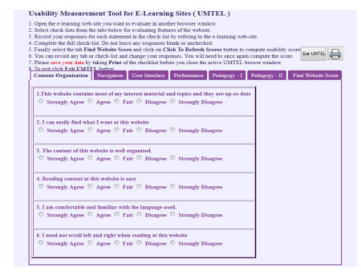Figure 3.3 UMTEL tool screenshot

6. You are supposed to inspect the target website and judge to what extent do you feel that the statement shown in the tool is correct for that website.

7. Record your response whether you strongly agree , agree , fair , disagree or strongly disagree to the statement - by checking the relevant radio button below the statement.( Refer to the figure above )

8. Your response to each statement in the checklist will be assigned points by the tool automatically as follows

Table 3.1 Response table

| **Response** | **Strongly Agree** | **Agree** | **Fair** | **Disagree** | **Strongly Disagree** |
| --- | --- | --- | --- | --- | --- |
| Point | 1.00 | 0.75 | 0.50 | 0.25 | 0.00 |

9.You can view some illustrations from the table below to get an idea of the usability evaluation. 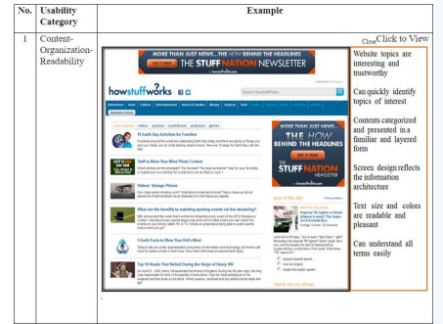

Figure 3.4 usability evaluation for Content Organization Readability

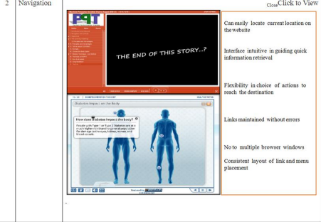

Figure 3.5 usability evaluation for Navigation

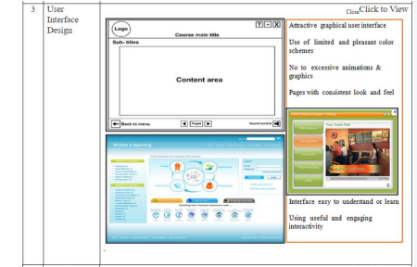Figure 3.6 usability evaluation for User Interface Design

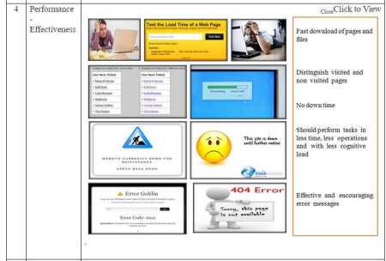Figure 3.7 usability evaluation for Performance Effectiveness

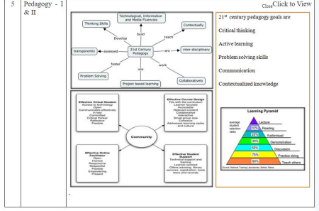Figure 3.8 usability evaluation for Pedagogy I and II

10.After you finish recording your responses for a category, you can move to the next category in the tool by clicking on the relevant tab within the tool. You may review the website in any sequence you wish.

11. After you finish reviewing the target website using all six checklists in the tool you can view the results by clicking the tab *“Find Website Score”.* You will need to press another button *“Click To Refresh Scores”* to see the usability scores. The result table will display total points for each category and its usability level as shown in the image below. On the right hand side you will see a level indicator which indicates summed up scores in a graphical form. When one has multiple sites to compare such a level indicator gives a visual understanding of sites in comparison to each other.

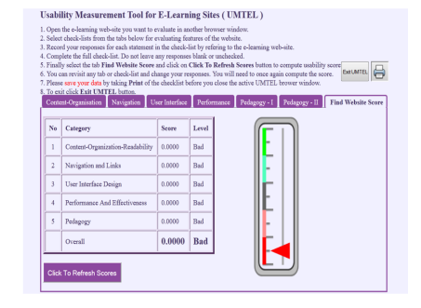Figure 3.9 Final result of the website score

12. Usability level for each category is assigned using the table below.

Table 3.2 Usability points and levels

| **Usability points** | **0<=X<=0.2** | **0.2<X<=0.4** | **0.4<X<=0.6** | **0.6<X<=0.8** | **0.8<X<=1.0** |
| --- | --- | --- | --- | --- | --- |
| Usability Level | Poor | Bad | Moderate | Good | Excellent |

**Note :** Your responses will not be stored in any database and will be available till the tool is there in the active browser window. If you close the browser window all your responses will be lost and you will have to fill up the responses again. There fore it is suggested to take a screen shot of each checklist and the final results after you finish recording your responses. You can use these screen shot to write your final usability report of a e-learning site.

**IV-TOOL/TOOLS**

An Usability Measurement Tool for E-Learning (UMTEL) was developed in house by the authors of Shakshat Virtual Lab at Indian Institute of Technology Guwahati to assist novice usability evaluators to evaluate the virtual laboratory's learning experience. (fig. 7 and fig.8 ) It was developed

using PhP, Mysql and Html programming languages. The tool records responses of evaluators to five categories of questions relevant to usability parameters. These categories are C1-Content / Organization and Readability ; C2- Navigation and Links ; C3- User Interface Design ; C4- Performance and Effectiveness ; C5-Pedagogic Usability. The responses to the questions were recorded using a semantic scale

**V-IMPLEMENTATION**

**Simulator**

To activate the UMTEL tool

**Simulator**

**https://hci-iitg.vlabs.ac.in/umtel_simulator.html**

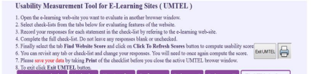Figure 3.10 Steps to use the UMTEL tool

Open https://www.coursera.org/

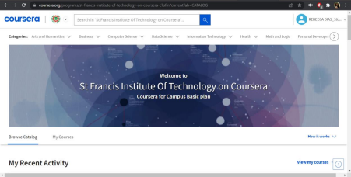

Figure 3.11.1 Coursera website

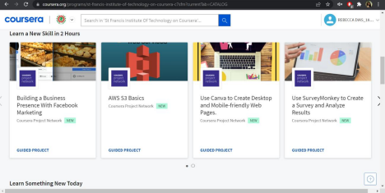

Figure 3.11.2 Coursera website

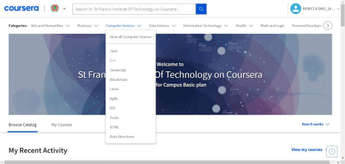Figure 3.11.3 Coursera website

a) Open the e-learning web-site you want to evaluate in another browser window. b) Select check-lists from the tabs below for evaluating features of the website. c) Record your response for each statement in the check-list by referring to the e-learning web-site. d) Complete the full check-list.Do not leave any response blank or unchecked. e) Finally select the tab Find Website Score and click on Click To Refresh Scores button to compute usability score.

f) You can revisit any tab or check-list and change your responses. You will need to once

again compute the score.

g) Please save your data by taking print of the checklist before you close the active UMTEL browser window.

h) To exit click EXIT UMTEL button

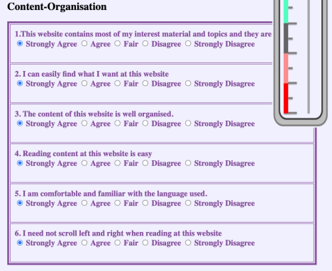Figure 3.12 Content Organization tab

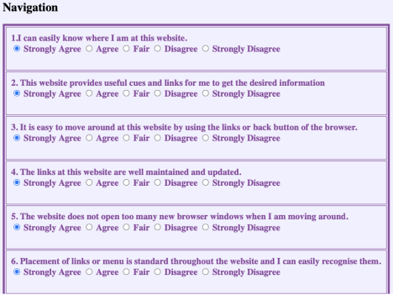Figure 3.13 Navigation tab

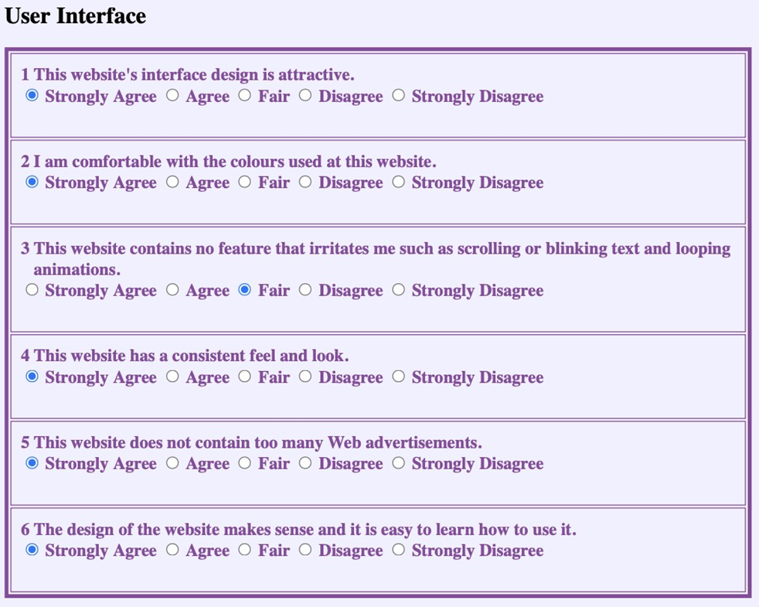

Figure 3.14 User Interface tab

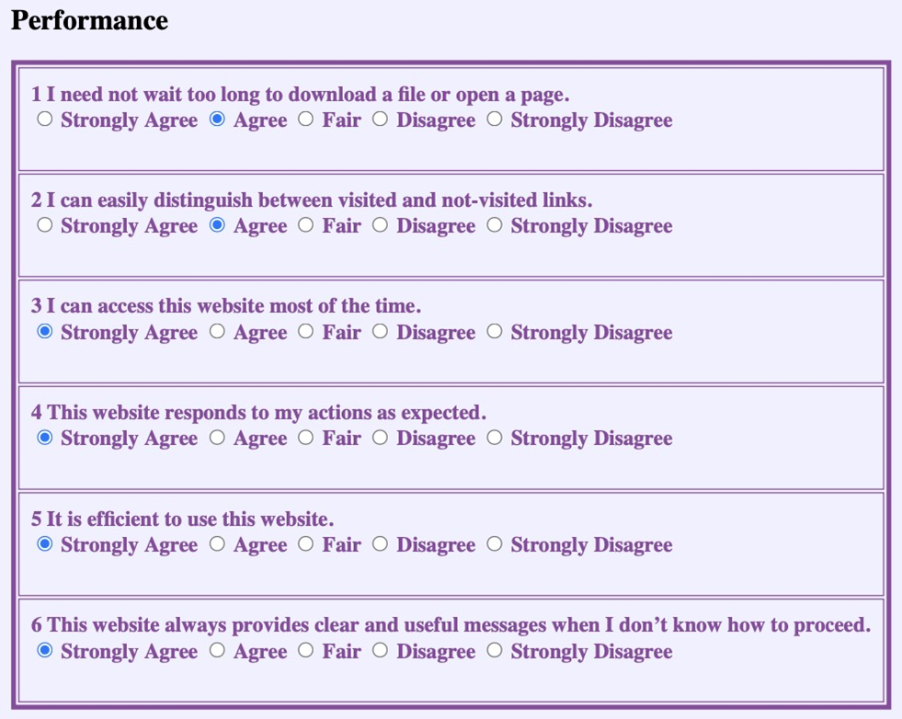

Figure 3.15 Performance tab

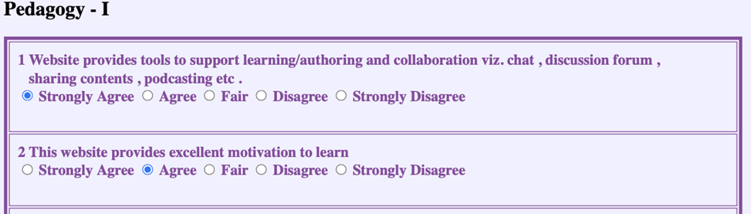

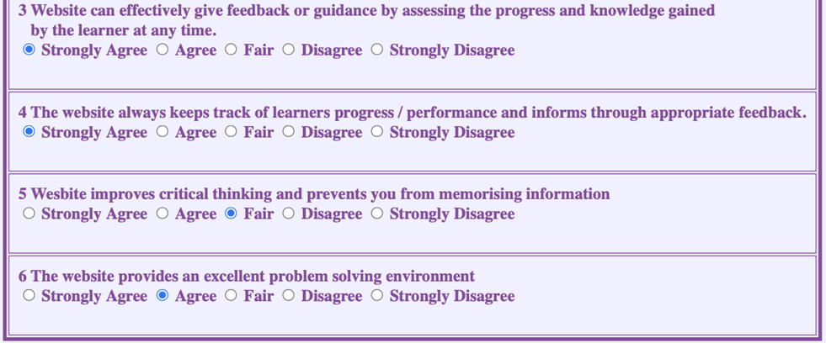

Figure 3.16 Pedadogy-I tab

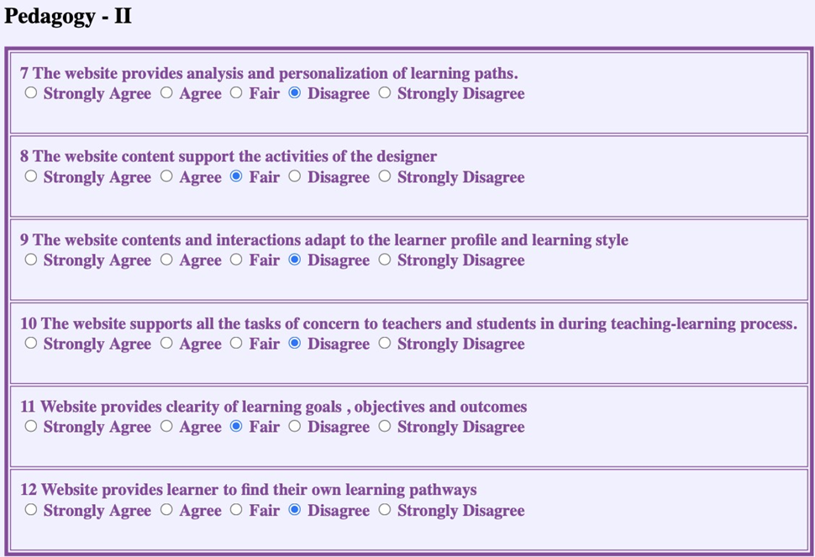

Figure 3.17 Pedadogy-II tab

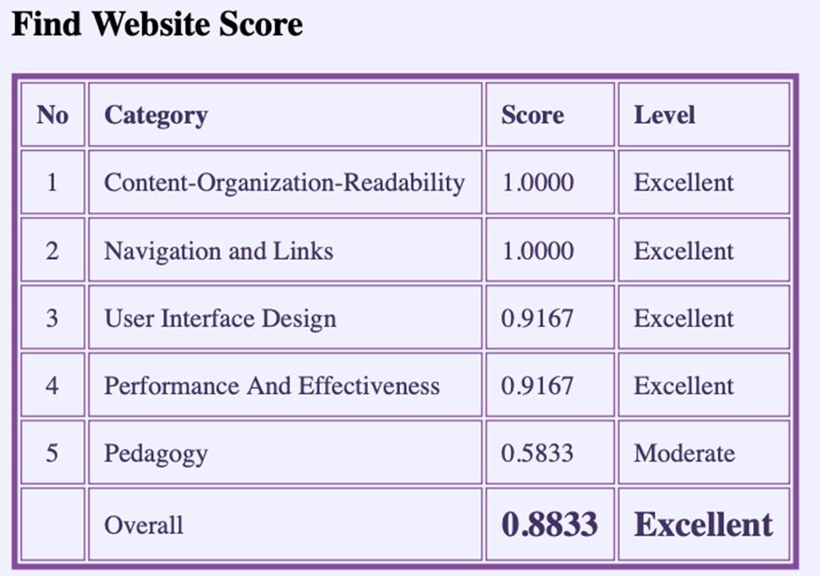



Figure 3.17 Website score table

**VI-CONCLUSION**

Identified and evaluated usability values of an e-learning website using Usability Measurement tool for E-learning(UMTEL)

**VII- REFERNCES**

**https://hci-iitg.vlabs.ac.in/umtel.html**

**https://www.crazyegg.com/blog/principles-website-usability/**