**St. Francis Institute of Technology**

**Department of Computer Engineering**

**Academic Year: 2021-2022 Semester: VIII**

**Subject: Human Machine Interaction Class / Branch / Division: BE/CMPN/A**

Name :-Rebecca Dias Roll Number:18

**Experiment No: 07**

**Aim:-** Learn the importance of menu and navigation

**I-OBJECTIVE**

To develop system menus and navigation schemes.

**II-THEORY**



alternatives the user has at appropriate points. These listings of choices are commonly called



the user in developing a mental model of the system Menus are effective because they utilize the



Working with menus reminds people of available options and information that they may not be



windows. When selected, a graphical menu item may lead to another menu, cause a window to



system presents a variety of menu styles to choose from. Included are entities commonly called



graphical and textual toolbars. In this experiment we have used online tool weebly.

**III-PROCEDURE**

# Student’s task:

Considering your application as a sample, design menu and navigational scheme for your application. Students are required to submit one version of menu and navigational scheme design.

# Guidelines:

While designing menus for GUI application, students must consider following

1. Choosing a proper menu structure suitable for the application
2. Proper ordering and grouping of menus
3. Use of line separators
4. Providing short cuts for menus using keyboard equivalents
5. Use of keyboard accelerators
6. Choosing appropriate menu titles.
7. Use of intent indicators
8. Providing defaults
9. Use of toggle menus wherever required.

For web based applications

1. Provide a global navigation bar at the top of each page.
2. Provide a local category or topical links navigation bar on the left side of a page.
3. Place minor illustrative, parenthetical, or footnote links at the end of the page.
4. For long pages, provide a navigation bar repeating important global or local links at the page bottom.

Examples:



# Figure1:Command button navigation bar



**Figure2 : Graphical or iconic navigation bar**

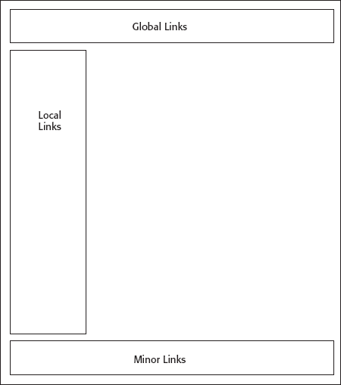

# Figure3: Web navigation component location

**IV-TOOL/TOOLS**

Wix.com Ltd. is a software company publicly listed in the US that provides cloud-based web development services. It allows users to create [HTML5](https://en.wikipedia.org/wiki/HTML5) websites and [mobile](https://en.wikipedia.org/wiki/Mobile_phone) sites through the use of online [drag and drop](https://en.wikipedia.org/wiki/Drag_and_drop) tools

**V-IMPLEMENTATION**

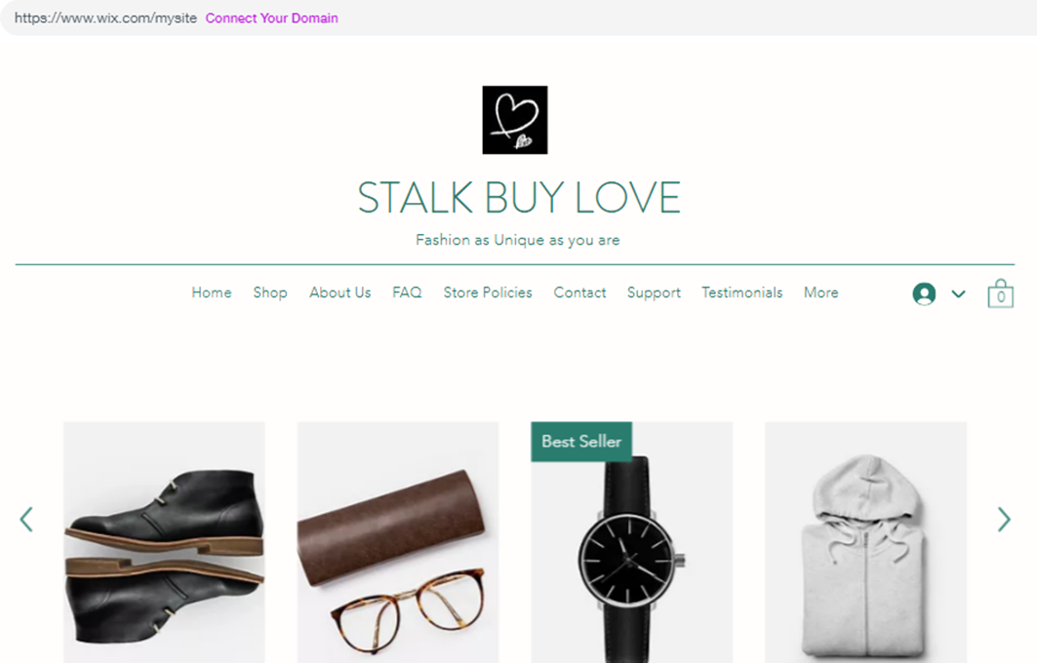

**Fig 5: Menu and Navigation**

**VI-CONCLUSION**

Thus we have developed an application using menus and navigation.

**VII- REFERNCES**

<https://www.justinmind.com/blog/navigation-design-almost-everything-you-need-to-know/>

<https://www.thecreativemomentum.com/blog/5-components-on-designing-the-ideal-navigation-bar>

[**https://www.wix.com**](https://www.wix.com)

**VIII-POST LAB QUESTION-ANSWER**

### Q 1What is navigation design?

Navigation design is the discipline of creating, analyzing and implementing ways for users to navigate through a website or app.

Navigation plays an integral role in how users interact with and use your products. It is how your user can get from point A to point B and even point C in the least frustrating way possible.

To make these delightful interactions, designers employ a combination of design patterns including links, labels and other UI elements. These patterns provide relevant information and make interacting with products easier.

* Good navigation design can:
* Enhance a user’s understanding
* Give them confidence using your product
* Provide credibility to a product

The best kind of navigation design is one which promotes usability. Poor navigation will result in fewer users for your product and this is why navigation design is central to user experience design.

Navigation design is complex and there are many design patterns to choose from when optimizing the user experience. A design pattern is a general, reusable solution to a problem.

No one pattern is necessarily better than the other. Each pattern that you use in your product will have to be carefully considered and tested before implementation.

This ensures that the navigation pattern you have chosen is right for your product but more importantly that it is right for your users.

## Q2 Explain Types of Navigation Menus

Typical navigation menus come in several varieties. While some of these choices are more common than others, they all have their own specialized purpose, and what may seem unworkable for one site might be the perfect choice for another.

### Horizontal Navigation Bar

The most common type of menu bar is the horizontal navigation. Users rely on this conventional menu to navigate their way around websites. While your more creative instincts might yearn for something unique, a standard top-oriented horizontal navigation bar is not just expected; the absence of one will normally frustrate your website visitors.

### Footer Navigation Bar

Another common menu-type is a bottom-oriented horizontal navigation menu. While this places navigation in a spot where users have to hunt for it, there are a couple cases in which a footer navigation bar is preferred.

### Vertical Navigation Bar

A vertical navigation menu is a modern option typically seen on mobile layouts. These are usually left-oriented but could be on either side of the screen to fit your website’s design.

### Responsive Menu Bar

While all menu bar designs should accommodate for mobile devices, there are some options that are designed just for that purpose. One of the most common is a hamburger menu, named for its icon’s three horizontal lines that resemble a hamburger.