**St. Francis Institute of Technology**

**Department of Computer Engineering**

**Academic Year: 2021-2022 Semester: VIII**

**Subject: Human Machine Interaction Class / Branch / Division: BE/CMPN/A**

Name :-Rebecca Dias Roll Number:18

**Experiment No: 08**

**Aim:-** Learn the use of statistical graphics.

**I-OBJECTIVE**

To learn and Make the use of statistical graphics

**II-THEORY**

# Description:

distortions by telling the truth about the data.

***Components of a Statistical Graphic***

Most statistical graphics have at least two axes, two scales, an area to present the data, a title, and sometimes a legend or key.

# Types of Statistical Graphics

—Curve and Line Graphs

—Surface Charts

—Scatter plots

—Bar Graphs

—Segmented or Stacked Bars

—Pie Charts

**III-PROCEDURE**

# Student’s task:

Considering your application as a sample, design statistical graphics application. Students are required to submit one version of statistical graphics application

# Guidelines:

While designing statistical graphics GUI application, students must consider following

1. Choosing the emphasized data
2. Minimize the non-data elements
3. 3 Minimize redundant data.
4. Show data variation, not design variation.
5. Provide the proper context for data interpretation.
6. Restrict the number of information-carrying dimensions depicted to the number of
7. Data dimensions being illustrated.
8. Employ data in multiple ways, whenever possible.
9. Maximize data density.
10. Employ simple data-coding schemes.
11. Avoid unnecessary embellishment of:

* Grids.
* Vibration.
* Ornamentation.

1. Fill the graph’s available area with data.

Example

.: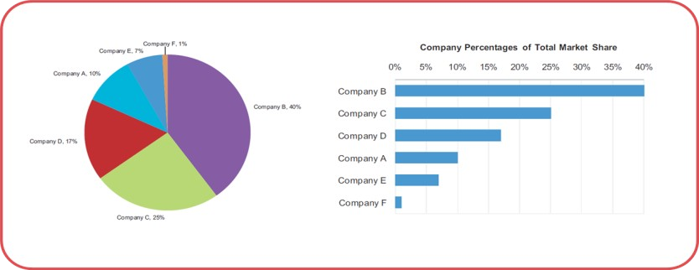

Figure 5.0: example of Pie Chart and Bar Chart

**Steps to create the Statastical Graph.**

* 1. Click Start---> All Programs------->Microsoft Office →Microsoft excel
  2. **Choose an existing spreadsheet by clicking "Open" in the "File" menu.** Create a new spreadsheet by clicking "New" in the document wizard or File menu.
  3. **Create a data series with a single independent variable.** Bar graphs are horizontal

charts that show numbers or data from 1 variable.

* + - Add the labels for the variable and the data at the top of the columns. For example, if you want to graph the number of tickets sold for each of the top 10 summer movie releases, you would write "Movie Title" on the top of the first column and "Tickets Sold" on top of the second column.
  1. **Consider adding a sub-data series in the third column.** With the bar graph function, you can use a clustered or stacked bar graph that shows a second number that is identified with the variable.
     + Make sure that the sub-data series is labeled at the top of the third column. Also, ensure that the data is given using the same format, such as dollars or numbers.
  2. **Highlight the entire series you have entered, including column titles.** Microsoft Excel will use your columns to separate the X and Y axis.
  3. **Click on the "Charts" tab of the horizontal user interface.** If you do not see the

"Charts" tab, go to the "Insert" menu and select "Charts" from the drop down menu.

* + - If you are using an older version of Microsoft Excel, you will need to go directly to the Insert menu and select "Charts" to access the chart wizard.
  1. **Click on the arrow next to the type of chart you would like to make.** If you want a traditional bar graph, you will choose "Bar." If you want a vertical graph, click the arrow next to "Column."
  2. **Select the type of bar graph you want from the choices available in the Bar menu.** You can choose 2-D, 3-D, Cylinder, Cone or Pyramid shaped bar graphs.
     + You can also choose to cluster or stack your bar graph to highlight a second type of data in your data series.

# Wait for the image of your graph to appear in the middle of your Excel sheet.

* 1. **Double click on the interior of your bar graph.**
  2. **Click through the options for fill, line, shadow, 3-D format and glow & soft edges to format your bar graph.** Click "Ok" when you are done formatting.
  3. **Double click the area near the exterior of your bar graph.** Choose a different font or formatting for the outside area of the graph. Click "Ok" after you make your

changes.

Click on "Alt Text" to name your graph and add a description. Click on "Properties" to choose the object positioning

# . Save your Excel sheet with your new bar graph.

**IV-TOOL/TOOLS**

[**https://itconnect.uw.edu/learn/workshops/online-tutorials/microsoft-office-2010/microsoft-excel-2010/**](https://itconnect.uw.edu/learn/workshops/online-tutorials/microsoft-office-2010/microsoft-excel-2010/)

# Excel

Microsoft Excel is a helpful and powerful program for data analysis and documentation. It is a spreadsheet program, which contains a number of columns and rows, where each intersection of a column and a row is a “cell.” Each cell contains one point of data or one piece of information. By organizing the information in this way, you can make information easier to find, and automatically draw information from changing data.

# Charts

Charts allow you to present data entered into a worksheet in a visual format, using a variety of graph types. Before you can make a chart you must first enter data into a worksheet.

**V-IMPLEMENTATION:**

**Dataset:**

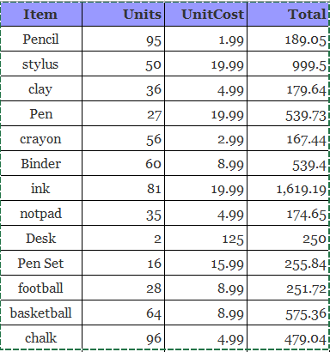

**Table 5.1: Items and their respective prices.**

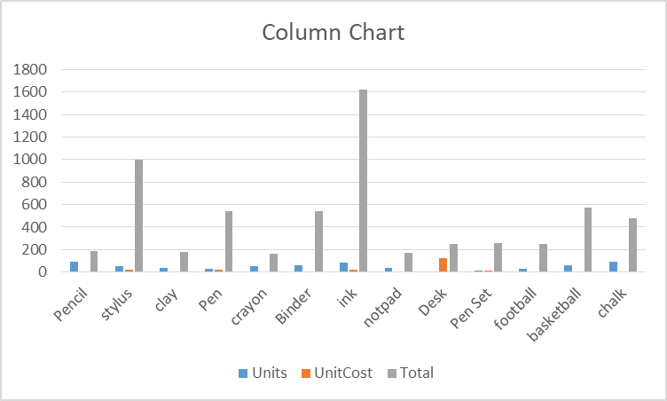

**Fig 5.1: Column Chart**

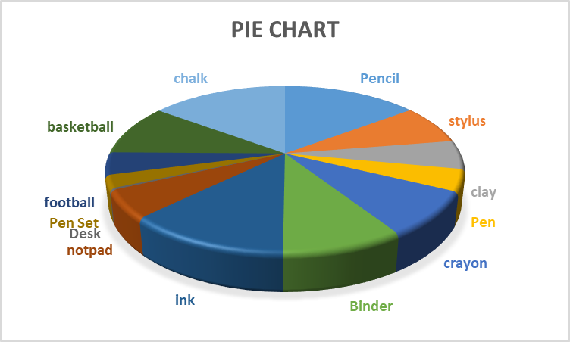

**Fig 5.2: Pie Chart**

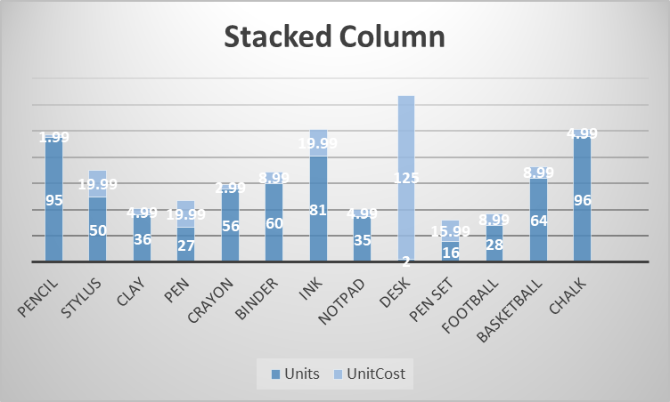

**Fig 5.3: Stacked Column Chart**

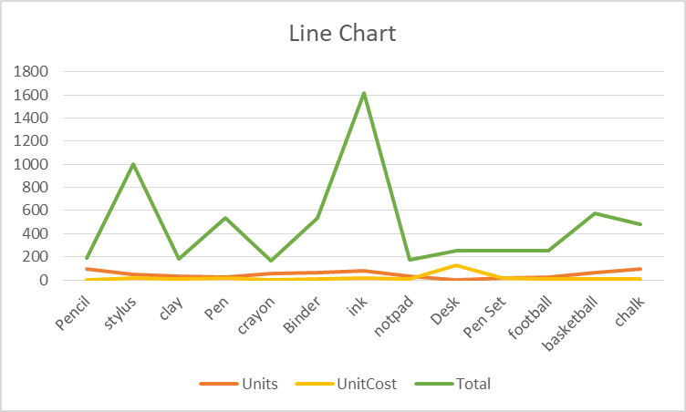

**Fig 5.4:Line Chart**

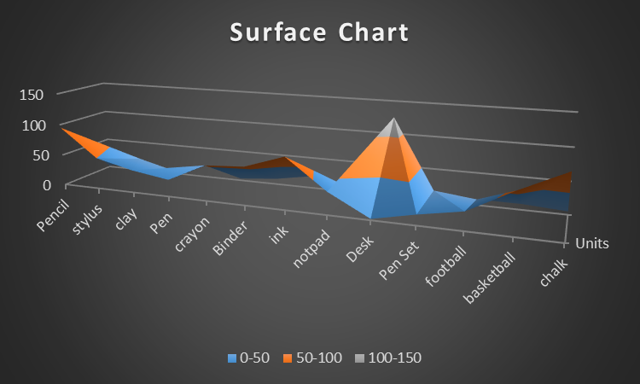

**Fig 5.5:Surface Chart**

**VI-CONCLUSION**

Thus we have studied the use of statistical graphic and implemented 5 statistical graphs.

**VII- REFERNCES**

[**https://byjus.com/maths/pie-chart/**](https://byjus.com/maths/pie-chart/)

[**https://www.thoughtco.com/frequently-used-statistics-graphs-4158380**](https://www.thoughtco.com/frequently-used-statistics-graphs-4158380)

[**https://itconnect.uw.edu/learn/workshops/online-tutorials/microsoft-office-2010/microsoft-excel-2010/**](https://itconnect.uw.edu/learn/workshops/online-tutorials/microsoft-office-2010/microsoft-excel-2010/)

**VIII-POST LAB QUESTION-ANSWER**

# Q1 Explain STATISTICAL GRAPHICS

# STATISTICAL GRAPHICS

Statistical graphs present data and the results of statistical analysis, assist in the analysis of data, and occasionally are used to facilitate statistical computation. Presentation graphs include the familiar bar graph, pie chart, line graph, scatterplot, and statistical map. Data analysis employs these graphical forms as well as others.