**St. Francis Institute of Technology**

**Department of Computer Engineering**

**Academic Year: 2021-2022 Semester: VIII**

**Subject: Human Machine Interaction Class / Branch / Division: BE/CMPN/A**

Name :-Rebecca Dias Roll Number:18

**Experiment No: 09**

**Aim:-** Understand the need of colors and animations. Develop UI for any application(eg: artists).

**I-OBJECTIVE**

**To understand and choose proper color and animation for UI for an artist.**

**II-THEORY**

# Description:

Color adds dimension, or realism, to screen usability. Color draws attention because it attracts a person’s eye. If used properly, it can emphasize the logical organization of information, facilitate the discrimination of screen components, accentuate differences among elements, and make displays more interesting. If used improperly, color can be distracting and possibly visually fatiguing, impairing the system’s usability.

Animation is a dynamic visual statement, form, and structure evolving through movement over time. Animations are popular objects that users encounter frequently, if not all the time. They have been used for different purposes and can be found in many computing environments, especially Web pages and online advertisements

**III-PROCEDURE**

# Student’s task:

Students have to develop UI for an artist: A celebrity in some form of art like music, dance, painting, martial arts, etc (not actors). This site will be used to display his works and should portray his character.

# Guidelines:

While choosing colors for display, one must consider these factors:

* The human visual system
* The possible problems that the colors’ use may cause
* The viewing environment in which the display is used
* The task of the user ,hardware on which the colors will be displayed. For the animation one must keep in mind.
* Do not Distract Attention from Salient Information
* Avoid Clutter
* Allow Appropriate Exposure Duration
* Manage the Positioning and Organization of Objects
* Adhere to Color Conventions
* Support Animation with Textual and Auditory Information
* Appreciate the Insights of Semiotics
* Comply with the Cooperative Maxims

**IV-TOOL/TOOLS**

**Wix.com Ltd.**  is an [Israeli](https://en.wikipedia.org/wiki/Israel) software company, providing cloud-based web development services. It allows users to create [HTML5](https://en.wikipedia.org/wiki/HTML5) websites and [mobile](https://en.wikipedia.org/wiki/Mobile_phone) sites through the use of online [drag and drop](https://en.wikipedia.org/wiki/Drag_and_drop) tools. Along with its headquarters and other offices in Israel, Wix also has offices in [Brazil](https://en.wikipedia.org/wiki/Brazil), [Canada](https://en.wikipedia.org/wiki/Canada), [Germany](https://en.wikipedia.org/wiki/Germany), [India](https://en.wikipedia.org/wiki/India), [Ireland](https://en.wikipedia.org/wiki/Republic_of_Ireland), [Lithuania](https://en.wikipedia.org/wiki/Lithuania), the [United States](https://en.wikipedia.org/wiki/United_States), and [Ukraine](https://en.wikipedia.org/wiki/Ukraine).[[3]](https://en.wikipedia.org/wiki/Wix.com#cite_note-world-3)

Users can add social plug-ins, e-commerce, online marketing, contact forms, e-mail marketing, and community forums to their web sites using a variety of Wix-developed and third-party applications. The Wix [website builder](https://en.wikipedia.org/wiki/Website_builder) is built on a [freemium](https://en.wikipedia.org/wiki/Freemium) business model, earning its revenues through premium upgrades.

**V-IMPLEMENTATION**

Steps to Create website using wix.com

1. Create a account in wix.com
2. Select a appropriate template based on your theme for website
3. Choose the template and then start editing it.
4. For animation select the view you want to animate you will get different option to customize the view and animate it.
5. You can add images of your choice and also for background you can add images or videos from external source or source provided by wix.com



Fig 9.1: Finance Business Website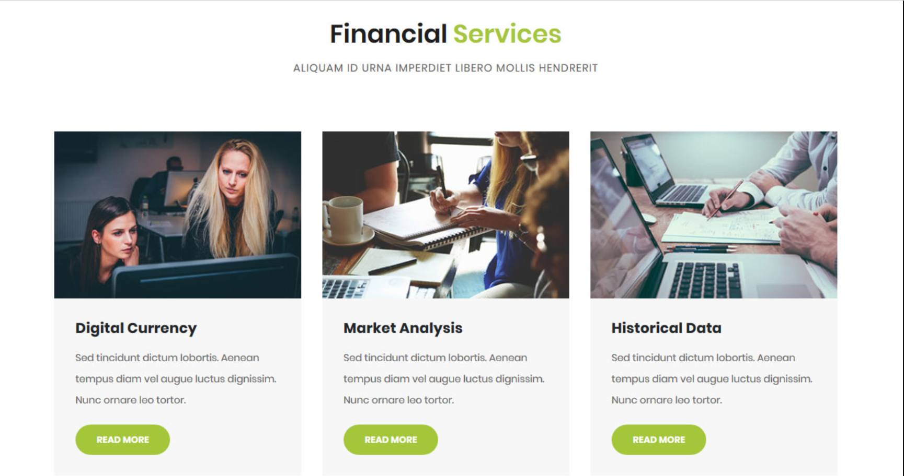

Fig 9.2: Finance Business Website;Financial Services



Fig 9.3: Finance Business Website;Get to know us

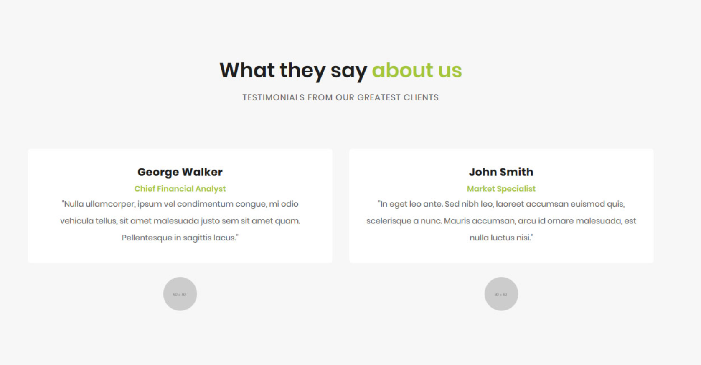

Fig 9.4: Finance Business Website; What they say about us.

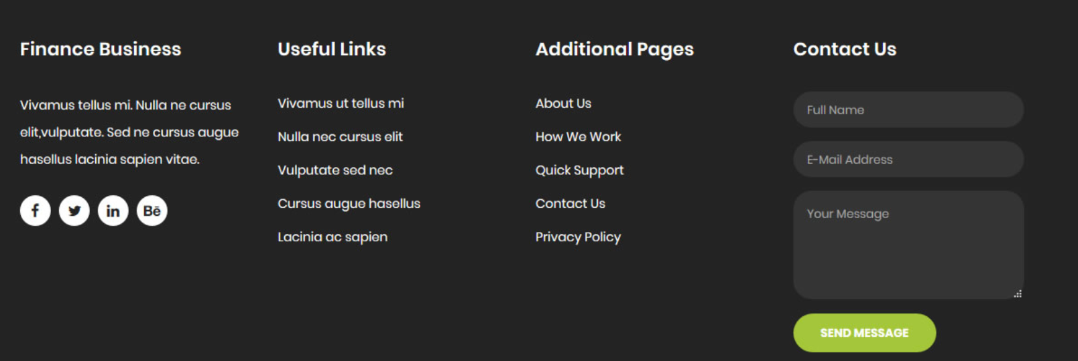

Fig 9.5: Finance Business Website

**VI-CONCLUSION**

Thus we have studied how to select proper colors and animation and created a finance business website using wix.com.

**VII- REFERENCES**

<https://en.wikipedia.org/wiki/Wix.com>

<https://www.wix.com/>

**VIII-POST LAB QUESTION-ANSWER**

Q1 What is Wix used for?

**Wix** provides customizable website templates and a drag-and-drop HTML5 web site builder that includes apps, graphics, image galleries, fonts, vectors, animations and other options. Users also may opt to create their web sites from scratch.

Q2 Is Wix actually free?

**Wix** is available for **free** for as long as you want. If you need professional features like your own domain name or ecommerce, you must choose from one of their premium plans ranging from “Combo” to “Business VIP”. The cheapest ad-**free** plan with a custom domain name costs $14 per month.

Q3 Do Web designers use Wix?

**Wix** makes it easy for any person to create websites – no **design** skills needed! But even experienced **web designers** can **use** our **web** publishing platform as a working tool. In fact, **Wix** can help **web designers** acquire new business and satisfy their clients in a speedy and professional manner.