**St. Francis Institute of Technology**

**Department of Computer Engineering**

**Academic Year: 2021-2022 Semester: VIII Subject: Human Machine Interaction Class / Branch / Division: BE/CMPN/A**

Name :-Rebecca Dias Roll Number:18

**Experiment No.: 1**

Aim:- To create a persona using a tool

**I-OBJECTIVE**

* To understand what is Persona and need for persona for a product or service.
* To create a Persona using an online tool

**II-THEORY**

**What is a Persona?**

* The Persona definition is that one or several fictional characters that can represent the majority of the potential users of product with conventional user demands and they are created through a great amount of quantitative and qualitative research. Persona answers the question “Who do we design for?” It is a powerful tool based on research findings in helping product function creation by optimizing the UX research and it not only represents a specific user but all of them, it can be understood as a typical character of the behavior, attitude, skills and contexts of all potential users.

**III-PROCEDURE**

## 5 Steps to creating user personas

### 1. Collect the information about your users

### 2. Identify behavioral patterns from research data

### 3. Create personas and prioritize them

### 4. Find scenario(s) of interaction and create user personas UX documentation

### 5. Share your findings and obtain acceptance from the team.

**IV-TOOL/TOOLS**

**HUBSPOT**

Personas are fictional, generalized characters that encompass the various needs, goals, and observed behavior patterns among your customers. Creating personas in your HubSpot account allows you to target these groups and categorize your contacts. Learn more about [using buyer personas](https://academy.hubspot.com/buyer-personas-videos-training) and check out the [Make My Persona tool](https://www.hubspot.com/make-my-persona).

To create a new persona or edit an existing persona:

* In your HubSpot account, click the settings **settings icon** in the main navigation bar.
* In the left sidebar menu, navigate to **Properties**.
* In the search bar, enter **Persona**.
* Click the **Persona** property. In the right panel, you can edit the property.
* To edit a persona, hover over the option and click **Edit**.
* To create a new persona, click add **Add another persona**.
* Enter **information** into the fields about your persona. Only the fields with *\** are required. To learn more about personas, click the **links** under the *Mastering Personas*section.
* When you're done, click **Save**.

**XTENSIO**

Every decision you make, from product features to the tone of your taglines, needs to answer your customers. User personas (or buyer personas) represent real, living and breathing people who will engage with your product.  
With our user persona template, you can:

* Create visually engaging user personas that align everyone in your company on who your ideal customer is: their behavior, needs, interest and motivators.
* Identify focused messaging and value propositions that speak to your target customer’s needs.
* Define clearer decision-making to ensure every business, design and marketing decision resonates with target consumers.

**V-IMPLEMENTATION**

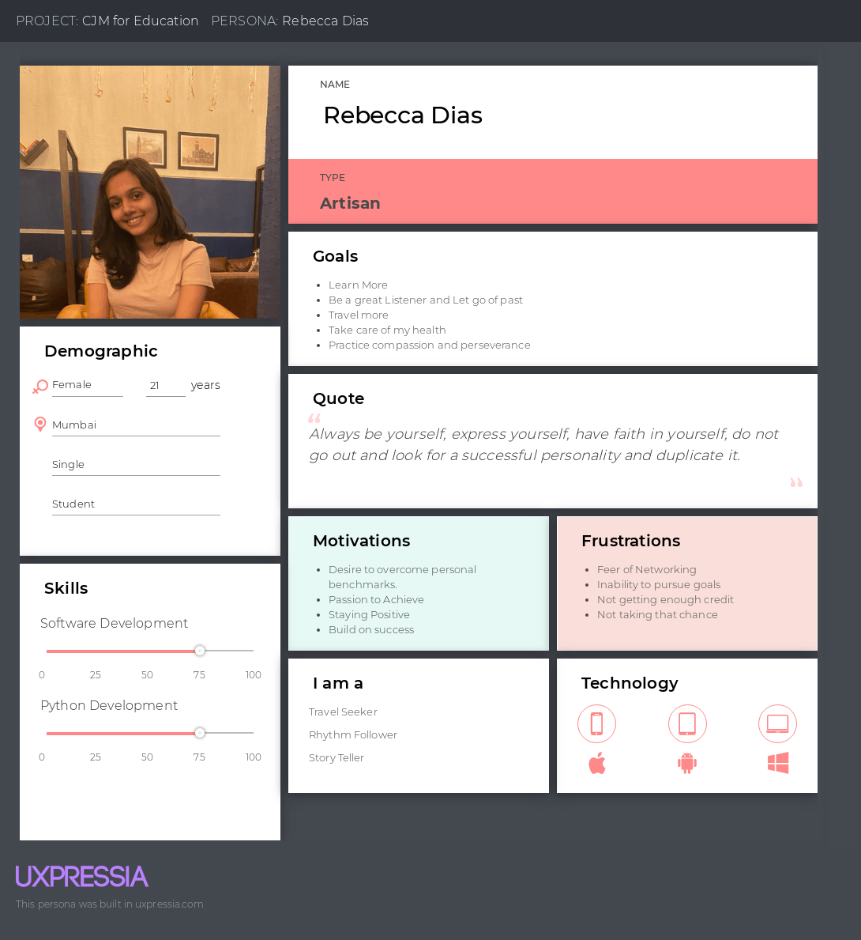

Figure :- 01 Persona created using Uxpressia tool

**VI- CONCLUSION**

Personas are powerful tools. Done properly user personas make the design process at hand less complex — they guide the ideation processes and help designers to achieve the goal of creating a good UX for the target users. Persona is created using online tool.

**VII-REFERENCES**

<https://xd.adobe.com/ideas/process/user-research/putting-personas-to-work-in-ux-design/>

<https://medium.muz.li/what-are-how-to-create-personas-step-by-step-guidelines-of-everything-49357da2cb59>

<https://knowledge.hubspot.com/contacts/create-and-edit-personas>

<https://xtensio.com/user-persona-template/>

**VIII-POST LAB QUESTION/ANSWER**

**Q1 What is a user persona?**

**Ans:** User personas are archetypical users whose goals and characteristics represent the needs of a larger group of users. Usually, a persona is presented in a one or two-page document (like the one you can see in the example below). Such 1–2-page descriptions include behavior patterns, goals, skills, attitudes, and background information, as well as the environment in which a persona operates. Designers usually create user persona template templates, which include a few fictional personal details to make the persona a realistic character (e.g. quotes of real users), as well as context-specific details (for example, for a banking app it makes sense to include a persona’s financial sophistication and major expenses).