**St. Francis Institute of Technology**

**Department of Computer Engineering**

**Academic Year: 2021-2022 Semester: VIII Subject: Human Machine Interaction Class / Branch / Division: BE/CMPN/A**

Name :-Rebecca Dias Roll Number:18

**Experiment No.: 2**

Aim:- To create a story using storyboardthat.com on any scenario

**I-OBJECTIVE**

* To learn online tool to create a storyboard
* To create a storyboard for any given scenario

**II- THEORY**

### What is Storyboardthat

[Storyboard That](https://www.storyboardthat.com/) is a browser-based storyboard creator that can be used to tell a story, explain a process, show relationships, or show the passage of time. Students and teachers can choose from a variety of layouts, scene backgrounds, characters of all types, textables, and props. Their choices can be edited in many different ways to personalize their creation.

## How does Storyboard That work?

A storyboard can be selected from a pre-created list or you can build one from scratch. The page is laid out with blank boards to fill in and a selection of menus to pick from. This offers drag-and-drop items such as characters and props that students and teachers can use to build original stories.

Despite the simplicity, it is all customizable with multiple color options and rich character details. Characters can change pose or actions as well as emotions with simple selections, making it possible to add emotion to a story visually as well as with words.

The use of "insta-poses," which shortcut you to a character's position based on the emotion you want displayed, is a really nice touch that makes this process quick and easy. Details such as each arm position or leg stance are available, if you want to fine tune the character into an exact orientation.

Speech and thought bubbles feature text that can be changed in size for flexibility.

**III-PROCEDURE**

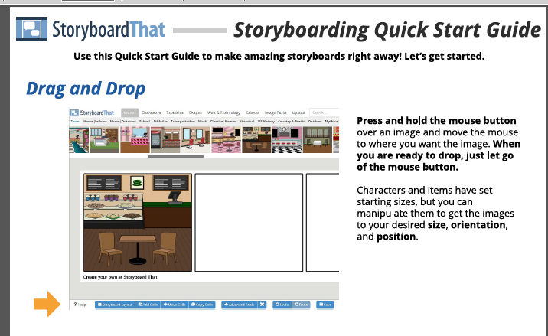

Figure 2.1:- Storyboardthat.com menu

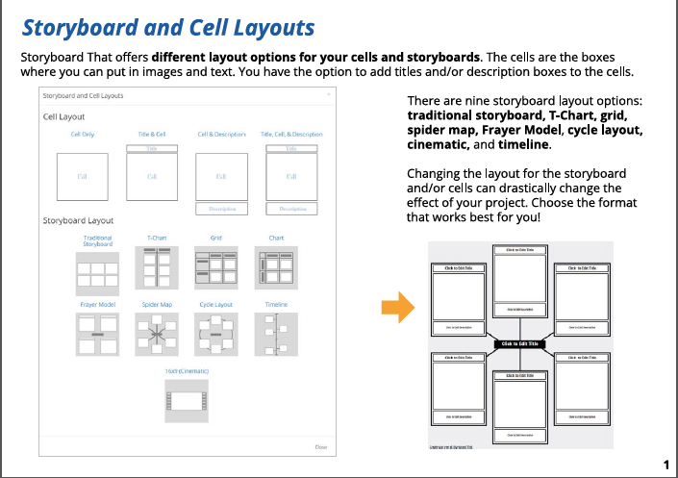

Figure 2.2:- Storyboardthat.com cell layout

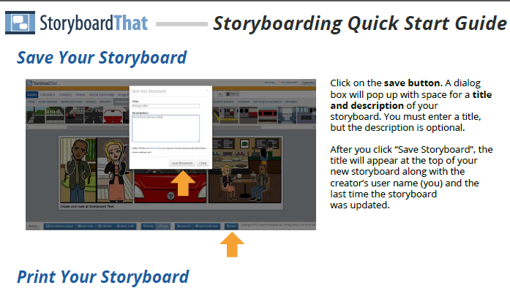

Figure 2.3:- Storyboardthat.com save and title description

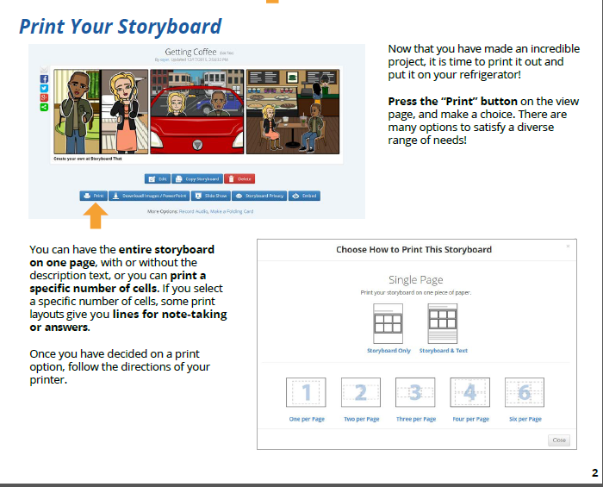

Figure 2.4:- Storyboardthat.com print window

**IV-TOOL/TOOLS**

Storyboard That is an easy drag-and-drop creation platform. We offer a free version and a premium subscription version with extensive abilities. The [Storyboard Creator](https://www.storyboardthat.com/storyboard-creator-for-education) allows people of all skill levels to create amazing visuals for teaching, learning, and communicating.

Started as a desktop application in 2012, Storyboard That has grown into a platform where teachers can create materials and lessons for their classes, students can take ownership of their voice and learning, and businesses can more effectively grow and communicate both internally and with clients.

**V-IMPLEMENTATION**

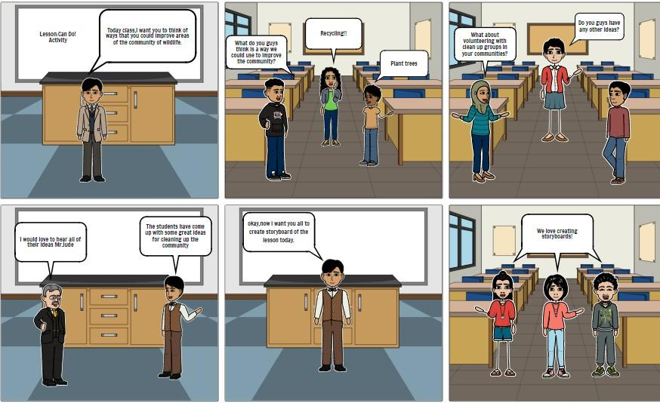

Figure 2.5:- Conversation between Professor and students about wildlife conservation using Storyboardthat.com

**Storyboard Title: Conserve Wildlife**

**Storyboard Description:**

In this story, there’s a scenario of a classroom wherein the professor tells the students to discuss how they can improve wildlife.

**Story Board Text:**

* Today class, I want you to think of ways that you could improve areas of the community of wildlife.
* What do you guys think is a way we could use to improve the community? ● Recycling!!
* Plant trees
* Do you guys have any other ideas?
* What about volunteering with clean up groups in your communities?
* I would love to hear all of their ideas Mr. Jude
* The students have come up with some great ideas for cleaning up the community ● Okay, now I want you all to create storyboard of the lesson today.
* We love creating storyboards!

**VI-CONCLUSION**

In this experiment we created a storyboard using the Storybaordthat online tool. Storybaord is a series of sketches showing how a user might interact with the technology or progress through a task. Often used with scenarios to bring in more detail and context

**VII-REFERENCES**

<https://www.storyboardthat.com/about/about-us#mission>

<https://www.storyboardthat.com/>

<https://www.techlearning.com/how-to/what-is-storyboard-that-and-how-does-it-work-best-tips-and-tricks>

<https://www.emergingedtech.com/2019/09/storyboard-that-exciting-edtech-tool-just-got-better/>

<https://storyboardartists.com/what-are-storyboards-used-for/>

<https://blog.hubspot.com/marketing/storyboard-software>

**VIII-POST LAB QUESTION/ANSWER**

Q1 How Storyboard can be used in different ways

### Ans: Students can use this tool as a graphic organizer to analyze ideas, show relationships, put things in order, or respond to reading, audio, or video tasks.

Students can create visual presentations and then record their own voices to speak the written text or explain what they have created in any language.

Storyboards can be exported as PowerPoints, Google Slides, Apple Keynotes, or PDF files, among other options. Students can present on a smart board or share their storyboards on Google Drive or Google Classroom after picking one of the many download options