**St. Francis Institute of Technology**

**Department of Computer Engineering**

**Academic Year: 2021-2022 Semester: VIII**

**Subject: Human Machine Interaction Class / Branch / Division: BE/CMPN/A**

Name :-Rebecca Dias Roll Number:18

**Experiment No: 05**

**Aim: -** To understand how to design an appropriate icon for a specific domain.

**I-OBJECTIVE**

* To understand icon design heuristics
* To design an appropriate icon for a specific domain.

**II-THEORY**

Icons are most often used to represent objects and actions with which users can interact with or that they can manipulate.

## [1] Characteristics of Icons

An icon possesses the 3 technical qualities of syntactics, semantics, and pragmatics.

**Syntactics**

It refers to an icon’s physical structure. Is it square, round, red, green, big, small? Are the similarities and differences obvious? Similar shapes and colors can be used to classify a group of related icons, communicating a common relationship.

**Semantics**

It is the icon’s meaning. To what does it refer—a file, a wastebasket, or some other object? Is this clear?

**Pragmatics**

It is how the icons are physically produced and depicted. Is the screen resolution sufficient to illustrate the icon clearly?

Syntactics, semantics, and pragmatics determine an icon’s effectiveness and usability.

## [2] Influences on Icon Usability

The following factors influence an icon’s usability:

* 1. Familiar.
  2. Clear and Legible.
  3. Simple.
  4. Consistent.
  5. Direct.
  6. Efficient.
  7. Discriminable.

**Familiarity**

How familiar is the object being depicted? Familiarity will reduce learning time. How familiar are the commonly seen icons in Figure.

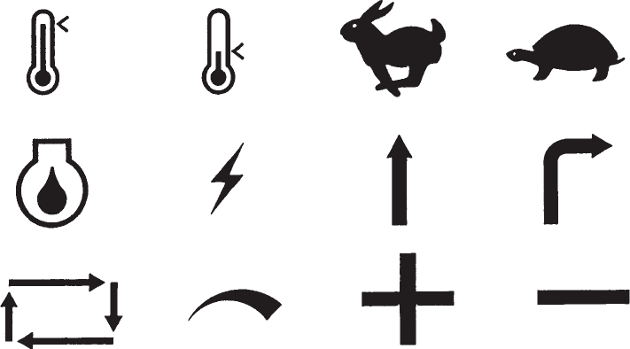

## Fig 5.1:- Some common icons

**Fig 5.2: The icons depicted in previous figure have the above meaning.**

**Clarity**

Is the icon legible? Does the shape, structure, and formation technique on the screen permit a clear and unambiguous depiction of what it is? Screen resolution should be sufficiently fine to establish clear differences of form at the normal working distance.

**Simplicity**

Is the icon simple? Is the shape clean and devoid of unnecessary embellishments? Too many parts will only confuse the screen viewer.

**Consistency**

Are families of icons consistent in structure and shape? Are the same icons displayed on different screens consistent in shape and structure? Are the same icons displayed in different sizes also consistent in structure and shape?

Directness

How ―sign-like‖ is the icon; how well does it convey its intended meaning? For concrete objects and actions, direct links are more easily established. Adjectives,adverbs, conjunctions, and prepositions can cause problems, however. Also, how does one easily convey concepts such as bigger, smaller, wider, or narrower?

Efficiency

In some situations, a graphics screen may be less efficient, consuming more screen display space than a word or requiring more physical actions by the user than text.

Discriminability

The symbols chosen must be visually distinguishable from other symbols. A person’s powers of differentiation for shapes and other forms of codes have been experimentally determined over the years.

The maximum number of codes that can be effectively differentiated by a human being, including geometric shapes, is summarized in Table 5.1.

## Table 5.1: Maximum Number of Codes for Effective Human Differentiation

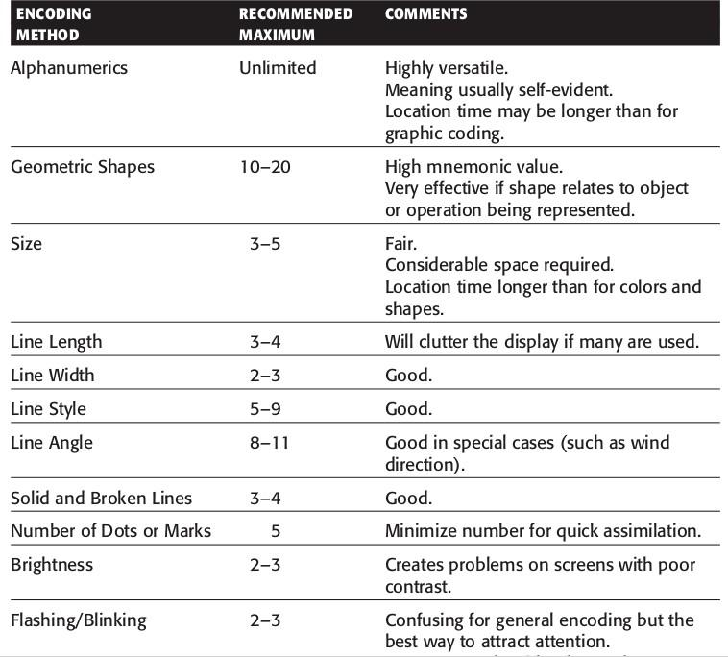

Context

The context of a symbol may change its meaning.

Expectancies

The symbol may be comprehended, but a false conclusion may be reached about the desired action because of an incorrect expectancy.

Complexity of task

The more abstract or complex the symbol, the more difficult it is to extract or interpret its intended meaning. It has been found that more concrete graphic messages are easier to comprehend than the more abstract. Icons, therefore, cannot completely replace words in more complex situations.

## [3] Creating Images

Concrete and familiar shapes

Ideally, an icon’s meaning should be self-evident. This is enhanced when concrete shapes are provided, those that look like what they are. An icon should also be intuitive or obvious, based upon a person’s pre-existing knowledge. Familiar shapes are those images that are well learned. (See figure).

## Fig 5.3: Concrete and familiar shapes

**Visually and conceptually distinct shapes**

It must be easy to tell icons apart so the chances of confusing them are minimized. Differentiation is aided when icons are visually different from one another. (See figure).

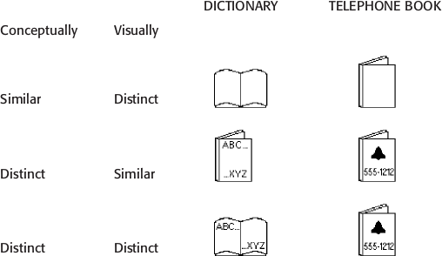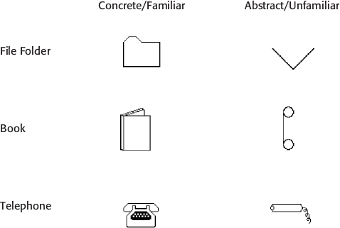

## Fig 5.4: Visually and conceptually distinct shapes

Visual distinctiveness is degraded when borders are placed around icons. (See figure).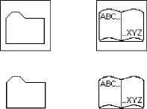

Drawing Images

## Fig 5.5: Borders degrading icon distinctiveness.

Simply reflect objects

Construct icons with as few graphical components as necessary, using no more than two or three, if possible. Also, use simple, clean lines, avoiding ornamentation.

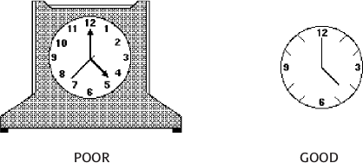

## Fig 5.6: Avoid excessive detail in icon design.

**Design as a set**

Do not design icons in isolation, but as a family considering their relationships to each other and the user’s tasks. Provide a common style.

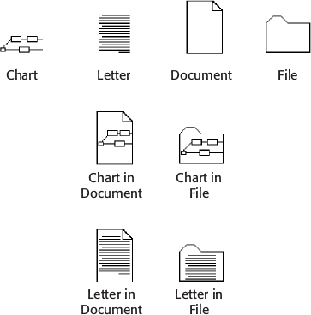

## Fig 5.7: Communication relationships in icons.

## [4] Icon Animation and Audition Animation:

An animated icon appears to move instead of maintaining a static position on the screen. Animation can take two forms:

* 1. static
  2. dynamic

A static icon’s appearance is unchanged over a period of time and changes only at the moment that a system event occurs. An ex-ample would be the open door of a mailbox shutting when an electronic message is received.

A dynamic icon’s movement is independent of a system event, changing appearance to represent functions, processes, states, and state transitions. An example is an icon that begins movement to illustrate an action when a pointer is moved close to it.

Animation can be used to provide feedback and to create visual interest. Researchers caution, however, that there are many outstanding issues.

**Audition**

Objects make sounds as they are touched, dragged, bumped against one another, opened, activated, and thrown away. Auditory icons are computer sounds replicating everyday sound-producing events. When a printer near one’s desk begins printing, the sound of the printing mechanism is heard. This provides auditory feedback that a print operation one has just asked for has successfully started. An auditory icon would be the same sound, generated by the computer.

Sounds can convey information about many events in computer systems, permitting people to listen to computers as we do in the everyday world. It may be well suited to providing information:

* 1. About previous and possible interactions.
  2. Indicating ongoing processes and modes.
  3. Useful for navigation.
  4. To support collaboration.

## [5] The Design Process

**Define purpose**

To begin the design process, first define the icon’s purpose and use. Have the design team brainstorm about possible ideas, considering real-world metaphors. Simple metaphors, analogies, or models with a minimal set of concepts are the best places to start in developing icons.

**Collect, evaluate, and sketch ideas**

Start by designing on paper, not on the computer (Fowler and Stanwick, 1995). Ask everyone to sketch his or her ideas. Do not worry about too much detail; exact pixel requirements are not necessary at this time.

Many icons will be displayed in monochrome. Color is an enhancing property; consider it as such.

**Test for expectation, recognition, and learning**

Choosing the objects and actions, and the icons to represent them, is not a precise process, and will not be easy.

**Test for legibility**

Verify the legibility and clarity of the icons in general. Also, verify the legibility of the icons on the screen backgrounds chosen. White or gray backgrounds may create difficulties.

Register new icons in the system’s registry

Create and maintain a registry of all system icons. Provide a detailed and distinctive description of all new icons.

## [6] Screen Presentation

General guidelines

Follow all relevant general guidelines for screen design. Icons are but one part of a larger picture.

**Number of icons**

A person’s ability to identify shapes is limited (see figure 7). A literature review, suggest using no more than eight to twelve or so functions that require icons at one time. At most, present no more than 20.

**Arranging icons**

Organize icons in a way that reflects the real-world organization of the user. Place object icons and action icons within different groupings. Visual scanning studies, in a non-iconic world, universally find that a top-to-bottom scan of columnar-oriented information is fastest.

**Object and action icons**

Conceptually similar items should always be arrayed together. Locating them will be easier.

**Interactive icons**

To provide a visual indication that an icon is interactive or ―click-able,‖ present it in a three- dimensional state raised from the screen background.

**Selected icon**

Ensure a selected icon is visually differentiable from unselected icons. One common method to achieve this is to present the selected icon in a three dimensional ―pressed‖ state.

**User arrangement**

Allow the user to arrange the icons in a manner that is meaningful for the task. A default arrangement should be provided, however.

**Iconic or text display**

In some situations, and for some users, pure text labels may be more meaningful than icons. The option to display text only should always be provided.

Icons are graphical representation of objects or actions. They are part of the visual language and communicate large information in a single glance which otherwise may need number of words.

There are two essential aspects of icon design

* Aesthetics (communication efficiency)
* Construction (realization & reproduction using digital medium)

**Aesthetics** is not only about looks and attractiveness; it is about how efficiently the icon functions vis-a-vis the human user. An icon can be very creative and good looking but can miserably fail in communicating the right meaning. A poor icon design may lead to human errors or accidents. Imagine a save icon in the shape of a basket being confused with a storage icon because visually a ‘basket’ represents it. The semantics of an icon - (what meaning a graphic symbol communicates) can therefore be creatively destructive. Some other factors that also contribute to aesthetics are shape, color, simplicity, order and proportions.

**Construction** aspect of an icon design is equally important. Vector based image construction is far more easy for computation, scaling, refreshing and display compared to pixilated construction. Pixilated icons require heavy sizes and have limited animation capabilities. On the other hand vector based icons may not be suitable for all situations and screen environments.

You should create separate icon sets for high, medium and low pixel density screens.

Pixel density of a mobile phone screen is calculated as follows:

      Specifications: display size=3.7 ”(diagonal) / resolution= 480 x 800 pixels

      Pixel density (PPI) = pixels per inch

      Width: height ratio is same as 1: 800/480

      Thus width= 1.9” and height=3.175” (By Pythagorean theorem and diagonal)

**PPI= 480** divided by width of 1.9 or 800 divided by 3.175 to give 252ppi.

      Human eye cannot distinguish the difference in PPI when the figure reaches a saturation point of about **250ppi or 300ppi** at the most.

**Design Heuristics**

1. Size of icon in context of screen size determines its visual impact. Based on this size pixilation should be determined. An icon at 64x64 may be better recognized and associated with by the user, than at 24x24. When 64x64 is sufficient there is not much gain to design a 128x128 icon.
2. An icon needs to be simple & yet represent what it is supposed to.
3. Icons generally mimic real world objects.

Icons should use minimum set of lines, colors etc. that are sufficient enough to recognize the real world object which the icon represents. (Refer figure above). Over designed graphically rich icons, though a matter of artistic satisfaction to the creator can unfortunate land up as sadistic frustration for the user. So simplicity is the rule and not an exception.

1. A new icon added to existing set must fit with other icons on the screen in terms of belongingness. Icons within same screen should look as a family. Technically all icons belonging to same screen should have same styling features (shape, size, color etc).
2. Unnecessary shades and shadows need to be avoided. This helps make the icon neat and trimmed aesthetically as well as functionally. Such an icon can be refreshed at a faster rate on the screen. Layers of rendering make the icon pixel-heavy requiring anti-aliasing to be performed compulsorily.
3. A good icon is self defining. It does not need word labels. For novice, first time users and users with memory difficulties it is normal for icons to have a label. The letters / alphabets used to make the labels need to be simple, non fancy and readable. The norms governing letter shape and style are practiced under the design specialization known as “Typography”.
4. Each style of alphabet is called by its name. Single alphabet or numeral is referred to as ‘font’. Fonts have sizes measured in ‘points’. Thus we have 6, 8, 10,12, 14,24 etc as font sizes.

**III-PROCEDURE**

* + Choose a domain for which the icon is to be designed.

Example:

Medical Domain

Restaurant

Law Firm

* + Define the purpose and the use of the ICON.
  + Describe the ICON using real world analogies and metaphors.
* Sketch an outline of your icon as familiar to you.
* Use any graphic designing tool like Photoshop and construct Icon from your sketch.
* Assign colors, shadows, highlights as you deem fit.

**IV-TOOL/TOOLS**

**INKSCAPE**

Inkscape is a free and open-source vector graphics editor developed for desktop. This professional-quality tool enables you to **create and edit vectors** such as illustrations, diagrams, line arts, charts, logos, icons, and even complex paintings. It is versatile, easy to use and a **serious alternative**to premium tools like Adobe Illustrator.

**V-IMPLEMENTATION AND TESTING**

Using INKSCAPE icon editing package, design the icon.

**Domain: Textile**

**Use of the Icon Designed:**

* A textile boutique icon is meant to let users familiar with the grasp what the shop is about.
* A brand logo helps the brand to be more singular and renowned
* It increases the brand value and helps in the sales.

**Design the Icon:**



**Figure 5.8: Textile Boutique Icon**

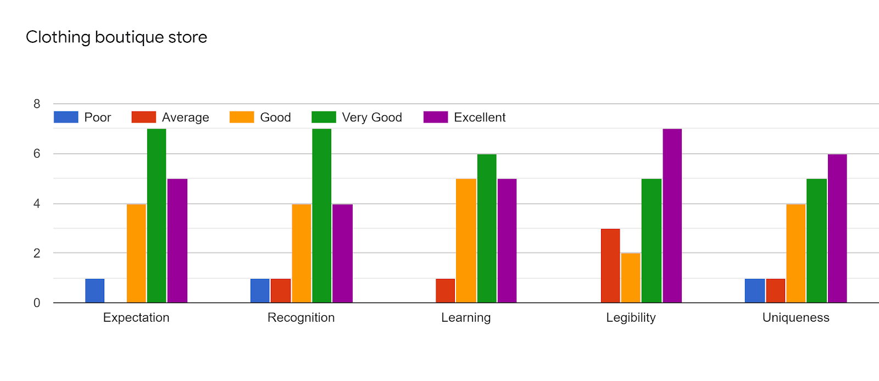

**Table 5.2- Icon testing criteria**

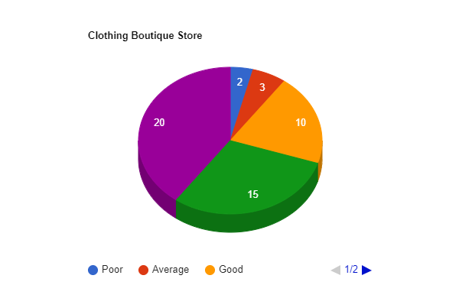

**Figure 5.8: Pie Chart of the responses**

**VI-CONCLUSION**

Icons are graphical representation of objects or actions and they convey ideas more quickly than words. In this experiment, we designed an icon in a gaming domain with the help of Inkscape App and specified its use. The icon was reviewed by the users and based on their results a pie chart was created.

**VII-POST LAB QUESTION-ANSWER**

**Q1 What  is Inkscape used for?**

**Ans**

Inkscape is a Free and open source vector graphics editor for GNU/Linux, Windows and

MacOS X. It offers a rich set of features and is widely used for both artistic and technical

illustrations such as cartoons, clip art, logos, typography, diagramming and flowcharting.

**VIII- REFERNCE**

<https://inkscape.en.softonic.com/>

<https://hci-iitg.vlabs.ac.in/icons.html>