**St. Francis Institute of Technology**

**Department of Computer Engineering**

**Academic Year: 2021-2022 Semester: VIII Subject: Human Machine Interaction Class / Branch / Division: BE/CMPN/A**

Name :-Rebecca Dias Roll Number:18

**Experiment No.: 1**

Aim:- To create a persona using a tool

**I-OBJECTIVE**

* To understand what is Persona and need for persona for a product or service.
* To create a Persona using an online tool

**II-THEORY**

**What is a Persona?**

* The Persona definition is that one or several fictional characters that can represent the majority of the potential users of product with conventional user demands and they are created through a great amount of quantitative and qualitative research. Persona answers the question “Who do we design for?” It is a powerful tool based on research findings in helping product function creation by optimizing the UX research and it not only represents a specific user but all of them, it can be understood as a typical character of the behavior, attitude, skills and contexts of all potential users.

# **The classification of Persona.**

Personas can be classified into 2 types in general: **Marketing Persona** and **Design Persona**.

1. Marketing Personas are typical characters of the customers of a product or a company, they have similarities in buying preference, social relations, mode of consumption and ages. Personas help the company determine how their customers will be;

2. Design Personas (For example the User Personas and the UX Personas) refer to the representatives of users of a product or service that have similar points in usage customs, product requirements, preferences and goals. They can describe the needs of potential users and help developers put their focus back on users during the function design, and make products conform to user requirements.

**III-PROCEDURE**

## 5 Steps to creating user personas

Personas can be created in a myriad of ways — it all depends on budget, type of a project and the type of data designers are able to collect. While detailed step-by-step instructions on how to create a persona are beyond the scope of this article, it’s still possible to provide a general flow on how to do it:

### 1. Collect the information about your users

The first step is to conduct [user research](https://xd.adobe.com/ideas/process/user-research/) to understand the target audience’s mindsets, motivations, and behaviors. The most accurate personas are based on actual field research — they are distilled from in-depth user interviews and observation data of real users. It’s essential to collect as much information and knowledge about users as possible by interviewing and/or observing a sufficient number of people who represent a target audience. The more a researcher observes and captures during these interviews, the more realistic the persona will be.

In a case when it’s impossible to interview/observe real individuals — time and money don’t allow for the user research needed to define accurate personas — it’s still possible to create a persona based on what the team knows about users. If your product is available on the market and has real users, you can rely on customer support logs and web analytics to create a persona. A persona created using this approach is known as a provisional persona, and is a great placeholder until real personas are created.

During this step, it is very important to avoid generating user personas of stereotypical users (users that don’t have any relation to the actual user’s reality). Completely fictional stories of imaginary people based on little or no research bring no value for the design process and in fact, can bring harm. Furthermore, poorly constructed personas can easily undermine the credibility of this technique.

### 2. Identify behavioral patterns from research data

The next step is analyzing research findings. The goal during this step is to find patterns in user research data that make it possible to group similar people together into types of users. There’s a simple strategy suggested by [Kim Goodwin](https://www.cooper.com/journal/2008/05/getting_from_research_to_perso):

* Once the research is finished, list all of the behavioral variables (i.e. ways in which users’ behavior differed).
* Map each interviewee (or real-life user attributes) against the appropriate set of variables.
* Identify trends (find a set of people clustering across six or eight variables). These grouping trends will then form the basis of each persona.

### 3. Create personas and prioritize them

Next, it’s important to assemble a persona’s descriptions around behavioral patterns. The researcher’s task here is to describe each persona in such a way that expresses enough understanding and empathy to understand the users. During this step, it’s best to avoid the temptation to add a lot of personal details: one or two bits of personality can bring a persona to life, but too many details will be distracting and will make the persona less credible as an analytical tool. Don Norman [put it this way](https://jnd.org/ad-hoc_personas_empathetic_focus/): “[personas] only need to be realistic, not real, not necessarily even accurate (as long as they accurately characterize the user base).”

Quite often, researchers create more than one persona for each product. Most interactive products have multiple audience [user segments](https://xd.adobe.com/ideas/process/user-research/user-segmentation-for-ux-design/) which is why it seems logical to construct multiple personas. However, with too many personas, the process can get out of hand. The personas can simply blur together. That’s why during this step it’s also important to minimize the number of user personas, so it’s possible to focus on design—and this may guarantee better success. While there’s no magic number, as a rule of thumb, three or four personas are enough for most projects.

**Tip:**If you have more than one persona it’s good to define the primary persona (the most relevant) and follow the rule “design for the primary – accommodate the secondary.” Design decisions should be made with the primary persona in mind and then tested (through a thought experiment) against the secondary personas.

### 4. Find scenario(s) of interaction and create user personas UX documentation

Personas have no value in and of themselves. They become valuable only when they tied up to a scenario. A scenario is an imagined situation that describes how a persona would interact with a product in a particular context to achieve its end goal(s). Scenarios help designers understand the main user flows – by pairing the user personas with the scenarios, designers gather requirements, and from those requirements, they create design solutions. Scenarios should be written from the persona’s perspective, usually at a high level, and articulate use cases that will likely happen.

Goal-directed design considers 3 things – persona, scenario and goal. Image by[Smashing Magazine](https://www.smashingmagazine.com/2014/08/a-closer-look-at-personas-part-1/).

Generally, when creating a user persona template you should include the following information:

* Persona name
* Photo
* Demographics (gender, age, location, marital status, family)
* Goals and needs
* Frustrations (or “pain points”)
* Behaviors
* Bits of personality (e.g. a quote or slogan that captures the personality)

A great tool that will help you during this step is the [Persona Creation and Usage Toolkit](http://www.interactionbydesign.com/presentations/olsen_persona_toolkit.pdf) developed by George Olsen. George has developed a comprehensive list of all the factors that can be considered for the persona description.

**Tip:**Avoid using real names or details of research participants or people you know. This can bias the objectivity of your user personas (you’ll focus on design for this person, rather than a group of people with similar characteristics).

### 5. Share your findings and obtain acceptance from the team

Socializing personas among stakeholders are critical in moving the design team toward action. All team members and stakeholders should have a positive association with personas and see the value in them. As people become familiar with the personas, they start talking about them as if they were actual people. A well-constructed persona almost becomes another member of the team.

**IV-TOOL/TOOLS**

**HUBSPOT**

Personas are fictional, generalized characters that encompass the various needs, goals, and observed behavior patterns among your customers. Creating personas in your HubSpot account allows you to target these groups and categorize your contacts. Learn more about [using buyer personas](https://academy.hubspot.com/buyer-personas-videos-training) and check out the [Make My Persona tool](https://www.hubspot.com/make-my-persona).

To create a new persona or edit an existing persona:

* In your HubSpot account, click the settings **settings icon** in the main navigation bar.
* In the left sidebar menu, navigate to **Properties**.
* In the search bar, enter **Persona**.
* Click the **Persona** property. In the right panel, you can edit the property.
* To edit a persona, hover over the option and click **Edit**.
* To create a new persona, click add **Add another persona**.
* Enter **information** into the fields about your persona. Only the fields with *\** are required. To learn more about personas, click the **links** under the *Mastering Personas*section.
* When you're done, click **Save**.

**XTENSIO**

Every decision you make, from product features to the tone of your taglines, needs to answer your customers. User personas (or buyer personas) represent real, living and breathing people who will engage with your product.  
With our user persona template, you can:

* Create visually engaging user personas that align everyone in your company on who your ideal customer is: their behavior, needs, interest and motivators.
* Identify focused messaging and value propositions that speak to your target customer’s needs.
* Define clearer decision-making to ensure every business, design and marketing decision resonates with target consumers.

https://xtensio.com/user-persona-template/

**V-IMPLEMENTATION**

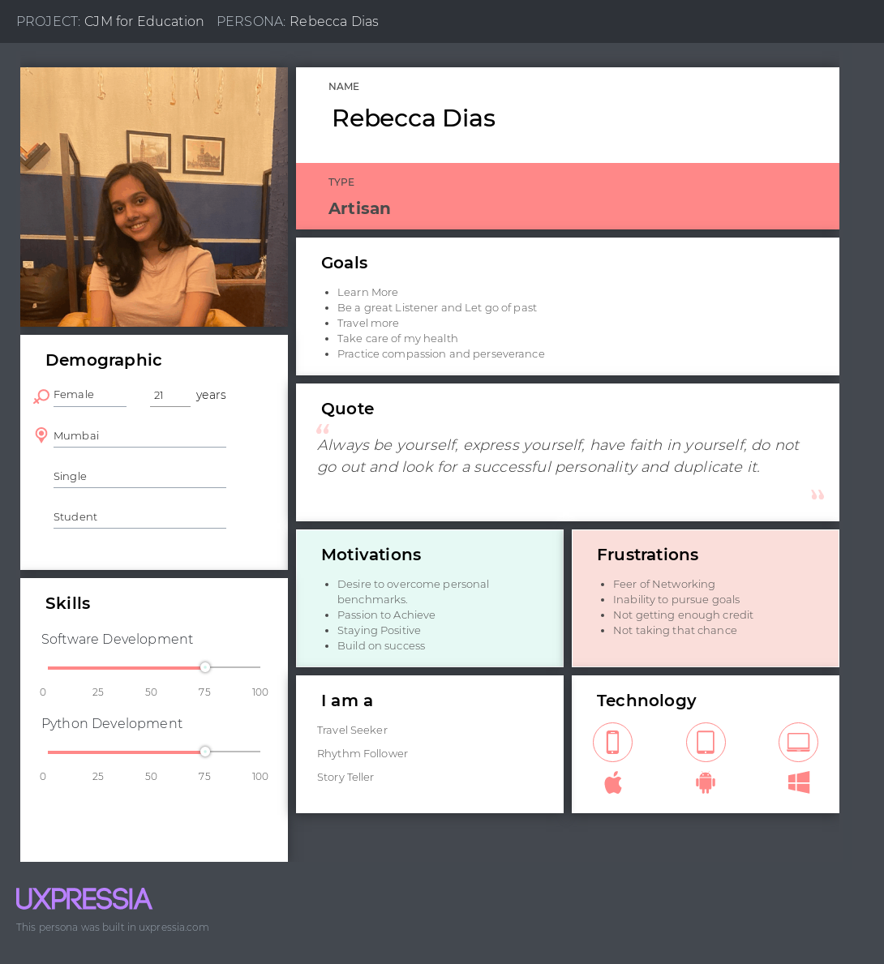

Figure :- 01 Persona created using Uxpressia tool

**VI- CONCLUSION**

Personas are powerful tools. Done properly user personas make the design process at hand less complex — they guide the ideation processes and help designers to achieve the goal of creating a good UX for the target users. Persona is created using online tool.

**VII-REFERENCES**

<https://xd.adobe.com/ideas/process/user-research/putting-personas-to-work-in-ux-design/>

<https://medium.muz.li/what-are-how-to-create-personas-step-by-step-guidelines-of-everything-49357da2cb59>

<https://knowledge.hubspot.com/contacts/create-and-edit-personas>

<https://xtensio.com/user-persona-template/>

https://xtensio.com/user-personas-necessary-or-not/

**VIII-POST LAB QUESTION/ANSWER**

**Q1 What is a user persona?**

**Ans**

User personas are archetypical users whose goals and characteristics represent the needs of a larger group of users. Usually, a persona is presented in a one or two-page document (like the one you can see in the example below). Such 1–2-page descriptions include behavior patterns, goals, skills, attitudes, and background information, as well as the environment in which a persona operates. Designers usually create user persona template templates, which include a few fictional personal details to make the persona a realistic character (e.g. quotes of real users), as well as context-specific details (for example, for a banking app it makes sense to include a persona’s financial sophistication and major expenses).

### **Q2-When and how should User Personas be used?**

**For Product and UX Designers:**  
The decision to build, change, or scrap a feature will come down to Personas’ use cases. Having internal teams complete preliminary User Personas based on assumptions ensures everyone is on the same page when it comes to beginning thoughts on target consumers. This way, when data supporting or conflicting company hypotheses arrive, the internal team remains in agreement on which product design strategies should remain the same and what should change.

**For Marketing and Advertising:**  
A unified understanding of consumer motivations, frustrations, goals, and priorities, allows for laser-focused, efficient marketing and advertising decisions. From choosing wording for copy and slogans, to selecting social media platforms, to investing advertising budget in the right direction, User Personas are essential to have on hand. They will position you and your internal team, not only to make informed decisions, but also to establish an emotional connection between your customer and your product.

**For Business Meetings and Decisions:**Defining target consumers will inform critical business strategies. Is there a big enough market for your product? If not, how do you steer it away from a small niche and towards a larger market fit? Who are the people that will make your business viable ?

What’s more, when it comes to attracting and meeting with outside investors, those individuals will ask about the intended market for your product, why this specific audience would be interested in your solutions, and how the decisions you’re making internally will attract their interest. Investors will want an easy-to-read, comprehensive deliverable– a User Persona document