**St. Francis Institute of Technology**

**Department of Computer Engineering**

**Academic Year: 2021-2022 Semester: VIII Subject: Human Machine Interaction Class / Branch / Division: BE/CMPN/A**

Name :-Rebecca Dias Roll Number:18

**Experiment No.: 2**

Aim:- To create a story using storyboardthat.com on any scenario

**I-OBJECTIVE**

* To learn online tool to create a storyboard
* To create a storyboard for any given scenario

**II- THEORY**

### What is Storyboardthat

[Storyboard That](https://www.storyboardthat.com/) is a browser-based storyboard creator that can be used to tell a story, explain a process, show relationships, or show the passage of time. Students and teachers can choose from a variety of layouts, scene backgrounds, characters of all types, textables, and props. Their choices can be edited in many different ways to personalize their creation.

## How does Storyboard That work?

A storyboard can be selected from a pre-created list or you can build one from scratch. The page is laid out with blank boards to fill in and a selection of menus to pick from. This offers drag-and-drop items such as characters and props that students and teachers can use to build original stories.

Despite the simplicity, it is all customizable with multiple color options and rich character details. Characters can change pose or actions as well as emotions with simple selections, making it possible to add emotion to a story visually as well as with words.

The use of "insta-poses," which shortcut you to a character's position based on the emotion you want displayed, is a really nice touch that makes this process quick and easy. Details such as each arm position or leg stance are available, if you want to fine tune the character into an exact orientation.

Speech and thought bubbles feature text that can be changed in size for flexibility.

**III-PROCEDURE**

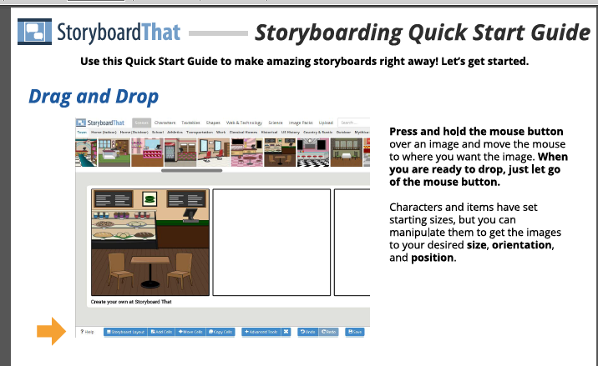

Figure 2.1:- Storyboardthat.com menu

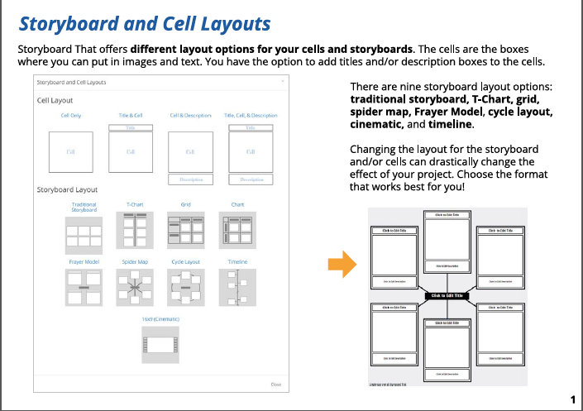

Figure 2.2:- Storyboardthat.com cell layout

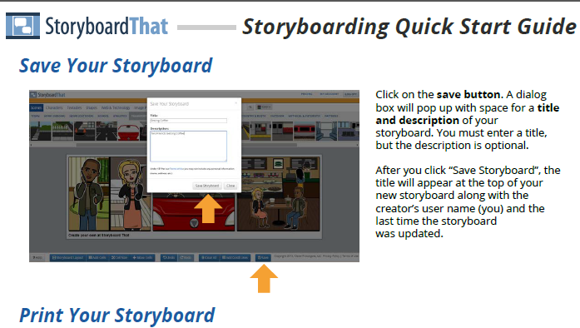

Figure 2.3:- Storyboardthat.com save and title description

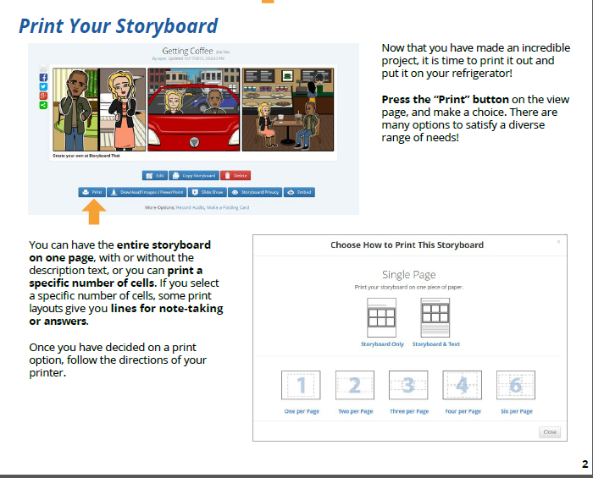

Figure 2.4:- Storyboardthat.com print window

**IV-TOOL/TOOLS**

Storyboard That is an easy drag-and-drop creation platform. We offer a free version and a premium subscription version with extensive abilities. The [Storyboard Creator](https://www.storyboardthat.com/storyboard-creator-for-education) allows people of all skill levels to create amazing visuals for teaching, learning, and communicating.

Started as a desktop application in 2012, Storyboard That has grown into a platform where teachers can create materials and lessons for their classes, students can take ownership of their voice and learning, and businesses can more effectively grow and communicate both internally and with clients.

**V-IMPLEMENTATION**

**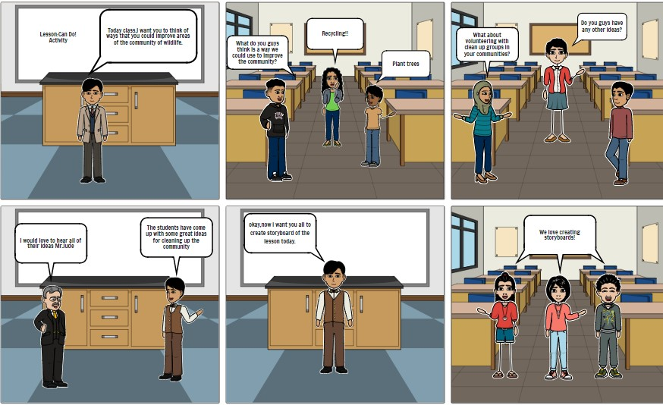**

Figure 2.5:- Conversation between Professor and students about wildlife conservation using Storyboardthat.com

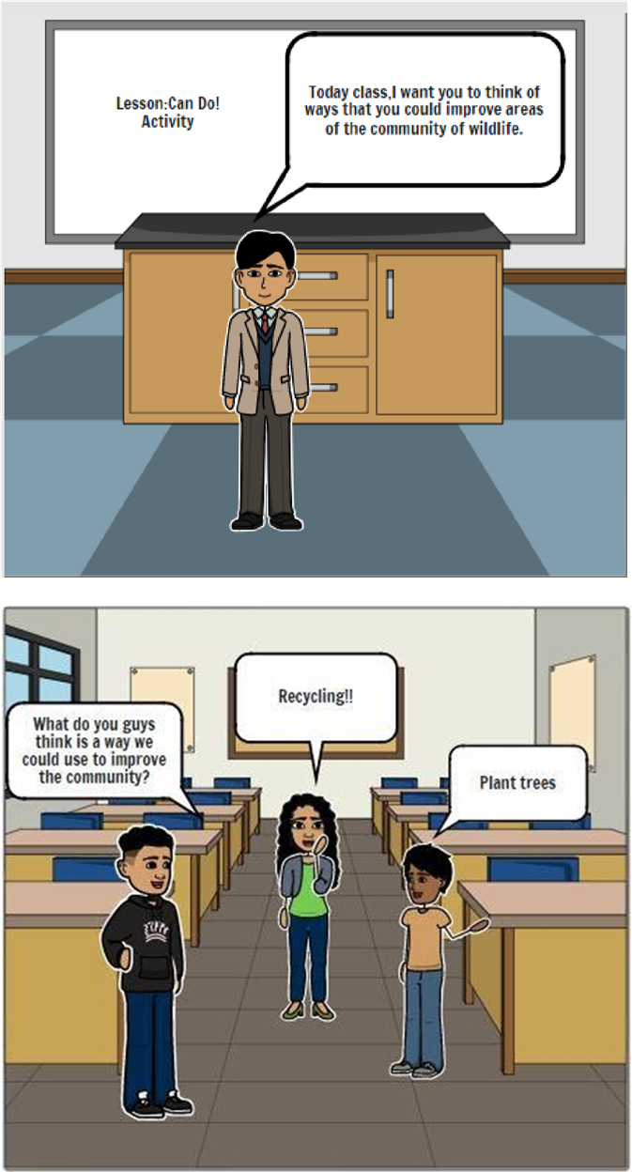

Fig 2.5.1: Enlarged Scenario 1

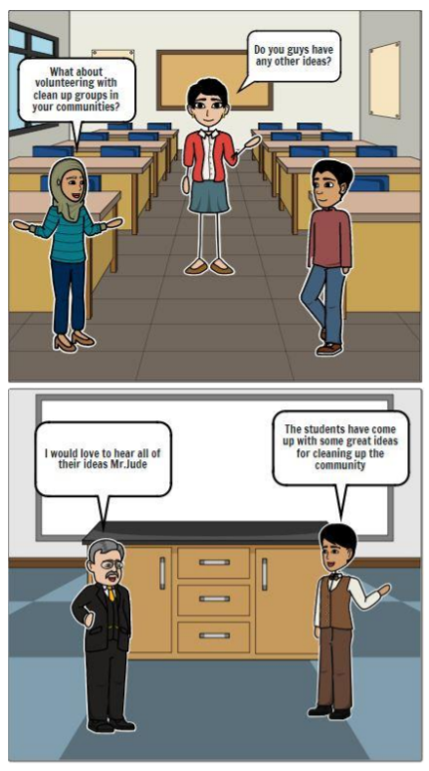

Fig 2.5.2: Enlarged Scenario 2

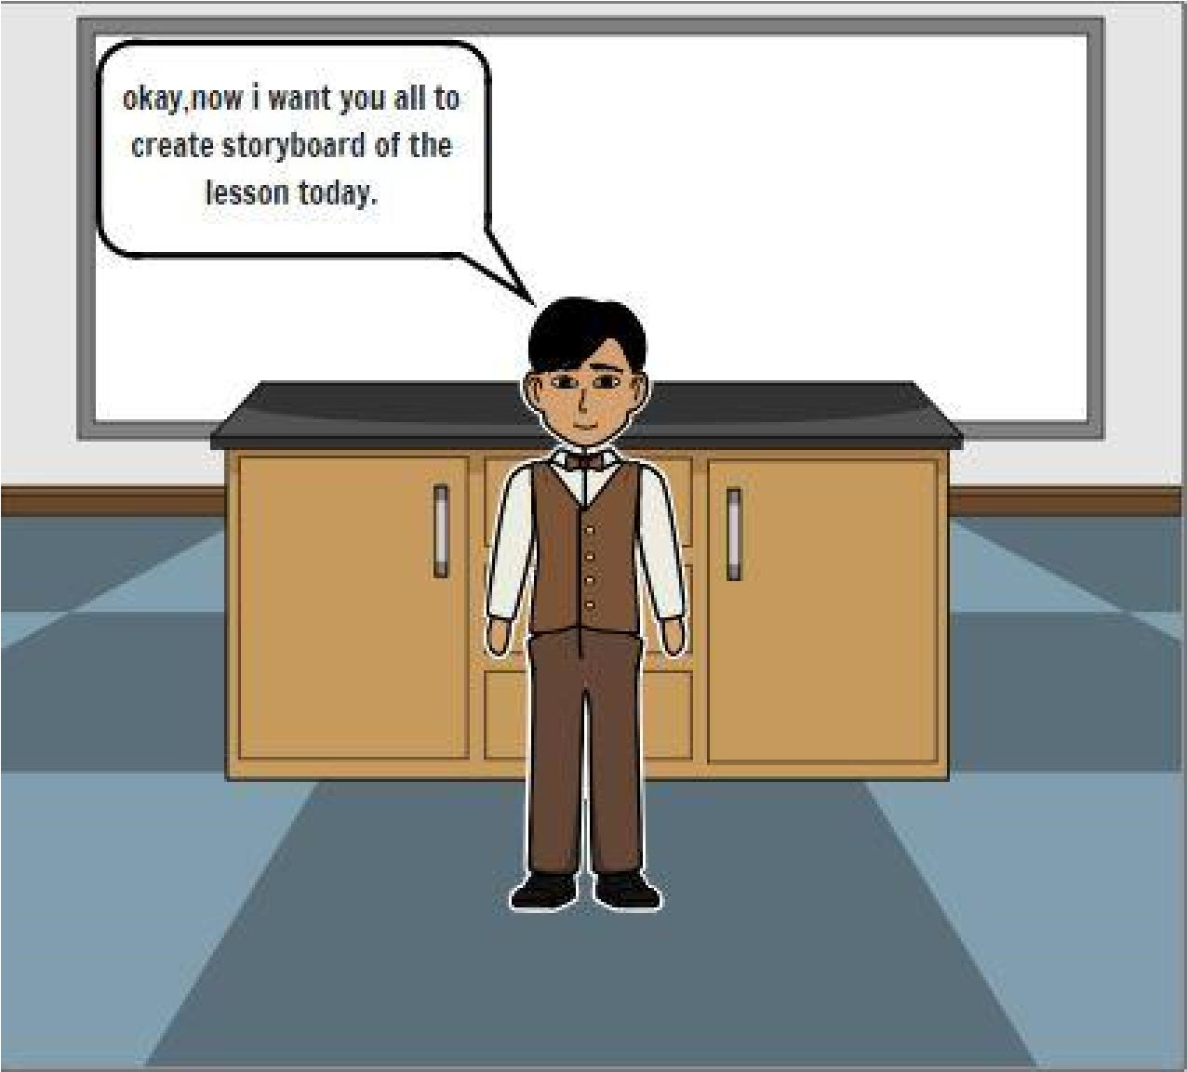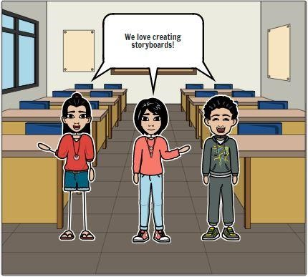

Fig 2.5.3: Enlarged Scenario 3

**Storyboard Title: Conserve Wildlife**

**Storyboard Description:**

In this story, there’s a scenario of a classroom wherein the professor tells the students to discuss how they can improve wildlife.

**Story Board Text:**

* Today class, I want you to think of ways that you could improve areas of the community of wildlife.
* What do you guys think is a way we could use to improve the community? ● Recycling!!
* Plant trees
* Do you guys have any other ideas?
* What about volunteering with clean up groups in your communities?
* I would love to hear all of their ideas Mr. Jude
* The students have come up with some great ideas for cleaning up the community ● Okay, now I want you all to create storyboard of the lesson today.
* We love creating storyboards!

**VI-CONCLUSION**

In this experiment we created a storyboard using the Storybaordthat online tool. Storybaord is a series of sketches showing how a user might interact with the technology or progress through a task. Often used with scenarios to bring in more detail and context

**VII-REFERENCES**

<https://www.storyboardthat.com/about/about-us#mission>

<https://www.storyboardthat.com/>

<https://www.techlearning.com/how-to/what-is-storyboard-that-and-how-does-it-work-best-tips-and-tricks>

<https://www.emergingedtech.com/2019/09/storyboard-that-exciting-edtech-tool-just-got-better/>

<https://storyboardartists.com/what-are-storyboards-used-for/>

<https://blog.hubspot.com/marketing/storyboard-software>

**VIII-POST LAB QUESTION/ANSWER**

**Q1 Define storyboard**

**Ans :**A panel or series of panels on which a set of sketches is arranged depicting consecutively the important changes of scene and action in a series of shots (as for a film, television show, or commercial)

### Q2 How Storyboard can be used in different ways

### Ans: Students can use this tool as a graphic organizer to analyze ideas, show relationships, put things in order, or respond to reading, audio, or video tasks.

Students can create visual presentations and then record their own voices to speak the written text or explain what they have created in any language.

Storyboards can be exported as PowerPoints, Google Slides, Apple Keynotes, or PDF files, among other options. Students can present on a smart board or share their storyboards on Google Drive or Google Classroom after picking one of the many download options

# Q3 What Are Storyboards Used For?

Ans: Storyboards can be used in almost any production application that requires visualization of a scene. Taking the time to use storyboards in a professional setting can eliminate trial-and-error or uncertainty commonly associated with new projects.

## ****Film****

Storyboards for film production are essentially large sketchbooks that outline the film or sections of the film from a creative point-of-view, to be used by, cinematographers and television commercial advertising clients to better visualize the scenes and find potential problems before they occur.

##### [**View Film Storyboard Samples**](http://famousframes.com/)

## ****Theatre****

Storyboards hold a special place in the theater setting. They are frequently used in pre-production as tools for directors and playwrights to better understand a layout of the scene.

##### [**View Theater Storyboards Samples**](http://famousframes.com/)

## ****Animatics****

Animatics are used in animation projects, typically after the storyboarding stage and consist of [simplified mock-ups](http://famousframes.com/animatics/) to provide a better idea of how the scene will look and feel in full-motion. Animatics allow animators and directors to work out a portion of a screenplay so they can fix any issues that may occur within the storyboard. This medium is also used by advertising agencies to create inexpensive test cases and as an aid in the creative process.

##### [**View Animatics and Animated Storyboards**](http://famousframes.com/)

## Advertising

Storyboards, 3D Art and animation play a large role in all aspects of advertising and pre-production for campaigns intended to influence or call to action. [Industries that use storyboards](http://famousframes.com/clientlogos/) in advertising production include commercial production, films, event launches, video games, new media and more. As more productions integrate digital technologies the association between traditional story art visualization and 3D art  are getting stronger

##### [**View Advertising Storyboards**](http://famousframes.com/)

## ****Photomatic****

A photomatic is a series of still photographs edited together and presented on screen in a sequence. This method of storyboarding is gaining popularity by advertisers to measure the effectiveness of a storyboard before committing to a full production. Similar to an animatic a photomatic is another research asset, to gauge the effectiveness of a campaign.

##### [**View Photomatic Storyboards**](http://famousframes.com/)

## ****Comic books****

Storyboard art can be used for scripting comic books, in order to staging the scene and to show positioning of the characters in the story. Comic book art and storyboard art are similar in look and style.

##### [**View Comic Book Storyboards**](http://famousframes.com/)

## ****Business****

Storyboards are [used by many businesses](http://famousframes.com/clientlogos/) today for planning advertising campaigns, commercials, events, proposals and other presentations intended to influence or call to action. Storyboards are also used for accounting to develop flowcharts, which can show measure the cost of consumable resources, identify and eliminate added expenses, determine metrics, and performance optimization.

**Q4 Explain different Storyboard Software**

**Ans :**Best Storyboard Software

### 1. [Storyboarder by Wonder Unit](https://wonderunit.com/storyboarder/" \t "_blank)

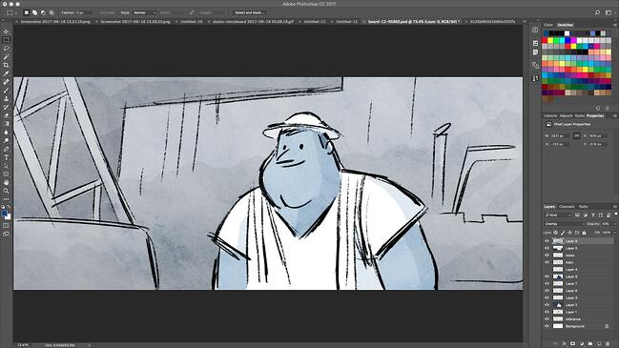

Figure 2.6:- Storyboarder GUI

Storyboarder is open source and free, making it one of your best options if you're working with a smaller budget. The program has a clean interface with all the necessary tools at your disposal, so it’s easy to quickly draw shapes and characters. You can also write dialogue, and enter timing information and shot type.

Storyboarder works collaboratively with Photoshop, which means you can edit your board in Photoshop for more precision, and it will automatically update in Storyboarder. This software lets you export to Premiere, Final Cut, Avid, PDF, or Animated GIF.

**Pricing**: Free

### 2. [Plot](https://theplot.io/)

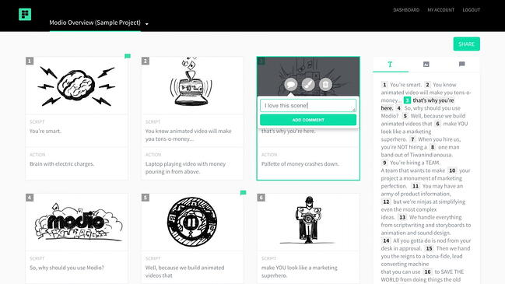

[***Image Source***](https://theplot.io/galleries/press-sample/)

Figure 2.7:-Plot GUI

Adrian Thompson made animated videos for seven years, and “came to despise how tedious it was to edit a basic storyboard template.” His frustration led him to create Plot, a free and fast storyboard creator with impressive users such as Vistaprint and Workday.

Each feature aims to make your process as quick and efficient as possible. You can add and delete scenes without copying and pasting text, incorporate images from anywhere on the web to visualize scenes faster, and collaborate with coworkers from within the software. Plot is a solid option if your team often works under tight deadlines and needs software to create storyboards quickly.

**Pricing**: [**$10/month**](https://theplot.io/#pricing)

### 3. [FrameForge Storyboard Studio](https://www.frameforge.com/" \t "_blank)

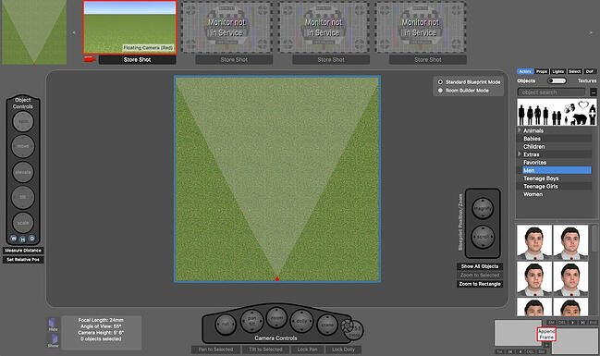

### Figure 2.8:- [FrameForge Storyboard Studio](https://www.frameforge.com/)

With impressive users including HBO, Netflix, and BBC, FrameForge is the real deal, but your team can still benefit even if you don’t have animation, drawing, or highly technical computer skills.

FrameForge offers Core and Professional versions of their product. The Professional option allows you to plan where you’ll place dollies and cranes (down to the inch). The software lets you import a script from any scriptwriting program. Plus, the storyboards include movement arrows, framing notations, angle of view, focal length, and more, so everyone on your video team, from preparation to production, is on the same page.

It works on any mobile device, and the export functions make it possible to download the final product as a PowerPoint presentation. FrameForge is a good option for teams that aim to create more full-fledged and lengthy videos for entertainment purposes.

**Pricing**: [**$498.95 one-time fee or $12.99/month (Core Edition)**](https://www.frameforge.com/products/frameforge-4-core-premium-subscription); [**$799 one-time fee or $24.99/month (Professional Edition)**](https://www.frameforge.com/products/frameforge-4-professional-subscription)

### 4. [Studiobinder](https://www.studiobinder.com/storyboard-creator/" \t "_blank)

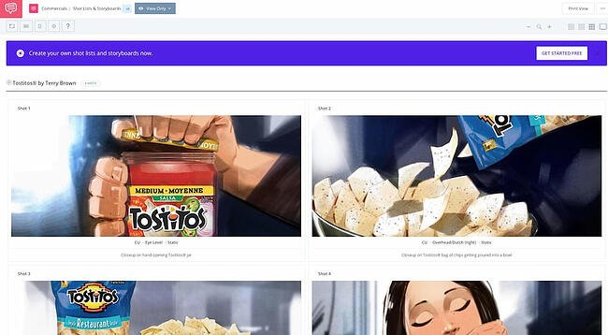

[***Image Source***](https://app.studiobinder.com/company/580e85847e7982164664e844/collab/5d28fb8d6c395a4819562576/projects/5d28aea5d6f13d13fbb8be92/shots/5d28aec8ac062314948fe1ab?filter=%257B%2522l%2522%253A%25225d28aec8ac062314948fe1ab%2522%257D&utm_source=blog&utm_medium=post&utm_campaign=sb-app-link&utm_content=tostitos-landing-page&utm_term=tostitos-landing-page)

Figure 2.8:- Studiobinder GUI

Studiobinder lets you customize every aspect of your visualization, and offers tools to filter columns, adjust the order of your scenes, upload images, change aspect ratios, color code shots, add notes, and more. Studiobinder also makes collaboration easy, with project management features to assign tasks and add comments.

Plus, if you want to preview your project from within the platform to show your team, there’s a nifty presentation mode. It touts impressive clients including BuzzFeed, ESPN, and CBS Interactive. This option is good for teams who need to collaborate on various stages of the video production process, and prefer customizable tools.

**Pricing**: [**$29/month (Indie); $49/month (Professional); $99/month (Studio)**](https://app.studiobinder.com/pricing)

### 5. [Boords Storyboard Creator](https://boords.com/storyboard-creator" \t "_blank)

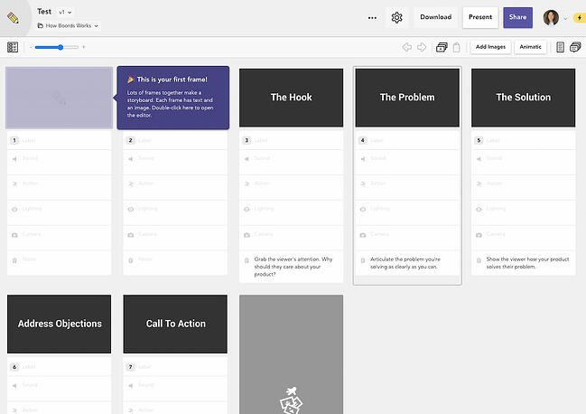

### Figure 2.9:- [Boords Storyboard Creator](https://boords.com/storyboard-creator)

This online storyboarding software allows you to easily collaborate with your team in a user-friendly web app. You can add images to each storyboard card and jot down quick notes for each progressive step of your video. Specify sound, action, lighting, and camera details — all without any advanced technical knowledge.

The power of this tool lies in its ease of use. While Storyboarder and FrameForge have a slight learning curve, Boords is one of those tools that you can simply access and start using straightaway.

What we love most about this tool is its notes at the bottom for each card. If you ever forget what you’re supposed to achieve scene-by-scene, Boords gives you a brief and helpful tip on what you should achieve in the shot. It also offers a unique Animatic Tool, and when you’re ready to share your animatic, you can share it online for feedback or export to Boords’ After Effects plugin. Plus, you can share your storyboard with coworkers or clients and let them comment within the platform.

**Pricing**: [**$36/month (Studio); $60/month (Company); $120/month (Company Plus)**](https://boords.com/pricing)

### 6. [makeStoryboard](https://makestoryboard.com/" \t "_blank)

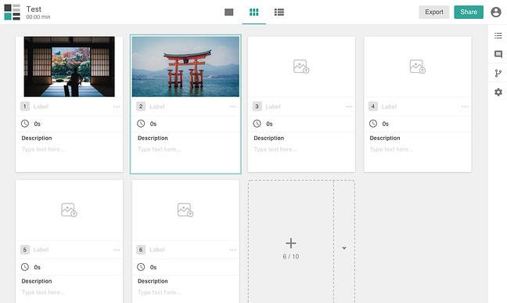

Figure 2.10:- makeStoryboard GUI

If you’re not necessarily interested in the fancier movie-making options in the list, makeStoryboard is a simple, user-friendly interface for quickly uploading camera shots, drawing stick figures in its built-in drawing tool, and incorporating text for scene details. The marker, pencil, and pen tools respond to any drawing tablet.

You can also add custom text fields for any additional details that are unique to your team and use case. When you’re happy with your storyboard, you can export it as a PDF to pitch your idea. Alternatively, you can send a private link so that stakeholders can review it without needing an account. Best of all, it offers a free subscription tier, making it a fantastic option for teams working with a smaller budget.

**Pricing**: [**Free; $12/month (Professional); $36/month (Team)**](https://makestoryboard.com/pricing)

### 7. [PowerProduction Software](https://www.powerproduction.com/index.php" \t "_blank)

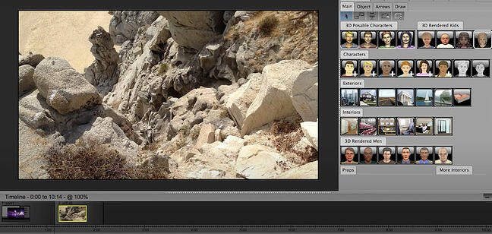

[***Image Source***](https://www.powerproduction.com/storyboard-artist.html)

Figure 2.10:- PowerProduction GUI

PowerProduction offers a variety of tools for storyboarding, varying from simple to more robust and all-inclusive. StoryBoard Quick, for instance, offers a library of artwork for characters, props, and locations, and allows you to design and share your ideas easily. StoryBoard Artist, on the other hand, offers a full-featured timeline, frame transitions, and 3D characters, and is more appropriate for animated video presentations.

PowerProduction also provides iPhone and Android app versions of their products, so you can visualize and create from anywhere. These products are used by big brands, including Disney, Universal, and 20th Century Fox, so if you choose this software, you’re in good company. If your team is interested in creating lengthy, high-quality, and even animated videos, this could be a good option.

**Pricing**: [**$129.99/year (StoryBoard Quick)**](https://store.powerproduction.com/StoryBoard-Quick-62--The-Fastest-StoryBoard-Software-On-The-Planet_p_48.html); [**$169.99/year (StoryBoard Quick Studio)**](https://store.powerproduction.com/StoryBoard-Quick-Studio-62_p_14.html); [**$269.99/year (StoryBoard Artist)**](https://store.powerproduction.com/StoryBoard-Artist-7--The-Professional-Choice-for-Previz_p_21.html); [**$399.99/year (StoryBoard Artist Studio)**](https://store.powerproduction.com/StoryBoard-Artist-7-Studio_p_16.html)

### 8. [Canva](https://www.canva.com/create/storyboards/" \t "_blank)

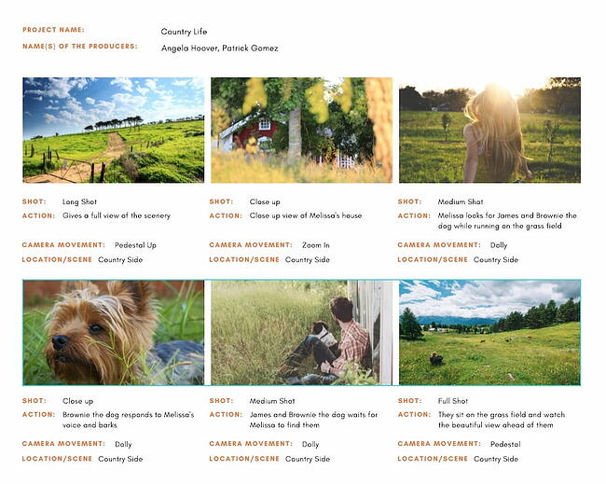

Figure 2.11:- Canva GUI

Creating a storyboard doesn’t have to stress you out, and Canva makes it especially easy, with a [**library of templates**](https://www.canva.com/templates/?query=storyboard) to choose from, one million stock images (or the option to upload your own), and grids and frames to organize your scenes. You can choose font types, customize colors, and include headers and subheaders.

If you’re working with someone else on the script or design, you can grant access for collaboration, and when you’re finished, you can share the design with your team through email or as a PDF file. If your team needs a simple and easy tool for simpler projects or to get your feet wet with the process of storyboarding, this is a good option.

**Pricing**: Free

### 9. [PanelForge](https://www.panel-forge.com/" \t "_blank)

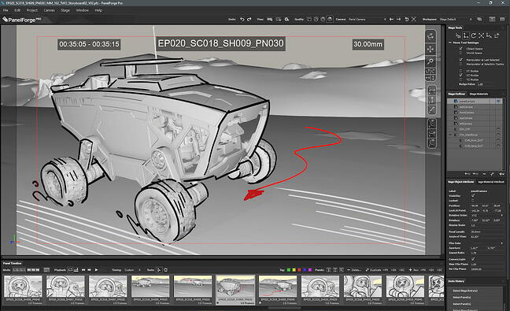

Figure 2.11:- PanelForge GUI

PanelForge offers an all-in-one pre-production storyboarding software, with drag-and-drop tools and flexible frames. With both a free public beta and a suite of paid plans, there’s no reason not to try it if you’re interested in using storyboarding for animatics and more complicated projects.

With PanelForge, you can create both 2D drawings and 3D layouts. It also allows you to create an animatic, and you can export and import files from Adobe Premiere and Final Cut Pro. PanelForge is ideal for experienced storyboarders and marketers who know their way around complex visualization tools.

Pricing: [**Free (Public Beta); $7.31/month (Pro); $1,411/year (Studio)**](https://www.panel-forge.com/buy.html)

### 10. [StoryboardThat](https://www.storyboardthat.com/" \t "_blank)

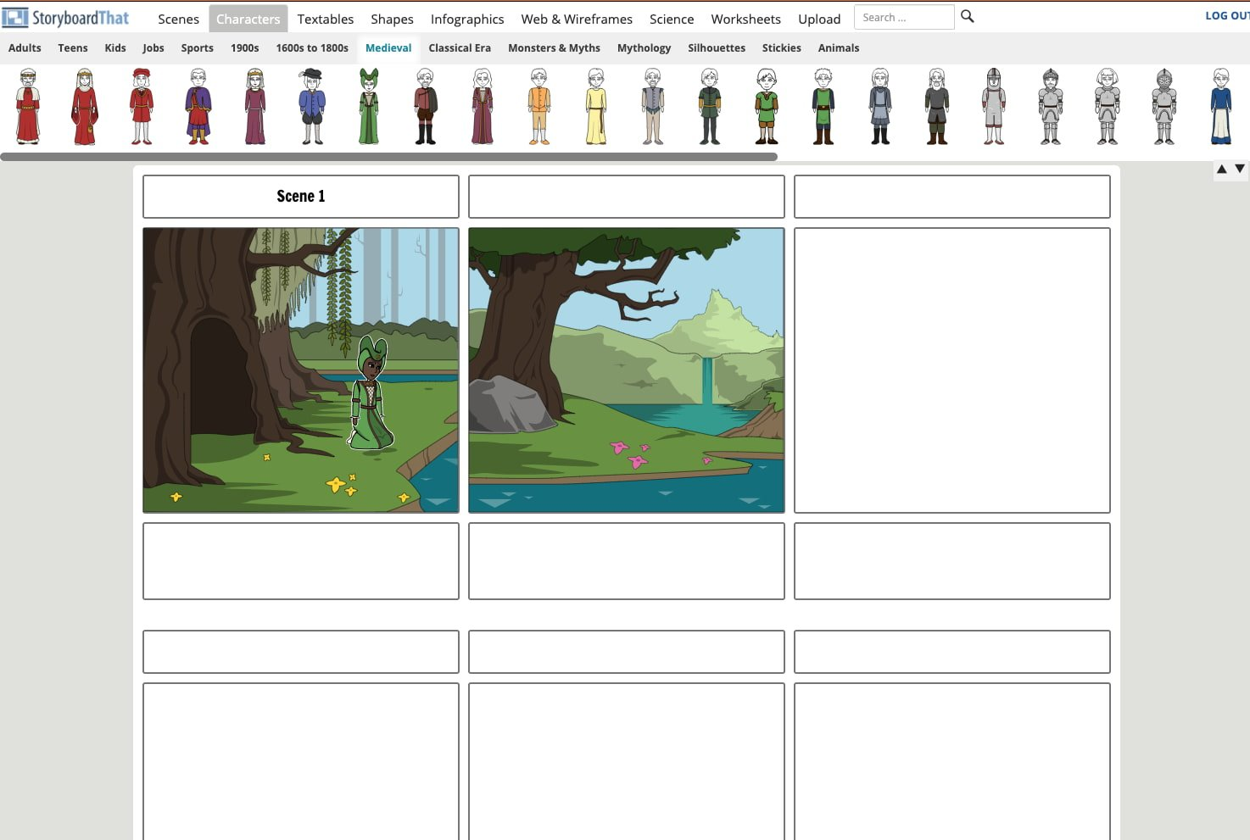

Figure 2.12:- StoryboardThat GUI

StoryboardThat is an intuitive, easy-to-use tool for creators who’d rather not draw (or who don’t know how to). The tool comes with hundreds of backgrounds and characters for you to build your storyboard.

On the free version, you can create two storyboards per week and choose between three- or six-cells storyboards. When you upgrade to the paid versions, you’ll be able to create unlimited storyboards, access hundreds of different layouts, and record audio.

**Pricing**: [**Free; $9.99/month (For Fun); $8.99/month (For Teachers); $14.99/month (For Work)**](https://www.storyboardthat.com/purchase)

## Use a Storyboarding Tool to Make Better Marketing Videos

A storyboarding tool can help you plan every shot and scene of your marketing video before you invest in production. The best part is that you can get started for free — and many times, you don’t have to draw anything at all. Using a storyboarding tool can improve your marketing videos exponentially, increasing the ROI from your video marketing strategy.