**Experiment 5**

Rebecca Dias TECMPNA Pid:182027 19

**Aim:** To study the use of network reconnaissance tools like WHOIS, dig, traceroute,nslookup to gather information about networks and domain registrars.

**Theory:**

**1. What is network reconnaissance?**

Network reconnaissance is a term for testing for potential vulnerabilities in a computer network. This may be a legitimate activity by the network owner/operator, seeking to protect it or to enforce its acceptable use policy. It also may be a precursor to external attacks on the network.

**2. What is passive reconnaissance? Give some examples.**

The process of collecting information about an intended target of a malicious [hack](https://www.webopedia.com/definitions/hack/) without the target knowing what is occurring is known as passive reconnaissance.Typical passive reconnaissance can include physical observation of an enterprise’s building, sorting through discarded computer equipment in an attempt to find equipment that contains data or discarded paper with [usernames](https://www.webopedia.com/definitions/username/) and [passwords](https://www.webopedia.com/definitions/password/), eavesdropping on employee conversations, researching the target through common Internet tools such as [Whois](https://www.webopedia.com/definitions/whois/), impersonating an employee in an attempt to collect information, and [packet sniffing](https://www.webopedia.com/definitions/sniffer/).

Examples of passive reconnaissance are listening to employees’ conversations, going through old garbage to find things of importance like username and password. It can also include using OSINT (Open-Source Intelligence gathering, which uses online information such as Twitter, Instagram, LinkedIn, etc. to gather information) techniques to gather even more information from a target.

**3. What is active reconnaissance? Give some examples**

The process of collecting information about an intended target of a malicious [hack](https://www.webopedia.com/definitions/hack/) by probing the target system is known as active reconnaissance. Active reconnaissance typically involves [port scanning](https://www.webopedia.com/definitions/port-scanning/) in order to find weaknesses in the target system (i.e., which [ports](https://www.webopedia.com/definitions/port/) are left vulnerable and/or if there are ways around the [firewall](https://www.webopedia.com/definitions/firewall/) and [routers](https://www.webopedia.com/definitions/router-hardware/)). The process of exploiting the system can then be carried out once the hacker has found a way to access the system.

In order to gather information from the target host, attackers normally use port scanning techniques. Nmap is a network scanner designed to determine details about a system and the programs running on it. By launching scans against a system or a range of IP addresses under a target’s control, a hacker can learn a significant amount of information about the target network. Metasploit is primarily designed as an exploitation toolkit. It contains a variety of different modules that have pre-packaged exploits for a number of vulnerabilities. With Metasploit, even a novice hacker has the potential to break into a wide range of vulnerable machines

**4. Execute the following commands and take screenshot of output**

**a. whois**

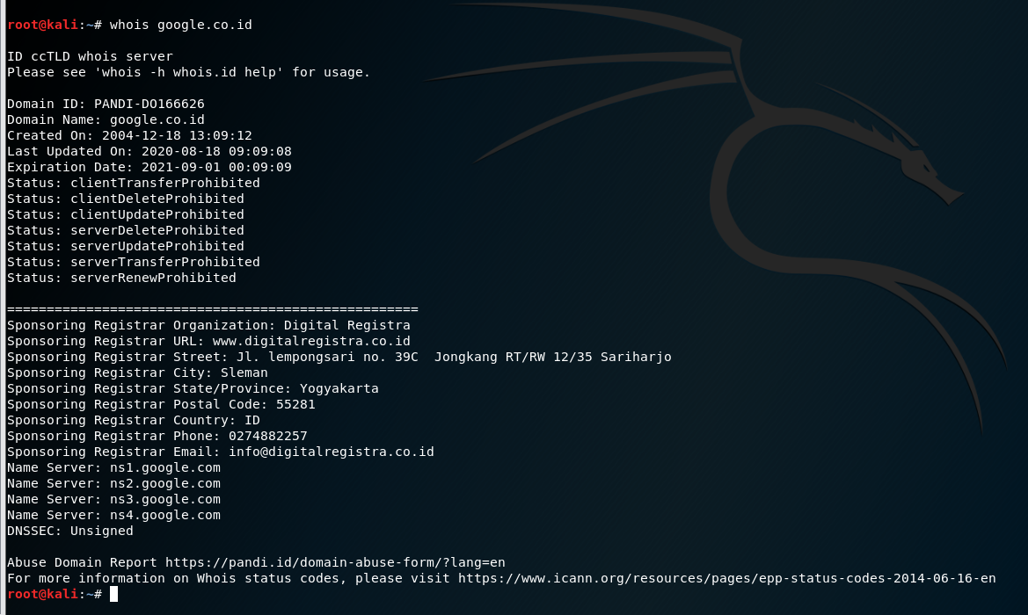

**b.dig**

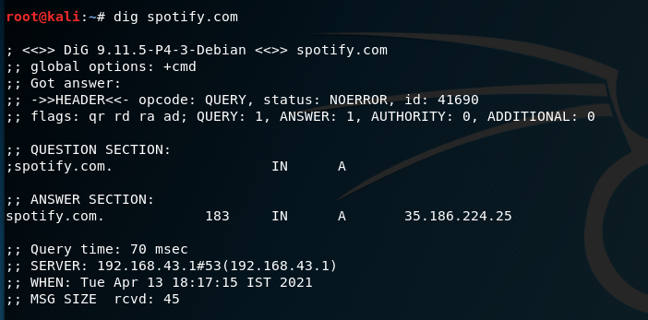

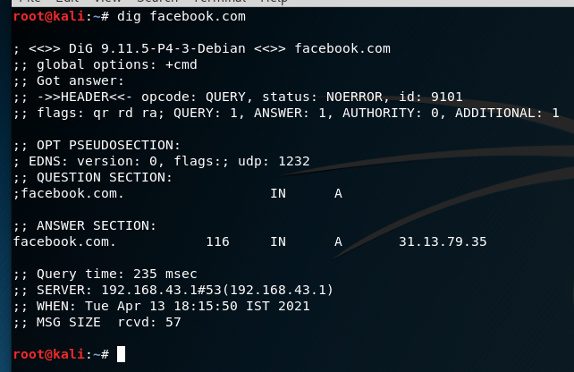

**c. traceroute**

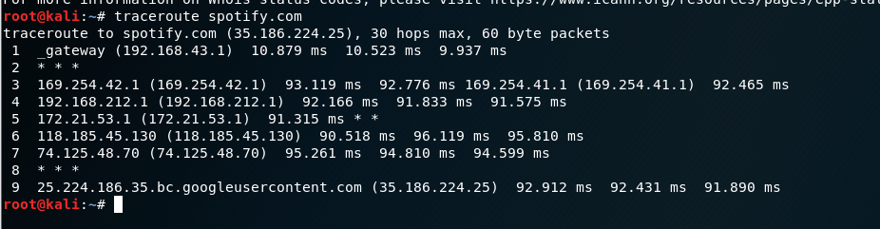

**d. nslookup**

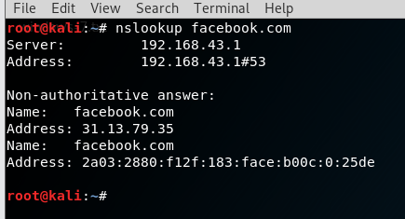

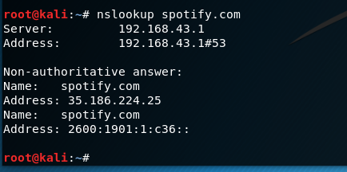

**e. ifconfig**

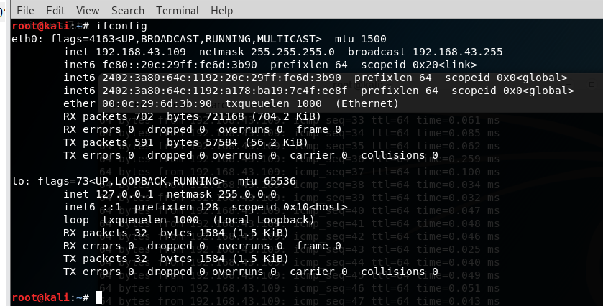

**f. ping**

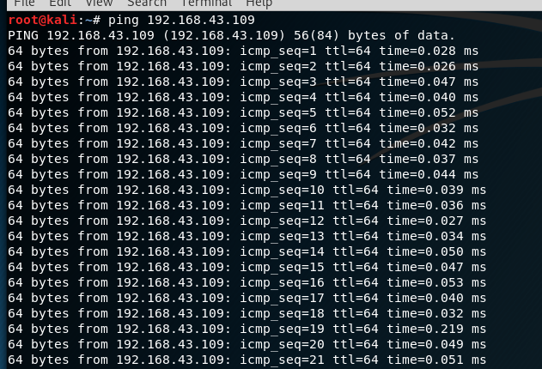

**g. nestat**

root@kali:~# netstat

Active Internet connections (w/o servers)

Proto Recv-Q Send-Q Local Address Foreign Address State

Active UNIX domain sockets (w/o servers)

Proto RefCnt Flags Type State I-Node Path

unix 3 [ ] DGRAM 14448 /run/systemd/notify

unix 2 [ ] DGRAM 26493 /run/user/0/systemd/notify

unix 16 [ ] DGRAM 14464 /run/systemd/journal/dev-log

unix 2 [ ] DGRAM 14477 /run/systemd/journal/syslog

unix 7 [ ] DGRAM 14493 /run/systemd/journal/socket

unix 2 [ ] DGRAM 17910 /run/user/131/systemd/notify

unix 3 [ ] STREAM CONNECTED 30813

unix 3 [ ] STREAM CONNECTED 29104

unix 3 [ ] STREAM CONNECTED 29060

unix 3 [ ] STREAM CONNECTED 29773

unix 3 [ ] STREAM CONNECTED 28714 /run/systemd/journal/stdout

unix 3 [ ] STREAM CONNECTED 26859 /run/systemd/journal/stdout

unix 3 [ ] STREAM CONNECTED 27681 /run/systemd/journal/stdout

unix 3 [ ] STREAM CONNECTED 25874 /run/systemd/journal/stdout

unix 2 [ ] DGRAM 28615

unix 3 [ ] STREAM CONNECTED 27004 /run/systemd/journal/stdout

unix 3 [ ] STREAM CONNECTED 27619 /run/systemd/journal/stdout

unix 3 [ ] STREAM CONNECTED 28976 /run/systemd/journal/stdout

unix 3 [ ] STREAM CONNECTED 24848 @/tmp/dbus-aa10o7vjgl

unix 3 [ ] STREAM CONNECTED 29894 /run/user/0/bus

unix 3 [ ] STREAM CONNECTED 28464 /run/systemd/journal/stdout

unix 3 [ ] STREAM CONNECTED 28856 /run/user/0/bus

unix 3 [ ] STREAM CONNECTED 28147 /run/user/0/bus

unix 3 [ ] STREAM CONNECTED 24818

unix 3 [ ] STREAM CONNECTED 20782

unix 3 [ ] STREAM CONNECTED 28038

unix 3 [ ] STREAM CONNECTED 29080 /var/run/dbus/system_bus_socket

unix 2 [ ] DGRAM 15402

unix 3 [ ] STREAM CONNECTED 28607 /run/systemd/journal/stdout

unix 3 [ ] STREAM CONNECTED 28975

unix 2 [ ] DGRAM 28286

unix 3 [ ] STREAM CONNECTED 27783 /run/user/131/bus

unix 3 [ ] STREAM CONNECTED 28604 /run/systemd/journal/stdout

unix 3 [ ] STREAM CONNECTED 28463 /run/systemd/journal/stdout

unix 3 [ ] STREAM CONNECTED 28118 /run/user/0/bus

unix 3 [ ] STREAM CONNECTED 24491 /run/user/131/pulse/native

unix 3 [ ] STREAM CONNECTED 52408 /var/run/dbus/system_bus_socket

unix 3 [ ] STREAM CONNECTED 29907 /run/user/0/bus

unix 2 [ ] DGRAM 13619

unix 3 [ ] STREAM CONNECTED 51924

unix 3 [ ] STREAM CONNECTED 29075 /var/run/dbus/system_bus_socket

unix 3 [ ] STREAM CONNECTED 24009

unix 3 [ ] STREAM CONNECTED 27639

unix 3 [ ] STREAM CONNECTED 27248 /run/user/0/pulse/native

unix 3 [ ] STREAM CONNECTED 29125

unix 3 [ ] STREAM CONNECTED 28877 /run/user/0/bus

unix 3 [ ] STREAM CONNECTED 28207 /run/systemd/journal/stdout

unix 3 [ ] STREAM CONNECTED 28146 @/tmp/.X11-unix/X1

unix 3 [ ] STREAM CONNECTED 27787 /run/user/131/bus

unix 3 [ ] STREAM CONNECTED 24788

unix 3 [ ] STREAM CONNECTED 22825 /run/user/131/bus

unix 3 [ ] STREAM CONNECTED 27073

unix 3 [ ] STREAM CONNECTED 25736

unix 3 [ ] STREAM CONNECTED 28625

unix 3 [ ] STREAM CONNECTED 27208

unix 3 [ ] STREAM CONNECTED 27622 /run/systemd/journal/stdout

unix 3 [ ] STREAM CONNECTED 28982 @/tmp/.X11-unix/X1

unix 3 [ ] STREAM CONNECTED 26880 /var/run/dbus/system_bus_socket

unix 3 [ ] STREAM CONNECTED 29090 @/tmp/dbus-VRc6fHAGjA

unix 3 [ ] STREAM CONNECTED 29745

unix 3 [ ] STREAM CONNECTED 28819

unix 3 [ ] STREAM CONNECTED 25344

unix 3 [ ] STREAM CONNECTED 27777

unix 3 [ ] STREAM CONNECTED 27659

unix 3 [ ] STREAM CONNECTED 26754 /run/systemd/journal/stdout

unix 3 [ ] STREAM CONNECTED 29204

unix 3 [ ] STREAM CONNECTED 28027

unix 3 [ ] STREAM CONNECTED 29961 /var/run/dbus/system_bus_socket

unix 3 [ ] STREAM CONNECTED 29073 @/tmp/dbus-VRc6fHAGjA

unix 3 [ ] STREAM CONNECTED 26538

unix 3 [ ] STREAM CONNECTED 27618

unix 3 [ ] STREAM CONNECTED 28937

unix 3 [ ] STREAM CONNECTED 28921 /run/systemd/journal/stdout

unix 3 [ ] STREAM CONNECTED 27480

unix 3 [ ] STREAM CONNECTED 27441 /run/systemd/journal/stdout

unix 3 [ ] STREAM CONNECTED 24714

unix 3 [ ] STREAM CONNECTED 20783 /run/systemd/journal/stdout

unix 3 [ ] STREAM CONNECTED 27168

unix 3 [ ] STREAM CONNECTED 17547 /var/run/dbus/system_bus_socket

unix 3 [ ] STREAM CONNECTED 29082 /var/run/dbus/system_bus_socket

unix 3 [ ] STREAM CONNECTED 28220 /run/user/0/bus

unix 3 [ ] STREAM CONNECTED 17549 /var/run/dbus/system_bus_socket

unix 3 [ ] STREAM CONNECTED 29480 /run/systemd/journal/stdout

unix 3 [ ] STREAM CONNECTED 29404 /run/systemd/journal/stdout

unix 3 [ ] STREAM CONNECTED 29865 /run/systemd/journal/stdout

unix 3 [ ] STREAM CONNECTED 28783

unix 3 [ ] STREAM CONNECTED 26856 /run/systemd/journal/stdout

unix 3 [ ] STREAM CONNECTED 29147

unix 3 [ ] STREAM CONNECTED 29748

unix 3 [ ] STREAM CONNECTED 27780 /run/user/131/bus

unix 3 [ ] STREAM CONNECTED 26778 /run/systemd/journal/stdout

unix 3 [ ] STREAM CONNECTED 21706 /run/systemd/journal/stdout

unix 3 [ ] STREAM CONNECTED 27576

unix 3 [ ] STREAM CONNECTED 28853 /run/user/0/bus

unix 3 [ ] STREAM CONNECTED 28439

unix 3 [ ] STREAM CONNECTED 51926

unix 3 [ ] STREAM CONNECTED 29076 /run/user/0/bus

unix 3 [ ] STREAM CONNECTED 28873 @/tmp/dbus-VRc6fHAGjA

unix 3 [ ] STREAM CONNECTED 30788

unix 3 [ ] STREAM CONNECTED 29146

unix 3 [ ] STREAM CONNECTED 29768 /run/systemd/journal/stdout

unix 3 [ ] STREAM CONNECTED 26872 /run/systemd/journal/stdout

unix 3 [ ] STREAM CONNECTED 27753 @/tmp/.X11-unix/X0

unix 3 [ ] STREAM CONNECTED 27751

unix 3 [ ] STREAM CONNECTED 29227 /run/systemd/journal/stdout

unix 3 [ ] STREAM CONNECTED 29074 /var/run/dbus/system_bus_socket

unix 3 [ ] STREAM CONNECTED 24663

unix 3 [ ] STREAM CONNECTED 19531

unix 3 [ ] STREAM CONNECTED 30721

unix 3 [ ] STREAM CONNECTED 29864 /run/systemd/journal/stdout

unix 3 [ ] STREAM CONNECTED 26866

unix 3 [ ] STREAM CONNECTED 17546 /var/run/dbus/system_bus_socket

unix 3 [ ] STREAM CONNECTED 29126

unix 3 [ ] STREAM CONNECTED 29034 /run/systemd/journal/stdout

unix 3 [ ] STREAM CONNECTED 25323

unix 3 [ ] STREAM CONNECTED 25166

unix 3 [ ] STREAM CONNECTED 27778

unix 3 [ ] STREAM CONNECTED 25936 /run/user/131/bus

unix 3 [ ] STREAM CONNECTED 24713

unix 3 [ ] STREAM CONNECTED 29406

unix 3 [ ] STREAM CONNECTED 27553 /run/user/0/bus

unix 3 [ ] STREAM CONNECTED 28639

unix 3 [ ] STREAM CONNECTED 27035 /var/run/dbus/system_bus_socket

unix 3 [ ] STREAM CONNECTED 32125 @/tmp/.ICE-unix/1327

unix 3 [ ] STREAM CONNECTED 28864

unix 3 [ ] STREAM CONNECTED 26888

unix 3 [ ] STREAM CONNECTED 17812

unix 3 [ ] STREAM CONNECTED 30727 /run/systemd/journal/stdout

unix 3 [ ] STREAM CONNECTED 29767

unix 3 [ ] STREAM CONNECTED 27680

unix 3 [ ] STREAM CONNECTED 26753 /run/systemd/journal/stdout

unix 3 [ ] STREAM CONNECTED 28875 /run/user/0/bus

unix 3 [ ] STREAM CONNECTED 30831

unix 3 [ ] STREAM CONNECTED 28577

unix 3 [ ] STREAM CONNECTED 29870 @/tmp/.ICE-unix/1327

unix 3 [ ] DGRAM 26496

unix 3 [ ] STREAM CONNECTED 29091 /var/run/dbus/system_bus_socket

unix 3 [ ] STREAM CONNECTED 28865 @/tmp/.X11-unix/X1

unix 3 [ ] STREAM CONNECTED 29058

unix 3 [ ] STREAM CONNECTED 28934 @/tmp/.X11-unix/X1

unix 3 [ ] STREAM CONNECTED 28460 /run/systemd/journal/stdout

unix 3 [ ] STREAM CONNECTED 27452 /run/user/0/bus

unix 3 [ ] STREAM CONNECTED 25322

unix 3 [ ] STREAM CONNECTED 24821

unix 3 [ ] STREAM CONNECTED 27708 /run/systemd/journal/stdout

unix 2 [ ] DGRAM 28102

unix 3 [ ] STREAM CONNECTED 28040 /run/user/0/bus

unix 3 [ ] STREAM CONNECTED 17126

unix 3 [ ] DGRAM 13948

unix 3 [ ] STREAM CONNECTED 28614

unix 2 [ ] DGRAM 26480

unix 3 [ ] STREAM CONNECTED 30460

unix 3 [ ] STREAM CONNECTED 27627

unix 3 [ ] STREAM CONNECTED 28826

unix 3 [ ] STREAM CONNECTED 26879

unix 3 [ ] STREAM CONNECTED 29105 /var/run/dbus/system_bus_socket

unix 3 [ ] STREAM CONNECTED 29033 /run/systemd/journal/stdout

unix 3 [ ] STREAM CONNECTED 25311

unix 3 [ ] STREAM CONNECTED 25164 /run/systemd/journal/stdout

unix 3 [ ] STREAM CONNECTED 26874 /run/systemd/journal/stdout

unix 3 [ ] STREAM CONNECTED 27704

unix 3 [ ] STREAM CONNECTED 24763

unix 3 [ ] STREAM CONNECTED 27552

unix 3 [ ] STREAM CONNECTED 28205 /run/systemd/journal/stdout

unix 3 [ ] STREAM CONNECTED 13760

unix 3 [ ] STREAM CONNECTED 29070 /var/run/dbus/system_bus_socket

unix 3 [ ] STREAM CONNECTED 27886

unix 3 [ ] STREAM CONNECTED 27621

unix 2 [ ] DGRAM 25488

unix 3 [ ] STREAM CONNECTED 25206 /run/user/0/bus

unix 3 [ ] STREAM CONNECTED 27883 /run/systemd/journal/stdout

unix 3 [ ] STREAM CONNECTED 26828 /run/systemd/journal/stdout

unix 2 [ ] DGRAM 30863

unix 3 [ ] STREAM CONNECTED 30728 /run/systemd/journal/stdout

unix 2 [ ] STREAM 25173

unix 2 [ ] DGRAM 27835

unix 3 [ ] STREAM CONNECTED 27660 /run/user/131/bus

unix 3 [ ] STREAM CONNECTED 21119 /var/run/dbus/system_bus_socket

unix 3 [ ] STREAM CONNECTED 28108 /run/user/0/bus

unix 3 [ ] STREAM CONNECTED 28626

unix 3 [ ] STREAM CONNECTED 27245

unix 2 [ ] DGRAM 26477

unix 3 [ ] STREAM CONNECTED 25962

unix 3 [ ] STREAM CONNECTED 27598

unix 3 [ ] STREAM CONNECTED 28784

unix 2 [ ] DGRAM 30921

unix 3 [ ] STREAM CONNECTED 29093 /var/run/dbus/system_bus_socket

unix 3 [ ] STREAM CONNECTED 29746

unix 3 [ ] STREAM CONNECTED 26860 /run/systemd/journal/stdout

unix 3 [ ] STREAM CONNECTED 27757

unix 3 [ ] STREAM CONNECTED 18177

unix 3 [ ] STREAM CONNECTED 26469

unix 3 [ ] STREAM CONNECTED 51927 @/tmp/dbus-VRc6fHAGjA

unix 3 [ ] STREAM CONNECTED 28627

unix 3 [ ] STREAM CONNECTED 30869 /var/run/dbus/system_bus_socket

unix 3 [ ] STREAM CONNECTED 28608 /run/systemd/journal/stdout

unix 3 [ ] STREAM CONNECTED 28872

unix 3 [ ] STREAM CONNECTED 28280 /var/run/dbus/system_bus_socket

unix 3 [ ] STREAM CONNECTED 16378

unix 3 [ ] DGRAM 13818

unix 3 [ ] STREAM CONNECTED 25400

unix 3 [ ] STREAM CONNECTED 26759 /run/systemd/journal/stdout

unix 3 [ ] STREAM CONNECTED 24734

unix 3 [ ] STREAM CONNECTED 26543 /var/run/dbus/system_bus_socket

unix 3 [ ] DGRAM 13947

unix 3 [ ] STREAM CONNECTED 29086 /var/run/dbus/system_bus_socket

unix 2 [ ] DGRAM 18737

unix 3 [ ] STREAM CONNECTED 29953 /var/run/dbus/system_bus_socket

unix 3 [ ] STREAM CONNECTED 30722 /run/systemd/journal/stdout

unix 3 [ ] STREAM CONNECTED 30731 /run/systemd/journal/stdout

unix 3 [ ] STREAM CONNECTED 29771 /run/systemd/journal/stdout

unix 3 [ ] STREAM CONNECTED 28838

unix 3 [ ] STREAM CONNECTED 27707

unix 3 [ ] STREAM CONNECTED 24785

unix 3 [ ] STREAM CONNECTED 29206

unix 3 [ ] STREAM CONNECTED 28871 /run/user/0/bus

unix 3 [ ] STREAM CONNECTED 17125

unix 3 [ ] STREAM CONNECTED 28611

unix 3 [ ] STREAM CONNECTED 28041 /run/user/0/bus

unix 2 [ ] DGRAM 27892

unix 3 [ ] STREAM CONNECTED 30724

unix 3 [ ] STREAM CONNECTED 27599

unix 3 [ ] STREAM CONNECTED 25490

unix 3 [ ] STREAM CONNECTED 27788 /var/run/dbus/system_bus_socket

unix 3 [ ] STREAM CONNECTED 29069 /run/user/0/bus

unix 3 [ ] STREAM CONNECTED 29725

unix 3 [ ] STREAM CONNECTED 25930 /run/user/131/bus

unix 3 [ ] STREAM CONNECTED 20780 /run/systemd/journal/stdout

unix 3 [ ] STREAM CONNECTED 27141

unix 3 [ ] STREAM CONNECTED 28700

unix 3 [ ] STREAM CONNECTED 18591

unix 3 [ ] STREAM CONNECTED 52400 /run/systemd/journal/stdout

unix 3 [ ] STREAM CONNECTED 28628

unix 2 [ ] DGRAM 25931

unix 3 [ ] STREAM CONNECTED 20974

unix 3 [ ] STREAM CONNECTED 32120

unix 3 [ ] STREAM CONNECTED 27547 /run/user/0/bus

unix 3 [ ] STREAM CONNECTED 25064

unix 3 [ ] STREAM CONNECTED 26855

unix 3 [ ] STREAM CONNECTED 21267 /run/systemd/journal/stdout

unix 3 [ ] DGRAM 13817

unix 3 [ ] STREAM CONNECTED 31752 @/tmp/.X11-unix/X1

unix 3 [ ] STREAM CONNECTED 29021

unix 2 [ ] DGRAM 25475

unix 3 [ ] STREAM CONNECTED 27782

unix 3 [ ] STREAM CONNECTED 24760

unix 3 [ ] STREAM CONNECTED 21134

unix 3 [ ] STREAM CONNECTED 27511

unix 3 [ ] STREAM CONNECTED 29102 /var/run/dbus/system_bus_socket

unix 3 [ ] STREAM CONNECTED 26924 /var/run/dbus/system_bus_socket

unix 2 [ ] DGRAM 29482

unix 3 [ ] STREAM CONNECTED 27647

unix 3 [ ] STREAM CONNECTED 28780

unix 3 [ ] STREAM CONNECTED 25065

unix 3 [ ] STREAM CONNECTED 25947 @/tmp/dbus-aa10o7vjgl

unix 3 [ ] STREAM CONNECTED 29019 /run/systemd/journal/stdout

unix 3 [ ] STREAM CONNECTED 28459 /run/systemd/journal/stdout

unix 3 [ ] STREAM CONNECTED 28820

unix 3 [ ] STREAM CONNECTED 26760 /run/systemd/journal/stdout

unix 3 [ ] STREAM CONNECTED 29952 /var/run/dbus/system_bus_socket

unix 3 [ ] STREAM CONNECTED 27536 /run/systemd/journal/stdout

unix 3 [ ] STREAM CONNECTED 28015

unix 3 [ ] STREAM CONNECTED 19578

unix 3 [ ] STREAM CONNECTED 17047

unix 3 [ ] STREAM CONNECTED 28653

unix 2 [ ] DGRAM 20759

unix 3 [ ] STREAM CONNECTED 31750 /run/user/0/pulse/native

unix 3 [ ] STREAM CONNECTED 28781

unix 3 [ ] STREAM CONNECTED 26852

unix 3 [ ] STREAM CONNECTED 30786 /run/systemd/journal/stdout

unix 3 [ ] STREAM CONNECTED 28651 /run/user/0/bus

unix 3 [ ] STREAM CONNECTED 29061 /run/user/0/bus

unix 3 [ ] STREAM CONNECTED 28862 /run/user/0/bus

unix 3 [ ] STREAM CONNECTED 24852 @/tmp/dbus-aa10o7vjgl

unix 3 [ ] STREAM CONNECTED 27755

unix 3 [ ] STREAM CONNECTED 24786 /run/systemd/journal/stdout

unix 3 [ ] STREAM CONNECTED 29909 /run/user/0/bus

unix 3 [ ] STREAM CONNECTED 27535

unix 3 [ ] STREAM CONNECTED 25107

unix 3 [ ] STREAM CONNECTED 14012

unix 3 [ ] STREAM CONNECTED 29024 @/tmp/dbus-VRc6fHAGjA

unix 3 [ ] STREAM CONNECTED 28217 /run/systemd/journal/stdout

unix 3 [ ] STREAM CONNECTED 26973 @/tmp/dbus-k9CMLylX

unix 2 [ ] DGRAM 25950

unix 3 [ ] STREAM CONNECTED 28939

unix 3 [ ] STREAM CONNECTED 17803

unix 3 [ ] STREAM CONNECTED 30732 /run/systemd/journal/stdout

unix 3 [ ] STREAM CONNECTED 27482

unix 3 [ ] STREAM CONNECTED 25167 /run/systemd/journal/stdout

unix 3 [ ] STREAM CONNECTED 27784

unix 3 [ ] STREAM CONNECTED 21660 /run/user/131/bus

unix 3 [ ] STREAM CONNECTED 25145 /run/systemd/journal/stdout

unix 3 [ ] STREAM CONNECTED 27578 @/tmp/.X11-unix/X1

unix 3 [ ] STREAM CONNECTED 17139

unix 3 [ ] STREAM CONNECTED 31934

unix 3 [ ] STREAM CONNECTED 25429 /run/systemd/journal/stdout

unix 3 [ ] STREAM CONNECTED 26890 /var/run/dbus/system_bus_socket

unix 3 [ ] STREAM CONNECTED 29089

unix 3 [ ] STREAM CONNECTED 28821 /run/user/0/bus

unix 3 [ ] STREAM CONNECTED 25942 /run/user/131/bus

unix 3 [ ] STREAM CONNECTED 27750

unix 3 [ ] STREAM CONNECTED 24764 /run/systemd/journal/stdout

unix 3 [ ] STREAM CONNECTED 27542

unix 3 [ ] STREAM CONNECTED 20779

unix 3 [ ] STREAM CONNECTED 52404 @/tmp/.X11-unix/X1

unix 3 [ ] STREAM CONNECTED 28640

unix 3 [ ] STREAM CONNECTED 27246

unix 2 [ ] DGRAM 17133

unix 3 [ ] STREAM CONNECTED 30725 /run/systemd/journal/stdout

unix 3 [ ] STREAM CONNECTED 27641

unix 3 [ ] STREAM CONNECTED 26832 /run/systemd/journal/stdout

unix 3 [ ] STREAM CONNECTED 17806 /run/systemd/journal/stdout

unix 3 [ ] STREAM CONNECTED 29318 /var/run/dbus/system_bus_socket

unix 3 [ ] STREAM CONNECTED 28603 /run/systemd/journal/stdout

unix 3 [ ] STREAM CONNECTED 28880 /run/systemd/journal/stdout

unix 3 [ ] STREAM CONNECTED 28287 /var/run/dbus/system_bus_socket

unix 3 [ ] STREAM CONNECTED 25345

unix 3 [ ] STREAM CONNECTED 27786

unix 3 [ ] STREAM CONNECTED 25875 /run/systemd/journal/stdout

unix 3 [ ] STREAM CONNECTED 27538

unix 3 [ ] STREAM CONNECTED 16971

unix 3 [ ] STREAM CONNECTED 28652

unix 3 [ ] STREAM CONNECTED 26161 /var/run/dbus/system_bus_socket

unix 3 [ ] STREAM CONNECTED 20046 /run/systemd/journal/stdout

unix 3 [ ] STREAM CONNECTED 29081 /var/run/dbus/system_bus_socket

unix 3 [ ] STREAM CONNECTED 28981

unix 3 [ ] STREAM CONNECTED 28839 /run/user/0/bus

unix 3 [ ] STREAM CONNECTED 26971

unix 2 [ ] DGRAM 17855

unix 3 [ ] STREAM CONNECTED 29068

unix 3 [ ] STREAM CONNECTED 29812

unix 3 [ ] STREAM CONNECTED 28455 /run/systemd/journal/stdout

unix 3 [ ] STREAM CONNECTED 28847 /run/systemd/journal/stdout

unix 3 [ ] STREAM CONNECTED 27684 /run/systemd/journal/stdout

unix 3 [ ] STREAM CONNECTED 24789 /run/systemd/journal/stdout

unix 3 [ ] STREAM CONNECTED 28189 @/tmp/.X11-unix/X1

unix 3 [ ] STREAM CONNECTED 28597 /run/systemd/journal/stdout

unix 3 [ ] STREAM CONNECTED 26499

unix 3 [ ] STREAM CONNECTED 27577

unix 3 [ ] STREAM CONNECTED 28979 /run/systemd/journal/stdout

unix 3 [ ] STREAM CONNECTED 26831

unix 3 [ ] STREAM CONNECTED 19659

unix 3 [ ] STREAM CONNECTED 13883 /run/systemd/journal/stdout

unix 3 [ ] STREAM CONNECTED 31770 @/tmp/dbus-VRc6fHAGjA

unix 3 [ ] STREAM CONNECTED 29059

unix 3 [ ] STREAM CONNECTED 29032

unix 3 [ ] STREAM CONNECTED 29724

unix 3 [ ] STREAM CONNECTED 24840

unix 3 [ ] STREAM CONNECTED 21262

unix 3 [ ] STREAM CONNECTED 51195

unix 3 [ ] STREAM CONNECTED 29226

unix 3 [ ] STREAM CONNECTED 28836

unix 3 [ ] STREAM CONNECTED 21493

unix 3 [ ] STREAM CONNECTED 28599

unix 3 [ ] STREAM CONNECTED 25932

unix 3 [ ] STREAM CONNECTED 29078 /var/run/dbus/system_bus_socket

unix 3 [ ] STREAM CONNECTED 28986

unix 3 [ ] STREAM CONNECTED 26830

unix 3 [ ] STREAM CONNECTED 17643 /var/run/dbus/system_bus_socket

unix 3 [ ] STREAM CONNECTED 29792

unix 3 [ ] STREAM CONNECTED 28208 /run/systemd/journal/stdout

unix 3 [ ] STREAM CONNECTED 25093 /run/systemd/journal/stdout

unix 3 [ ] STREAM CONNECTED 27785 /run/user/131/bus

unix 3 [ ] STREAM CONNECTED 27683

unix 3 [ ] STREAM CONNECTED 24736 /run/systemd/journal/stdout

unix 3 [ ] STREAM CONNECTED 30213 /run/systemd/journal/stdout

unix 3 [ ] STREAM CONNECTED 29456

unix 3 [ ] STREAM CONNECTED 27512 /run/systemd/journal/stdout

unix 3 [ ] STREAM CONNECTED 28039

unix 3 [ ] STREAM CONNECTED 31930

unix 3 [ ] STREAM CONNECTED 28566

unix 3 [ ] STREAM CONNECTED 32124

unix 3 [ ] STREAM CONNECTED 28978

unix 3 [ ] STREAM CONNECTED 26865

unix 3 [ ] STREAM CONNECTED 17813 /var/run/dbus/system_bus_socket

unix 2 [ ] DGRAM 30796

unix 3 [ ] STREAM CONNECTED 28570

unix 3 [ ] STREAM CONNECTED 28762 /run/user/0/bus

unix 3 [ ] STREAM CONNECTED 27658

unix 3 [ ] STREAM CONNECTED 18273

unix 3 [ ] STREAM CONNECTED 28457 @/tmp/.ICE-unix/1327

unix 3 [ ] STREAM CONNECTED 28443

unix 3 [ ] STREAM CONNECTED 28272

unix 3 [ ] STREAM CONNECTED 17548 /var/run/dbus/system_bus_socket

unix 3 [ ] STREAM CONNECTED 52407 /run/user/0/bus

unix 3 [ ] STREAM CONNECTED 28567 /run/user/0/pulse/native

unix 3 [ ] STREAM CONNECTED 21802 /var/run/dbus/system_bus_socket

unix 3 [ ] STREAM CONNECTED 28186 /run/user/0/bus

unix 3 [ ] STREAM CONNECTED 26885

unix 2 [ ] DGRAM 13815

unix 3 [ ] STREAM CONNECTED 30789 /run/systemd/journal/stdout

unix 3 [ ] STREAM CONNECTED 29097

unix 3 [ ] STREAM CONNECTED 29770

unix 3 [ ] STREAM CONNECTED 27808

unix 3 [ ] STREAM CONNECTED 24735

unix 3 [ ] STREAM CONNECTED 21120

unix 3 [ ] STREAM CONNECTED 27491

unix 3 [ ] STREAM CONNECTED 20753

unix 3 [ ] STREAM CONNECTED 28596

unix 3 [ ] DGRAM 26495

unix 3 [ ] STREAM CONNECTED 28987 @/tmp/dbus-VRc6fHAGjA

unix 3 [ ] STREAM CONNECTED 27882 /run/systemd/journal/stdout

unix 3 [ ] STREAM CONNECTED 26863

unix 3 [ ] STREAM CONNECTED 30785

unix 3 [ ] STREAM CONNECTED 29085

unix 3 [ ] STREAM CONNECTED 24737 /run/systemd/journal/stdout

unix 3 [ ] STREAM CONNECTED 23747 @/tmp/.X11-unix/X0

unix 3 [ ] STREAM CONNECTED 28061 /var/run/dbus/system_bus_socket

unix 3 [ ] STREAM CONNECTED 27050

unix 3 [ ] STREAM CONNECTED 29025 /run/user/0/bus

unix 3 [ ] STREAM CONNECTED 27710 /var/run/dbus/system_bus_socket

unix 3 [ ] STREAM CONNECTED 28938 @/tmp/dbus-VRc6fHAGjA

unix 3 [ ] STREAM CONNECTED 25948 /run/user/131/bus

unix 3 [ ] STREAM CONNECTED 30798

unix 3 [ ] STREAM CONNECTED 29031

unix 3 [ ] STREAM CONNECTED 29018

unix 3 [ ] STREAM CONNECTED 28879 /run/systemd/journal/stdout

unix 3 [ ] STREAM CONNECTED 28837

unix 3 [ ] STREAM CONNECTED 27807

unix 3 [ ] STREAM CONNECTED 26777 /run/systemd/journal/stdout

unix 3 [ ] STREAM CONNECTED 22824

unix 3 [ ] STREAM CONNECTED 29205

unix 3 [ ] STREAM CONNECTED 27539 /run/systemd/journal/stdout

unix 3 [ ] STREAM CONNECTED 51928

unix 3 [ ] STREAM CONNECTED 28576

unix 3 [ ] STREAM CONNECTED 27555

unix 3 [ ] STREAM CONNECTED 31749

unix 3 [ ] STREAM CONNECTED 28835

unix 3 [ ] STREAM CONNECTED 25428 /run/systemd/journal/stdout

unix 3 [ ] STREAM CONNECTED 17805 /run/systemd/journal/stdout

unix 3 [ ] STREAM CONNECTED 30801

unix 3 [ ] STREAM CONNECTED 29022 /run/systemd/journal/stdout

unix 3 [ ] STREAM CONNECTED 29793

unix 3 [ ] STREAM CONNECTED 28849 /run/user/0/bus

unix 3 [ ] STREAM CONNECTED 25496 /run/user/0/bus

unix 3 [ ] STREAM CONNECTED 28818

unix 3 [ ] STREAM CONNECTED 27779

unix 3 [ ] STREAM CONNECTED 27657

unix 3 [ ] STREAM CONNECTED 24761 /run/systemd/journal/stdout

unix 3 [ ] STREAM CONNECTED 27543

unix 3 [ ] STREAM CONNECTED 25186

unix 3 [ ] STREAM CONNECTED 28600 /run/systemd/journal/stdout

unix 3 [ ] STREAM CONNECTED 27887

unix 3 [ ] STREAM CONNECTED 24664 /var/run/dbus/system_bus_socket

unix 3 [ ] STREAM CONNECTED 29915 /run/user/0/bus

unix 3 [ ] STREAM CONNECTED 27165 @/tmp/.X11-unix/X1

unix 3 [ ] STREAM CONNECTED 26160 @/tmp/dbus-UVpbXgbs

unix 3 [ ] STREAM CONNECTED 17804

unix 3 [ ] STREAM CONNECTED 29092

unix 3 [ ] STREAM CONNECTED 29705

unix 3 [ ] STREAM CONNECTED 25163

unix 3 [ ] STREAM CONNECTED 27705 /run/systemd/journal/stdout

unix 3 [ ] STREAM CONNECTED 24817

unix 3 [ ] STREAM CONNECTED 30764 /run/systemd/journal/stdout

unix 3 [ ] STREAM CONNECTED 28060 /var/run/dbus/system_bus_socket

unix 3 [ ] STREAM CONNECTED 51922

unix 2 [ ] DGRAM 28641

unix 3 [ ] STREAM CONNECTED 32121 @/tmp/.X11-unix/X1

unix 3 [ ] STREAM CONNECTED 26601

unix 3 [ ] STREAM CONNECTED 26853 /run/systemd/journal/stdout

unix 3 [ ] STREAM CONNECTED 28223 /run/systemd/journal/stdout

unix 2 [ ] DGRAM 24542

unix 3 [ ] STREAM CONNECTED 22234

unix 3 [ ] STREAM CONNECTED 29937

unix 3 [ ] STREAM CONNECTED 29856

unix 3 [ ] STREAM CONNECTED 20422

unix 3 [ ] STREAM CONNECTED 21658

unix 3 [ ] STREAM CONNECTED 29230 /run/systemd/journal/stdout

unix 3 [ ] STREAM CONNECTED 28184

unix 3 [ ] STREAM CONNECTED 24854 /run/user/131/bus

unix 3 [ ] STREAM CONNECTED 29950 /run/user/0/bus

unix 3 [ ] STREAM CONNECTED 17916

unix 3 [ ] STREAM CONNECTED 27457

unix 3 [ ] STREAM CONNECTED 26776

unix 3 [ ] STREAM CONNECTED 25909

unix 3 [ ] STREAM CONNECTED 30814 @/tmp/.X11-unix/X1

unix 3 [ ] STREAM CONNECTED 29885

unix 3 [ ] STREAM CONNECTED 24658 /run/systemd/journal/stdout

unix 3 [ ] STREAM CONNECTED 28510

unix 3 [ ] STREAM CONNECTED 25023 /run/user/131/bus

unix 3 [ ] STREAM CONNECTED 18366

unix 3 [ ] STREAM CONNECTED 27453

unix 3 [ ] STREAM CONNECTED 21356 /run/user/131/pulse/native

unix 3 [ ] STREAM CONNECTED 23750 /run/user/131/bus

unix 3 [ ] STREAM CONNECTED 28923 /run/systemd/journal/stdout

unix 2 [ ] DGRAM 26151

unix 3 [ ] STREAM CONNECTED 21649

unix 3 [ ] STREAM CONNECTED 28488

unix 3 [ ] STREAM CONNECTED 25477 /run/user/0/bus

unix 3 [ ] STREAM CONNECTED 24847

unix 3 [ ] STREAM CONNECTED 18410

unix 3 [ ] STREAM CONNECTED 27253

unix 3 [ ] STREAM CONNECTED 25935 /run/user/131/bus

unix 3 [ ] STREAM CONNECTED 26766 /run/user/131/bus

unix 3 [ ] STREAM CONNECTED 16226 /run/systemd/journal/stdout

unix 3 [ ] STREAM CONNECTED 29309 /var/run/dbus/system_bus_socket

unix 3 [ ] STREAM CONNECTED 29815 @/tmp/.X11-unix/X1

unix 3 [ ] STREAM CONNECTED 21001 @/tmp/.X11-unix/X0

unix 3 [ ] STREAM CONNECTED 29927 /run/user/0/bus

unix 3 [ ] STREAM CONNECTED 28486 /run/systemd/journal/stdout

unix 3 [ ] STREAM CONNECTED 23026

unix 3 [ ] STREAM CONNECTED 30867 /var/run/dbus/system_bus_socket

unix 3 [ ] STREAM CONNECTED 23749 /var/run/dbus/system_bus_socket

unix 3 [ ] STREAM CONNECTED 31890 @/tmp/dbus-VRc6fHAGjA

unix 3 [ ] STREAM CONNECTED 29083 /run/user/0/bus

unix 3 [ ] STREAM CONNECTED 24444

unix 3 [ ] STREAM CONNECTED 28517

unix 3 [ ] STREAM CONNECTED 28103 /run/user/0/bus

unix 3 [ ] STREAM CONNECTED 24844

unix 3 [ ] DGRAM 22997

unix 3 [ ] STREAM CONNECTED 18212

unix 3 [ ] STREAM CONNECTED 24793 /run/systemd/journal/stdout

unix 3 [ ] STREAM CONNECTED 29889

unix 2 [ ] DGRAM 17517

unix 3 [ ] STREAM CONNECTED 29255 /run/systemd/journal/stdout

unix 3 [ ] STREAM CONNECTED 28514

unix 3 [ ] STREAM CONNECTED 25021 @/tmp/dbus-aa10o7vjgl

unix 3 [ ] STREAM CONNECTED 22532 /run/user/131/bus

unix 3 [ ] STREAM CONNECTED 16232 /run/systemd/journal/stdout

unix 3 [ ] STREAM CONNECTED 27730 @/tmp/.X11-unix/X0

unix 3 [ ] STREAM CONNECTED 24693 @/tmp/.ICE-unix/836

unix 2 [ ] DGRAM 29969

unix 3 [ ] STREAM CONNECTED 29893

unix 3 [ ] STREAM CONNECTED 23883

unix 3 [ ] STREAM CONNECTED 28521

unix 3 [ ] STREAM CONNECTED 26826 @/tmp/dbus-aa10o7vjgl

unix 3 [ ] STREAM CONNECTED 18412 /run/user/131/bus

unix 3 [ ] STREAM CONNECTED 27252

unix 3 [ ] STREAM CONNECTED 24849 @/tmp/.X11-unix/X0

unix 3 [ ] STREAM CONNECTED 26740

unix 3 [ ] STREAM CONNECTED 30816 /run/user/0/bus

unix 3 [ ] STREAM CONNECTED 29869

unix 3 [ ] STREAM CONNECTED 28867 /run/user/0/bus

unix 3 [ ] STREAM CONNECTED 29959 /run/user/0/bus

unix 3 [ ] STREAM CONNECTED 25949

unix 3 [ ] STREAM CONNECTED 23831 @/tmp/dbus-aa10o7vjgl

unix 2 [ ] DGRAM 29886

unix 3 [ ] STREAM CONNECTED 32141 /run/user/0/bus

unix 3 [ ] STREAM CONNECTED 29308

unix 3 [ ] STREAM CONNECTED 28152

unix 3 [ ] STREAM CONNECTED 25343 @/tmp/dbus-VRc6fHAGjA

unix 3 [ ] STREAM CONNECTED 25012 /run/systemd/journal/stdout

unix 3 [ ] DGRAM 17912

unix 3 [ ] STREAM CONNECTED 26827

unix 3 [ ] STREAM CONNECTED 26764 @/tmp/dbus-aa10o7vjgl

unix 3 [ ] STREAM CONNECTED 29813

unix 3 [ ] STREAM CONNECTED 25620

unix 3 [ ] STREAM CONNECTED 29252 /run/systemd/journal/stdout

unix 3 [ ] STREAM CONNECTED 28489 /run/systemd/journal/stdout

unix 3 [ ] STREAM CONNECTED 28823

unix 3 [ ] STREAM CONNECTED 24660

unix 3 [ ] STREAM CONNECTED 17515

unix 3 [ ] STREAM CONNECTED 26721

unix 3 [ ] STREAM CONNECTED 22233

unix 3 [ ] STREAM CONNECTED 29814

unix 3 [ ] STREAM CONNECTED 28512

unix 3 [ ] DGRAM 22998

unix 3 [ ] STREAM CONNECTED 27255 /var/run/dbus/system_bus_socket

unix 3 [ ] STREAM CONNECTED 26800

unix 3 [ ] STREAM CONNECTED 25902

unix 3 [ ] STREAM CONNECTED 19542 /run/systemd/journal/stdout

unix 3 [ ] STREAM CONNECTED 29934

unix 3 [ ] STREAM CONNECTED 29914

unix 3 [ ] STREAM CONNECTED 28511 /run/systemd/journal/stdout

unix 3 [ ] STREAM CONNECTED 27781 /run/user/131/bus

unix 3 [ ] STREAM CONNECTED 25010

unix 3 [ ] STREAM CONNECTED 22531

unix 3 [ ] STREAM CONNECTED 25928

unix 3 [ ] STREAM CONNECTED 26752 @/tmp/dbus-aa10o7vjgl

unix 3 [ ] STREAM CONNECTED 17768 /var/run/dbus/system_bus_socket

unix 3 [ ] STREAM CONNECTED 29094 /var/run/dbus/system_bus_socket

unix 3 [ ] STREAM CONNECTED 20421

unix 3 [ ] STREAM CONNECTED 21659

unix 2 [ ] DGRAM 29291

unix 3 [ ] STREAM CONNECTED 28518

unix 3 [ ] STREAM CONNECTED 17545

unix 3 [ ] STREAM CONNECTED 25535

unix 3 [ ] STREAM CONNECTED 26807

unix 3 [ ] STREAM CONNECTED 23739 /run/systemd/journal/stdout

unix 3 [ ] STREAM CONNECTED 17271 /run/systemd/journal/stdout

unix 3 [ ] STREAM CONNECTED 29265 /var/run/dbus/system_bus_socket

unix 3 [ ] STREAM CONNECTED 28515 /run/systemd/journal/stdout

unix 3 [ ] STREAM CONNECTED 18373 /run/user/131/bus

unix 3 [ ] STREAM CONNECTED 26803

unix 3 [ ] STREAM CONNECTED 25879

unix 3 [ ] STREAM CONNECTED 17279

unix 3 [ ] STREAM CONNECTED 17172

unix 3 [ ] STREAM CONNECTED 29948

unix 3 [ ] STREAM CONNECTED 29890 @/tmp/.X11-unix/X1

unix 3 [ ] STREAM CONNECTED 21263 /run/systemd/journal/stdout

unix 3 [ ] STREAM CONNECTED 21661 /run/user/131/bus

unix 3 [ ] STREAM CONNECTED 28858 /run/user/0/bus

unix 3 [ ] STREAM CONNECTED 27140 /run/user/0/bus

unix 3 [ ] STREAM CONNECTED 24851

unix 3 [ ] DGRAM 17913

unix 3 [ ] STREAM CONNECTED 23740 /run/systemd/journal/stdout

unix 3 [ ] STREAM CONNECTED 20155

unix 3 [ ] STREAM CONNECTED 29938

unix 3 [ ] STREAM CONNECTED 29292 /var/run/dbus/system_bus_socket

unix 3 [ ] STREAM CONNECTED 28989 @/tmp/.X11-unix/X1

unix 3 [ ] STREAM CONNECTED 14013 /run/systemd/journal/stdout

unix 3 [ ] STREAM CONNECTED 27171 /run/user/0/pulse/native

unix 3 [ ] STREAM CONNECTED 28701

unix 3 [ ] STREAM CONNECTED 21352 /run/user/131/bus

unix 3 [ ] STREAM CONNECTED 16383 /run/systemd/journal/stdout

unix 3 [ ] STREAM CONNECTED 15330

unix 3 [ ] STREAM CONNECTED 29476

unix 3 [ ] STREAM CONNECTED 29958

unix 3 [ ] STREAM CONNECTED 28300 /run/systemd/journal/stdout

unix 3 [ ] STREAM CONNECTED 26749 /run/systemd/journal/stdout

unix 3 [ ] STREAM CONNECTED 25905 @/tmp/.X11-unix/X0

unix 3 [ ] STREAM CONNECTED 25899

unix 3 [ ] STREAM CONNECTED 29077 @/tmp/dbus-VRc6fHAGjA

unix 3 [ ] STREAM CONNECTED 27549 /run/user/0/bus

unix 3 [ ] STREAM CONNECTED 25020

unix 3 [ ] STREAM CONNECTED 22562

unix 3 [ ] STREAM CONNECTED 26768 /run/systemd/journal/stdout

unix 3 [ ] STREAM CONNECTED 29911

unix 3 [ ] STREAM CONNECTED 29229

unix 3 [ ] STREAM CONNECTED 28785 @/tmp/dbus-VRc6fHAGjA

unix 3 [ ] STREAM CONNECTED 28119

unix 3 [ ] STREAM CONNECTED 17544

unix 3 [ ] STREAM CONNECTED 17343 /var/run/dbus/system_bus_socket

unix 3 [ ] STREAM CONNECTED 19532 /run/systemd/journal/stdout

unix 3 [ ] STREAM CONNECTED 28298 /var/run/dbus/system_bus_socket

unix 3 [ ] STREAM CONNECTED 26743

unix 3 [ ] STREAM CONNECTED 25862

unix 2 [ ] DGRAM 17329

unix 3 [ ] STREAM CONNECTED 29067 /run/user/0/bus

unix 3 [ ] STREAM CONNECTED 25019

unix 3 [ ] STREAM CONNECTED 30448

unix 3 [ ] STREAM CONNECTED 28222 /run/systemd/journal/stdout

unix 3 [ ] STREAM CONNECTED 25934

unix 3 [ ] STREAM CONNECTED 26804 /run/systemd/journal/stdout

unix 3 [ ] STREAM CONNECTED 29863

unix 3 [ ] STREAM CONNECTED 28110

unix 3 [ ] STREAM CONNECTED 25937 /run/user/131/bus

unix 3 [ ] STREAM CONNECTED 27254

unix 3 [ ] STREAM CONNECTED 25939

unix 3 [ ] STREAM CONNECTED 26765

unix 3 [ ] STREAM CONNECTED 28945 /run/systemd/journal/stdout

unix 3 [ ] STREAM CONNECTED 24661 /run/systemd/journal/stdout

unix 2 [ ] DGRAM 21780

unix 3 [ ] STREAM CONNECTED 32140

unix 3 [ ] STREAM CONNECTED 27487

unix 3 [ ] STREAM CONNECTED 27153 /var/run/dbus/system_bus_socket

unix 3 [ ] STREAM CONNECTED 30212

unix 3 [ ] STREAM CONNECTED 21650 /run/systemd/journal/stdout

unix 3 [ ] STREAM CONNECTED 24792 /run/systemd/journal/stdout

unix 3 [ ] STREAM CONNECTED 17963 /var/run/dbus/system_bus_socket

unix 3 [ ] STREAM CONNECTED 29879

unix 3 [ ] STREAM CONNECTED 20430

unix 3 [ ] STREAM CONNECTED 25476

unix 3 [ ] STREAM CONNECTED 26883 /var/run/dbus/system_bus_socket

unix 3 [ ] STREAM CONNECTED 29704

unix 3 [ ] STREAM CONNECTED 25908

unix 3 [ ] STREAM CONNECTED 26741 /run/systemd/journal/stdout

unix 3 [ ] STREAM CONNECTED 17815 @/tmp/dbus-yjOyLBV7

unix 3 [ ] STREAM CONNECTED 27648

unix 3 [ ] STREAM CONNECTED 29884

unix 2 [ ] DGRAM 20064

unix 3 [ ] STREAM CONNECTED 28859 /run/user/0/bus

unix 3 [ ] STREAM CONNECTED 18411

unix 3 [ ] STREAM CONNECTED 27458

unix 3 [ ] STREAM CONNECTED 25903 @/tmp/.X11-unix/X0

unix 3 [ ] STREAM CONNECTED 21155 @/tmp/.X11-unix/X0

unix 3 [ ] STREAM CONNECTED 29857

unix 3 [ ] STREAM CONNECTED 20429

unix 2 [ ] DGRAM 16296

unix 3 [ ] STREAM CONNECTED 28876 /var/run/dbus/system_bus_socket

unix 3 [ ] STREAM CONNECTED 24856

unix 3 [ ] STREAM CONNECTED 24489 /var/run/dbus/system_bus_socket

unix 3 [ ] STREAM CONNECTED 26801 /run/systemd/journal/stdout

unix 3 [ ] STREAM CONNECTED 25880 /run/user/131/bus

unix 3 [ ] STREAM CONNECTED 17285

unix 3 [ ] STREAM CONNECTED 28944 /run/systemd/journal/stdout

unix 2 [ ] DGRAM 17129

unix 3 [ ] STREAM CONNECTED 27514 /run/systemd/journal/stdout

unix 3 [ ] STREAM CONNECTED 24853

unix 3 [ ] STREAM CONNECTED 29457 /run/systemd/journal/stdout

unix 3 [ ] STREAM CONNECTED 25309

unix 3 [ ] STREAM CONNECTED 21785 /run/systemd/journal/stdout

unix 3 [ ] STREAM CONNECTED 16306 /run/systemd/journal/stdout

unix 3 [ ] STREAM CONNECTED 24845 @/tmp/.X11-unix/X0

unix 3 [ ] STREAM CONNECTED 25929

unix 3 [ ] STREAM CONNECTED 29880 @/tmp/.X11-unix/X1

unix 3 [ ] STREAM CONNECTED 28485

unix 3 [ ] STREAM CONNECTED 28444 /run/systemd/journal/stdout

unix 3 [ ] DGRAM 14451

unix 3 [ ] STREAM CONNECTED 26744 /run/systemd/journal/stdout

unix 3 [ ] STREAM CONNECTED 22237

unix 3 [ ] STREAM CONNECTED 17641 /var/run/dbus/system_bus_socket

unix 3 [ ] STREAM CONNECTED 29079 /var/run/dbus/system_bus_socket

unix 3 [ ] STREAM CONNECTED 21002 /run/user/131/bus

unix 3 [ ] STREAM CONNECTED 28855 /run/user/0/bus

unix 3 [ ] STREAM CONNECTED 28185 /var/run/dbus/system_bus_socket

unix 2 [ ] DGRAM 17557

unix 3 [ ] STREAM CONNECTED 25571

unix 3 [ ] STREAM CONNECTED 28850 /run/systemd/journal/stdout

unix 3 [ ] STREAM CONNECTED 25479 /var/run/dbus/system_bus_socket

unix 3 [ ] STREAM CONNECTED 27661 /run/user/131/bus

unix 2 [ ] DGRAM 25745

unix 3 [ ] STREAM CONNECTED 29860

unix 3 [ ] STREAM CONNECTED 23012 /run/user/131/bus

unix 3 [ ] STREAM CONNECTED 29251

unix 3 [ ] STREAM CONNECTED 28519

unix 3 [ ] STREAM CONNECTED 27147 /var/run/dbus/system_bus_socket

unix 3 [ ] STREAM CONNECTED 25022

unix 3 [ ] STREAM CONNECTED 18372

unix 3 [ ] DGRAM 14450

unix 3 [ ] STREAM CONNECTED 28299 /run/systemd/journal/stdout

unix 3 [ ] STREAM CONNECTED 25900

unix 3 [ ] STREAM CONNECTED 23830

unix 3 [ ] STREAM CONNECTED 29400 /var/run/dbus/system_bus_socket

unix 3 [ ] STREAM CONNECTED 29912 /run/user/0/bus

unix 3 [ ] STREAM CONNECTED 25254 /run/systemd/journal/stdout

unix 3 [ ] STREAM CONNECTED 25251 /run/systemd/journal/stdout

unix 3 [ ] STREAM CONNECTED 27267 /run/systemd/journal/stdout

unix 3 [ ] STREAM CONNECTED 20428 @/tmp/dbus-aa10o7vjgl

unix 3 [ ] STREAM CONNECTED 26767 /run/systemd/journal/stdout

unix 3 [ ] STREAM CONNECTED 24545

unix 3 [ ] STREAM CONNECTED 29064 /run/user/0/bus

unix 3 [ ] STREAM CONNECTED 28197

unix 3 [ ] STREAM CONNECTED 28729

unix 3 [ ] STREAM CONNECTED 19535 /run/systemd/journal/stdout

unix 3 [ ] STREAM CONNECTED 23827

unix 3 [ ] STREAM CONNECTED 22238

unix 3 [ ] STREAM CONNECTED 29887

unix 3 [ ] STREAM CONNECTED 28191

unix 3 [ ] STREAM CONNECTED 21794 /run/systemd/journal/stdout

unix 3 [ ] STREAM CONNECTED 25014 @/tmp/.X11-unix/X0

unix 3 [ ] STREAM CONNECTED 26751

unix 3 [ ] STREAM CONNECTED 17270

unix 3 [ ] STREAM CONNECTED 29932

unix 3 [ ] STREAM CONNECTED 29254

unix 3 [ ] STREAM CONNECTED 28988

unix 3 [ ] STREAM CONNECTED 28713

unix 3 [ ] STREAM CONNECTED 27811 /run/user/131/pulse/native

unix 3 [ ] STREAM CONNECTED 29949

root@kali:~#

**Conclusion:**

In this experiment we learned about the various types of commands in kali linux.

We learned about the use of network reconnaissance tools like WHOIS, dig, traceroute,nslookup to gather information about networks and domain registrars along with it we also studied what is passive and active reconnaissance. By using these tools we gathered information about various networks and domain registrars and thus, successfully implemented the experiment.