# EXPERIMENT – 4

Implementation of Linear Regression

# CLASS: TE CMPN A PID:182027

**NAME: Rebecca Dias ROLL NO.: 19 Aim:** Implement Linear Simple Regression model

# Theory:

* **Explain Regression**

Regression analysis is a statistical method that helps us to analyse and understand the relationship between two or more variables of interest. The process that is adapted to perform regression analysis helps to understand which factors are important, which factors can be ignored and how they are influencing each other.

# Explain types of linear Regression

Linear Regression is generally classified into two types:

* 1. Simple Linear Regression

https://miro.medium.com/max/459/0*z0VzAemwX1iCqyOM.pngIn Simple Linear Regression, we try to find the relationship between a single independent variable (input) and a corresponding dependent variable (output). This can be expressed in the form of a straight line.

* Y represents the output or dependent variable
* β0 and β1 are two unknown constants that represent the intercept and coefficient (slope) respectively.
* ε (Epsilon) is the error term.
  1. Multiple Linear Regression

In Multiple Linear Regression, we try to find the relationship between 2 or more independent variables (inputs) and the corresponding dependent variable (output).

The independent variables can be continuous or categorical. The equation that describes how the predicted values of y is related to p independent variables is called as Multiple Linear Regression equation:

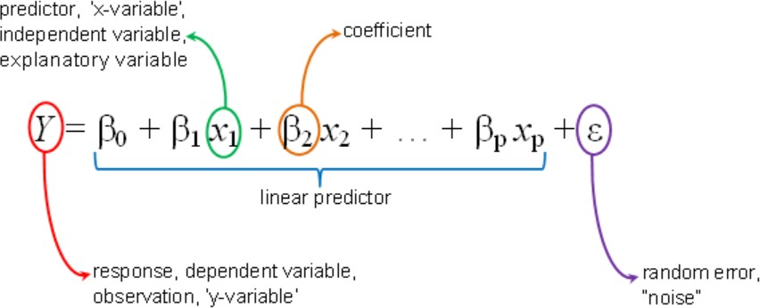

# Differentiate in Regression and classification

|  |  |
| --- | --- |
| **Regression Algorithm** | **Classification Algorithm** |
| In Regression, the output variable must be of continuous nature or real value. | In Classification, the output variable must be a discrete value. |
| The task of the regression algorithm is to map the input value (x) with the continuous output variable(y). | The task of the classification algorithm is to map the input value(x) with the discrete output variable(y). |
| Regression Algorithms are used with continuous data. | Classification Algorithms are used with discrete data. |
| In Regression, we try to find the best fit line, which can predict the output more accurately. | In Classification, we try to find the decision boundary, which can divide the dataset into different classes. |
| Regression algorithms can be used to solve the regression problems such as Weather Prediction, House price prediction, etc. | Classification Algorithms can be used to solve classification problems such as Identification of spam emails, Speech Recognition, Identification of cancer cells, etc. |
| The regression Algorithm can be further divided into Linear and Non-linear Regression. | The Classification algorithms can be divided into Binary Classifier and Multi- class Classifier. |

* **Manually solve the problem given**

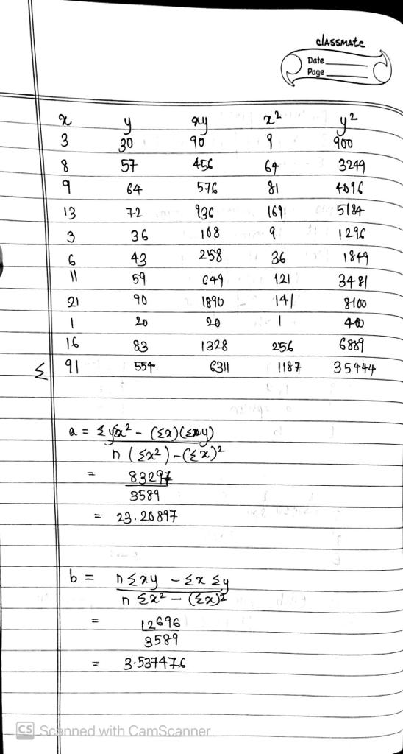

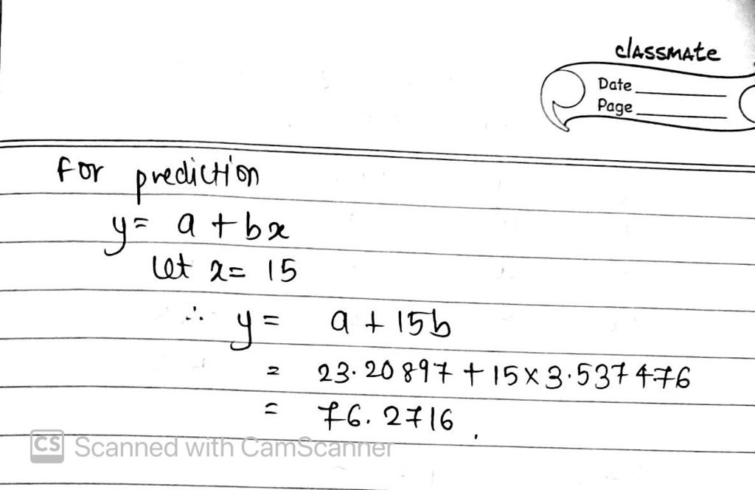

**Implementation:**

* **Develop a model of linear regression for the above data set given (take values of data set at run time)**

|  |
| --- |
| import numpy as np  import matplotlib.pyplot as plt  def predict(b0,b1,x):  return b1+b0*x  def coefficient(x,y):  xm=np.mean(x)  ym=np.mean(y)  X2=[(x[i])* (x[i]) for i in range(len(x))]  Y2=[(y[i])* (y[i]) for i in range(len(y))]  XY=[(y[i])* (x[i]) for i in range(len(y))]  num1=sum(y)*sum(X2)-sum(x)*sum(XY)  den=len(x)sum(X2)-sum(x)*2  num2=len(x)*sum(XY)-sum(x)*sum(y)  b1=num1/den  b0=num2/den  return b0,b1  x=list(map(int,input("Enter x (Year of Experience) : ").split()))  y=list(map(int,input("Enter y (Salary in $100): ").split()))  b0,b1=coefficient(x,y)  print("b0 : ",b0,"\n","b1 : ",b1)  n=int(input("Enter value : "))  print("Expected salary : ",predict(b0,b1,n))  x1=np.linspace(min(x),max(x),10)  y1=b1+b0*x1  plt.scatter(x,y)  plt.xlabel("X")  plt.ylabel("Y")  plt.plot(x1,y1,'-r')  plt.show() |

# Plot the linear regression line.

* **For new tuple of x try to predict the value of y using the model. (take any new value of years of experience at run time and predict salary)**

