# DWML

# CLASS: TE CMPN A PID:182027

**NAME: Rebecca Dias ROLL NO.: 19**

**Aim:** Implement Linear Simple Regression model

**Code:**

|  |
| --- |
| import numpy as np  import matplotlib.pyplot as plt  def predict(b0,b1,x):      return b1+b0*x  def coefficient(x,y):      xm=np.mean(x)      ym=np.mean(y)      X2=[(x[i])* (x[i]) for i in range(len(x))]      Y2=[(y[i])* (y[i]) for i in range(len(y))]      XY=[(y[i])* (x[i]) for i in range(len(y))]      num1=sum(y)*sum(X2)-sum(x)*sum(XY)      den=len(x)*sum(X2)-sum(x)**2      num2=len(x)*sum(XY)-sum(x)*sum(y)      b1=num1/den      b0=num2/den      return b0,b1  # x=list(map(int,input("Enter x  : ").split()))  x=[43,21,25,42,57,59]  # y=list(map(int,input("Enter y : ").split()))  y=[99,65,79,75,87,81]  b0,b1=coefficient(x,y)  print("a : ",b1,"\n","b : ",b0)  # n=int(input("Enter value : "))  n=75  print("Expected Glucose level : ",predict(b0,b1,n))  x1=np.linspace(min(x),max(x),10)  y1=b1+b0*x1  plt.scatter(x,y)  plt.xlabel("X")  plt.ylabel("Y")  plt.plot(x1,y1,'-r')  plt.show() |

**Output:**

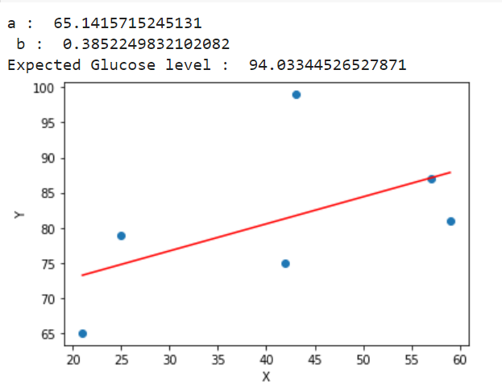

**Sum:**



