**Experiment 1**

**Rebecca Dias TE-CMPN-A2 Roll No: 19**

**Aim**:- a. To implement McCulloch Pitts model in Python

b. To implement a basic neuron model

**Theory:-**

* What is McCulloch Pitt’s model?

McCulloch (neuroscientist) and Pitts (logician) proposed a highly simplified computational model of the neuron (1943)

-g aggregates the inputs

-f takes a decision based on this aggregation

-The inputs can be excitatory or inhibitory

- y = 0 if any xi is inhibitory, else

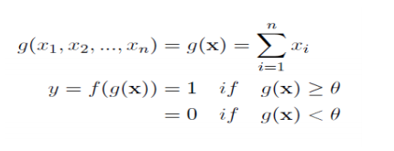

-ϴ is called the thresholding parameter

-This is called Thresholding Logic

-Fixed weights: wi= +1 for excitatory synapses, wi= -1 for inhibitory synapses

-Fixed thresholds: T is the neuron’s threshold value – Needs to be exceeded by the weighted sum of signals for the neuron to fire.

-Allows binary 0, 1 states only

-Operates under a discrete-time assumption

-Weights and the neurons’ thresholds are fixed in the model and no interaction among network neurons

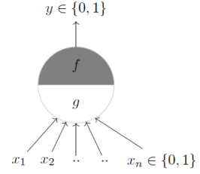

* Solve the basic gates with examples of linearly separable and non-separable model.

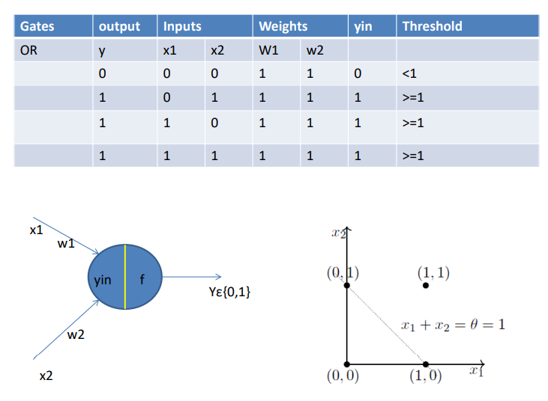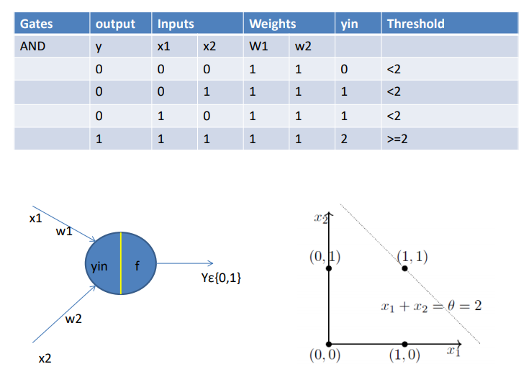

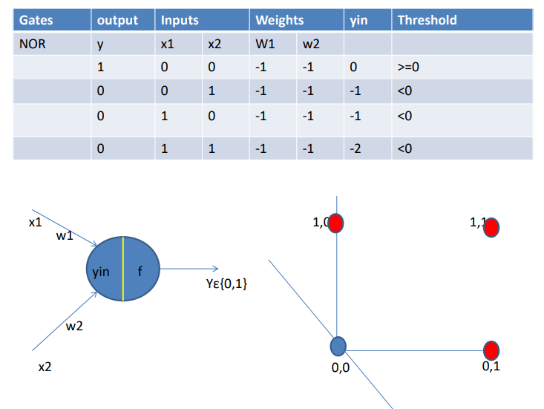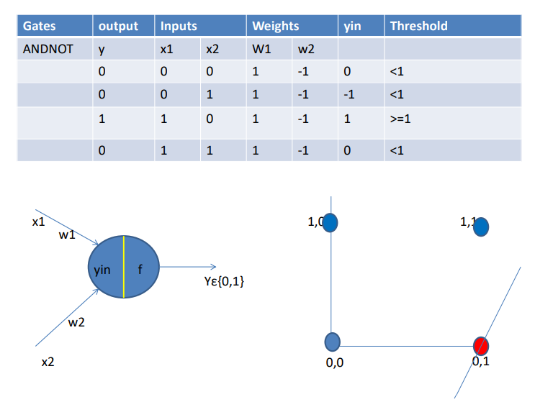

**Implementation:-**

<https://colab.research.google.com/drive/18NhTJaoEAbEU4L-bRt6clEaQT7Ejk5Ne?usp=sharing>

<https://docs.google.com/spreadsheets/d/1yTq4mBCIb1ELRRWpDrsaqPVr0NKnxSwRq8omy7tMFbU/edit?usp=sharing>

1. To implement McCulloch Pitts model

Logic:-

1. Enter values of inputs
2. Enter values of weights
3. Compute net
4. For different cases compute the threshold
5. Displays those which belongs to a class and those which doesn’t belong for each of the basic gates
6. To implement basic neuron model

**Conclusion:**

Successfully implemented McCulloch Pitts model and basic neuron model. The dataset was taken from UCI Repository(Wine Data set) which resulted into an accuracy of 41.66.

We then established the concept of MuCulloch-Pitts neuron, the first ever mathematical model of a biological neuron. We represented the boolean functions using the M-P neuron.