EXPERIMENT 03

CLASS: TE CMPN A PID: 182027

NAME: REBECCA DIAS ROLL NO. : 19

# Aim:

Use project management tool from [www.projectlibre.com](http://www.projectlibre.com/) to prepare schedule and do the estimation for the project using FP estimation technique and COCOMO estimation method

# Project: Hospital Management System Theory:

## Effort Estimation Tool:

a. Project planning: Estimation (cost and effort)

* 1. Function point (FP) metric

A Function Point (FP) is a unit of measurement to express the amount of business functionality an information system (as a product) provides to a user. FPs measure software size. They are widely accepted as an industry standard for functional sizing.

The basic and primary purpose of the functional point analysis is to measure and provide the software application functional size to the client, customer, and the stakeholder on their request. Further, it is used to measure the software project development along with its maintenance, consistently throughout the project irrespective of the tools and the technologies.

**Number of external inputs** – from user or another application

**Number of external inquiries** – request from user that generates an on-line output (E.G. IRCTC)

**Number of external outputs**

**Number of internal logical files** (maintained by system)

### Number of external interface files Transactional Functional Type:

#### **External Input (EI):** EI processes data or control information that comes from outside the application’s boundary. The EI is an elementary process.

**External Output (EO):** EO is an elementary process that generates data or control information sent outside the application’s boundary.

**External Inquiries (EQ):** EQ is an elementary process made up of an input-output combination that results in data retrieval.

#### **Internal Logical File (ILF):** A user identifiable group of logically related data or control information maintained within the boundary of the application.

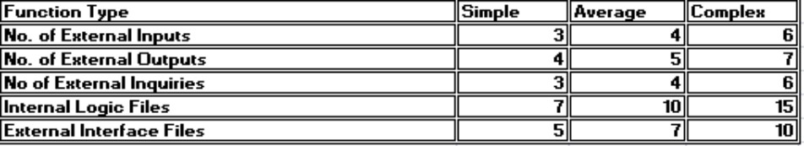**External Interface File (EIF):** A group of user recognizable logically related data allusion to the software but maintained within the boundary of another software.

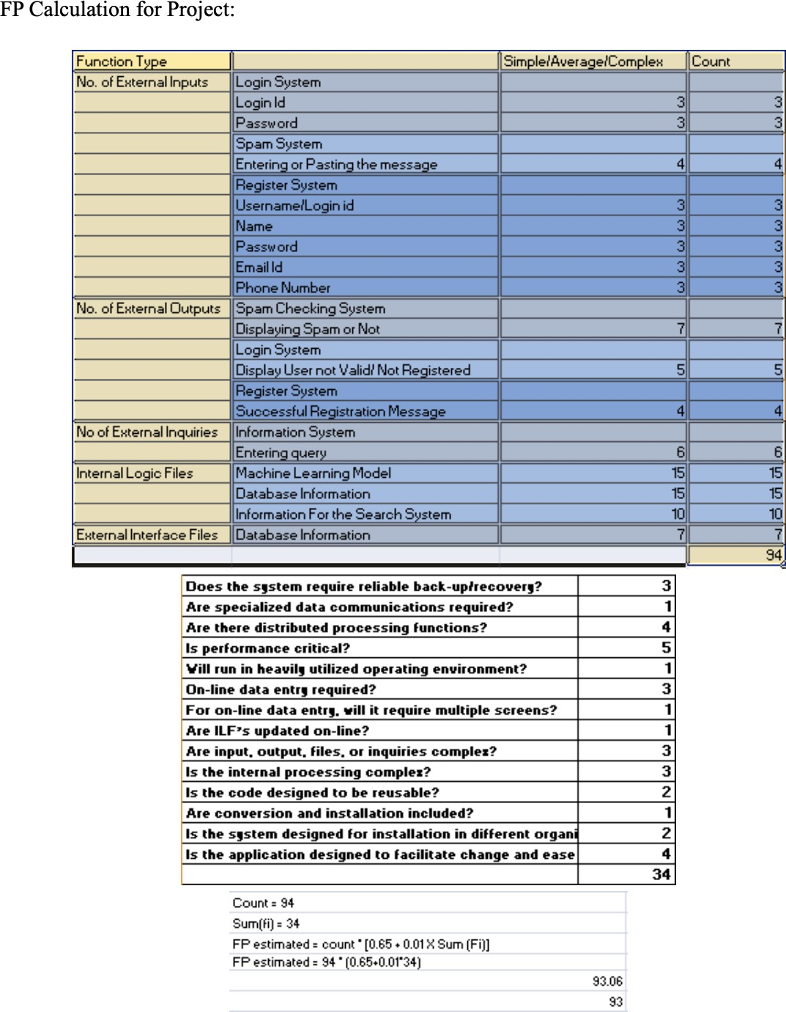

1. Cost Constructive Model (COCOMO1, COCOMO 2)

Cocomo (Constructive Cost Model) is a regression model based on LOC, i.e number of Lines of Code. It is a procedural cost estimate model for software projects and often used as a process of reliably predicting the various parameters associated with making a project such as size, effort, cost, time and quality. It was proposed by Barry Boehm in 1970 and is based on the study of 63 projects, which make it one of the best-documented models.

The key parameters which define the quality of any software products, which are also an outcome of the Cocomo are primarily Effort & Schedule:

1. Effort: Amount of labor that will be required to complete a task. It is measured in person-months units.
2. Schedule: Simply means the amount of time required for the completion of the job, which is, of course, proportional to the effort put. It is measured in the units of time such as weeks, months.

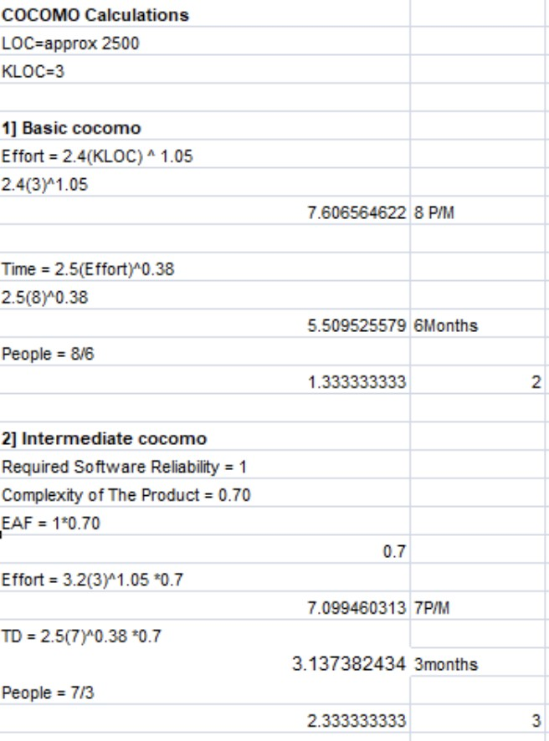

## Gantt chart/timeline chart (MS Project / Project Libre/ Atlassian Jira project management tool)

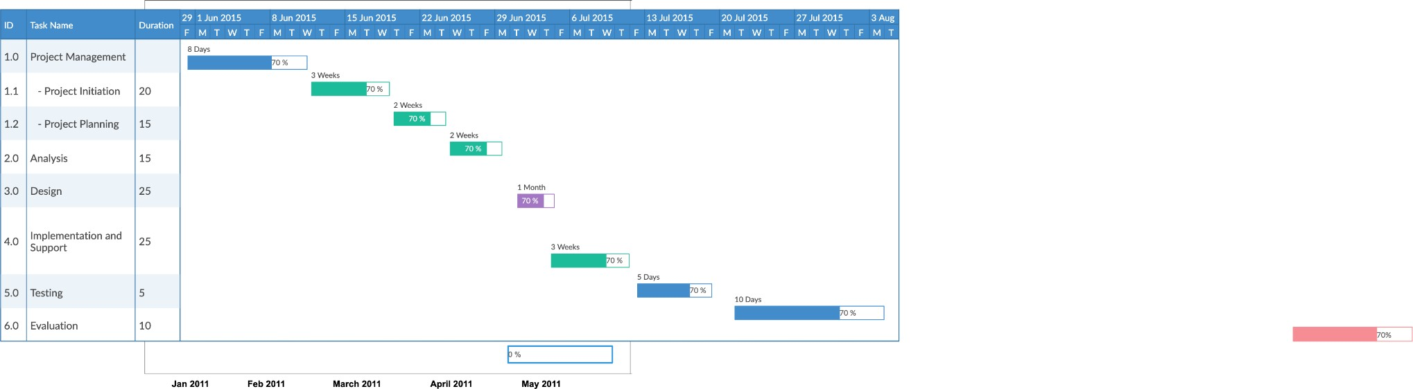

1. Work Breakdown Structure (WBS Chart Pro / ProjectLibre)

A Work Breakdown Structure includes dividing a large and complex project into simpler, manageable and independent tasks. The root of this tree (structure) is labelled by the Project name itself. For constructing a work breakdown structure, each node is recursively decomposed into smaller sub-activities, until at the leaf level, the activities become undividable and independent. It follows a Top-Down approach.

Steps:

* Step-1: Identify the major activities of the project.
* Step-2: Identify the sub-activities of the major activities.
* 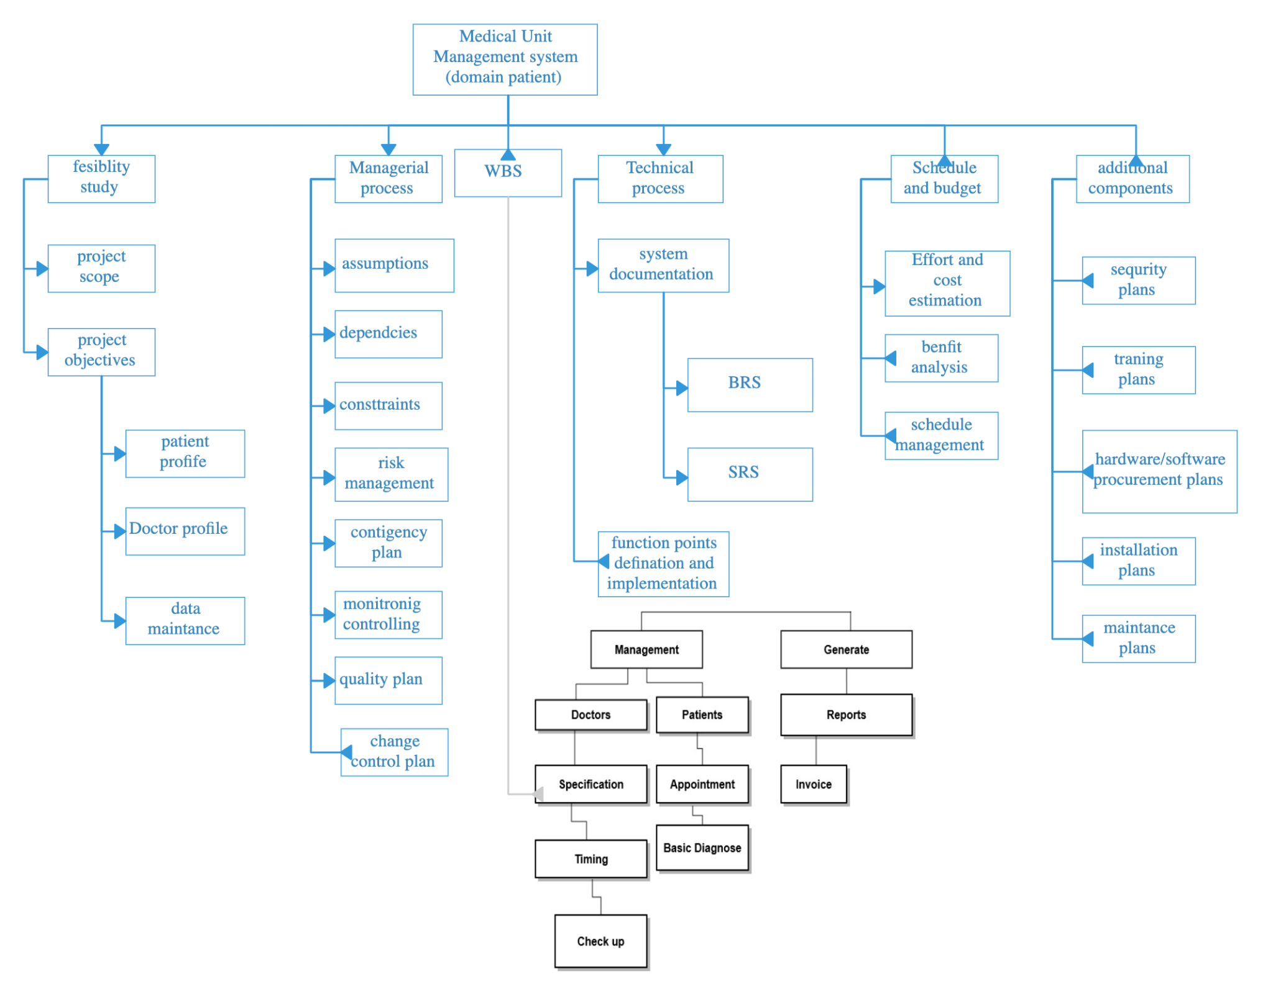Step-3: Repeat till undividable, simple and independent activities are created

# CONCLUSION:

From this experiment, we were introduced to the concept of project estimation for the software. There are multiple ways like FP(Function Point) estimation and COCOMO that is constructive cost model estimation. We made project cost estimation using both techniques for our software project. Later we understood concepts of timeline chart and Work Breakdown Structure. We implemented a Timeline chart in Atlassian Jira and also in Microsoft Word. We also made WBS or Work Breakdown Structure for the project.