EXPERIMENT 06

CLASS: TE CMPN A PID: 182027

NAME: REBECCA DIAS ROLL NO. : 19

# Aim:

Draw Data Flow Diagram(DFD) upto 2 levels for the project

# Project: hospital management project. Theory:

## Brief theory about Flow diagrams

A flowchart is a picture of the separate steps of a process in sequential order. It is a generic tool that can be adapted for a wide variety of purposes, and can be used to describe various processes, such as a manufacturing process, an administrative or service process, or a project plan. It's a common [process](https://asq.org/quality-resources/process-analysis-tools)

 [analysis tool](https://asq.org/quality-resources/process-analysis-tools) and one of the [seven basic quality tools](https://asq.org/quality-resources/seven-basic-quality-tools). COMMONLY USED SYMBOLS IN DETAILED FLOWCHARTS

the box.



One step in the process. The step is written inside the box. Usually, only one arrow goes out of Direction of flow from one step or decision to another.

Decision based on a question. The question is written in the diamond. More than one arrow goes out of the diamond, each one showing the direction the process takes for a given answer to the question. (Often the answers are "yes" and "no.")

Delay or wait

Link to another page or another flowchart. The same symbol on the other page indicates that the flow continues there.

Input or output

Document

Alternate symbols for start and end points

## Detail theory about DFD

Data flow diagrams are used to graphically represent the flow of data in a business information system. DFD describes the processes that are involved in a system to transfer data from the input to the file storage and reports generation.

Data flow diagrams can be divided into logical and physical. The logical data flow diagram describes flow of data through a system to perform certain functionality of a business. The physical data flow diagram describes the implementation of the logical data flow.

### Notation

* A rounded rectangle represents a process
* 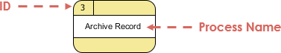Processes are given IDs for easy referencing

### Process Example

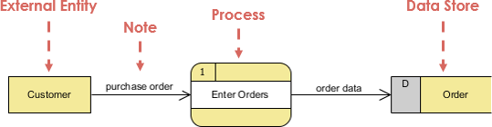

Data Flow

A data-flow is a path for data to move from one part of the information system to another. A data-flow may represent a single data element such the Customer ID or it can represent a set of data element (or a data structure).

Example:

* Customer_info (LastName, FirstName, SS#, Tel #, etc.)
* Order_info (OrderId, Item#, OrderDate, CustomerID, etc.).

### Data flow Example:

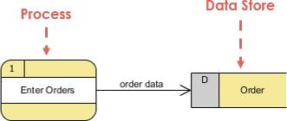

Notation

* Straight lines with incoming arrows are input data flow
* Straight lines with outgoing arrows are output data flows Note that:

Because every process changes data from one form into another, at least one data-flow must enter and one data-flow must exit each process symbol.

### Rule of Data Flow

One of the rule for developing DFD is that all flow must begin with and end at a processing step. This is quite logical, because data can't transform on its own with being process. By using the thumb rule, it is quite easily to identify the illegal data flows and correct them in a DFD.

## Draw the DFD for the problem statement (2 to 3 levels)

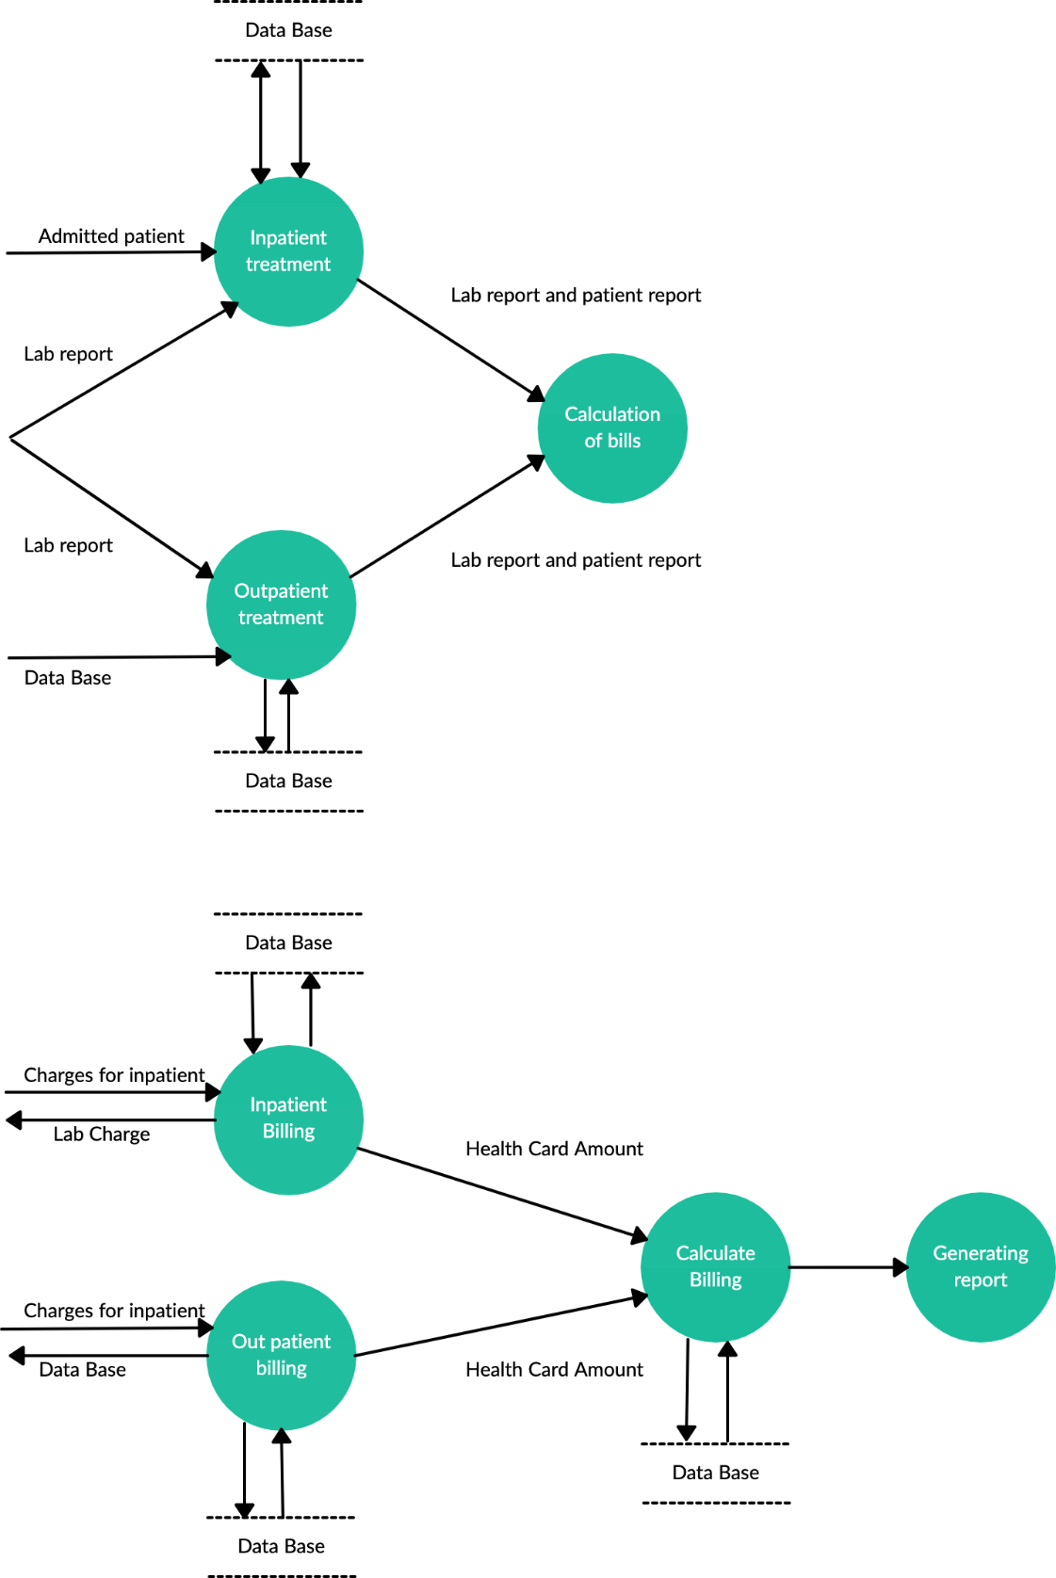

Conclusion:

In this experiment, we have drawn a Data Flow Diagram(DFD) upto 2 levels for the hospital management project.