EXPERIMENT 09

CLASS: TE CMPN A PID: 182027

NAME: REBECCA DIAS ROLL NO. : 19

Aim:

1. Develop test cases for the project using white box testing and Automated testing with Selenium Automated testing tool
2. Testing by White Box technique

# Theory:

## Define Testing.

Testing is a method to check whether the actual software product matches expected requirements and to ensure that software product is Defect free. It involves execution of software/system components using manual or automated tools to evaluate one or more properties of interest. The purpose of software testing is to identify errors, gaps or missing requirements in contrast to actual requirements.

Some prefer saying Software testing as a [White Box](https://www.guru99.com/white-box-testing.html) and [Black Box Testing](https://www.guru99.com/black-box-testing.html). In simple terms, Software Testing means the Verification of Application Under Test (AUT). This tutorial introduces testing software to the audience and justifies its importance.

## Types of testing techniques

Typically Testing is classified into three categories.

* Functional Testing
* Non-Functional Testing or [Performance Testing](https://www.guru99.com/performance-testing.html)
* Maintenance (Regression and Maintenance)

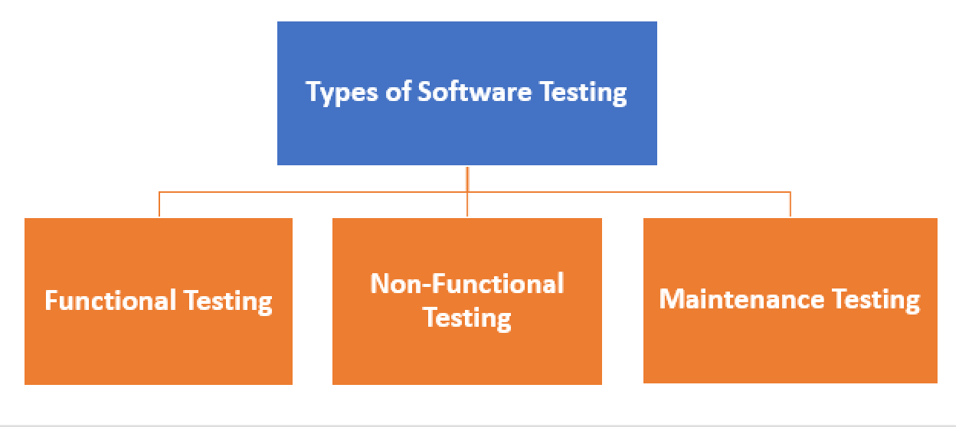

Types of Testing

Testing Category

Functional Testing

[Unit Testing](https://www.guru99.com/unit-testing-guide.html) [Integration Testing](https://www.guru99.com/integration-testing.html) Smoke

UAT ( User Acceptance Testing) Localization

Globalization Interoperability So on

Non-Functional Testing

Performance Endurance Load Volume Scalability Usability

So on

Maintenance Regression Maintenance

## Types of Testing Strategies:

**Unit Testing:** This software testing approach is followed by the programmer to test the unit of the program. It helps developers to know whether the individual unit of the code is working properly or not.

**Integration testing:** It focuses on the construction and design of the software. You need to see that the integrated units are working without errors or not.

**System testing:** In this method, your software is compiled as a whole and then tested as a whole. This testing strategy checks the functionality, security, portability, amongst others.

* 1. Compare white box and black box testing techniques

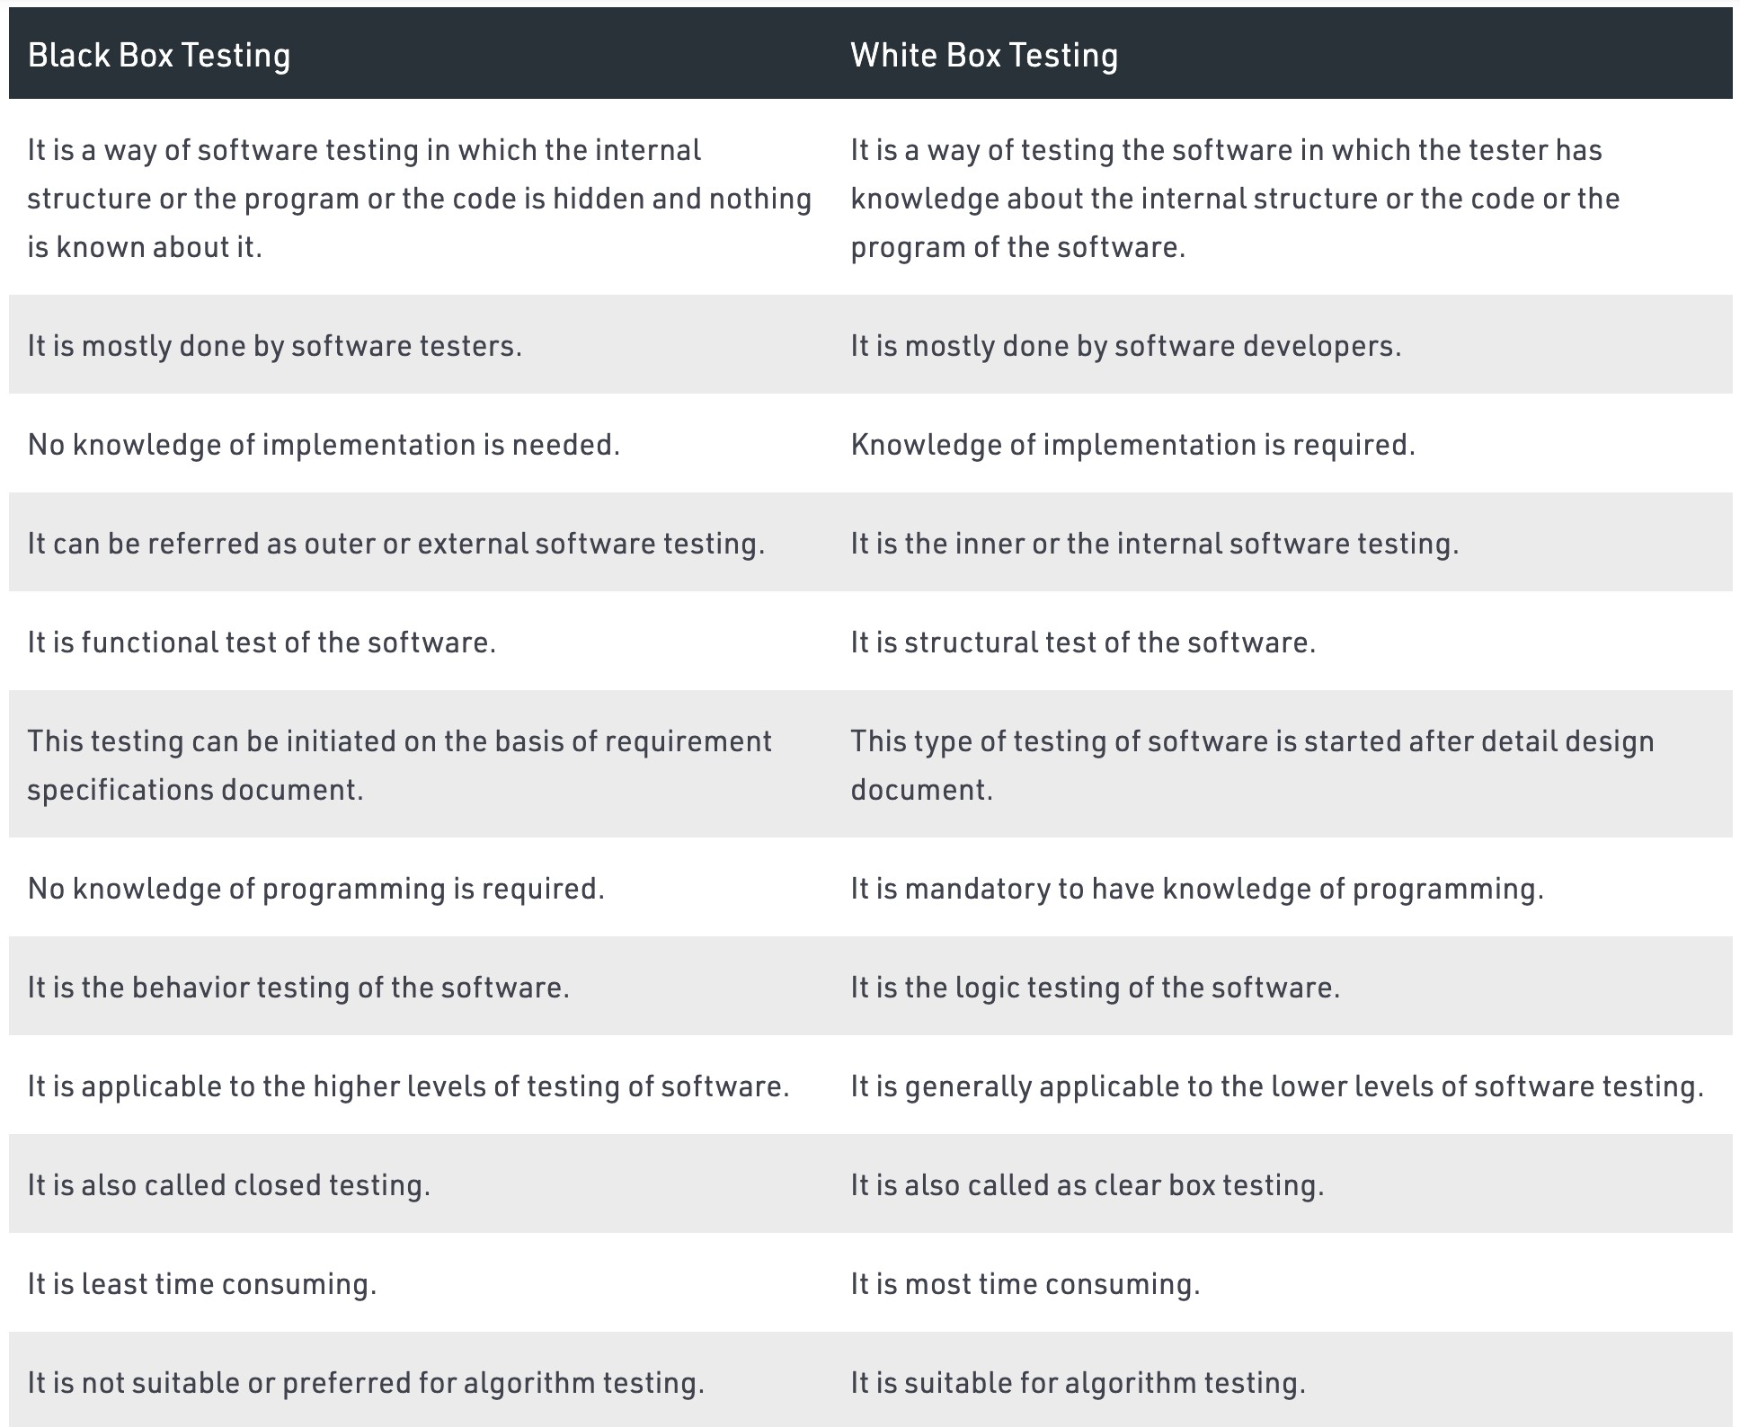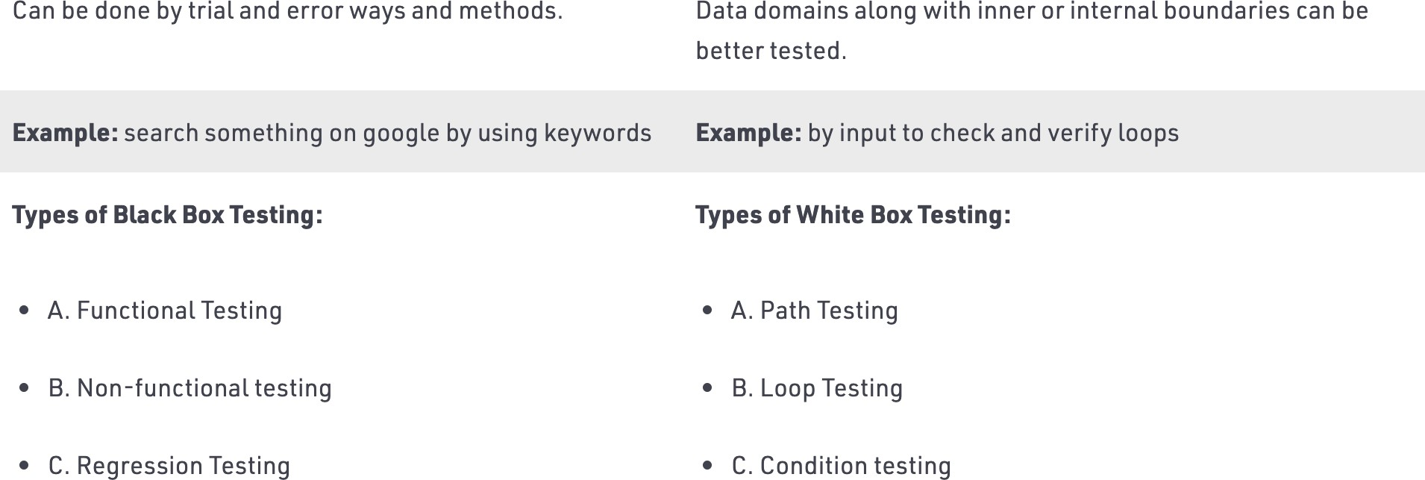

* 1. Apply white box to any of the project modules.

**Basis path testing & Compute the Cyclomatic Complexity**

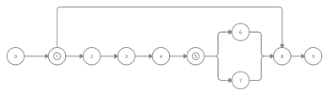Code:

Login()

If loginIsSucessfull()

Homepage

Browse Properties page Print(“Enter property id”); If propertyIsAvailable()

Print(‘Is Bookable’);

Else

Print(‘Unavailable’);

End if End if Logout()

Cyclomatic Complexity:

V(G) = 2+1 = 3

**Paths:**

0-1-2-3-4-5-6-8-9

0-1-2-3-4-5-7-8-9

0-1-8-9

## Define Test case? Give template of test case.

1. A test case is a set of actions executed to verify a particular feature or functionality of your software application.
2. A test case contains test steps, test data, precondition, postcondition developed for specific test scenario to verify any requirement.
3. The test case includes specific variables or conditions, using which a testing engineer can compare expected and actual results to determine whether a software product is functioning as per the requirements of the customer.

|  |  |  |  |  |  |  |
| --- | --- | --- | --- | --- | --- | --- |
| Test Case ID | Test Scenario | Test Steps | Test Data | Expected Results | Actual Results | Pass/Fail |
| TU01 | Check Customer Login with valid Data | 1. Go to site [http://demo.gur u99.com](http://demo.guru99.com/) 2. Enter UserId 3. Enter Password 4. Click Submit | Userid  = guru99  Password  = pass99 | User should Login into an application | As Expected | Pass |
| TU02 |  | 1. Go to site [http://demo.gur u99.com](http://demo.guru99.com/) 2. Enter UserId 3. Enter Password 4. Click Submit | Userid  = guru99  Password  = pass99 | User should not Login into an application | As Expected | Pass |

# Conclusion:

In this experiment we learnt about Testing and different techniques of testing i.e., White-Box Testing and Black-Box Testing. We also learnt about various types of testing strategies defined in software engineering literature. Then we compared the white box and black box testing techniques. Using all that we learnt, we developed test cases for our project and then we applied white box testing to check availability of property of our Real Estate Management System project. We found the basis path testing then computed the Cyclomatic Complexity and made a test case table for identified logical paths to be tested. Thus, we successfully completed this experiment.