EXPERIMENT 01

CLASS: TE CMPN A PID: 182027

NAME: REBECCA DIAS ROLL NO. : 19

# Aim

Prepare a detailed statement of problem for the selected/allotted mini project and identify suitable process models for the same with justification.

# Problem Statement

The Hospital Management System aims at providing a smooth experience of patients, staff and hospital authorities. The interactions between the hospital and the patient can be simplified for the convenience of both sides. The main function of the system is to register and store patient details and doctor details and various other details and retrieve these details as and when required, and also to manipulate these details meaningfully. Since security remains the main criteria so there will be a facility to give a unique id for every patient. All medical records have to be protected and only accessible for the allowed users. Users can search availability of a doctor and the details of a patient using the id. The database can be entered using a username and password. It is accessible either by an administrator or receptionist. Only they can add data and make changes in the database. The data can be retrieved easily. The interface is very user-friendly.

# Abstract

This project is an insight into the design and implementation of a Hospital Management

System. Our main intention is to allow this application to be used by most hospitals. This system is designed to manage all challenges related to the management of medicine that were initially handled locally and manually. This system will help in managing the medicine stock. It can provide a convenient way of storing/managing the patient details, medicine details, number of stocks currently available, etc.

# Technical Flow

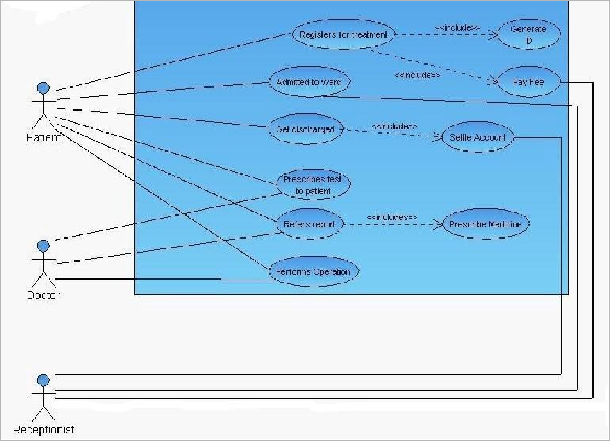

Software Process Model Selected

*Waterfall model*

So based on our problem statement, the chosen software process model we have selected is the **Waterfall model**. That means, Order in which the activities of a software development project will be undertaken will be in a breakdown of activities into linear sequential phases, where each phase depends on the result of the previous one.

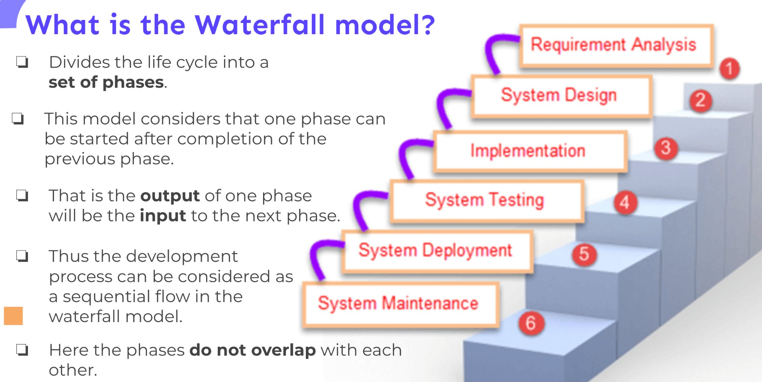

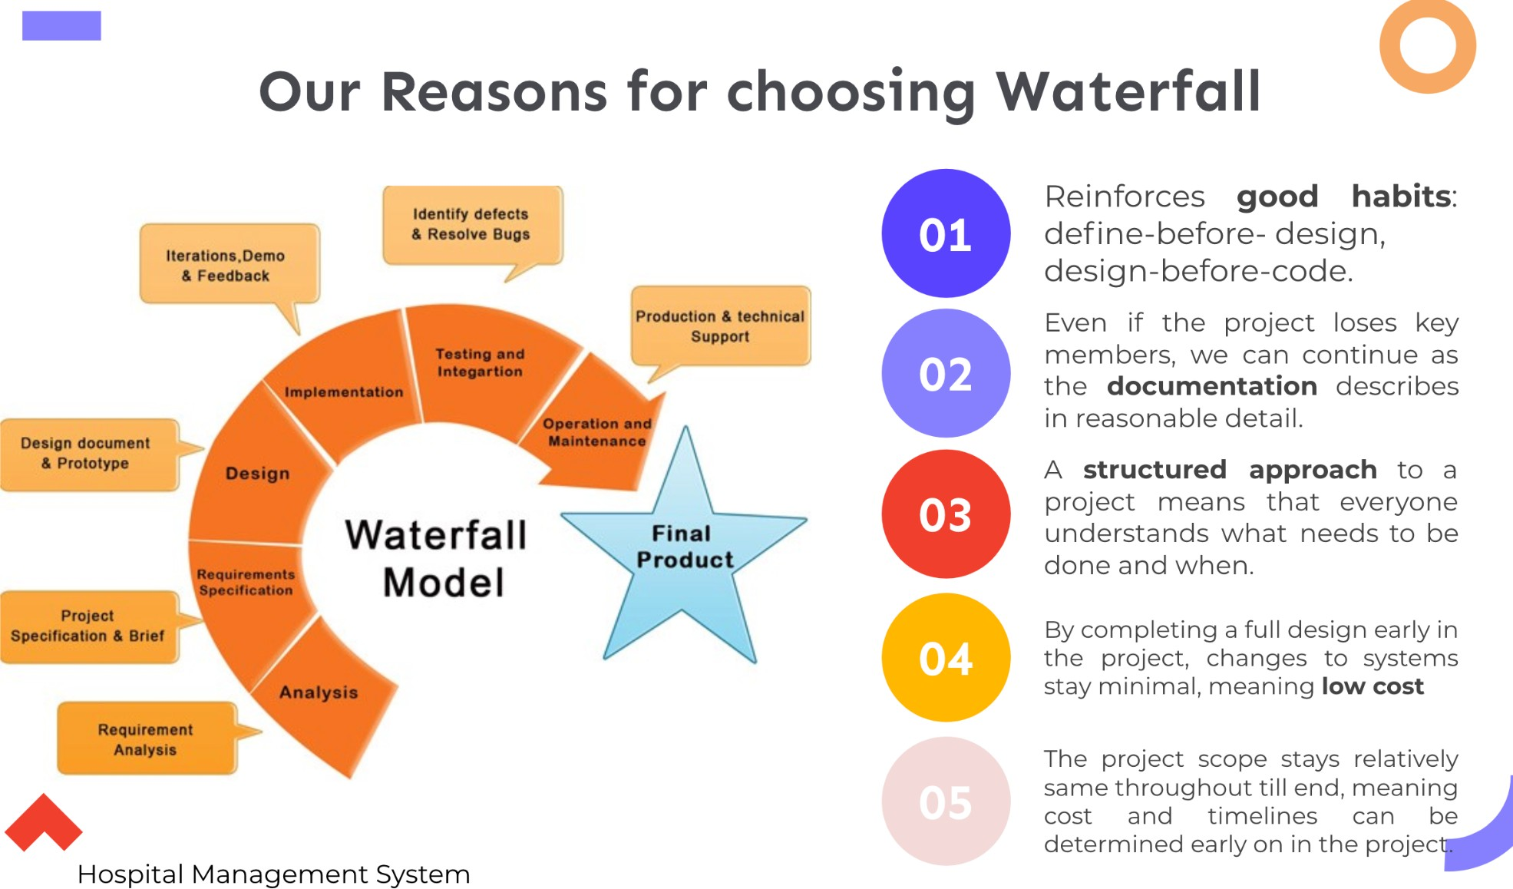

# Societal Impact

Health systems have a positive impact on the economic performance of other sectors in the national economy, through the jobs they generate and from the purchase of goods and services. Providing guidance and tools to engage in stronger dialogue with ministries of finance and international institutions, to prevent disinvestment in health. It provides a framework that policy-makers at national, regional and local levels can apply to demonstrate health systems are a key sector for driving forward the implementation of local and national goals for sustainable development.

# Conclusion

Hospital management systems are all about modernizing a hospital through use of technology. Computers help in it and take over the manual system for quick and easy functioning. This hospital management system is quite reliable and is proven on many stages. All the basic requirements of the hospital are provided in the hospital in order to manage it perfectly and a large amount of data can also be stored . It gives many facilities like searching for the details of patient, billing facilities as well as the creation of test reports.

Taking into account all the mentioned details, we can make the conclusion that the hospital management system is the inevitable part of the lifecycle of the modern medical institution. It automates numerous daily operations and enables smooth interactions of the users. Developing the hospital system software is a great opportunity to create the distinct, efficient and fast delivering healthcare model. Implementation of hospital management system projects helps to store all kinds of records, provide coordination and user communication, implement policies, improve day-to-day operations, arrange the supply chain, manage financial and human resources, and market hospital services. This beneficial decision covers the needs of the patients, staff and hospital authorities and simplifies their interactions. It has become the usual approach to manage the hospital. Many clinics have already experienced its advantages and continue developing new hospital management system project modules.