EXPERIMENT 07

CLASS: TE CMPN A PID: 182027

NAME: REBECCA DIAS ROLL NO. : 19

Aim

Develop Activity / State Transition diagram for the project.

# Theory

UML, Unified Modeling Language, is a standardized modeling language consisting of an integrated set of diagrams, developed to help system and software developers for specifying, visualizing, constructing, and documenting the artifacts of software systems, as well as for business modeling and other non-software systems. The UML represents a collection of best engineering practices that have proven successful in the modeling of large and complex systems. The UML is a very important part of developing object oriented software and the software development process. The UML uses mostly graphical notations to express the design of software projects. Using the UML helps project teams communicate, explore potential designs, and validate the architectural design of the software.

## The primary goals in the design of the UML as follows:

1. Provide users with a ready-to-use, expressive visual modeling language so they can develop and exchange meaningful models.
2. Provide extensibility and specialization mechanisms to extend the core concepts. 3. Be independent of particular programming languages and development processes. 4. Provide a formal basis for understanding the modeling language.
3. Encourage the growth of the OO tools market.
4. Support higher-level development concepts such as collaborations, frameworks, patterns and components.
5. Integrate best practices.

UML 2.0 defines thirteen types of diagrams, divided into three categories:

## Structure Diagrams include

* Class Diagram
* Object Diagram
* Component Diagram
* Composite Structure Diagram
* Package Diagram
* Deployment Diagram.

## Behaviour Diagrams include

* Use Case Diagram
* Activity Diagram
* State Machine Diagram.

## Interaction Diagrams includes

* Sequence Diagram
* Communication Diagram
* Timing Diagram
* Interaction Overview Diagram.

Activity diagram is another important diagram in UML to describe the dynamic aspects of the system. Activity diagram is basically a flowchart to represent the flow from one activity to another activity. The activity can be described as an operation of the system. The control flow is drawn from one operation to another. This flow can be sequential, branched, or concurrent. Activity diagrams deal with all type of flow control by using different elements such as fork, join, etc

The basic purpose of activity diagrams is similar to the other four diagrams. It captures the dynamic behaviour of the system. Activity is a particular operation of the system. Activity diagrams are not only used for visualizing the dynamic nature of a system, but they are also used to construct the executable system by using forward and reverse engineering techniques. The only missing thing in the activity diagram is the message part.

It does not show any message flow from one activity to another. Activity diagram is sometimes considered as the flowchart. Although the diagrams look like a flowchart, they are not. It shows different flows such as parallel, branched, concurrent, and single.

The purpose of an activity diagram can be described as −

* Draw the activity flow of a system.
* Describe the sequence from one activity to another.
* Describe the parallel, branched and concurrent flow of the system.

## State Transition Diagram:

State Transition diagram describes different states of a component in a system. The states are specific to a component/object of a system. A State transition diagram describes a state machine. State machine can be defined as a machine which defines different states of an object and these states are controlled by external or internal events. State transition diagram is one of the UML diagrams used to model the dynamic nature of a system. They define different states of an object during its lifetime and these states are changed by events.

State transition diagrams are useful to model the reactive systems. Reactive systems can be defined as a system that responds to external or internal events.

State transition diagram describes the flow of control from one state to another state. States are defined as a condition in which an object exists and it changes when some event is triggered.

The most important purpose of State transition diagrams is to model the lifetime of an object from creation to termination.

The main purposes of using State transition diagrams are:

⚫ To model the dynamic aspect of a system.

⚫ To model the life time of a reactive system.

⚫ To describe different states of an object during its life time.

⚫ Define a state machine to model the states of an object.

## Symbols and Notations of State Transition Diagram:

Initial state

The initial state symbol is used to indicate the beginning of a state machine diagram. Final state This symbol is used to indicate the end of a state machine diagram.

Decision box

It contains a condition. Depending upon the result of an evaluated guard condition, a new path is taken for program execution.

Transition

A transition is a change in one state into another state which has occurred because of some event. A transition causes a change in the state of an object. It is represented by an arrow.

States

States represent situations during the life of an object. It is used to represent any static as well as dynamic situations. It is denoted using a rectangle with round corners. The name of a state is written inside the rounded rectangle.

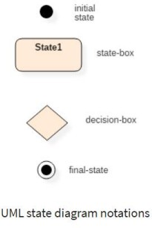

# State Diagram

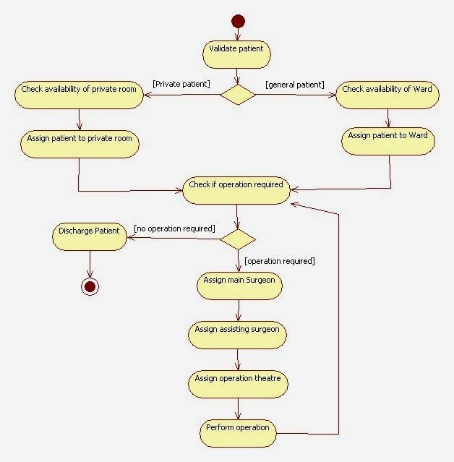Following is the state diagram for Hospital Management System

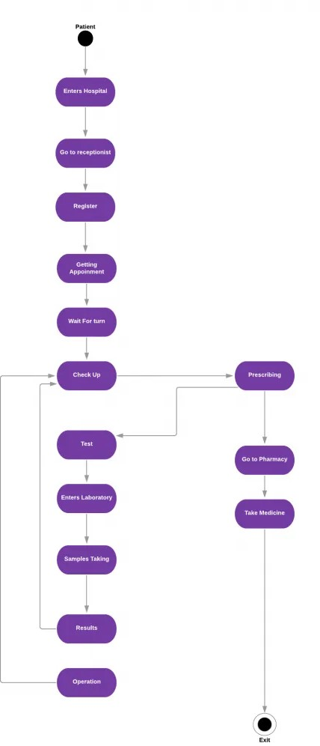

# Activity Diagram



Conclusion

In this experiment we learnt to create a State Diagram and Activity Diagram. UML State machine diagram and activity diagram are both behavioural diagrams but have different emphases. Activity diagram is flow of functions without trigger mechanism, state machine consists of triggered states. Using the concepts of State Transition Diagram and Activity Diagram, we made a State Diagram and Activity Diagram for Hospital Management System. Thus, we have completed the experiment successfully.