**EXPERIMENT 07**

CLASS: TE CMPN A ROLL NO. : 19

NAME: REBECCA DIAS PID: 182027

**Aim:** To find the first and follow sets of a given grammar.

**Theory:**

What are first and follow sets?

The construction of a predictive parser is aided by two functions associated with a grammar G. These functions, FIRST and FOLLOW, allow us to fill in the entries of a predictive parsing table for G.

Rules to compute FIRST set:

1. If x is a terminal, then FIRST(x) = { ‘x’ }
2. If x-> Є, is a production rule, then add Є to FIRST(x).
3. If X->Y1 Y2 Y3….Yn is a production,
   1. FIRST(X) = FIRST(Y1)
   2. If FIRST(Y1) contains Є then FIRST(X) = { FIRST(Y1) – Є } U {

FIRST(Y2) }

* 1. If FIRST (Yi) contains Є for all i = 1 to n, then add Є to FIRST(X).

Rules to compute FOLLOW set:

1. FOLLOW(S) = { $ }, where S is the starting Non-Terminal 2. If A -> pBq is a production, where p, B and q are any grammar symbols, then everything in FIRST(q) except Є is in FOLLOW(B).

1. If A->pB is a production, then everything in FOLLOW(A) is in FOLLOW(B).
2. If A->pBq is a production and FIRST(q) contains Є,

then FOLLOW(B) contains { FIRST(q) – Є } U FOLLOW(A)

How are these sets used by the parser?

To check if given grammar is LL(1) or not, we need to construct a parse table. This table can be constructed using FIRST and FOLLOW sets. Given below are the rules on how to construct the parse table using FIRST and FOLLOW sets – For each production X → α

* for each terminal t in First(α): put α in table[X,t]
* if epsilon is in First(α) then:

for each terminal t in Follow(X): put α in table[X,t]

The grammar is not LL(1) if and only if there is more than one entry for any cell in the table.

Find the FIRST and FOLLOW of a grammar –

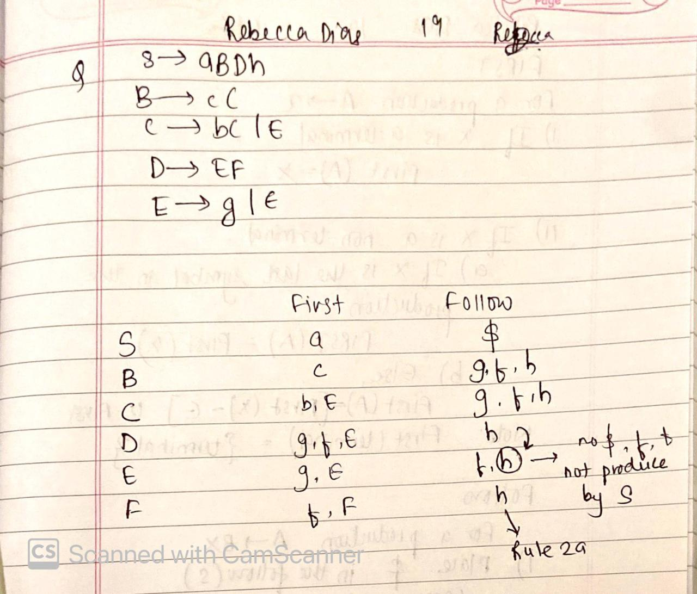

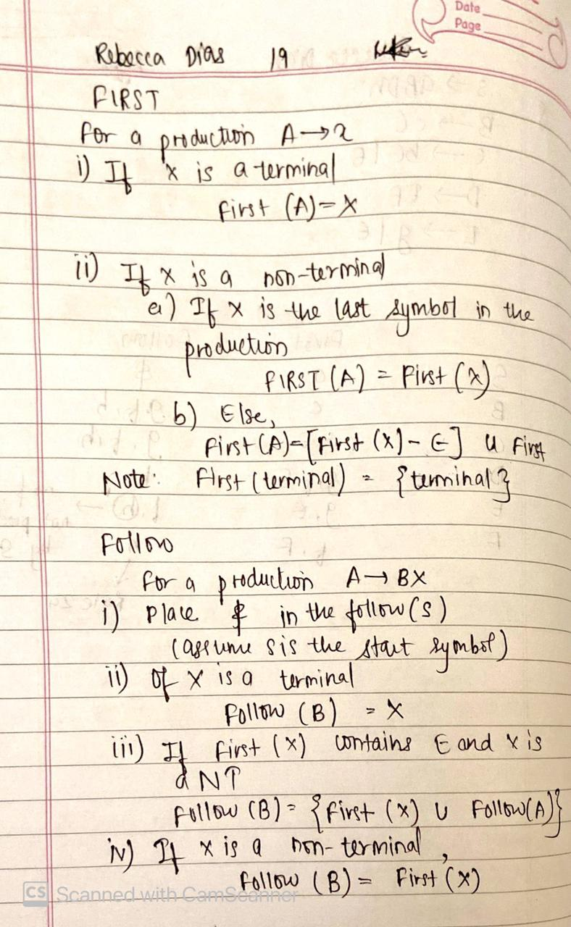

**Implementation:**

Psuedo code

# CODE:

|  |
| --- |
| print("If\n\tA->abc|epsilon\n\tB->pqr\nthen,\n\tNumber of unique non-terminals on LHS=2\n\tnon-terminal number 1: A\n\tnon-terminal number 2: B\n\tRHS for non-terminal 1: abc|epsilon\n\tRHS for non-terminal 2: pqr")  print("-"*55)  num=int(input("Enter the number of unique non-terminals on LHS: "))  nt_list=[]  production_list=[]  first_list=[]  follow_list=[]  for i in range(num):      nt=input(f"Enter non-terminal number {i+1}: ")      production=input(f"Enter RHS for non-terminal number {i+1}: ")      nt_list.append(nt)      production_list.append(production)      first_list.append([])      follow_list.append([])  follow_list[0].append('$')  def nt_present(f_list,production,index,j):      for first_value in first_list[index]:          if (first_value=="epsilon"):              if (j==len(production)-1):                  f_list.append("epsilon")              elif (production[j+1] in nt_list):                  nt_present(f_list,production,nt_list.index(production[j+1]),j+1)              elif (production[j+1] not in nt_list):                  f_list.append(production[j+1])          else:              f_list.append(first_value)      return    for i in reversed(range(num)):      nt=nt_list[i]      productions=production_list[i]      t_productions=productions.split("|")      j=0      for production in t_productions:          if (production=="epsilon"):              first_list[i].append(production)              continue          elif (production[j] not in nt_list):              first_list[i].append(production[j])          else:              index=nt_list.index(production[j])              nt_present(first_list[i],production,index,j)    def follow_nt_present(p_idx,f_list,production,j):      nt_index=nt_list.index(production[j])      for first in first_list[nt_index]:          if (first=="epsilon"):              if (j==len(production)-1):                  for follow in follow_list[p_idx]:                      f_list.append(follow)              elif (production[j+1] not in nt_list):                  f_list.append(production[j+1])              else:                  follow_nt_present(p_idx,f_list,production,j+1)          else:              f_list.append(first)      return  for prod_idx,productions in enumerate(production_list):      for production in productions.split("|"):              if (production=="epsilon"):                  continue              else:                  for j in range(len(production)):                      if (production[j] in nt_list):                          nt_index=nt_list.index(production[j])                          if (j==len(production)-1):                              if (nt_index==prod_idx):                                  continue                              for follow_value in follow_list[prod_idx]:                                  follow_list[nt_index].append(follow_value)                          elif (production[j+1] not in nt_list):                              follow_list[nt_index].append(production[j+1])                          else:                              follow_nt_present(prod_idx,follow_list[nt_index],production,j+1)  print("-"*55)  for i in range(num):      print(f"{nt_list[i]}\tFIRST: {first_list[i]}\tFOLLOW: {follow_list[i]}") |

# OUTPUT:

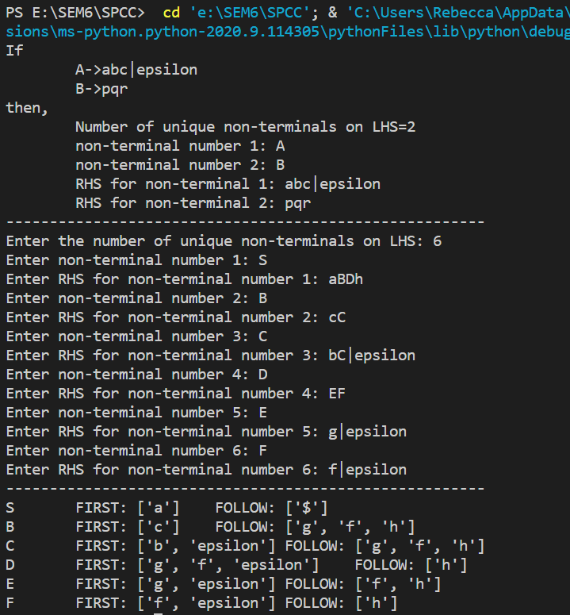

**CONCLUSION:**

The first and follow sets can be found for any given grammar.