**EXPERIMENT 09**

CLASS: TE CMPN A ROLL NO. : 19

NAME: REBECCA DIAS PID: 182027

**Aim:**

To implement intermediate code generation.

# Theory:

## Role of an intermediate code generator

Intermediate code can be either language specific (e.g., Byte Code for Java) or language independent (three-address code). Intermediate code generator receives input from its predecessor phase, semantic analyzer, in the form of an annotated syntax tree. That syntax tree then can be converted into a linear representation, e.g., postfix notation. Intermediate code tends to be machine independent code. Therefore, code generator assumes to have unlimited number of memory storage (register) to generate code.

## Intermediate representations – DAG and 3AC

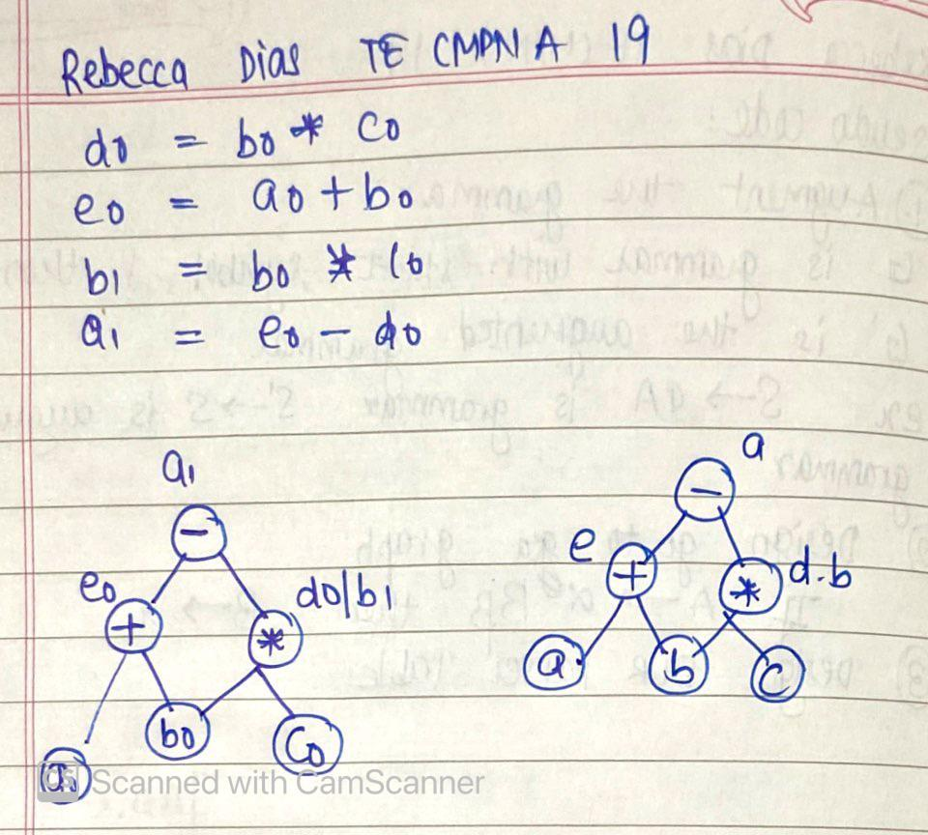

**Different representations of 3AC – quadruples, triples, SSA**

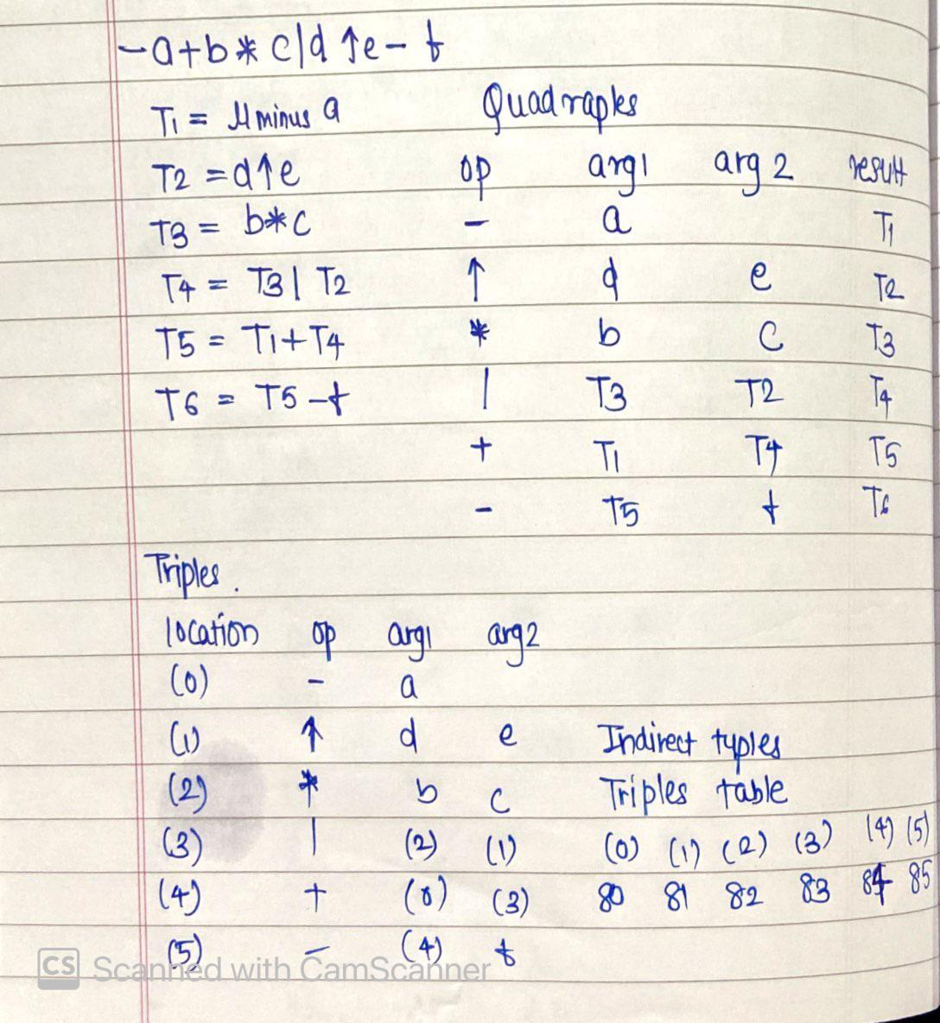

**Implementation:**

**Pseudo Code**

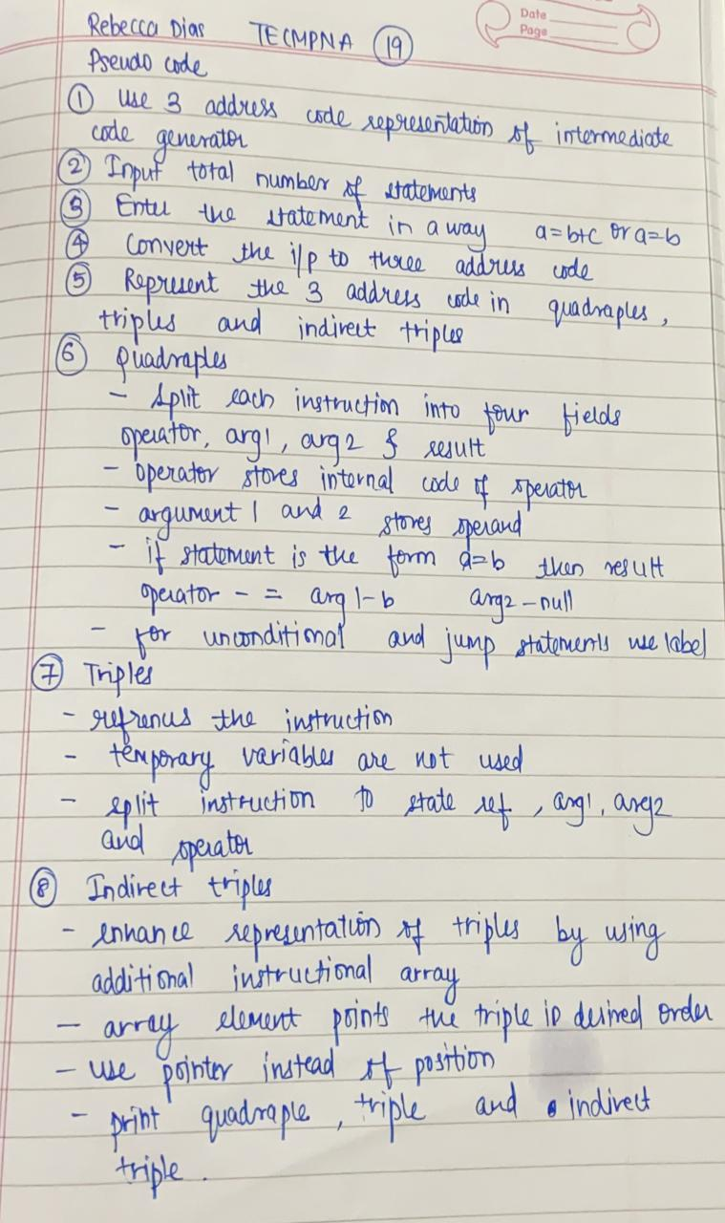

**Code**

def quadruples(e ,l):

    a = 0

    if l==3:

        a = 1

        arg2.append(' ')

    else:

        a = 2

    for i in range(a,l):

        if e[i].isalpha():

            if i == 2:

                arg1.append(e[i])

            else:

                arg2.append(e[i])

        elif e[i] in operator:

            op.append(e[i])

    result.append(e[0])

    location[e[0]] = j

    return

print('REBECCA DIAS TE CMPN A 19/182027')

n = int(input('Enter the number of expressions: '))

exp = []

print(f'Enter the {n} expressions in 3 address code:')

for i in range(n):

    exp.append(input())

operator = ['+','-','*','/','^','=']

op = []

arg1 = []

arg2 = []

result = []

j = 0

location = {}

for e in exp:

    quadruples(e,len(e))

    j = j + 1

print('\n__________Quadruples__________\nop\targ1\targ2\tresult\n')

for i in range(n):

    print(op[i],'\t',arg1[i],'\t',arg2[i],'\t',result[i],'\n')

print('\n____________Triples____________\nlocation\top\targ1\targ2\n')

for i in range(n):

    if arg1[i] in location and arg2[i] in location:

        print(i,'\t\t',op[i],'\t',location[arg1[i]],'\t',location[arg2[i]])

    elif arg1[i] in location:

        print(i,'\t\t',op[i],'\t',location[arg1[i]],'\t',arg2[i])

    elif arg2[i] in location:

        print(i,'\t\t',op[i],'\t',arg1[i],'\t',location[arg2[i]])

    else:

        print(i,'\t\t',op[i],'\t',arg1[i],'\t',arg2[i])

print('\n_________Indirect Triples_________\nlocation\top\targ1\targ2\n')

j = 1001

for i in range(n):

    if arg1[i] in location and arg2[i] in location:

        print(j,'\t\t',op[i],'\t',location[arg1[i]],'\t',location[arg2[i]])

    elif arg1[i] in location:

        print(j,'\t\t',op[i],'\t',location[arg1[i]],'\t',arg2[i])

    elif arg2[i] in location:

        print(j,'\t\t',op[i],'\t',arg1[i],'\t',location[arg2[i]])

    else:

        print(j,'\t\t',op[i],'\t',arg1[i],'\t',arg2[i])

    j = j + 1

## Output

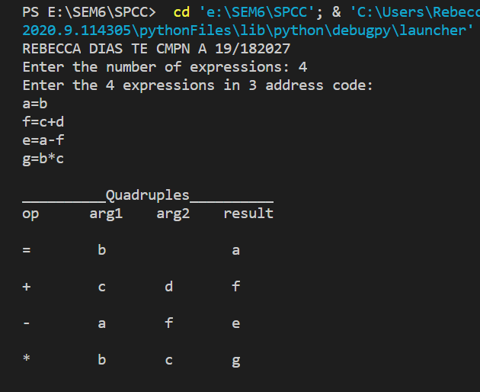

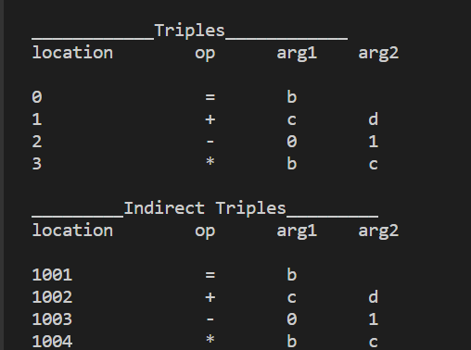

**Conclusion:**

The intermediate code is generated from the statements. In this experiment we studied the role of intermediate code generator and computed the different representations of three address code for the given expressions. Thus we successfully implemented the experiment.